

|  |  |
| --- | --- |
| 20/21- MAT021 FOUNDATIONS OF OPERATIONAL RESEARCH AND ANALYTICS - INDIVIDUAL Coursework (SIMULATION MODEL) | Abstract  In this coursework, the provided dataset contains four types of data: Scheduled Arrival, Unscheduled Arrival, Scheduled Service and Unscheduled Service of police cars in a maintenance garage. Using MS Excel, we defined the distributions of the given dataset and then generated a simulation model, where the two types of arrivals happen, and we set the priority of the label for unscheduled arrivals of police cars. Unscheduled police cars will disrupt the operation of scheduled police cars for this purpose and they will be serviced before. As a service area resource, we used a mechanic who would work in the shop for 8 hours a day and 7 days a week. In order to make our simulation model, we used Simul8 software and used some Simul8 default labels to make our model work properly. After running the simulation model, we achieved a 95% confidence interval for our model's resource utilization. The developed system is general and can be adapted to suit the needs of any police car maintenance garage in evaluating policies in the following areas:   * Obtain a 95% confidence interval for the utilisation of the mechanic. * Number of scheduled and Unscheduled cars waiting for service * Waiting time of scheduled cars for service (hours) * Time schedule cars spent with the mechanic (hours) * Time scheduled cars spent in garage, including interrupted time (hours) * Factors of influence do unscheduled police cars have on the overall service time of the scheduled cars     SIVA SATHGURU PANDIYARAJAN  STUDENT NUMBER: 2105259 |

Data Analysis

Arrival Data Analysis: The distribution of Scheduled and Unscheduled Arrival data was first distinguished and analyzed by Excel. The below are the steps that were followed for data analysis of the arrival data:

1. To comprehend the frequency distribution of the data of Scheduled Arrival and Unscheduled Arrival, it was needed to plot Histograms, followed by the examination of skewness of the given information. After that to analyse statistically, we utilized box-plot charts and looked for exceptions to standardize our appearance information and get the best possible proportion of central tendency and standard deviation.
2. We explored the arrival data of Scheduled cars and got the diagram appeared in **Fig-1**. We made a column for discrete values of the cars per batch (Number of vehicles per day) and found three batch sizes of 2, 3 and 4 and in another column, we counted their frequency. After that calculation was made for the probability of each discrete values of the batch, which is shown in the accompanying table:

|  |  |  |  |
| --- | --- | --- | --- |
| Serial Number | Cars in Batch | Frequency | Probability |
| 1 | 2 | 93 | 0.25479452 |
| 2 | 3 | 186 | 0.50958904 |
| 3 | 4 | 86 | 0.23561644 |

A bar graph was plotted, which shows that the distribution for the batching out of scheduled arrivals are **Poisson Distribution with Mean = 2.98** and utilized this distribution in the batching out of scheduled arrivals. We utilized fixed distribution with fixed value **24** for scheduled arrivals as the group of cars are coming in like clockwork (every 24 hours).

1. 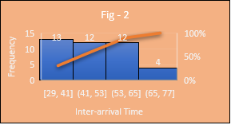Later began exploring the information of Unscheduled appearances. To recognize the distribution, we evaluated the inter-arrival time and the relative frequency of the discrete values of them in excel. As the skewness of the inter-arrival time was **zero**, we could reason that the distribution should be Normal. After that, a graph was plotted (**Fig-2**), where we fitted Inter-arrival time as x-pivot and Frequency as y-hub. From the information of Inter-arrival time, we got **Mean = 47.86** and **Standard Deviation = 6.93**.
2. Finally, in order to incorporate them in our simulation model, we reported all our acquired estimates of mean and standard deviation.

Service Data Analysis: We have analysed the Service Time data needed for Scheduled Arrivals and Unscheduled Arrivals using Excel. The means adopted for data investigation of the service time for arrival data are as follows:

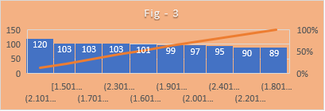1. We examined the given information of service time needed for Scheduled cars and got the chart appeared in **Fig-3.** From the frequency distribution, skewness, and kurtosis, we could presume that the given information has a Uniform Distribution with **Lower Bound 1.5** and **Upper Bound 2.5,** which we utilized in our simulation model.

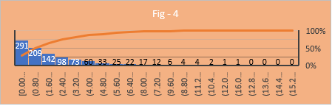2. We later started operating with the Service Time for Unscheduled Arrivals data issued. Additionally, subsequent to making all the charts (**Fig-4**) and different traits, we could determine that the given information has Exponential Probability Distribution with **Mean 2.34**.

SIMULATION MODEL

Subsequent to getting all the distributions and any remaining viewpoints we continued towards making our simulation model. From the outset, we made an AFD of our model and afterward cast this model into Simul8 programming **(Fig-5).** The means that we follow to make our simulation model are as per the following:

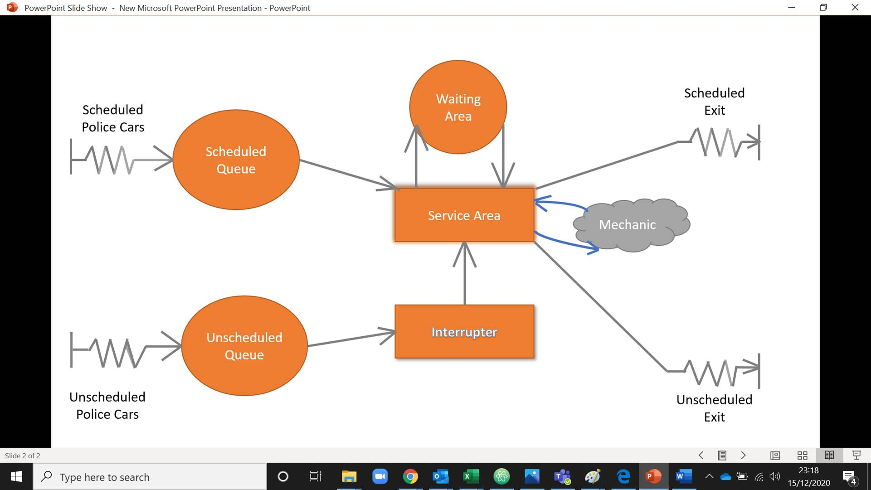

1. Two starting points were established, one for scheduled arrivals and another for unscheduled arrivals, and all distributions were used for both, as seen in the section of this report on Arrival Data Investigation.
2. After that two queues were made, one is a scheduled queue to meet all scheduled arrivals and another is an unscheduled queue to reach all unscheduled arrivals.
3. From the scheduled queue, all vehicles will straight forwardly enter to the service area, though the unscheduled cars will experience an interrupter. This interrupter will intrude on the work going on in service area of a booked cars and send this to the waiting region and permit the unscheduled car to enter the service area as the unscheduled police cars are of priority.
4. From that point onward, the unscheduled police vehicles will move to the Unscheduled Exit Point and the Scheduled vehicle which is holding up in the Waiting Area will go to the Service Area and after fix, it will go to the Scheduled Exit Point and afterward just other booked vehicles which were holding up in the Scheduled line, will be pushed to the service area for repair.
5. In our model, we have utilized few labels, for example,

**Due Name,** which contains the leftover work time for the interrupted work of the scheduled police vehicles. When the work of a scheduled car is interrupted, this label will be refreshed naturally to contain how long is left to complete the work for that vehicle. Along these lines, it is necessary to set Due name on each start point. For that in the Due label, we added planned arrivals and unscheduled arrivals and set them with their respective distributions, which are depicted in the Arrival data analysis part of this report.

**Work Type Label,** which advises simul8 about two forms of work types in our model, one is planned arrival, and another one is unscheduled arrival. That is the reason we have added these two arrivals and set the fixed values as 1 and 2 for scheduled arrivals and unscheduled arrivals separately to show Simul8 that there are two distinctive work types.

**Priority Label,** this label is a default label in Simul8 as like others in which we have added Scheduled Arrivals and Unscheduled Arrivals with fixed value of 1 and 2 respectively to prioritise Unscheduled police cars. This label also route outs the scheduled and unscheduled cars to their respective exit.

1. In order to interrupt an activity (service area in this case where scheduled cars are interrupted), we need to add an activity where we set the fixed distribution with fixed value as zero, which enables randomness to be eradicated. Likewise, it interferes the service of scheduled car and send it to the waiting area and send the unscheduled car in service area for fixing.
2. In Service Area, fixed distribution was used with Due Label, which will work accordingly to the Due Label. Also, in Routing Out of the Service Area, priority label was used so that Unscheduled Cars get priority and we set the batching out as fixed value 1 as only 1 car can be serviced at a time and go out from the service area.
3. The entire cycle will be finished by a resource named “Mechanic”. The vehicles in the garage can come at any time, yet the service area will be opened 8 hours each day, as the Mechanic will be accessible only during this period. That is the reason we set the clock properties of this model as a day in and day out, which permits the vehicles to come whenever. However, we set the movements – one is the Day shift, which is from 10:00 AM to 18:00 PM and another is the Night shift, which is from 19:00 PM to 02:00 AM. But the Mechanic will be available for the day move. In this way, the vehicles which will come after the closure of the garage should stand by until the following day of the opening of the garage.
4. Then from the Trial Setup option in Simul8, we settled on 100 trials, and to get a 95% confidence interval, we choose 95% from the display range.

|  |  |  |  |
| --- | --- | --- | --- |
|  | Minimum | Average | Maximum |
| Number of scheduled cars waiting for service | 0 | 3.027 | 19 |
| Waiting time of scheduled cars for service (hours) | 8 | 16.79 | 84.63 |
| Number of unscheduled cars waiting for service | 0 | 0 | 1 |
| Time schedule cars spent with the mechanic (hours) | 0.04 | 1.95 | 2.50 |
| Time scheduled cars spent in garage, including interrupted time (hours) | 10.20 | 20.35 | 88.22 |

1. After executing for 100 trials-run the below output will appear as shown in the chart:

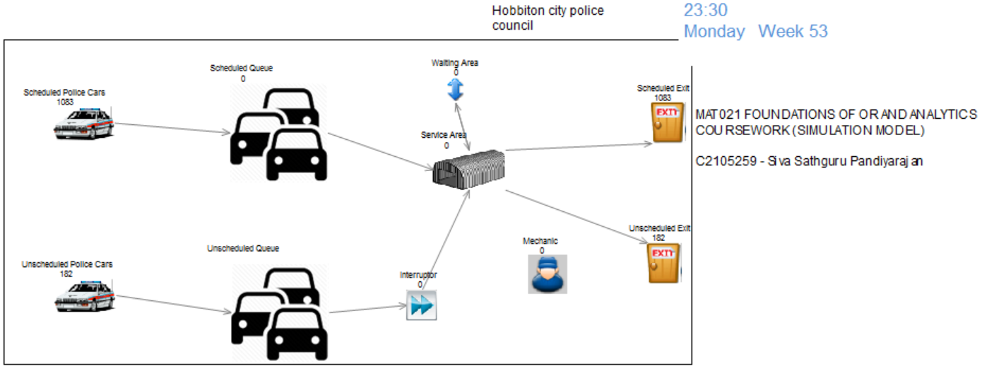

Simulation Model – After 100 trial runs

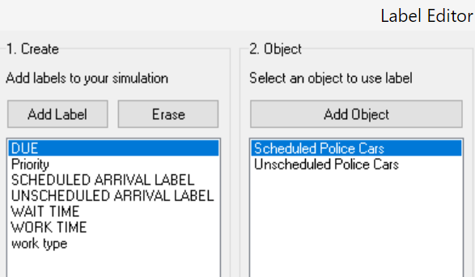 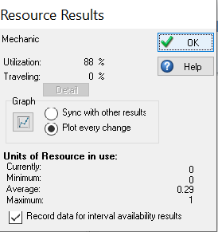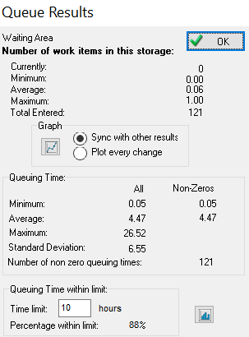

MODEL VERIFICATION AND VALIDATION

First using Simul8 web visual verification, we checked our model and then compared the number of scheduled arrivals and unscheduled arrivals with the given dataset. In our model, there are about the same number of arrivals taking place. After that for the results obtained from our simulation model, we split the inter-arrival times by 182 cars for 8760 hours a year and got 48.13, which is almost equal to the mean of the inter-arrival times we got from the given dataset. We thus logically checked and then validated our model.

RECOMMENDATION

If a mechanic is still available during the night shift, so scheduled cars are serviced in less time and if they arrive at night, they do not need to wait for hours for the garage to open on the next day.

ASSUMPTIONS

**Q1. What if there were no unscheduled police cars?**

* The average time spent in the garage on scheduled vehicles is lower.
* There are no scheduled vehicles entering the waiting area.
* After running the model for 100 trials, the Mechanic’s Utilization falls from 88 percent to 74 percent.

**Q2. What if scheduled and unscheduled car arrival rates change?**

* After increasing the number of scheduled arrivals, the number of scheduled cars increased, and the number of cars also increased in the scheduled queue. But there was not much change in the overall number of cars entering the waiting area.
* If we increase the batch of unscheduled arrivals, the number of unscheduled arrivals has also increased, and the resource has serviced all the unscheduled arrivals. But in the scheduled queue, the number of scheduled cars increased, and the waiting time of the scheduled cars increased accordingly, too.
* When we reduced the batch of scheduled arrivals, the number of scheduled arrivals of cars was reduced, but the resource served all the cars (mechanic).

**Q3. What happens if the mechanic works six days a week?**

* It has little effect on scheduled arrivals, but more cars are waiting for service in the scheduled queue, and a larger number of cars have reached the waiting area.
* All unscheduled arrivals have been serviced.
* Utilization of Mechanic has risen from 88% to 99%.

CONCLUSION

Some labels with real parameters were used, which allowed this model to run correctly. The batching out of the service area equally distributes the number of all cars between the scheduled exit and the unscheduled exit if we do not add the default label called Due. Only scheduled cars will go to the scheduled exit after using this mark, and unscheduled cars will go to the unscheduled exit. So, in our model, using labels is very essential.

This model of simulation is a generalized model, so we did not add the dataset given with it.

APPENDICES:

