**Episode 1: The CCNA Certification and Networking Basics**

**Duration:** 90 minutes

**Language:** English

This first episode begins with an overview of the CCNA program, including the new consolidated CCNA. Then a review of the first two sections of content that the exam covers: Network Fundamentals and Network Access.

**Episode 2: CCNA – Getting Acquainted with Internet Protocol (IP), Connectivity & Services**

**Duration:**60 minutes

**Language:** English

A brief review of the basics of the CCNA program, followed by a deep dive into the second section of the exam, which covers the basics of IP Connectivity and IP Services.

**Episode 3: CCNA - Building on the Basics with Security, Automation, & Programmability**

**Duration:** 60 minutes

**Language:** English

In this final episode, there will be a brief recap of the first two episodes, then a deep-dive into the third section of the exam, which covers Security Fundamentals, as well as Automation and Programmability.

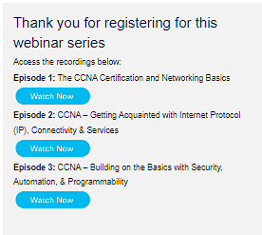

CCNA certification

CCNA certification proves you have what it takes to navigate the ever-changing landscape of IT. CCNA exam covers networking fundamentals, IP services, security fundamentals, automation and programmability. Designed for agility and versatility, CCNA validates that you have the skills required to manage and optimize today's most advanced networks.

The CCNA training course and exam give you the foundation to take your career in any direction. When you certify with Cisco, you are living proof of the standard and rigor that businesses recognize and trust to meet and exceed market demands.

# **CCNA: The Beginning of Your Networking Journey – The Essentials Series part 1**

Joanna Gardner

Product Marketing Manager, Certifications

Anna Rubin

Manager, Exam Development Certifications

Julie Armaganian

CCNA Exam Program Manager

