C# Sharp program to accept two integers and check whether they are equal or not.

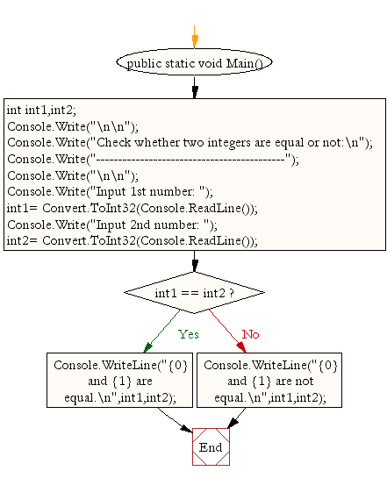

C# program to check whether a given number is even or odd.

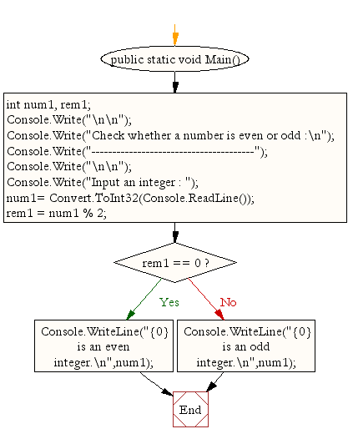

C# Sharp program to check whether a given number is positive or negative.

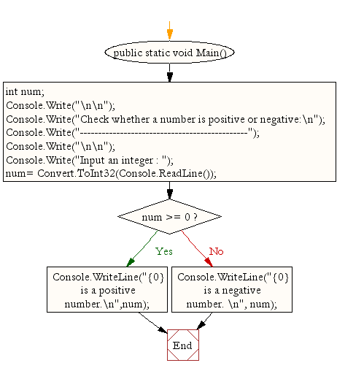

C# Sharp program to find whether a given year is a leap year or not.

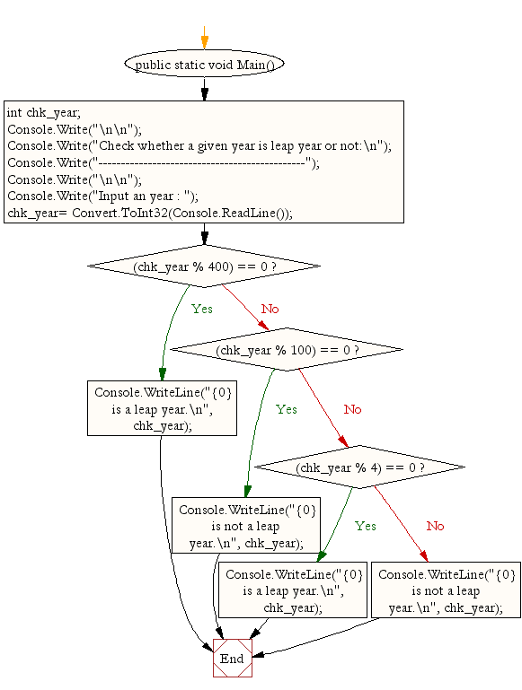

C# Sharp program to read age of a candidate and determine whether it is eligible for casting his/her own vote.

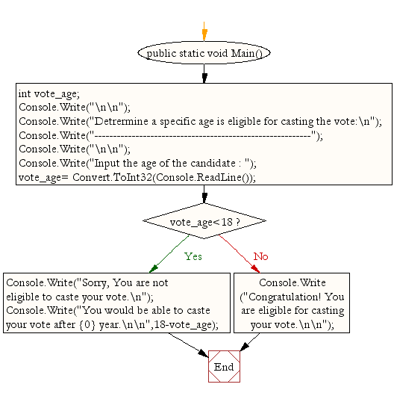

C# Sharp program to read the value of an integer m and display the value of n is 1 when m is larger than 0, 0 when m is 0 and -1 when m is less than 0.

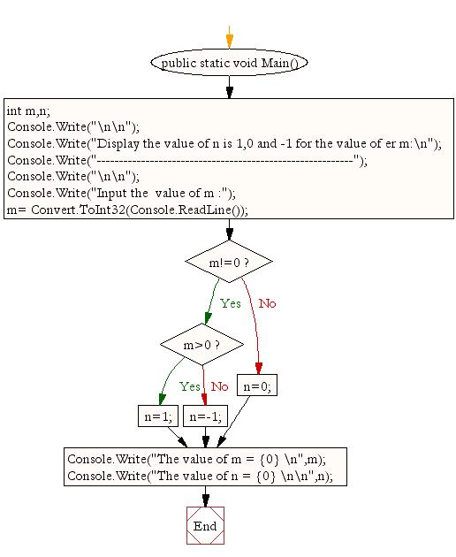

C# Sharp program to accept the height of a person in centimeter and categorize the person according to their height.

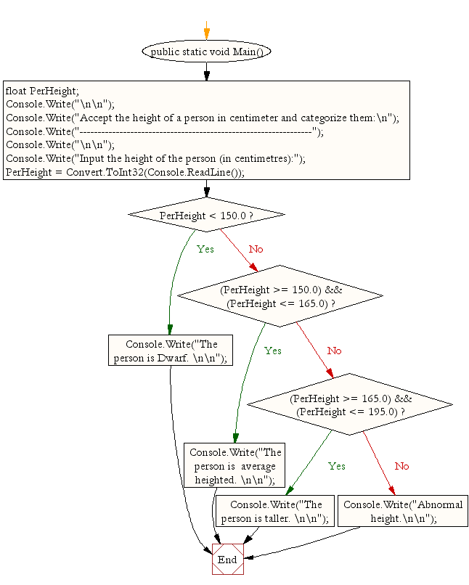

C# program to find the largest of three numbers.

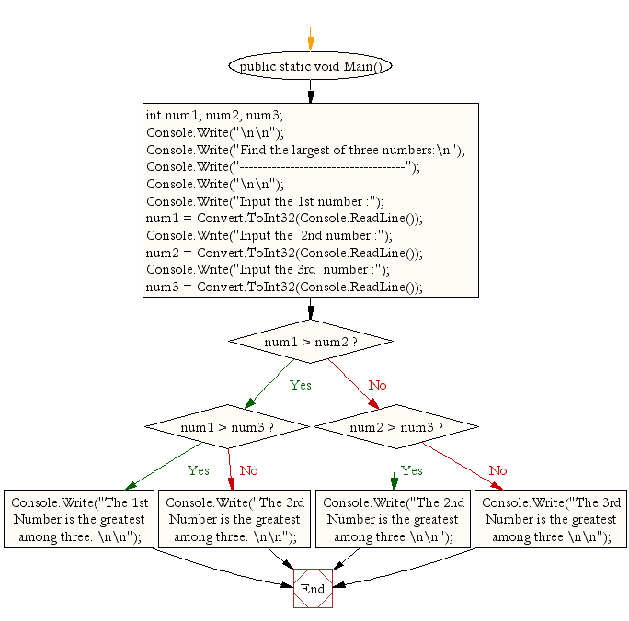

C# program to accept a coordinate point in an XY coordinate system and determine in which quadrant the coordinate point lies.

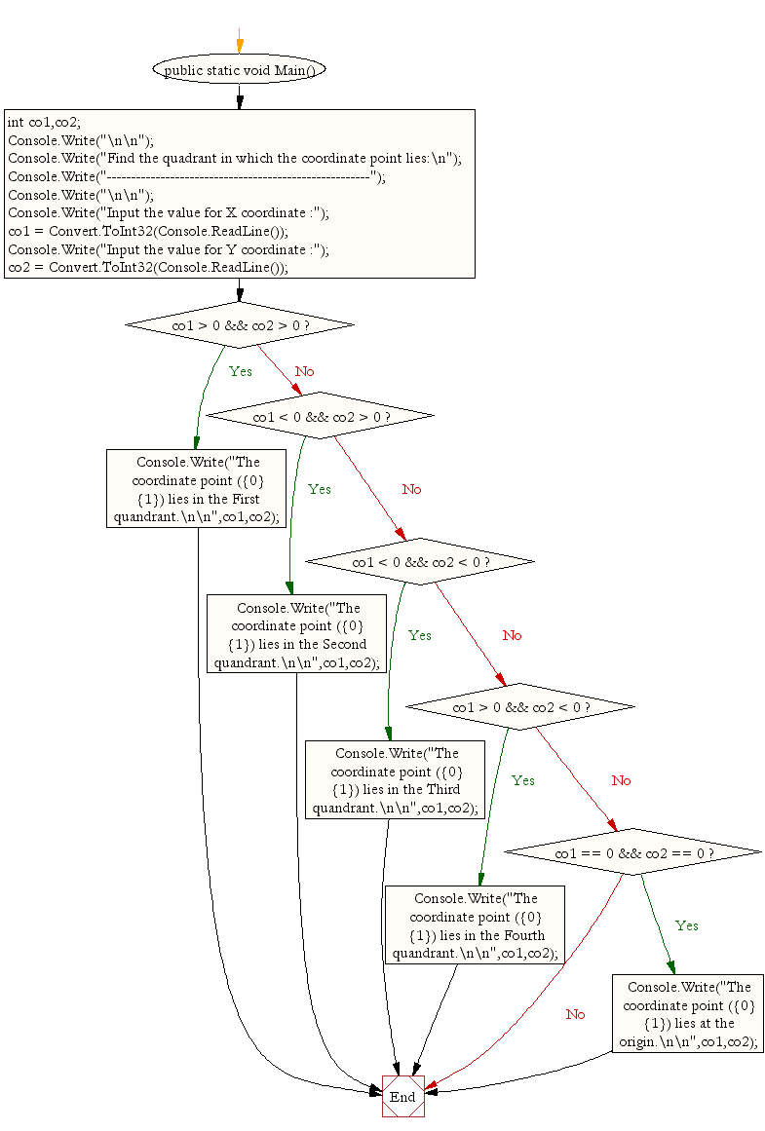

C program to find the eligibility of admission for a professional course based on the following criteria:

Marks in Maths >=65  
Marks in Phy >=55  
Marks in Chem>=50  
Total in all three subject >=180  
or  
Total in Math and Subjects >=140

