C# Sharp to store elements in an array and print it.

Read and Print elements of an array:

-----------------------------------------

Input 10 elements in the array :

element - 0 : 2

element - 1 : 4

element - 2 : 6

element - 3 : 8

element - 4 : 10

element - 5 : 12

element - 6 : 14

element - 7 : 16

element - 8 : 18

element - 9 : 20

Elements in array are: 2 4 6 8 10 12 14 16 18 20

Write a program in C# Sharp to read n number of values in an array and display it in reverse order.

Test Data :  
Input the number of elements to store in the array :3  
Input 3 number of elements in the array :  
element - 0 : 2  
element - 1 : 5  
element - 2 : 7

Expected Output:  
The values store into the array are:  
2 5 7  
The values store into the array in reverse are :  
7 5 2

Write a program in C# Sharp to find the sum of all elements of the array.

Test Data :  
Input the number of elements to be stored in the array :3  
Input 3 elements in the array :  
element - 0 : 2  
element - 1 : 5  
element - 2 : 8  
Expected Output :  
Sum of all elements stored in the array is : 15

 Write a program in C# Sharp to copy the elements one array into another array.

Test Data :  
Input the number of elements to be stored in the array :3  
Input 3 elements in the array :  
element - 0 : 15  
element - 1 : 10  
element - 2 : 12  
Expected Output:  
The elements stored in the first array are :  
15 10 12  
The elements copied into the second array are :  
15 10 12

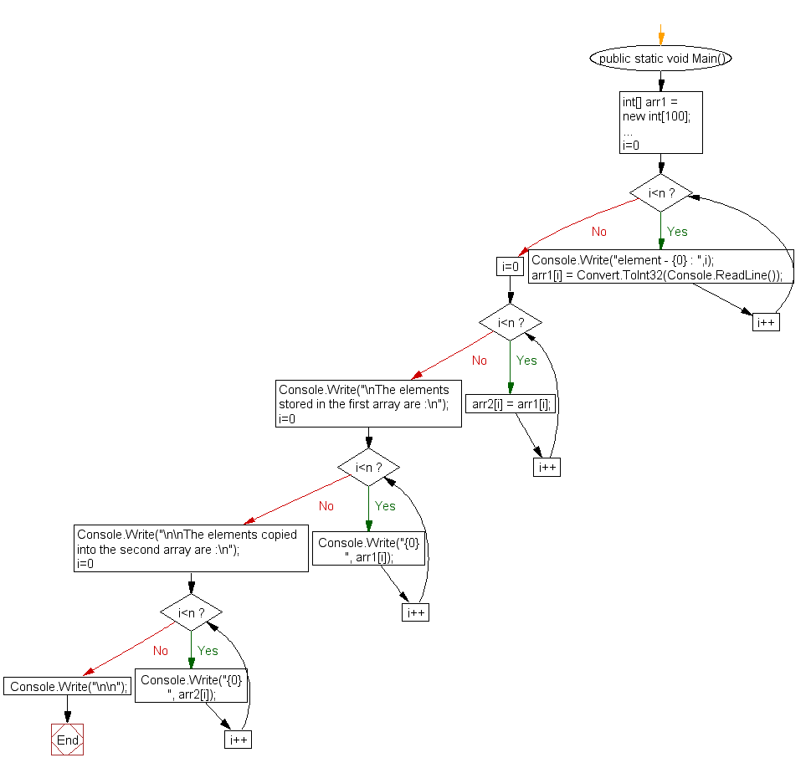

C# Sharp to count a total number of duplicate elements in an array.

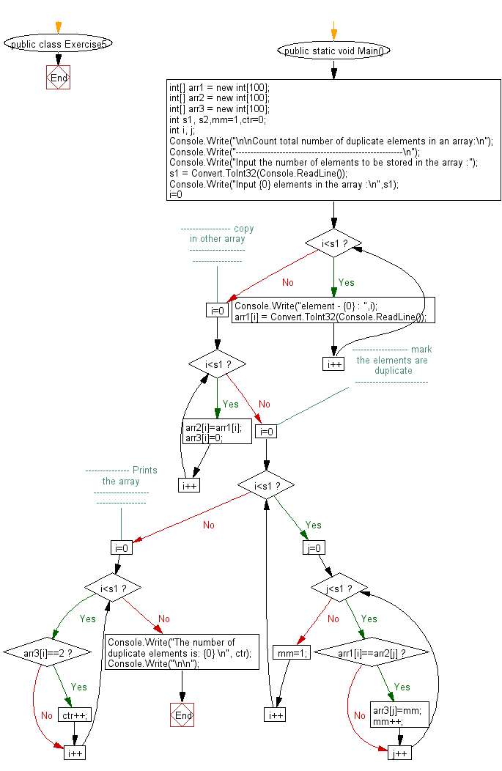

C# Sharp to print all unique elements in an array.

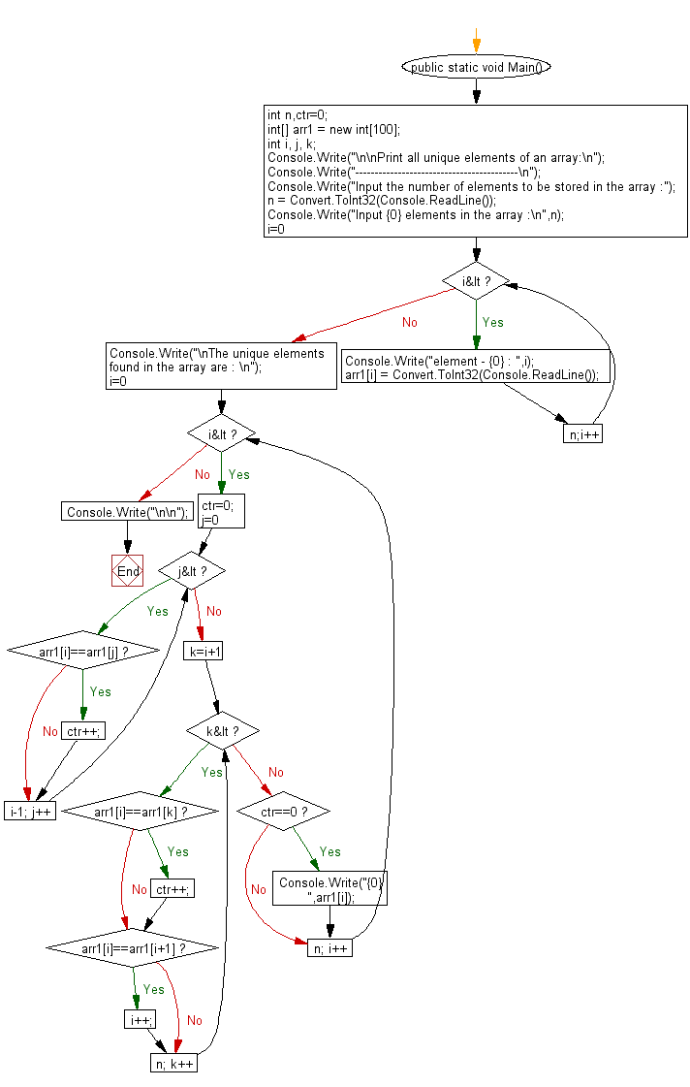

C# Sharp to merge two arrays of same size sorted in ascending order.

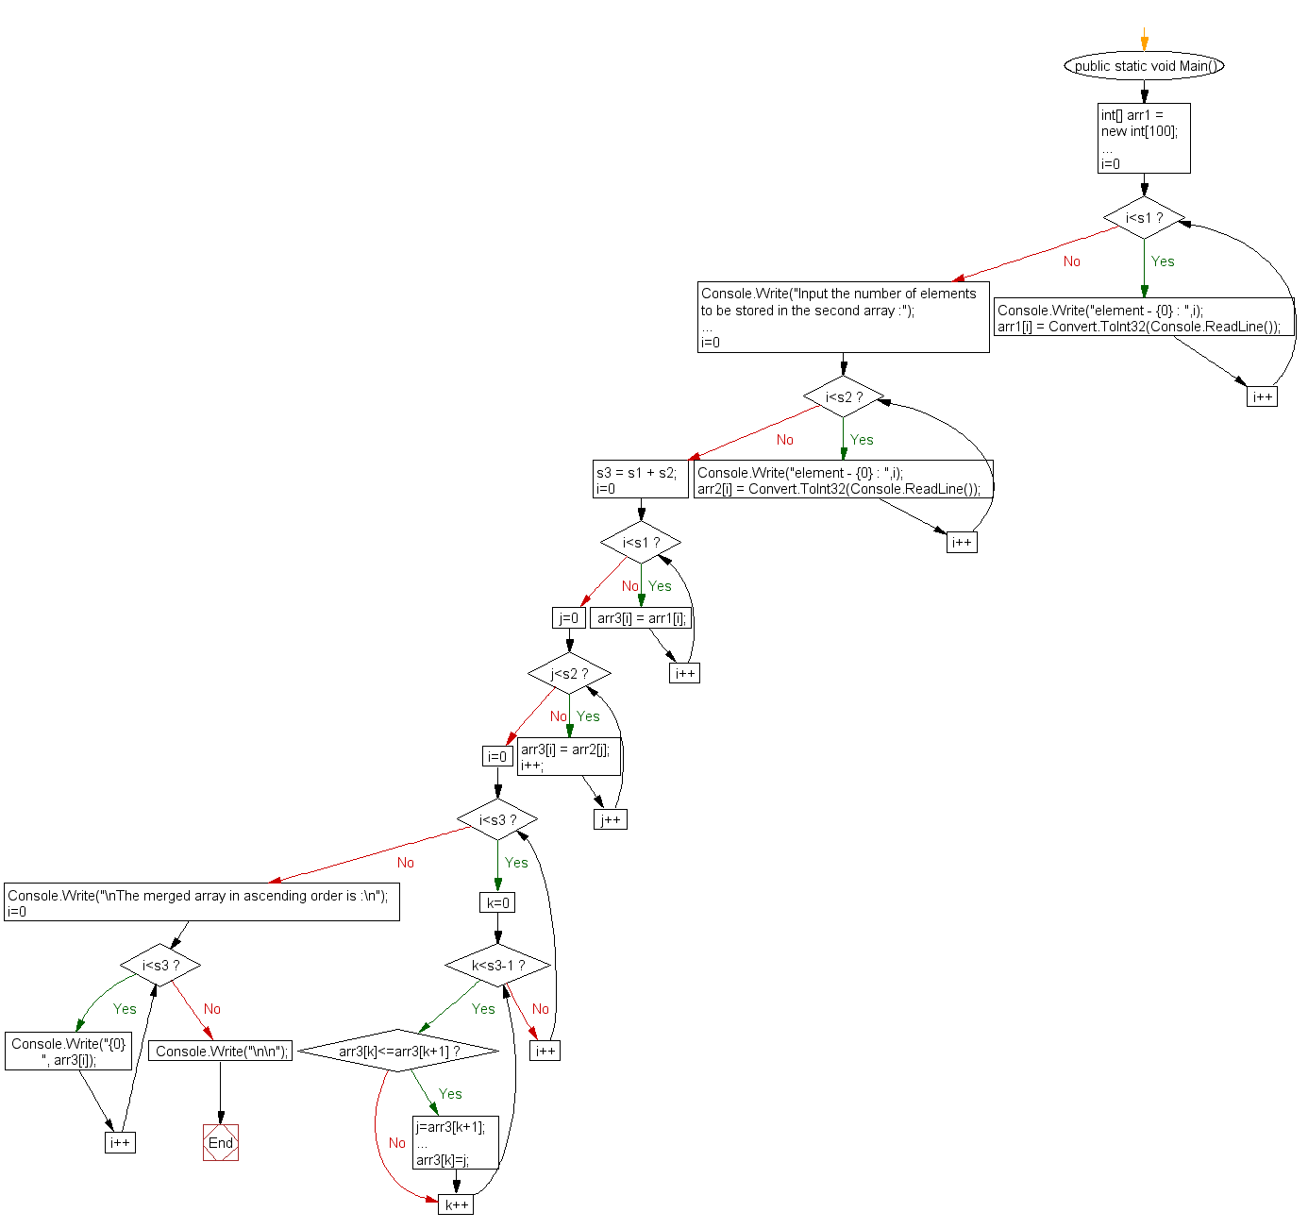

C# Sharp to count the frequency of each element of an array.

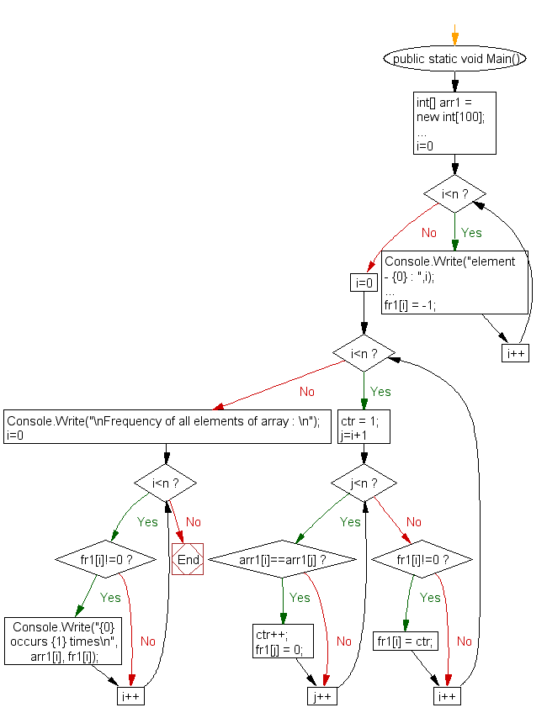

C# Sharp to find maximum and minimum element in an array.

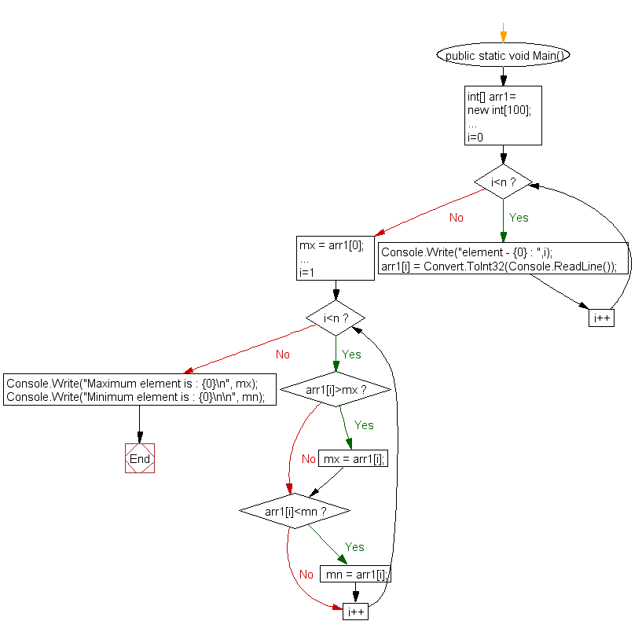

C# Sharp to separate odd and even integers in separate arrays.

