C# Sharp to display the first 10 natural numbers-use For Loop

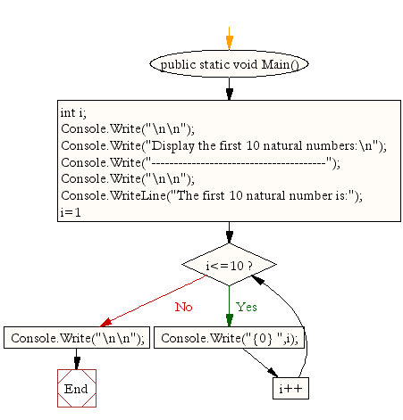

C# Sharp program to find the sum of first 10 natural numbers.-for Loop

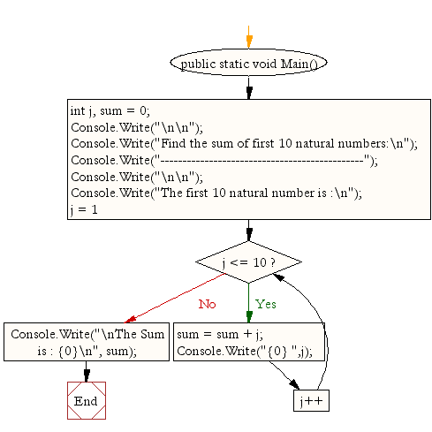

C# Sharp to display n terms of natural number and their sum.-For Loop

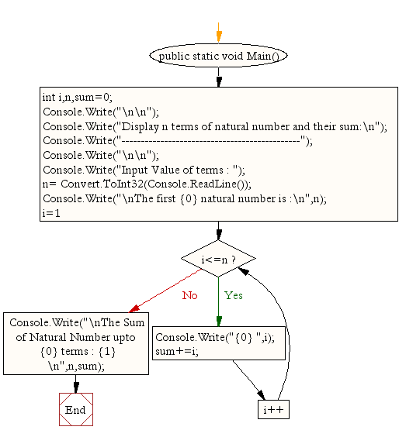

C# Sharp to read 10 numbers from keyboard and find their sum and average.

Input the 10 numbers :

Number-1 :2

Number-2 :4

Number-3 :6

Number-4 :8

Number-5 :10

Number-6 :12

Number-7 :14

Number-8 :16

Number-9 :18

Number-10 :20

The sum of 10 no is : 110

The Average is : 11

C# Sharp to display the cube of the number upto given an integer.

Test Data :  
Input number of terms : 5  
Expected Output :  
Number is : 1 and cube of the 1 is :1  
Number is : 2 and cube of the 2 is :8  
Number is : 3 and cube of the 3 is :27  
Number is : 4 and cube of the 4 is :64  
Number is : 5 and cube of the 5 is :125

C# Sharp to display the multiplication table of a given integer.

Test Data :  
Input the number (Table to be calculated) : 15  
Expected Output :  
15 X 1 = 15  
...  
...  
15 X 10 = 150

 C# Sharp to display the multiplication table vertically from 1 to n.

Test Data :  
Input upto the table number starting from 1 : 8  
Expected Output :  
Multiplication table from 1 to 8  
1x1 = 1, 2x1 = 2, 3x1 = 3, 4x1 = 4, 5x1 = 5, 6x1 = 6, 7x1 = 7, 8x1 = 8  
...  
1x10 = 10, 2x10 = 20, 3x10 = 30, 4x10 = 40, 5x10 = 50, 6x10 = 60, 7x10 = 70, 8x10 = 80

C# Sharp to display the n terms of odd natural number and their sum

Test Data  
Input number of terms : 10  
Expected Output :  
The odd numbers are :1 3 5 7 9 11 13 15 17 19  
The Sum of odd Natural Number upto 10 terms : 100

C# Sharp to display the pattern like right angle triangle using an asterisk.

The pattern like :

\*

\*\*

\*\*\*

\*\*\*\*

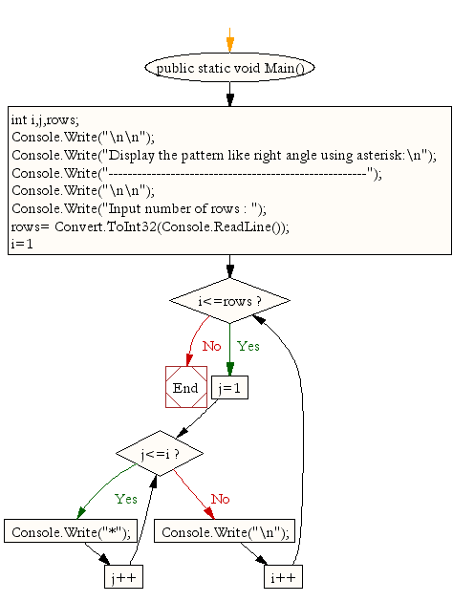

C# Sharp to display the pattern like right angle triangle with a number.

The pattern like :

1

12

123

1234

