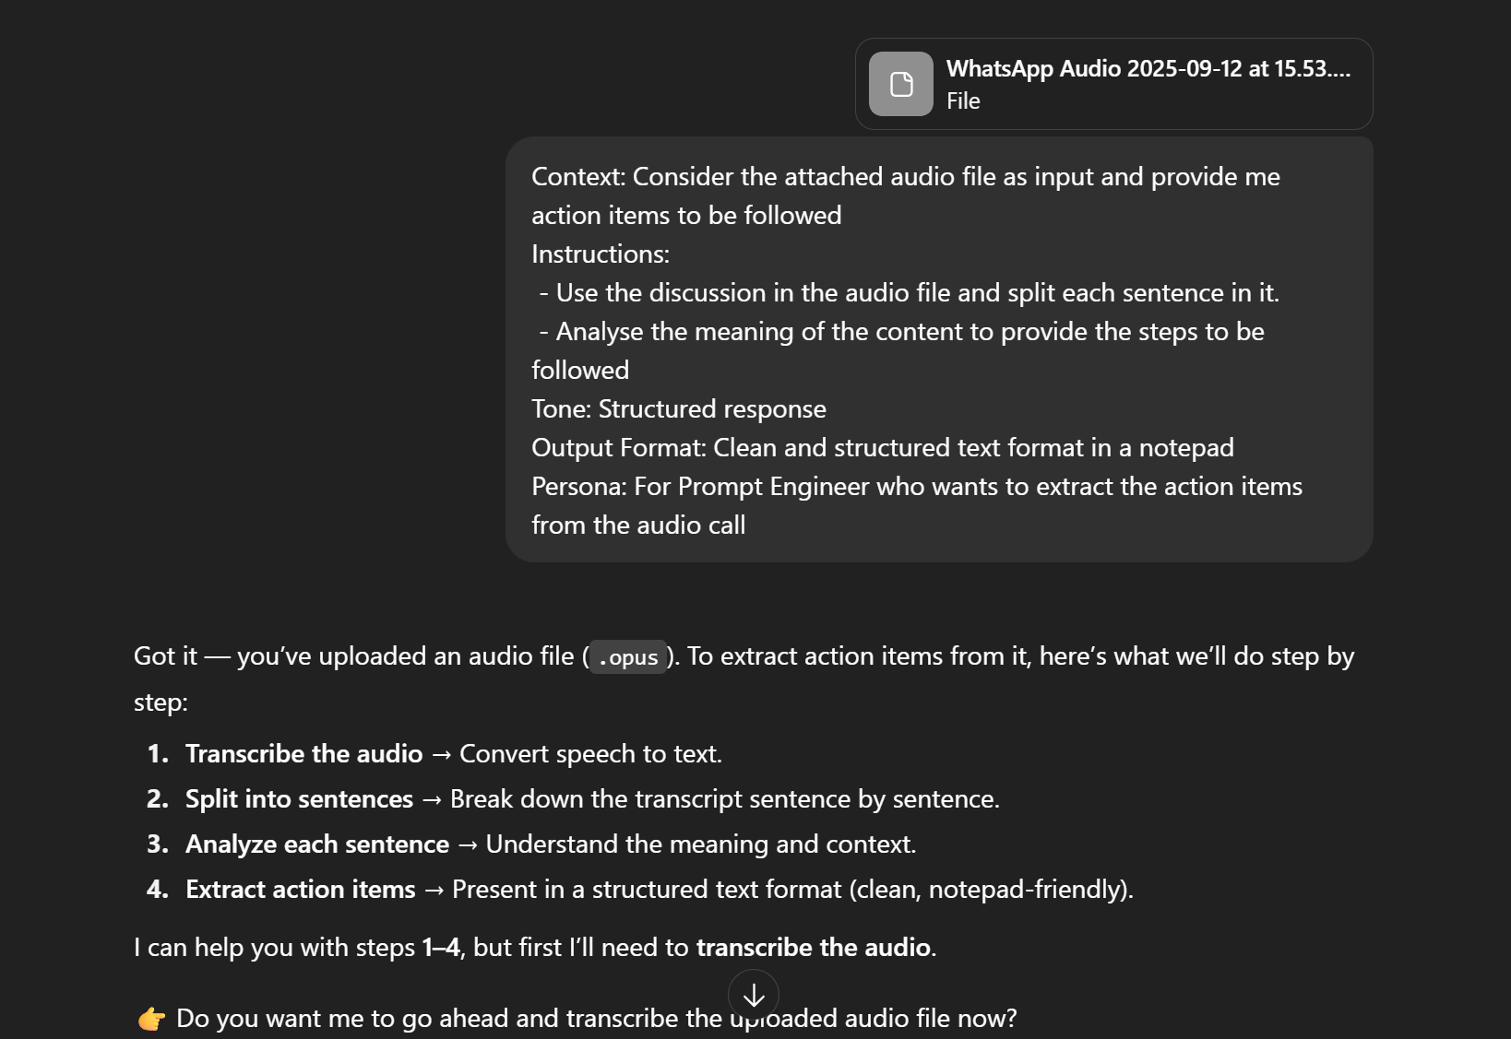

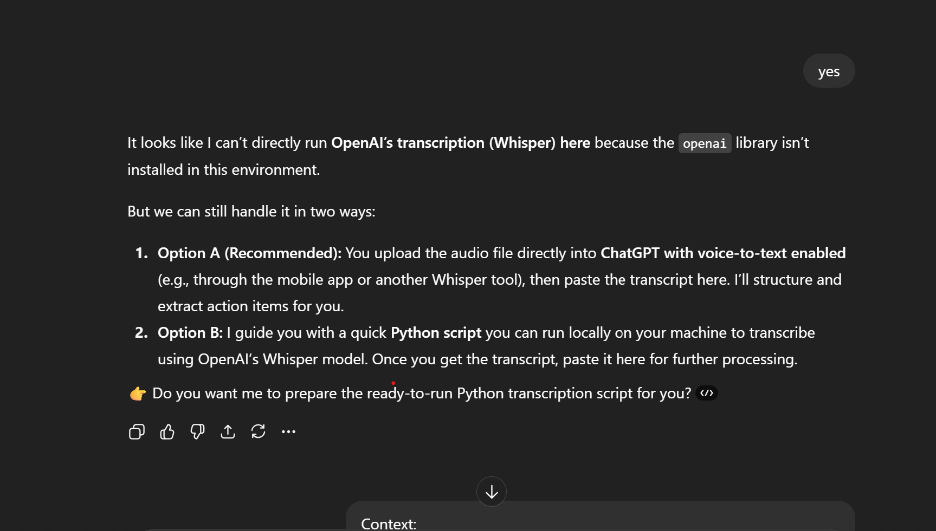

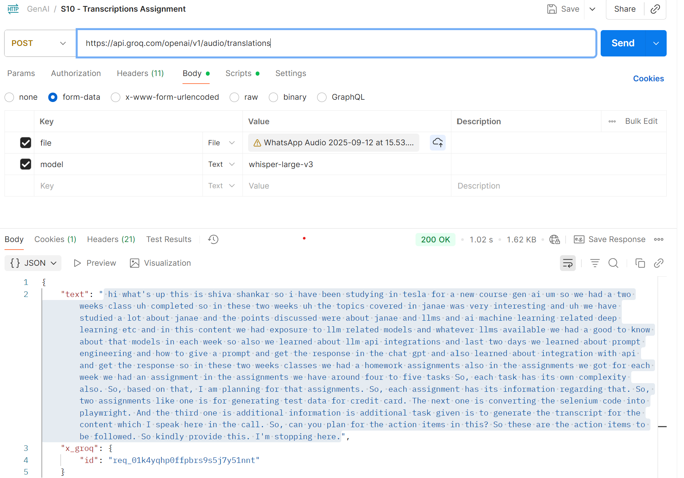

MY Final PROMPT:

Context:

Generate the action items to be followed for below given audio converted text transcript:

"hi what's up this is sivashankar so i have been studying in tesleaf for a new course gen ai. so we had a two weeks class uh completed so in these two weeks uh the topics covered in janae was very interesting and uh we have studied a lot about janae and the points discussed were about janae and llms and ai machine learning related deep learning etc and in this content we had exposure to llm related models and whatever llms available we had a good to know about that models in each week so also we learned about llm api integrations and last two days we learned about prompt engineering and how to give a prompt and get the response in the chat gpt and also learned about integration with api and get the response so in these two weeks classes we had a homework assignments also in the assignments we got for each week we had an assignment in the assignments we have around four to five tasks So, each task has its own complexity also. So, based on that, I am planning for that assignments. So, each assignment has its information regarding that. So, two assignments like one is for generating test data for credit card. The next one is converting the selenium code into playwright. And the third one is additional information is additional task given is to generate the transcript for the content which I speak here in the call. So, can you plan for the action items in this? So these are the action items to be followed. So kindly provide this. I'm stopping here."

Instructions:

- Use the discussion transcripted from the audio file and split each sentence in it.

- Analyse the meaning of the content to provide the steps to be followed

Tone: Structured response

Output Format: Clean and structured text format in a notepad

Persona: For Prompt Engineer who wants to extract the action items from the audio call

