Classroom activity1:

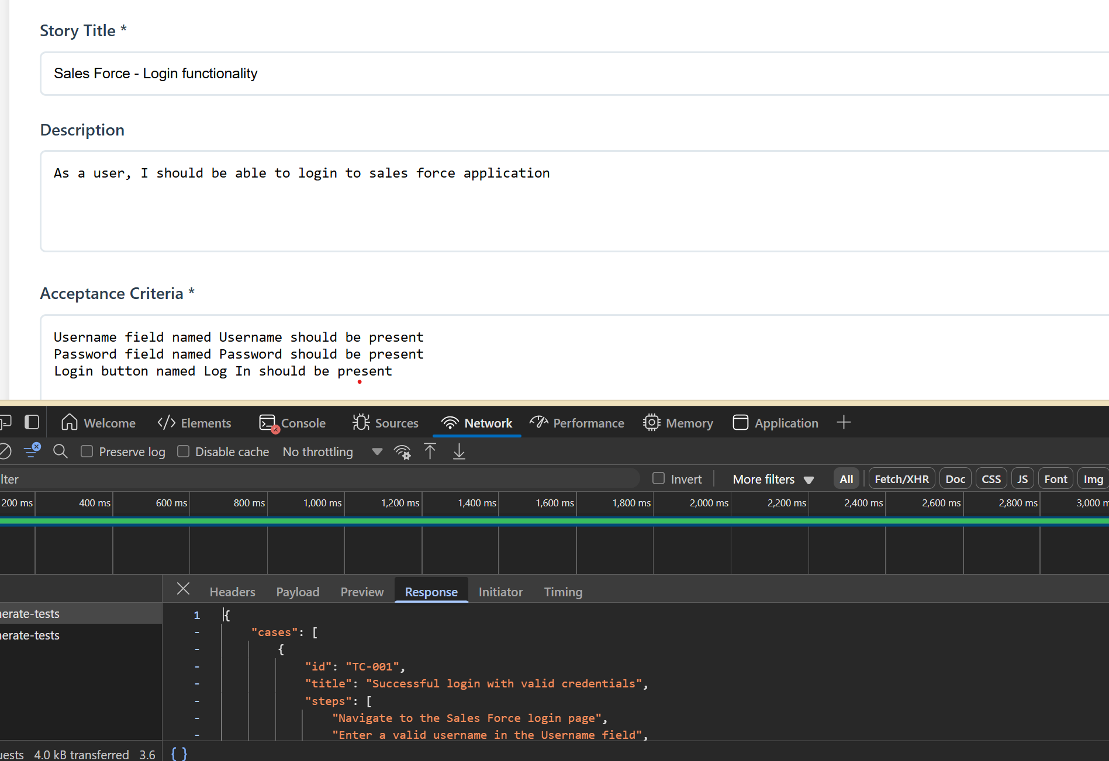

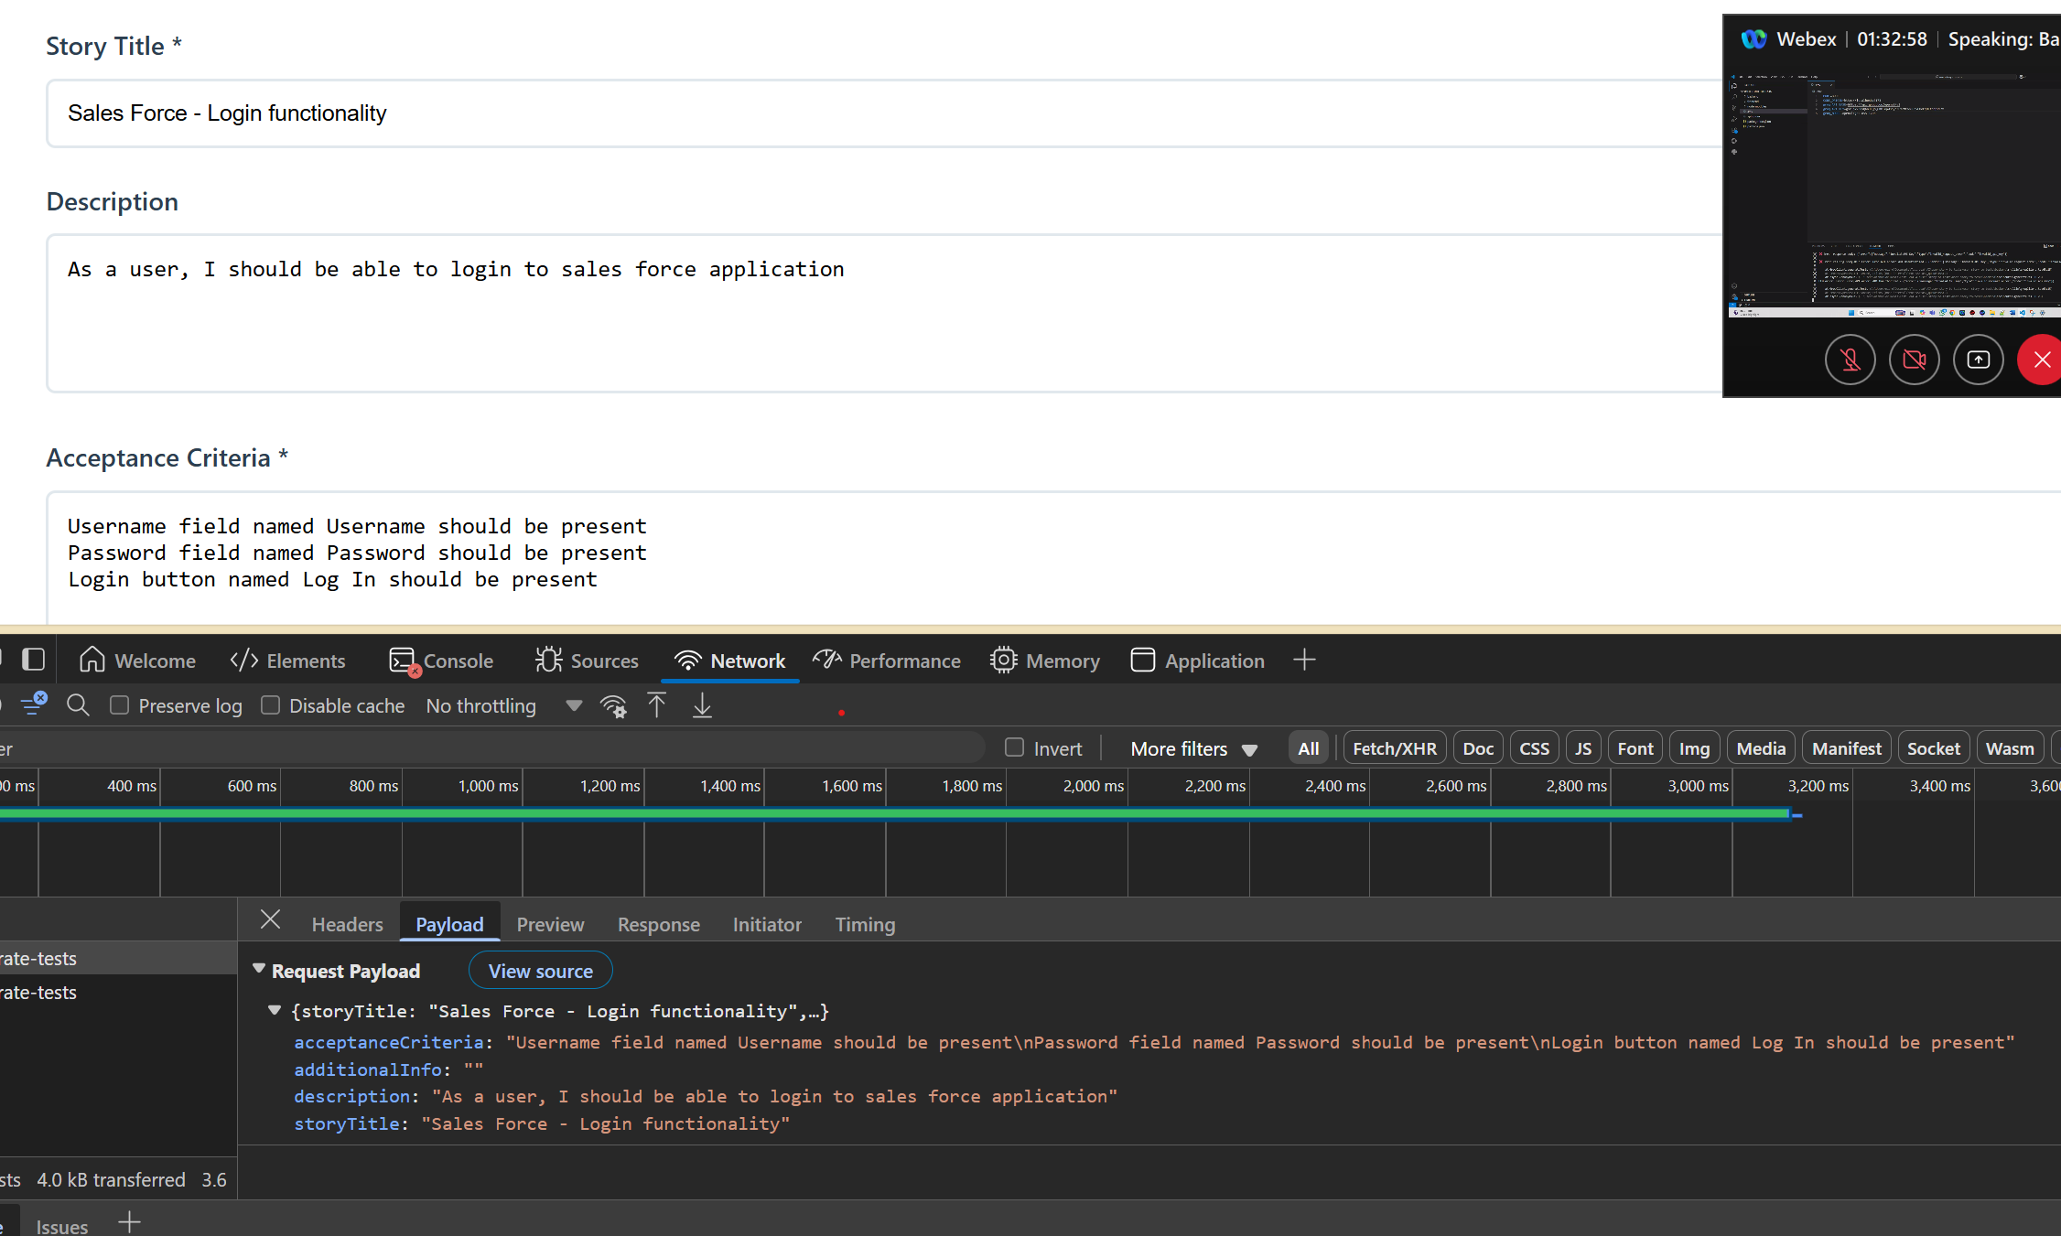

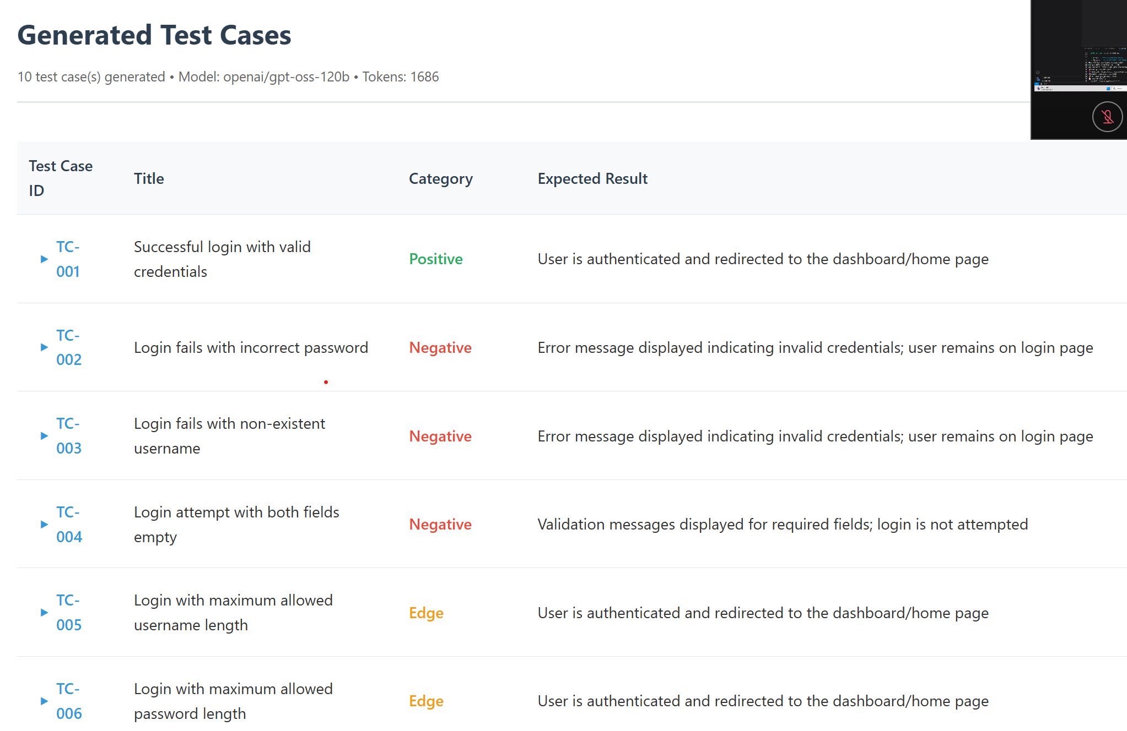

Classroom activity2:

Objective :

- Build test case category choices when generating tests

Front end

- You need to have checkboxes for multiple category

- Positive - Negative - Edge

- Changes in App.tsx, types.ts

Back end

- Changes in schemas.ts, prompt.ts

Instructions:

- Category list should be Positive, Negative, E2E, Performance

- Default to All when none selected

- multi select

Prompt Used in Copilot in Ask mode and executed in Agent mode:

Context:

You are an AI assistant to make edit to my existing code to add the following functionality

- Checkbox for users to choose what test category to generate tests for given user story

Instructions

- Scan my entire front end and back end code base

- Improve the look and feel in the front end for checkbox

- Add the functionality for backend to add the category in the request and in the user prompt and provide the response

- Provide me the expected changes first . Once I approve, you can edit the files.

