OBLATE PROVINCE OF JAFFNA
Website Content Blueprint & Upload-Ready Content • 2026

17 MINISTRIES. MANY PLACES. ONE MISSION.
1847 – 2026

Website identity
A professional missionary website presenting the history, charism, mission, ministries, formation, leadership, international presence, publications, news and contact information of the Oblate Province of Jaffna.

“He has sent us to evangelize the poor.”

1. Source & Editorial Basis
This document is prepared as the working website blueprint and upload-ready copy for the Oblate Province of Jaffna.
Primary content basis: the supplied 2026 historical/ministry source material, especially pages 43–101, including the sections on history, present ministries, international mission and the concluding “17 Ministries — One Mission” framework.
External verification/reference basis: official OMI Jaffna, OMI World and OMI Colombo Province information previously reviewed for current institutional wording, history and leadership.
Important geographic wording
The website will not describe the Province as serving only “Northern and Eastern Sri Lanka.” The preferred institutional framing is: “The Oblates serve the people of God island-wide and abroad,” with particular attention to Tamil-speaking people and communities across Sri Lanka and to the wider missionary needs of the Church.

Publication check
Historical names, dates and former-provincial chronology will be checked against Province archives before final publication. The current official leadership information will be rechecked whenever the website is updated.

2. Updated Website Structure
Main section | Updated contents
Home | Hero, charism, mission, ministries, history, latest news, vocation, international mission, contact.
About Us | Who We Are, Charism, Mission, Vision, St Eugene de Mazenod, History, Timeline, Heritage.
Leadership | Provincial Superior, Provincial Council, Administration, Former Provincials.
Our Ministries | 17 ministry areas and individual ministry detail pages.
Parishes & Communities | Parish directory and missionary presence by location.
Formation & Vocations | Vocation journey, formation houses, discernment, prayer/contact.
International Mission | Missionaries abroad, international formation, diaspora chaplaincy.
News & Events | News, feasts, events, announcements and pastoral updates.
Publications | Yazha-Thoni, Zeal and downloadable publications.
Media / Digital Mission | Photo, video, YouTube/social links and digital evangelization.
Contact | Address, phone, email, enquiry form, map and social channels.

3. HOME PAGE — Upload-Ready Content

Hero section
OBLATE PROVINCE OF JAFFNA
17 Ministries. Many Places. One Mission.
1847 – 2026
A missionary journey of faith, service, healing, reconciliation and hope.
Primary buttons: EXPLORE OUR MISSION | OUR HISTORY | CONTACT US

Welcome
Welcome to the Oblate Province of Jaffna, part of the worldwide Missionary Oblates of Mary Immaculate. The Oblate missionary presence in Sri Lanka began in 1847, and the first Oblates reached Jaffna in 1848. From those beginnings, the mission has grown through pastoral ministry, education, formation, social service, reconciliation, community development and many other forms of accompaniment.
Today, the Oblates continue to serve the people of God island-wide and abroad. With a particular missionary presence among Tamil-speaking people and communities across Sri Lanka, the Province seeks to proclaim the Good News, accompany people in their joys and struggles, and respond to the needs of the Church and society.

Charism
EVANGELIZING THE POOR
The Oblate charism begins with a missionary movement towards people who are poor, abandoned, wounded or pushed to the margins. Evangelization is not limited to words. It becomes presence, accompaniment, education, compassion, justice, reconciliation and service.

Mission
Empowered by the Good News, we work for a healing society in and through the light of the Good News.

Vision
A life towards a renewed, just and free society.

17 Ministries — One Mission
From parishes and schools to youth centres, counselling, rehabilitation, peacebuilding, community development, formation and diaspora ministry, the Province serves in many places and through many forms of missionary presence.

History teaser
1847 — The first Oblates arrive in Ceylon.
1848 — The first Oblates reach Jaffna.
1988 — The Jaffna mission becomes a Vice Province.
2001 — The Oblate Province of Jaffna becomes an independent Province.
2026 — The missionary journey continues.

Call to action
Discover the story. Meet the mission. Walk with the people. Pray for vocations. Support missionary service. Join us in building a renewed, just and free society.

4. ABOUT US

Who We Are
The Missionary Oblates of Mary Immaculate are a Roman Catholic missionary religious congregation founded by St Eugene de Mazenod. The Oblate vocation is rooted in the proclamation of the Gospel, especially among the poor and those most in need of hope, accompaniment and healing.
The Oblate Province of Jaffna is part of this worldwide missionary family. Its history in Sri Lanka reaches back to 1847, when the first Oblates arrived in Ceylon. In Jaffna, the mission developed through language learning, pastoral presence, education, formation, village ministry and accompaniment of communities through times of peace, suffering and social change.

Our Charism
Evangelizing the poor.
For the Oblate, the poor are not simply people who lack material resources. Poverty can also appear through abandonment, exclusion, displacement, addiction, disability, loneliness, injustice, conflict and loss of hope. Evangelizing the poor therefore means going towards people, listening to them, walking with them and proclaiming the Good News through word and life.

What the Charism Means Today
- Go where people need the Gospel.
- Listen before speaking and accompany before judging.
- Serve people whose dignity is threatened.
- Build communities of faith and hope.
- Promote justice, peace and reconciliation.
- Care for creation and future generations.
- Form young people and future missionaries.
- I have included contemporary media and digital platforms as new missionary spaces.

Mission
Empowered by the Good News, we work for a healing society in and through the light of the Good News.

Vision
A life towards a renewed, just and free society.

5. ST EUGENE DE MAZENOD & OUR HISTORY

St Eugene de Mazenod
Eugene de Mazenod looked at a society marked by poverty, religious decline and social change and refused to remain indifferent. He preached to the poor, accompanied young people, reached prisoners and sought ways to communicate the Gospel in language people could understand.
His missionary conviction was simple and demanding: the Gospel must go out. It must reach people where they are. This missionary spirit became the foundation of the Oblate vocation.

1816 — Missionaries of Provence
In 1816, Eugene de Mazenod and his companions began a missionary community in Aix-en-Provence. They became known as the Missionaries of Provence. Their purpose was to preach the Gospel, evangelize the poor, renew faith, form Christian communities and go wherever the Church needed missionaries.

1826 — Missionary Oblates of Mary Immaculate
In 1826, Pope Leo XII officially approved the congregation, which became the Missionary Oblates of Mary Immaculate. The name expressed their missionary identity and their belonging to Mary Immaculate.

The Call from Ceylon
Bishop Orazio Bettachini, Vicar Apostolic of Jaffna, travelled to Europe seeking missionaries for the vast mission of northern Ceylon. Eugene de Mazenod accepted the invitation and the Oblates were sent to a new mission field.

The First Four Missionaries
- Fr Étienne Semeria, OMI
- Fr Joseph Alexandre Ciamin, OMI
- Fr Louis Marie Keating, OMI
- Bro Gaspard de Steffanis, OMI
They left Marseille on 21 October 1847. They were leaving their homeland, families and familiar culture to begin a missionary journey across the ocean.

28 November 1847 — Arrival in Ceylon
The first Oblates landed at Galle on 28 November 1847. The missionary journey in Sri Lanka had begun.

Mannar and Mantotte
In the Mannar region, Fr Joseph Ciamin was entrusted with the Mannar–Mantotte–Vanny mission. Beginning his ministry there on 8 February 1848, he faced the challenge of serving Tamil-speaking people without initially knowing the language. Learning to listen, learn and enter the life of the people became a foundational missionary attitude.

10 March 1848 — Arrival in Jaffna
On 10 March 1848, the first group of Oblates reached Jaffna. The missionaries began by learning Tamil, understanding local culture and walking with the people. Jaffna gradually became a central part of the Oblate missionary story.

From Jaffna to the Villages
The mission moved beyond the city into villages, coastal communities and islands, reaching places such as Mannar, Point Pedro and Mullaitivu. Missionaries celebrated Mass, preached, baptized, visited families, taught children, formed catechists and helped establish Christian communities.

Disease, Suffering and Compassion
The early mission encountered poverty, disease, isolation and difficult travel. Epidemics and cholera brought fear and death. Missionaries cared for the sick, accompanied families, buried the dead and consoled those who grieved. Some missionaries themselves became victims of disease. Their witness showed that evangelization must become compassion, presence, service and love.

Education as Evangelization
Education became a major dimension of the Oblate apostolate. Schools, teachers, formation and institutions helped generations gain knowledge, dignity and opportunity. The missionary entered the classroom as teacher, formator, mentor and guide.

Building the Local Church
The Oblates sought not simply to establish foreign institutions but to help the local Church grow. They worked with communities, encouraged vocations, developed pastoral structures, schools and institutions, and contributed to the formation of people and communities of faith.

Times of Crisis
As Sri Lanka experienced political and social change, ethnic tensions, conflict, displacement and loss, the Oblate mission increasingly became a ministry of accompaniment and healing. The missionary vocation called for standing beside people in their pain and helping communities seek hope, dignity, justice, peace and reconciliation.

1988 — Vice Province
The historical development of the Jaffna mission led to its becoming a Vice Province in 1988.

2001 — Independent Province
In 2001, the Oblate Province of Jaffna became an independent Province.

2026 — The Mission Continues
The mission today carries the same missionary heart into new realities: pastoral ministry, education, youth, children, counselling, rehabilitation, peacebuilding, community development, formation, international mission and the digital world.

6. 1847–2026 TIMELINE
Date / period | Milestone
1816 | Missionaries of Provence begin under Eugene de Mazenod.
1826 | The congregation receives papal approval as the Missionary Oblates of Mary Immaculate.
21 Oct 1847 | Four Oblate missionaries leave Marseille for Ceylon.
28 Nov 1847 | The first Oblates arrive in Ceylon at Galle.
8 Feb 1848 | Fr Joseph Ciamin begins ministry in the Mannar–Mantotte–Vanny mission.
10 Mar 1848 | The first group of Oblates reaches Jaffna.
19th century | Mission expands through villages, islands, education, pastoral ministry and formation.
1988 | Jaffna becomes a Vice Province.
2001 | Jaffna becomes an independent Oblate Province.
2026 | The Province presents its mission through 17 ministries, many places and one missionary spirit.

7. OUR MINISTRIES — 17 MINISTRIES, ONE MISSION
The supplied ministry source material presents the Province through a broad missionary vision. The ministries below are organized for website publication while retaining the terminology and places identified in the source.
No. | Ministry | Places named in source | Website description
01 | Administration | Thodarpaham – Jaffna | Administration exists for mission: coordinating missionaries, supporting communities, planning pastoral activities and directing resources towards missionary needs.
02 | Mission Preaching | Amathi Aham – Vavuniya | Mission preaching brings the Gospel to communities through preaching, renewal and accompaniment.
03 | Hospital & Prison Chaplaincy | Hospitals and prisons | A ministry of presence among people who are sick, isolated, vulnerable or forgotten, offering prayer, pastoral care, dignity and hope.
04 | Formal Education | St Patrick’s College; St Anthony’s Maha Vidyalayam — Muthur; Patima School — Mannar; Kalmunai Carmel Fatima College; Fatima Maha Vidyalayam — Iranapalai; St Anthony’s Vidyalayam — Colombo; Kokkulai Sigala Vidyalayam | Formal education is one of the Province’s continuing missionary commitments, supporting children and young people through schools, formation, learning and values-based education.
05 | Non-Formal Education | Annai Illam – Kanakapuraikulam; OBTEC – Kanakapuram; Amala Uthayam – Uppuvelli; Anjali Aham – Point Pedro | Learning opportunities, skills development, personal growth and social empowerment beyond the traditional classroom.
06 | Youth Animation | Gnanatheepam Youth Empowerment Centre – Ariyalai | Accompanying young people through formation, empowerment, leadership, faith and life challenges.
07 | Children’s Animation | Amala Annai Anpaham – Mulangavil | Creating spaces where children receive care, formation, protection, encouragement and hope.
08 | Parish Ministry | Jaffna, Mannar, Badulla, Galle, Trincomalee, Ratnapura and other missionary communities | Celebration of the Eucharist and sacraments, proclamation of the Word, family ministry, children and youth ministry, care for the sick and formation of Christian communities.
09 | Formation | Colombuthurai, Keeri, Ampitiya | Preparing future missionaries through prayer, study, community life, pastoral experience, spiritual direction, human formation and discernment.
10 | Psycho-Social Counselling | Amaithi Thedral – Mullaitivu; Valarpirai / ICOF – Chundikuli | Accompanying people and families carrying psychological wounds, emotional burdens and social difficulties.
11 | Care for Persons with Disabilities | Amathi Karangal – Mankulam | Recognizing dignity, inclusion, participation and the gifts of persons living with disabilities.
12 | Rehabilitation | Thiruppunamai / CRADA – Thoddaveli; Eugene De Mazenod Home – Batticaloa; Nampikai Illam – Ariyalai | Supporting people affected by addiction, exclusion or difficult life circumstances towards dignity, responsibility, relationships and hope.
13 | Justice, Peace & Integrity of Creation | Centre for Peace and Reconciliation – Paranthan | Working for justice, dignity, dialogue, reconciliation, peace and care for creation, especially in communities carrying wounds of conflict.
14 | Spiritual Renewal & Animation | Sangamam – Kopay | Retreats, prayer, reflection and formation that renew personal faith and strengthen communities.
15 | Community Development | Nesakarangal – Iyackachchi; Amathi Vanam – Skandhapuram; Amathik Kalam – Kokkilai; Amala Aruvi – Mullikulam; Malarum Mullai – Oddusuddan; Eugene Nivasa – Avissawella | Empowering communities through education, livelihood support, leadership, women’s development, youth development and support for vulnerable families.
16 | Retired Oblates | Amala Utpavam – Colombuthurai | Caring for elderly and retired missionaries with dignity, gratitude, fraternity and community.
17 | Oblate Community / Fathers’ House | Colombo Oblate House – Borella | A community space for prayer, fraternity, rest, support and shared missionary life.

Administration — Thodarpaham, Jaffna
The first dimension of mission is the service of leadership and administration. From Thodarpaham in Jaffna, the Province coordinates and supports its missionary activities. Administration is not simply about managing an organization. It is about enabling mission.

Mission Preaching — Amathi Aham, Vavuniya
Mission preaching carries the Good News into communities and invites people to renewal. The ministry seeks to make the Gospel accessible through preaching, pastoral presence and accompaniment.

Hospital & Prison Chaplaincy
In hospitals and prisons, the Church reaches people who may feel forgotten or rejected. Chaplaincy communicates a simple message of dignity: people are not forgotten, God has not abandoned them, and no person should be reduced to illness, imprisonment or suffering.

Formal Education
Education has been one of the great contributions of the Oblate mission. The Province’s institutions seek not merely to produce successful students, but to form responsible human beings — people of character who can serve society. Education becomes a pathway from poverty to opportunity.

Non-Formal Education
Not everyone has access to conventional education. Non-formal education creates opportunities for learning, skills development, personal growth and social empowerment. Learning can create employment opportunities, restore confidence and open a new future.

Youth Animation
Young people are at the heart of the future. Youth ministry is not simply about organizing programmes; it is about accompanying young people through the challenges of life, helping them discover their gifts and forming them for responsible participation in Church and society.

Children’s Animation
Children’s ministry creates spaces where children can experience care, formation, protection, friendship and hope. The mission begins by recognizing every child as a person of dignity and possibility.

Parish Ministry
Parish ministry brings together Eucharist, Word, families, children, youth, the sick, sacramental life and Christian community building. The Province currently serves in 12 parishes across Sri Lanka, each a place of worship, accompaniment and missionary service.

Formation of Future Missionaries
Formation prepares young men who discern and prepare for the Oblate vocation. It includes prayer, study, community life, pastoral experience, spiritual direction, human formation, missionary exposure and discernment. The goal is a missionary heart able to listen, forgive, cross cultures and stand beside the poor.

Psycho-Social Counselling
Counselling ministries accompany people who carry psychological wounds, emotional burdens and difficult family or social circumstances. The mission offers listening, support, dignity, spiritual strength and hope.

Care for Persons with Disabilities
Persons living with disabilities deserve dignity, opportunity, participation, respect and a voice. The Oblate mission seeks to stand with people who are often pushed to the margins, recognizing them as persons with gifts, dreams and dignity.

Rehabilitation
The rehabilitation mission accompanies people affected by addiction and social exclusion. Rehabilitation is more than stopping an addiction; it is helping a person rediscover dignity, relationships, responsibility and hope.

Justice, Peace & Reconciliation
Peace is more than the absence of war. It requires justice, dignity, dialogue, forgiveness and reconciliation. The Oblate mission seeks to accompany communities towards healing while recognizing that reconciliation does not mean forgetting the past; it means having the courage to face it and build a different future.

Integrity of Creation
The land, sea, water and environment are part of human life. Environmental damage often affects vulnerable communities first. Caring for creation is therefore part of caring for people and protecting the future.

Spiritual Renewal & Animation
Faith can become routine and communities can become tired. Spiritual renewal helps people rediscover their relationship with God through prayer, retreats, reflection and formation. The goal is renewal of the heart and renewed Christian community life.

Community Development
True development is not simply giving something to people. It means empowering people to discover their own strength, develop opportunities, participate in decisions and build their own future. The missionary walks alongside the community — not above it and not instead of it.

Retired Oblates
Mission does not lose its value when a missionary becomes elderly. Those who have spent decades serving the Church deserve care, dignity and gratitude. Their lives and memories are part of Oblate history.

Oblate Fathers’ House
Missionaries spend much of their lives going out to serve, but missionaries also need prayer, fraternity, rest and support. The Colombo Oblate House in Borella provides a community setting where members of the Oblate family can live and continue their shared missionary life.

8. PARISHES & MISSIONARY COMMUNITIES
The Province currently serves in 12 parishes. I have included a searchable parish directory with parish name, location, Mass times and contact details. Current schedules will be published only after confirmation by the responsible parish.
No. | Parish
01 | Maniyam Thoddam Parish — Jaffna
02 | Kanakarayankulam Parish — Vavuniya
03 | Hapurugala Parish — Ratnapura
04 | St. Jude Parish — Pasara
05 | Muthur Parish — Trincomalee
06 | Anthoniyarpuram Parish — Mannar
07 | Akkarayan Parish — Kilinochchi
08 | Thachanamadhu Parish — Mannar
09 | Anninganda Parish — Galle
10 | Kokkulai Parish — Mullaitivu
11 | Thirukovil Parish — Batticaloa
12 | Sambalthevu Parish — Trincomalee

Directory rule
Do not publish outdated Mass times, phone numbers or clergy assignments. Each parish page will have a “Last verified” date and a responsible contact.

9. FORMATION & VOCATIONS

Formation Houses Named in the Source
- St Joseph’s Juniorate – Colombuthurai
- Pre-Novitiate, Gnanodhayam – Keeri
- De Mazenod Scholasticate – Colombuthurai
- Oblate Scholasticate – Ampitiya

Vocation Page Copy
A missionary vocation is a call to give one’s life in service of the Gospel. The Oblate Province accompanies those who discern this call through prayer, study, community life, pastoral experience, spiritual direction and missionary formation.
If you sense a call to missionary life, begin with prayer and conversation. The vocation journey is a process of discernment: discovering where Christ is calling you and learning how your gifts can become a service to others.
CALL TO ACTION: DISCERN YOUR VOCATION | CONTACT THE VOCATION TEAM | REQUEST PRAYER

10. INTERNATIONAL MISSION
The story of the Province does not end within Sri Lanka. The source identifies Oblates from the Province serving as missionaries in Mexico, Kenya, Denmark, Italy, the United Kingdom, Norway, Australia and Pakistan.
The mission has come full circle. Missionaries once came to Sri Lanka from other countries. Today, Sri Lankan Oblates are also sent to other parts of the world.

Formation Beyond Sri Lanka
- Philippines — ongoing formation
- Australia — formation experience
- Rome — formation experience

Diaspora Chaplaincy
The source identifies diaspora chaplaincy in France. When people migrate, they may carry language, culture, traditions and faith with them. The Church accompanies people far from home, and the missionary can become a bridge between homeland and new homeland.
International identity
Present the Province as part of a universal Oblate family. Use an interactive world map showing current mission countries, but only after the country list and current assignments have been verified.

11. DIGITAL MISSION & MEDIA
The first Oblates had no television, radio, internet, smartphones or social media. Yet they faced the same missionary question: how do we reach people with the Gospel? Today, the digital world is another missionary field.
The church building remains a mission field. The village remains a mission field. The school and hospital remain mission fields. The smartphone screen, social media, video and digital storytelling are also mission fields.

Website Media Sections
- Photo Gallery
- Video / YouTube
- Homilies and reflections
- Mission stories
- Vocation stories
- Feasts and events
- Historical archive
- Downloadable publications
- Social media links

Digital mission principle
Technology should serve evangelization, human dignity and community. The goal is not simply to increase views or followers; it is to use contemporary communication to bring people closer to Christ and to connect people with the missionary life of the Church.

12. NEWS, EVENTS & PUBLICATIONS

News & Events
The News & Events section will be a living record of Province activities. Every post will include a clear title, date, location, short summary, photographs and, where appropriate, a contact person.

Feasts & Events
Create a calendar view with filters for liturgical celebrations, Province events, parish events, formation activities, youth events, social initiatives and commemorations.

Publications
Yazha-Thoni — The Lyre Boat: the official news bulletin of the Province.
Zeal — Annual Magazine: a scholastic publication containing reflections, articles and community news.

Publication fields
- Title
- Publication date
- Edition / volume
- Cover image
- Short description
- Download / read online button
- Archive category

13. LEADERSHIP

Provincial Superior
Very Rev. Fr. Paul Jeyanthan Pachchek, OMI
Present Provincial Superior: Fr. Jeyanthan Pachchk, OMI (2023–2026).

Provincial Council 2026–2029
- Pakkiyanathan Antony Jesuthasan — 1st Councilor
- Francis Loshington Antonipillai — 2nd Councilor
- Sathiyaseelan Pathinathan — 3rd Councilor
- Jayabalan Balasingham — 4th Councilor
- Anson Regikumar Tharcious — 5th Councilor

Provincial Bursar
Rev. Fr. Joseph J. Kamalananthan, OMI

Former Provincials
The current official website lists former Provincial Superiors. Because some dates in the published list overlap, I will verify the chronology with Province archives before presenting it as a definitive historical timeline.
Name | Dates currently listed
Fr. Louis Ponnaiah, OMI | 1984–1991
Rev. Fr. P. P. Philip | 1991–1997
Rev. Fr. P. Jesunesan | 1989–1999
Rev. Fr. Jeevendra Paul | 1999–2004
Rev. Fr. S.M. Selvaratnam | 2005–2008
Rev. Fr. Paul Natchathiram | 2008–2014
Rev. Fr. Edwin Vasantharajah | 2014–2020
Rev. Fr. Eugene Benedict | 2020–2022

14. CONTACT PAGE

Oblate Province of Jaffna
657/1 Hospital Road, Jaffna, Sri Lanka
Telephone: 021-2222721
Email: omi.jafprovince@gmail.com

Contact Sections Included
- General enquiries
- Vocations
- Parish enquiries
- Publications / media
- Mission support and donations
- Safeguarding / pastoral concerns

Contact form fields
- Name
- Email / phone
- Reason for enquiry
- Message
- Consent / privacy acknowledgement

15. WEBSITE DESIGN & UX BLUEPRINT

Visual identity
- Primary: deep institutional blue
- Secondary: warm gold
- Supporting: white, neutral grey and restrained earth/green tones
- I have planned the website around authentic missionary, pastoral, educational and community photographs
- I have prioritized documentary realism over generic stock photography

Typography
- Headings: strong professional serif or institutional display face
- Body: clean, highly readable sans-serif
- Tamil: professional Unicode Tamil font with consistent weights
- Keep line lengths comfortable for long historical content

Navigation
I have planned a clean top navigation with a prominent “Our Ministries” entry, a language switcher (English | தமிழ் | සිංහල), and a compact mobile menu with quick access to Contact, Ministries and Vocations.

Homepage visual hierarchy
- Hero — Province identity + mission statement
- Charism — Evangelizing the poor
- Mission / Vision
- 17 Ministries
- History timeline
- Featured mission story
- Latest news / events
- International mission
- Vocations
- Contact

Photography rules
- I have planned to use real Province photographs wherever available.
- I will preserve authenticity and avoid over-editing faces or documentary images.
- I have focused the visual direction on people actively participating in mission, not only buildings.
- I have included captions identifying place, ministry and date when known.
- I will obtain appropriate permission for identifiable children and sensitive pastoral cases.

16. PAGE-BY-PAGE CONTENT ARCHITECTURE
Page | Purpose
Home | Short, visual and action-oriented. Do not place the entire history on the homepage.
Who We Are | Institutional identity and current missionary purpose.
Charism | Meaning of “Evangelizing the poor” with contemporary examples.
Mission | Official mission statement followed by explanation.
Vision | Official vision statement followed by practical expression.
St Eugene de Mazenod | Founder, missionary inspiration and key dates.
History | Long-form historical narrative from the supplied source.
Timeline | Major dates in a visual chronological format.
Ministries | Master directory of all 17 ministry areas.
Individual ministry pages | Purpose, places, activities, photographs, contact and related stories.
Parishes | Searchable parish directory.
Formation & Vocations | Formation houses, discernment and contact.
International Mission | Mission countries, formation abroad and diaspora.
News & Events | Current content and archive.
Publications | Yazha-Thoni, Zeal and archive.
Media | Photo/video/digital mission.
Leadership | Current leadership and verified historical leadership.
Contact | Address, phone, email, map and enquiry form.

17. FOOTER — FINAL WEBSITE COPY
OBLATE PROVINCE OF JAFFNA
Missionary Oblates of Mary Immaculate
17 Ministries. Many Places. One Mission.
1847 – 2026
Serving the people of God island-wide and abroad.
Quick links: About Us | Ministries | Parishes | Vocations | News & Events | Publications | Contact
External links: OMI World | OMI Colombo Province | Official social media channels

18. FINAL WEBSITE CONTENT CHECKLIST
- ☐ Confirm Province logo and brand assets.
- ☐ Confirm all current leadership names and photographs.
- ☐ Verify former Provincial chronology before publishing.
- ☐ Verify each parish name, location, clergy contact and Mass schedule.
- ☐ Verify every ministry location and current operational status.
- ☐ Confirm international mission countries and current assignments.
- ☐ Confirm formation locations and current formation status.
- ☐ Add current safeguarding / child protection information if applicable.
- ☐ Add privacy policy and cookie notice where legally required.
- ☐ Add accessibility basics: alt text, contrast, keyboard navigation and readable font sizes.
- ☐ Add English, Tamil and Sinhala language versions.
- ☐ Set up Google Analytics / privacy-compliant analytics only after institutional approval.
- ☐ Set up SEO titles and descriptions for every page.
- ☐ Compress images for performance while retaining quality.
- ☐ Add search and ministry filters.
- ☐ Add last-updated dates to leadership, parish and event pages.
- ☐ Create a historical archive section for old publications and photographs.

19. BASIC SEO COPY
Page | SEO text
Home title | Oblate Province of Jaffna | Missionary Oblates of Mary Immaculate
Home description | Discover the Oblate Province of Jaffna — 1847–2026. Explore our charism, mission, ministries, history, formation, parishes, international mission and news.
About title | About the Oblate Province of Jaffna | Our Charism & Mission
Ministries title | Our Ministries | Oblate Province of Jaffna
History title | History of the Oblates in Jaffna | 1847–2026
Vocations title | Oblate Vocations | Discern a Missionary Calling
Contact title | Contact the Oblate Province of Jaffna

20. SOURCE NOTES
Source material supplied by the user: historical and ministry document, pages 43–101, including the 2026 “17 Ministries — One Mission” presentation and ministry/place lists.
Official institutional references reviewed: Oblate Province of Jaffna; OMI World; OMI Colombo Province.
For final publication, I will maintain a source register with the exact page, publication, archive reference or official URL supporting every historical claim and current operational detail.
Editorial principle
Where the supplied source and a current website page differ, do not silently reconcile them. Flag the discrepancy for Province review and publish only the version formally approved by the Province.

21. CLOSING WEBSITE MESSAGE
The story is not finished. The mission continues.
From the first Oblate missionaries who crossed the ocean in 1847 to the many missionaries, communities and collaborators serving today, the journey has always been about the same Gospel: bringing Christ’s hope to people, especially the poor, abandoned and wounded.
Many places. Many people. Many needs. One Gospel. One Christ. One missionary spirit.
OBLATES OF JAFFNA • 1847–2026
“He has sent us to evangelize the poor.”

22. MAP & CONTACT DIRECTORY
This section is designed for the website’s main Contact / Locations area. The supplied contact documents provide Oblate names and phone numbers, while the supplied Excel sheet provides additional mobile numbers and email addresses. Where an email is not listed in the Excel sheet, it is intentionally left blank.
For the live website, I have planned an interactive map with searchable locations and clickable contact cards. This document contains the complete content structure for implementation.

22.1 Contact Page — Hero
FIND AN OBLATE COMMUNITY NEAR YOU
Our missionary presence reaches many places across Sri Lanka. The map provides a visual way to find an Oblate house, parish or ministry centre, while the contact directory provides names, phone numbers and email addresses.
VIEW ALL LOCATIONS ON GOOGLE MAPS

22.2 Main Province Contact
Contact | Details
Oblate Province of Jaffna | Missionary Oblates of Mary Immaculate
Provincial House | Thodarpaham, 657/1, Hospital Road, Jaffna
Provincial Superior | Fr. Paul Jeyanthan Pachchek, OMI (2023–2026)
Phone | +94 77 722 0182
Website general email | omi.jafprovince@gmail.com
Map | Open the Provincial House location in Google Maps

Open Provincial House in Google Maps

22.3 Interactive Map — Interactive Map Layout
- Full-width Sri Lanka map with location pins across the Province’s missionary presence.
- Search / filter options: Oblate name | parish | house | ministry | location.
- Each location pin opens a card containing the house/ministry name and a responsible Oblate, with phone and email when available, plus “Get Directions”.
- I have included a list view beside the map for mobile accessibility.
- Visitors will be able to search by Oblate name, parish, house, ministry or location. The parish directory clearly identifies the 12 current parishes served by the Province.
- I have included a “Last verified” field for live contact records.
- I will publish only personal contact information that has been formally approved for public publication.

22.4 Map Locations & Houses
House / Location | Address | Main contact / purpose | Phone
OMI Provincial House – Thodarpaham — Jaffna | 657/1, Hospital Road, Jaffna | Fr. Jeyanthan Paul Pachchek, OMI / Provincial Superior | +94 77 722 0182
Amala Utpavam — Jaffna | Swamiyar Veethi, Columbuthurai, Jaffna | Multiple Oblates listed in supplied Jaffna directory | See contact directory
St Joseph’s OMI Seminary — Jaffna | Swamiyar Road / Swamiyar Veethi, Columbuthurai, Jaffna | Formation community | See contact directory
Vasanthaham – De Mazenod Scholasticate — Jaffna | Swamiyar Veethi, Columbuthurai, Jaffna | Formation community | See contact directory
Sangamam — Jaffna | St. Mary’s Lane, Kopay, Jaffna | Spiritual renewal / animation | See contact directory
Gnanatheepam YEC — Jaffna | 30/2, Pannai Valavu, Kandy Road, Ariyalai, Jaffna | Youth Empowerment Centre | See contact directory
Nambikkai Illam — Jaffna | 835, Navalar Road, Ariyalai, Jaffna | Rehabilitation / care ministry | See contact directory
Anjali Aham — Jaffna | Nellandai Veethi, Thumpalai, Point Pedro | Non-formal / community ministry | See contact directory
St Patrick’s College — Jaffna | St. Patrick’s Road, Jaffna | Education / Oblate contact | See contact directory
St Antony’s Church – Pasayoor — Jaffna | Pasayoor, Jaffna | Parish contact | See contact directory
Annai Illam — Kilinochchi | No. 87, Kanahampikai Kulam, Kilinochchi | Community / non-formal education | See contact directory
Amaithy Vanam — Kilinochchi | 455 Anna Silai Road, Akkarayankulam, Kilinochchi | Community / counselling ministry | See contact directory
OBTEC — Kilinochchi | No. 76, Kanahapuram, Kilinochchi | Non-formal education | See contact directory
Nesakkarangkal — Kilinochchi | Sangathar Vayal, Pullaveli Road, Iyakkachchi | Community development | See contact directory
Amaithy Thendral — Mullaitivu | Unnapulavu, Mullaitivu | Psycho-social / community support | See contact directory
Our Lady of Good Voyage – Kokkilai — Mullaitivu | Kokkilai, Mullaitivu | Parish contact | See contact directory
Amathy Kalam — Mullaitivu | Kokilai, Mullaitivu | Community development | See contact directory
Amaithy Aham — Vavuniya | 26 Goods Shed Road, Vavuniya | Mission / counselling / community support | See contact directory
St Antony’s Church – Kanagarayan Kulam — Vavuniya | A9 Road, Kanagarayan Kulam, Vavuniya | Parish contact | See contact directory
Gnanodhayam — Mannar | Thalvupadu Road, Keeri, Mannar | Formation / community | See contact directory
CRADA — Mannar | Station Road, Thottaveli, Mannar | Rehabilitation / community development | See contact directory
St Antony’s Church – Thatchanamarutha Madhu — Mannar | Patampitti / Thatchanamarutha Madhu, Mannar | Parish contact | See contact directory
St Anthony’s Church – Thevanpitty — Mannar | Thevanpitty, Mannar | Parish contact | See contact directory
Sacred Heart Church – Iruthayapuram — Trincomalee | Iruthayapuram, Muthur | Parish contact | See contact directory
St John the Baptist Church – Sambaltheevu — Trincomalee | Sambaltheevu, Trincomalee | Parish contact | See contact directory
Amala Uthayam — Trincomalee | CTB Road, Uppuvely, Trincomalee | Community ministry | See contact directory
St Eugene de Mazenod Home — Batticaloa | No. 290/2, Trinco-Batti Road, Batticaloa | Rehabilitation / community care | See contact directory
St Paul the Hermit Church – Passara — Badulla | Passara, Badulla | Parish contact | See contact directory
Eugene Nivasa / OMI Fathers’ House — Ratnapura | No. 956/1, Ratnapura Road, Dehiyahapitiya, Avissawella | Community / retired Oblate care | See contact directory
Kandy Oblate contact — Kandy | Kandy | Oblate contact | +94 77 628 6506
Sacred Heart Church – Anninkanda — Deniyaya | Anninkanda, Deniyaya | Parish contact | See contact directory

Map links for web implementation:
- OMI Provincial House – Thodarpaham — Jaffna: Open map
- Amala Utpavam — Jaffna: Open map
- St Joseph’s OMI Seminary — Jaffna: Open map
- Vasanthaham – De Mazenod Scholasticate — Jaffna: Open map
- Sangamam — Jaffna: Open map
- Gnanatheepam YEC — Jaffna: Open map
- Nambikkai Illam — Jaffna: Open map
- Anjali Aham — Jaffna: Open map
- St Patrick’s College — Jaffna: Open map
- St Antony’s Church – Pasayoor — Jaffna: Open map
- Annai Illam — Kilinochchi: Open map
- Amaithy Vanam — Kilinochchi: Open map
- OBTEC — Kilinochchi: Open map
- Nesakkarangkal — Kilinochchi: Open map
- Amaithy Thendral — Mullaitivu: Open map
- Our Lady of Good Voyage – Kokkilai — Mullaitivu: Open map
- Amathy Kalam — Mullaitivu: Open map
- Amaithy Aham — Vavuniya: Open map
- St Antony’s Church – Kanagarayan Kulam — Vavuniya: Open map
- Gnanodhayam — Mannar: Open map
- CRADA — Mannar: Open map
- St Antony’s Church – Thatchanamarutha Madhu — Mannar: Open map
- St Anthony’s Church – Thevanpitty — Mannar: Open map
- Sacred Heart Church – Iruthayapuram — Trincomalee: Open map
- St John the Baptist Church – Sambaltheevu — Trincomalee: Open map
- Amala Uthayam — Trincomalee: Open map
- St Eugene de Mazenod Home — Batticaloa: Open map
- St Paul the Hermit Church – Passara — Badulla: Open map
- Eugene Nivasa / OMI Fathers’ House — Ratnapura: Open map
- Kandy Oblate contact — Kandy: Open map
- Sacred Heart Church – Anninkanda — Deniyaya: Open map

22.5 Individual Oblate Contact Directory
The following directory is presented as one unified Oblate contact list, without district-based divisions. Each public contact entry contains only the Oblate name, phone number and email address. It is compiled from the supplied contact documents and the supplied Excel contact sheet.
Oblate | Phone | Email
Fr. Jeyanthan Paul Pachchek,OMI | +94 77 722 0182 | frjeyomi@yahoo.com
Rev. Bro. Jesinton Logu OMI | +94 76 184 2941 | logujasington@gmail.com
Rev. Fr. A.S. Jenis OMI | +94 76 262 6234 | asjenis@gmail.com
Rev. Fr. Atputharaja OMI, | +94 77 506 4412 | —
Rev. Fr. David Vincent Patrick, OMI | +94 77 981 9355 | —
Rev. Fr. F. Daniel OMI | +94 77 230 1369 | —
Rev. Fr. Grecian Remoshan OMI | +94 76 628 1237 | gremoshan1993@gmail.com
Rev.Fr. A. A. Anton Xavier Amalraj, OMI | +94 76 532 3643 | amalrajomi@gmail.com
Rev.Fr. A. Jeevendra Paul, OMI | +94 77 739 9003 | —
Rev.Fr. A. Sylvester, OMI | +94 77 108 3638, +94 77 644 9481 | —
Rev.Fr. Alban Rajasingam, OMI | +94 77 479 6613 | —
Rev.Fr. C.S. Croos, OMI | — | —
Rev.Fr. F.L.N. Croos, OMI | +94 77 990 6310 | —
Rev.Fr. Jegankumar Coonghe, OMI | +94 75 914 8166, +94 76 262 3434 | —
Rev.Fr. Jerome Lambert, OMI | +94 77 298 9206 | —
Rev.Fr. Joseph Aloysius Roy, OMI | +94 77 712 2025 | —
Rev.Fr. Joseph Kamalananthan, OMI | +94 77 604 0108 | kamal75omi@gmail.com
Rev.Fr. Joseph Raj Claier, OMI | +94 77 991 5998 | rajclaieromi@gmail.com
Rev.Fr. Louis Ponniah, OMI | — | —
Rev.Fr. M. Paul Nadchethiram, OMI | +94 77 691 3177 | paul_omi@hotmail.com
Rev.Fr. P.P.Philip, OMI | — | —
Rev.Fr. S. Jeyarajan Coonghe, OMI | +94 77 665 0047 | —
Rev.Fr. S. Patrick Leo, OMI | +94 77 491 9080, +94 77 193 7764 | —
Rev.Fr. S. Santhirathas, OMI | +94 77 694 7080 | —
Rev.Fr. S.M. Selvaratnam, OMI | +94 77 716 4193, +94 76 736 7239 | —
Rev.Fr. Sathiyaseelan, OMI | +94 77 730 0593 | sathiomi.ps@gmail.com
Rev.Fr. Sebamalai Thuram, OMI | +94 77 454 2631 | —
Rev.Fr. Sebasty Nicholas, OMI | +94 72 467 6783 | —
Rev.Fr. Soosai Damian, OMI | +94 77 728 3702 | —
Rev.Fr. Stanislaus Philips, OMI | +94 77 720 1639 | —
Rev.Fr. Stany Anthonipillai, OMI | +94 77 771 1641 | —
Rev.Fr. Wenceslaus, OMI | +94 77 375 5156 | —
Rev. Bro. S.J. Amir, OMI | +94 77 442 4491 | —
Rev. Bro. T. Jenistan Benedict, OMI | +94 77 148 4034 | jenistanbededictomi@gmail.com
Rev.Fr. A. Celestine Mascringhe, OMI | +94 77 614 3396 | —
Rev.Fr. A. Emmanuel, OMI | +94 76 710 6806 | —
Rev.Fr. Alstan Roache, OMI | +94 77 474 8067 | alstan.omi@gmail.com
Rev.Fr. Arulappu Vimalanathan, OMI | +9477521166 | —
Rev.Fr. I. Selva Vijenthiran, OMI | +94 77 266 0209 | vijen80@yahoo.com
Rev.Fr. J. Alphen Seger, OMI | +94 77 481 0124 | alphenseger@gmail.com
Rev.Fr. Jeevaratnam OMI | +94 77 997 4639 | —
Rev.Fr. M. Sebamalai Perera, OMI | +94 77 239 5801 | —
Rev.Fr. P.J. Yogarajah, OMI | +94 77 139 6906 | —
Rev.Fr. S. Patrick Leo, OMI | +94 77 193 7764 | —
Rev.Fr. S. Swampillai, OMI | +94 77 352 9094 | —
Rev.Fr. Sebamalai Anpurasa, OMI | +94 77 864 8548 | anpuomi1970@gmail.com
Rev. Fr. Amirtharaj, OMI | +94 77 619 7201 | —
Rev. Fr. J. Jenybert Croos, OMI, | +94 76 655 5419 | jenycroos10101988@gmail.com
Rev. Fr. Roystan, OMI | +94 77 410 6737 | roystans2020@gmail.com
Rev. Fr. S. Edwin Vasantharajah, OMI | +94 77 178 0027 | —
Rev. Fr. S. Vincent, OMI | +94 77 541 1454, +94 77 730 3454 | svmichaelomi@gmail.com
Rev.Fr. A. Danistan | +94 76 292 7959 | danistan17@gmail.com
Rev.Fr. Arulrasa Amalathas, OMI | +94 77 961 4671 | chicaamal@hotmail.com
Rev.Fr. B. Jeyabalan, OMI | +94 77 226 3630 | —
Rev.Fr. G . Remoshan, OMI | +94 76 628 1237 | gremoshan1993@gmail.com
Rev.Fr. Hubert, OMI | +94 77 780 5388 | —
Rev.Fr. J. Lebourn, OMI | +94 77 789 7515 | lebournomi@gmail.com
Rev.Fr. M. Deloshan Rajeeve, OMI | +94 77 007 4303 | deloshan.omi@gmail.com
Rev.Fr. T.A. Regikumar, OMI | +94 77 233 4242 | regikumar33@gmail.com
Rev.Fr. V. Anucious OMI | +94 76 770 5211, +94 75 775 5262 | —
Rev. Bro. RajaJenistan James Rajakulendran, OMI | +94 75 784 5049 | jamesjenistanomi@gmail.com
Rev. Fr. S.A. Sebastian Ravel, OMI | +94 77 190 0223, +94 76 532 3113 | —
Rev.Fr. A. A. X. Amalraj , OMI | +94 76 532 3643 | amalrajomi@gmail.com
Rev.Fr. A. Aldrin, OMI | +94 76 643 1080 | —
Rev.Fr. A.Vijiyakamalan, OMI | +94 77 955 9160 | —
Rev.Fr. Anthonymuthu Croos, OMI, | +94 77 197 6818, +94 77 110 0626 | —
Rev.Fr. Antony Jesuthasan, OMI | +94 77 552 8669 | —
Rev.Fr. Augustine Confucious, OMI | +94 77 917 7127 | —
Rev.Fr. J. Gerald, OMI | +94 77 331 5549, +94 76 766 8779 | jesurajahgerrald@gmail.com
Rev.Fr. S. A. Poncian, OMI | +94 77 386 4144 | saponcianomi@gmail.com
Rev.Fr. S. Arul Sutharson, OMI | +94 77 628 6506 | arulsutharson19791203@gmail.com
Rev.Fr. Santhirathas OMI | +94 77 694 7080 | —
Rev.Fr. Y.C. Marino, OMI | +94 76 347 2646 | ycmarino1993@Gmail.com

22.6 Contact Data Rules for the Live Website
- I have used the supplied contact lists as the source for Oblate names and phone information.
- I have used the supplied Excel sheet as the source for additional mobile numbers and email addresses.
- Do not create an email address from a person’s name when the source does not provide one.
- Where two sources contain different phone numbers, show the number approved by the Province after verification rather than silently choosing one.
- I will maintain a private master contact database and publish only the fields approved for public contact.
- The website contact cards will provide Call, WhatsApp (only where officially approved), Email and Directions buttons.
- Every contact card will include a Last Verified field.
- The directory will include Oblate-name search and optional filters for parish, house, ministry or location.
- Phone numbers will use tel: links and emails will use mailto: links.
- I have included accessible map alternatives so visitors can find contacts without using the map.

22.7 Contact Card Format
OBLATE NAME
Phone: +94 XX XXX XXXX
Email: name@example.com
Last verified: DD Month YYYY
Buttons: CALL | EMAIL | GET DIRECTIONS

22.8 Privacy & Safeguarding Note
Because this directory contains personal mobile numbers and email addresses, I have included a privacy and safeguarding requirement: every individual contact must be approved before publication. Private numbers or emails intended only for internal use will not be displayed. Contact information for children, vulnerable persons and sensitive pastoral situations will never be publicly displayed.

23. VISUAL PREVIEW — UPDATED WEBSITE
These previews show the visual direction of the updated OMI Jaffna website after implementation. I have prepared the layout around the updated content, 12 parishes, 17 ministries and unified contact/map concept. The live website will use the Province’s approved logo, real photographs and final brand assets.
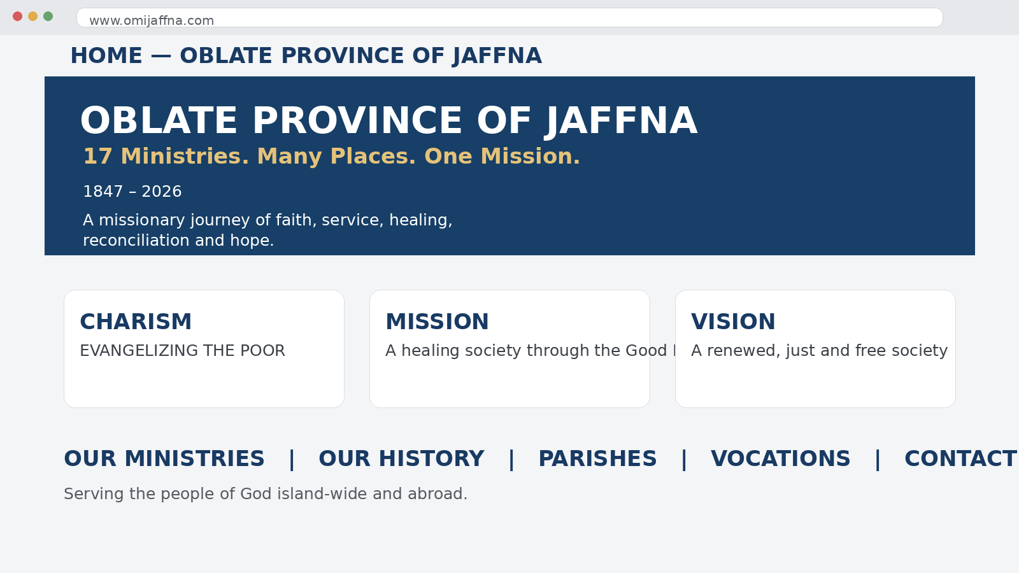
Home Page
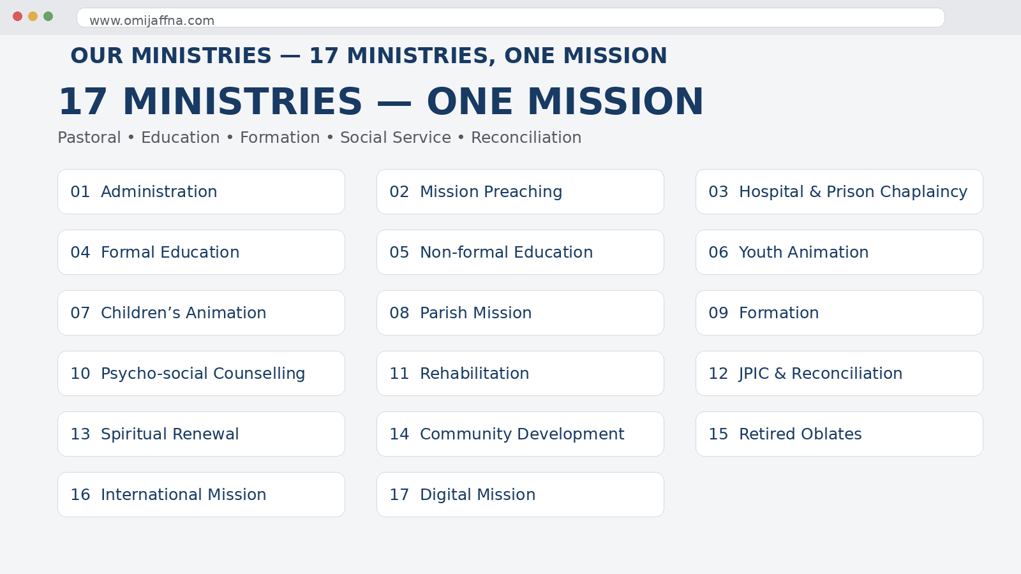
17 Ministries Page
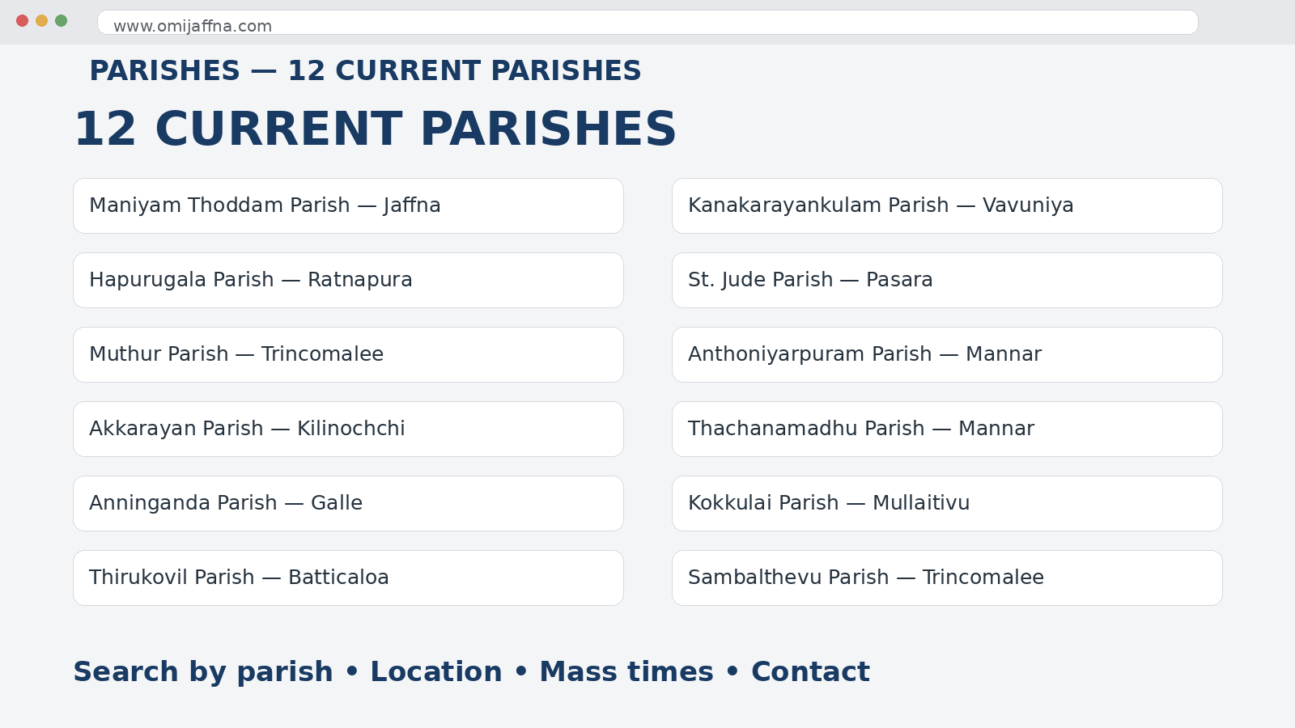
12 Parishes Page
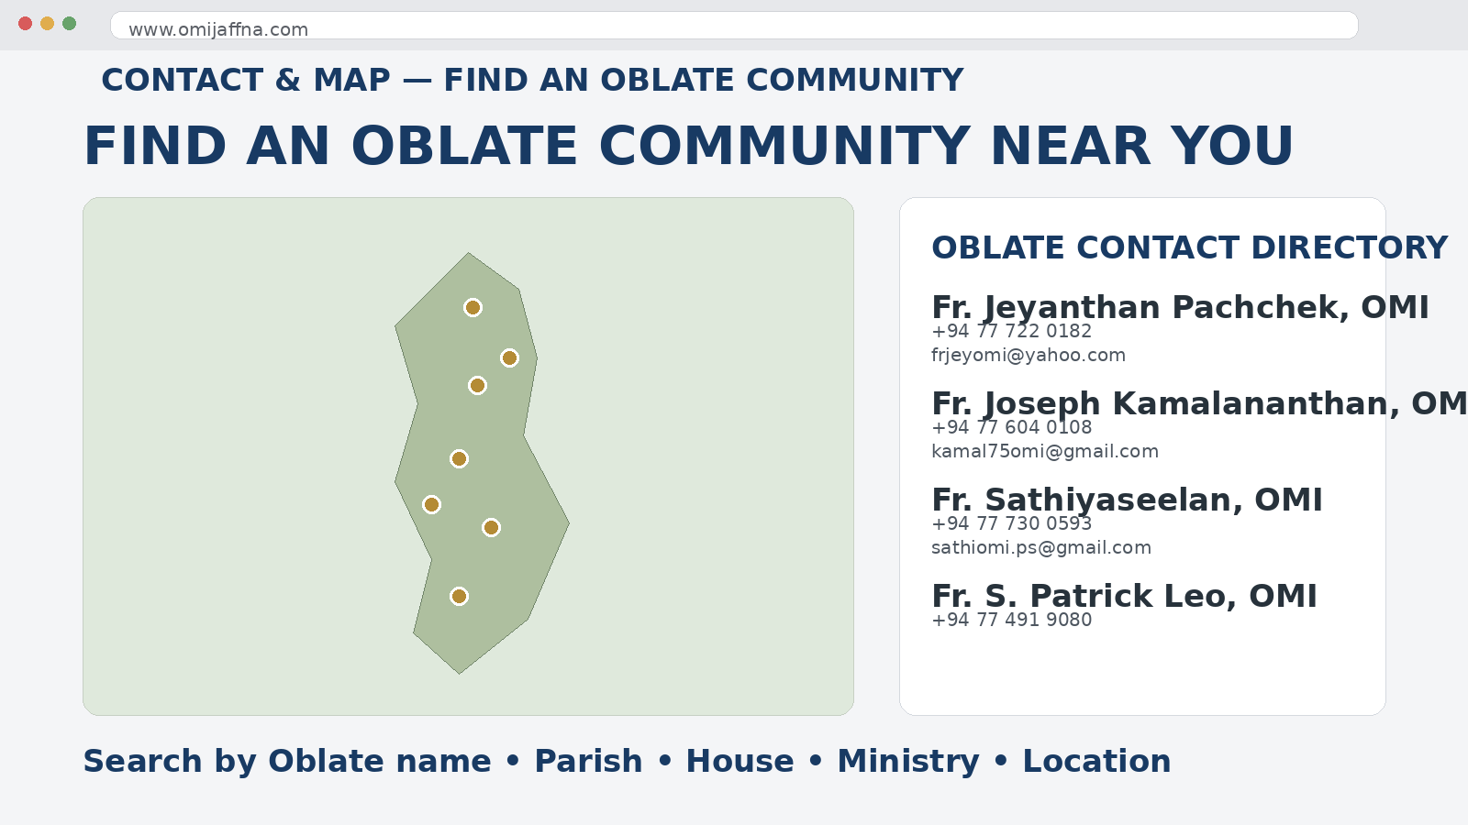
Contact & Interactive Map
OMI JAFFNA WEBSITE UPDATE • 2026

FINAL MEDIA HUB CONTENT LIST
- Photos — parish life, feasts, ministries, formation, community visits and historical photographs.
- Videos — Masses, celebrations, ministry documentaries, short videos, event highlights and recorded programmes.
- Podcasts — conversations, reflections, vocation stories and missionary experiences.
- Articles — news stories, historical features, pastoral reflections, ministry reports and formation content.
- Interviews — Oblates, parish leaders, collaborators, youth, beneficiaries and mission partners.
- Homilies & Reflections — approved spiritual resources and faith-formation content.
- Testimonials — personal stories and community experiences.
- Publications & Downloads — Yazha Thoni, Zeal, newsletters, annual reports, brochures and approved documents.
- Search & Filters — media type, year, parish, ministry, speaker/author and topic.
- Related Content — every media item can connect visitors to the relevant parish, ministry, event, history or person.

MEDIA & VISUAL PREVIEW NOTE
These previews are design mockups, not claims that these photographs or media items already exist online. For the live website, I will use approved OMI Jaffna photographs, videos, recordings and publications, with captions, dates, credits and permissions where required. The existing OMI Jaffna site already provides News & Events, Feasts & Events and Publications as content areas.

CLICK-BY-CLICK VISUAL WEBSITE PROTOTYPE
This section shows what a visitor will see after clicking each main menu item and each major ministry/information item. Each screen is a sample wireframe: the live site can replace placeholders with approved OMI Jaffna photographs, videos, documents and media.

WHAT APPEARS WHEN I CLICK EACH ITEM
This is the click-by-click prototype. For every item below, the first line is the menu/card the visitor clicks, and the visual sample shows the page that opens. This is the level of detail I want the final website developer to follow.

1. CLICK → HOME
When the visitor clicks “HOME”, this page appears: Welcome message, Charism, Mission, Vision, featured ministries, latest news, upcoming events, media highlights, quick links.
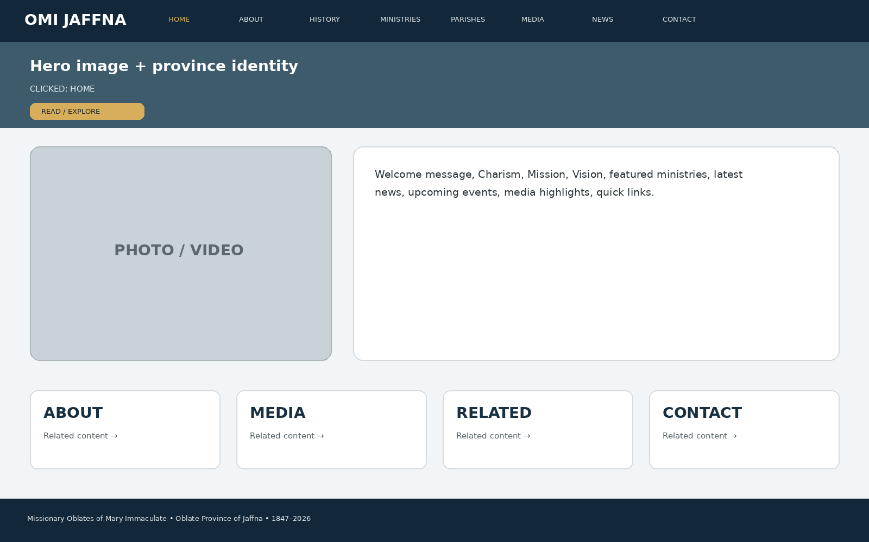
Developer instruction: keep the same header/navigation, show the page title immediately, use approved images/media in the main visual area, present the information in clear cards/sections, and connect the page to related ministries, parishes, media, news or contact information.

2. CLICK → CHARISM
When the visitor clicks “CHARISM”, this page appears: What our charism means, St Eugene de Mazenod, mission spirituality, scripture/quote area, related history and ministries.
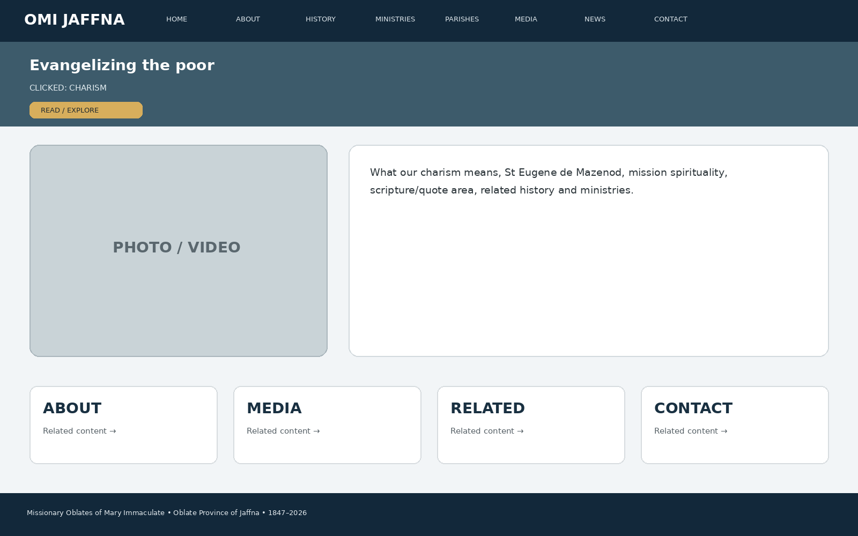
Developer instruction: keep the same header/navigation, show the page title immediately, use approved images/media in the main visual area, present the information in clear cards/sections, and connect the page to related ministries, parishes, media, news or contact information.

3. CLICK → MISSION
When the visitor clicks “MISSION”, this page appears: Mission statement, how the mission is lived today, ministry cards, parish mission, social mission, formation and digital mission.
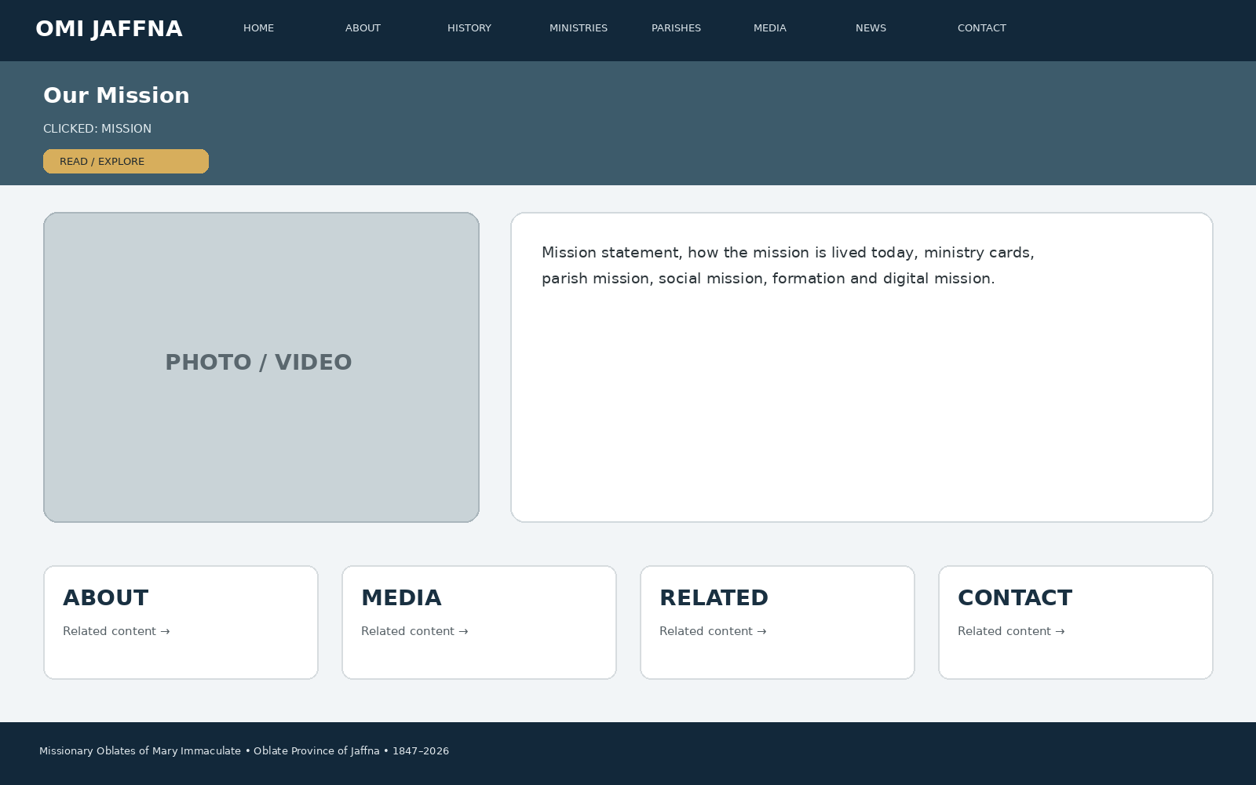
Developer instruction: keep the same header/navigation, show the page title immediately, use approved images/media in the main visual area, present the information in clear cards/sections, and connect the page to related ministries, parishes, media, news or contact information.

4. CLICK → VISION
When the visitor clicks “VISION”, this page appears: Vision statement, renewed/just/free society, strategic themes, stories of impact and links to ministries.
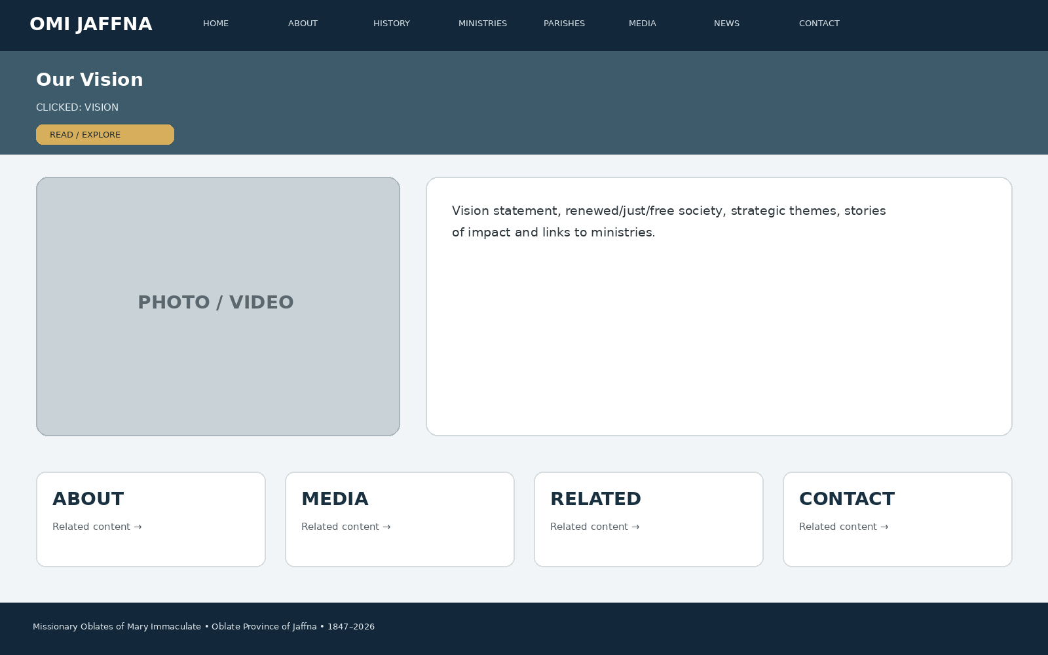
Developer instruction: keep the same header/navigation, show the page title immediately, use approved images/media in the main visual area, present the information in clear cards/sections, and connect the page to related ministries, parishes, media, news or contact information.

5. CLICK → WHO WE ARE
When the visitor clicks “WHO WE ARE”, this page appears: Who the Oblates are, identity, presence in Sri Lanka, international family, Province profile and leadership link.
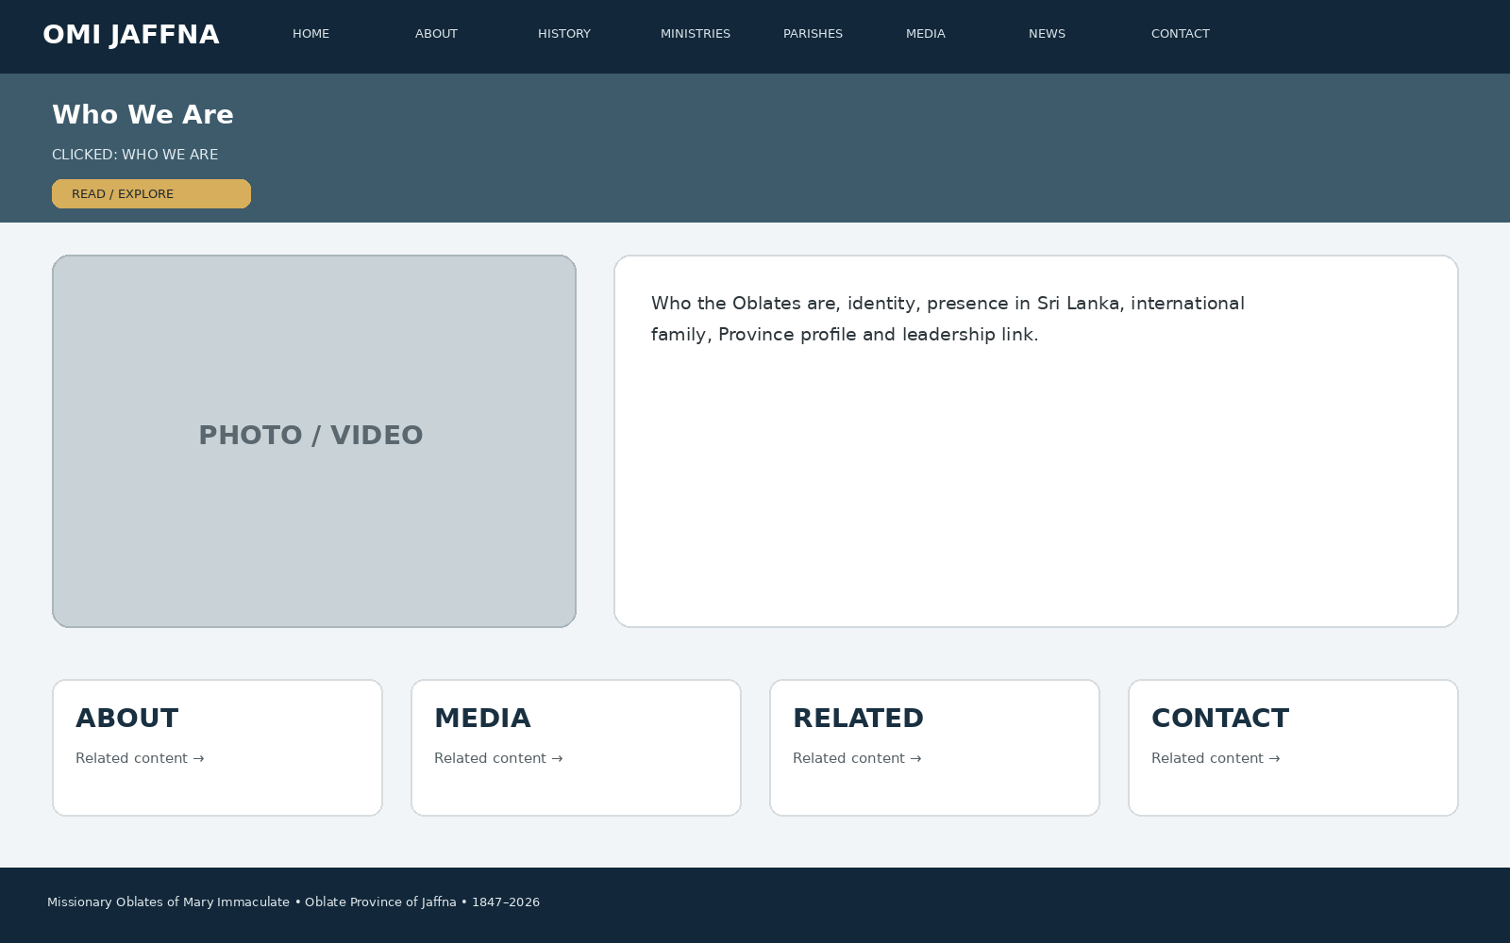
Developer instruction: keep the same header/navigation, show the page title immediately, use approved images/media in the main visual area, present the information in clear cards/sections, and connect the page to related ministries, parishes, media, news or contact information.

6. CLICK → ST EUGENE DE MAZENOD
When the visitor clicks “ST EUGENE DE MAZENOD”, this page appears: Founder biography, missionary vocation, poor and abandoned, Oblate spirituality, timeline, quotations and related history.
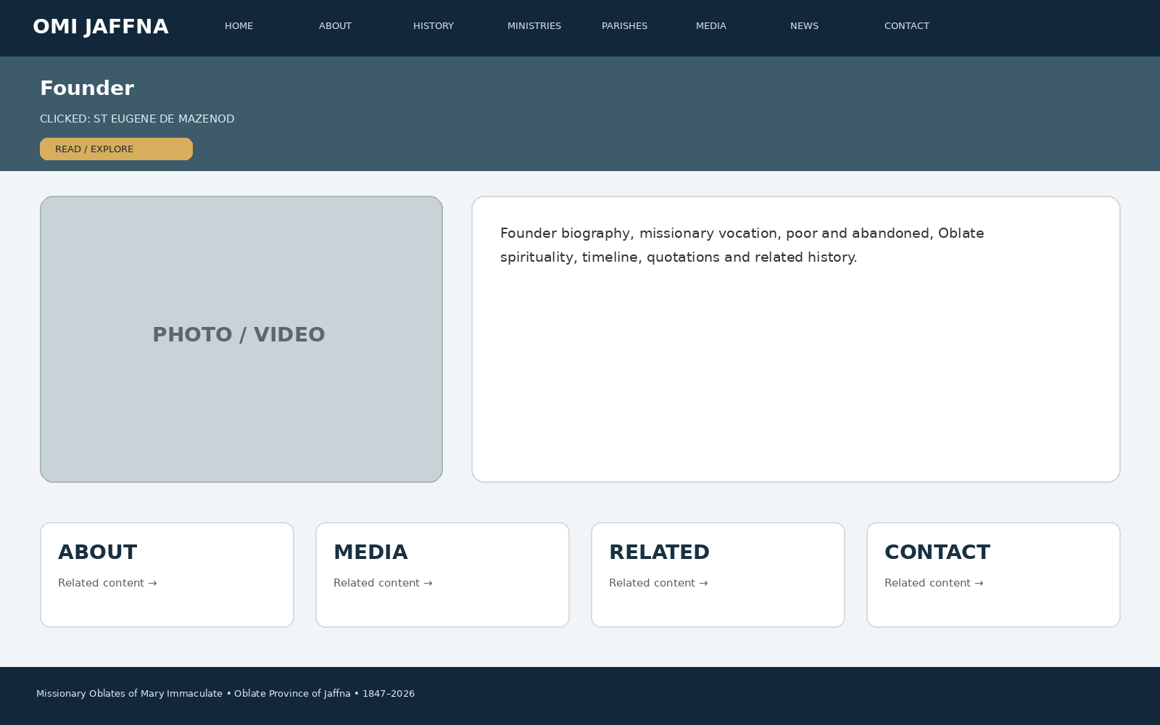
Developer instruction: keep the same header/navigation, show the page title immediately, use approved images/media in the main visual area, present the information in clear cards/sections, and connect the page to related ministries, parishes, media, news or contact information.

7. CLICK → HISTORY
When the visitor clicks “HISTORY”, this page appears: Interactive timeline: 1816, 1826, 1847, 1848, expansion, hardships, education, local Church, 1988 Vice Province, 2001 Province, 2026 mission.
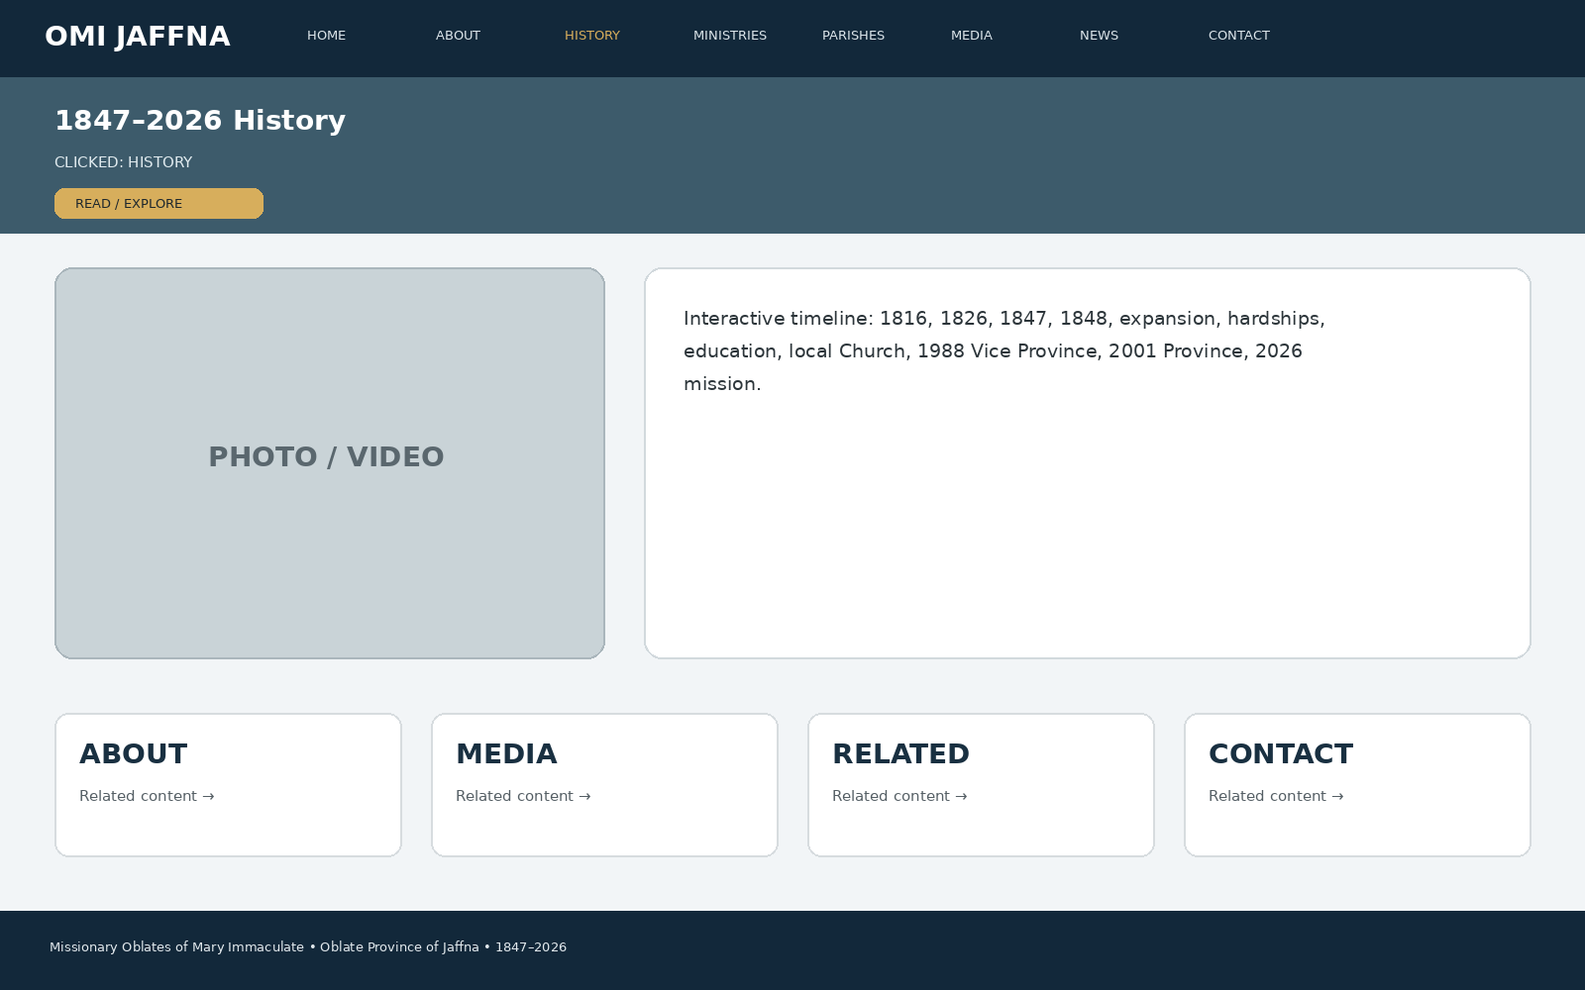
Developer instruction: keep the same header/navigation, show the page title immediately, use approved images/media in the main visual area, present the information in clear cards/sections, and connect the page to related ministries, parishes, media, news or contact information.

8. CLICK → 1816
When the visitor clicks “1816”, this page appears: Foundation story, historical image area, key milestone, related St Eugene section.
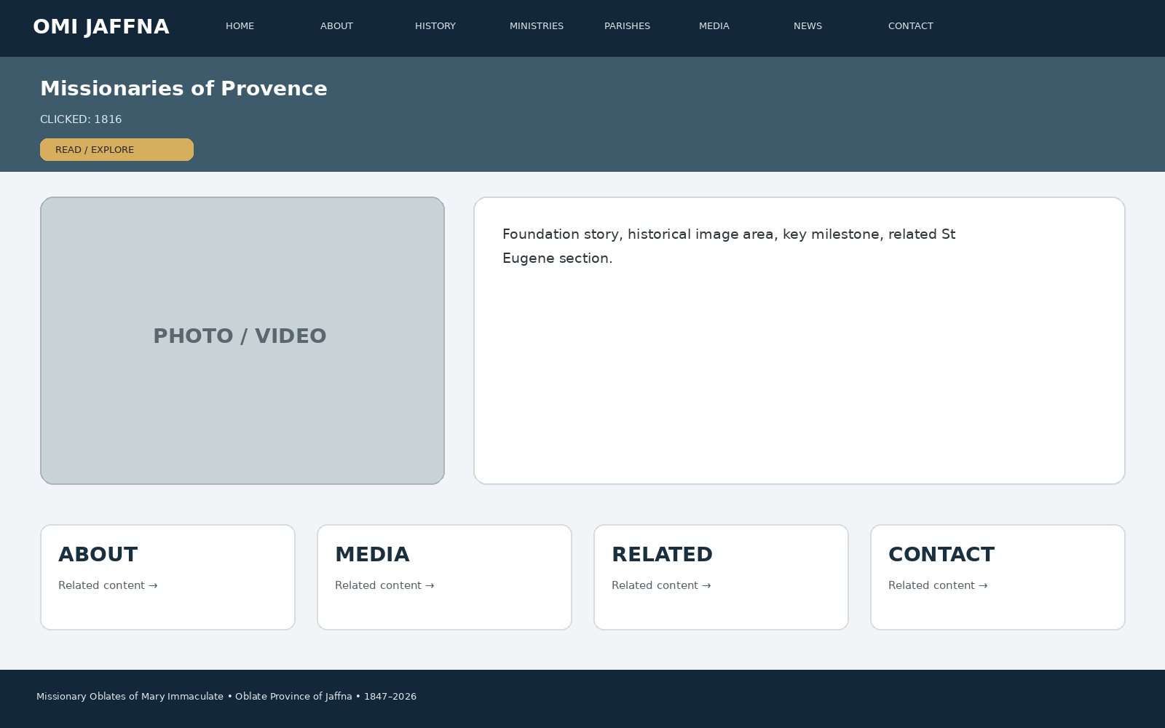
Developer instruction: keep the same header/navigation, show the page title immediately, use approved images/media in the main visual area, present the information in clear cards/sections, and connect the page to related ministries, parishes, media, news or contact information.

9. CLICK → 1826
When the visitor clicks “1826”, this page appears: Papal approval, identity and development, historical context.
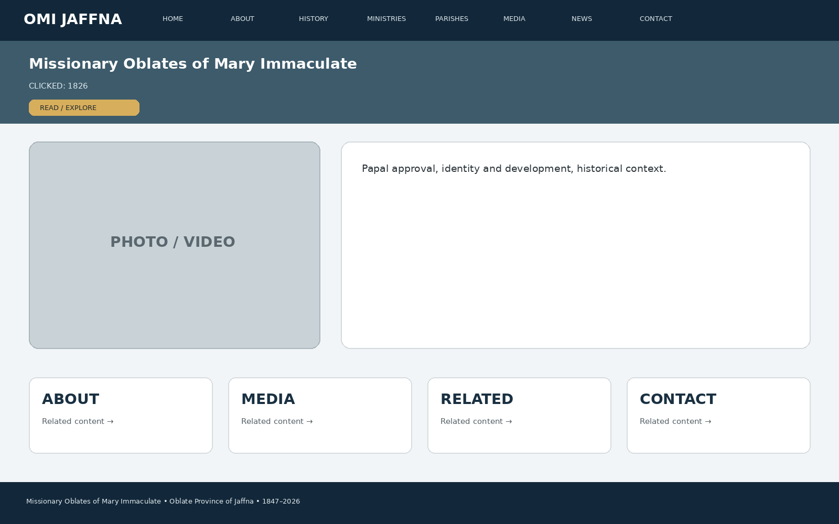
Developer instruction: keep the same header/navigation, show the page title immediately, use approved images/media in the main visual area, present the information in clear cards/sections, and connect the page to related ministries, parishes, media, news or contact information.

10. CLICK → 1847
When the visitor clicks “1847”, this page appears: Bishop Bettachini, first Oblates, departure/arrival story, map and historical photograph.
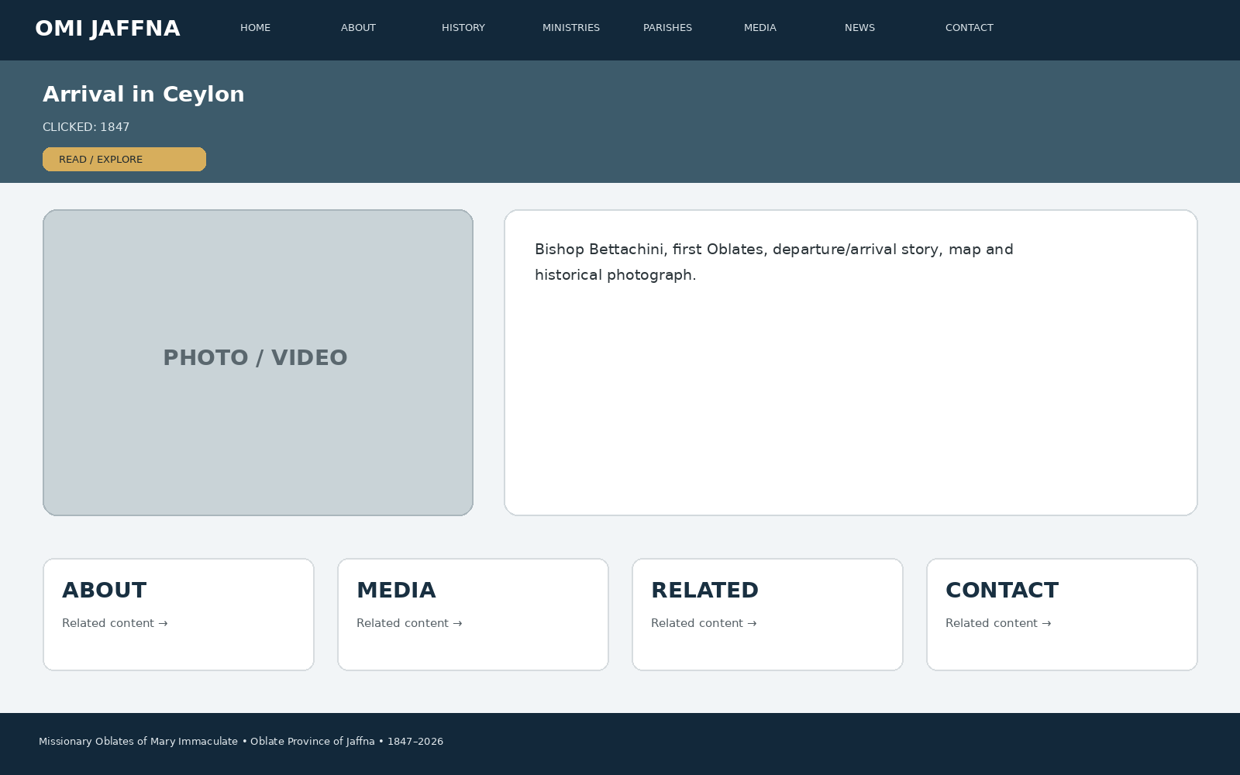
Developer instruction: keep the same header/navigation, show the page title immediately, use approved images/media in the main visual area, present the information in clear cards/sections, and connect the page to related ministries, parishes, media, news or contact information.

11. CLICK → 1848
When the visitor clicks “1848”, this page appears: 10 March 1848, first Oblates in Jaffna, Tamil learning/inculturation, early mission.
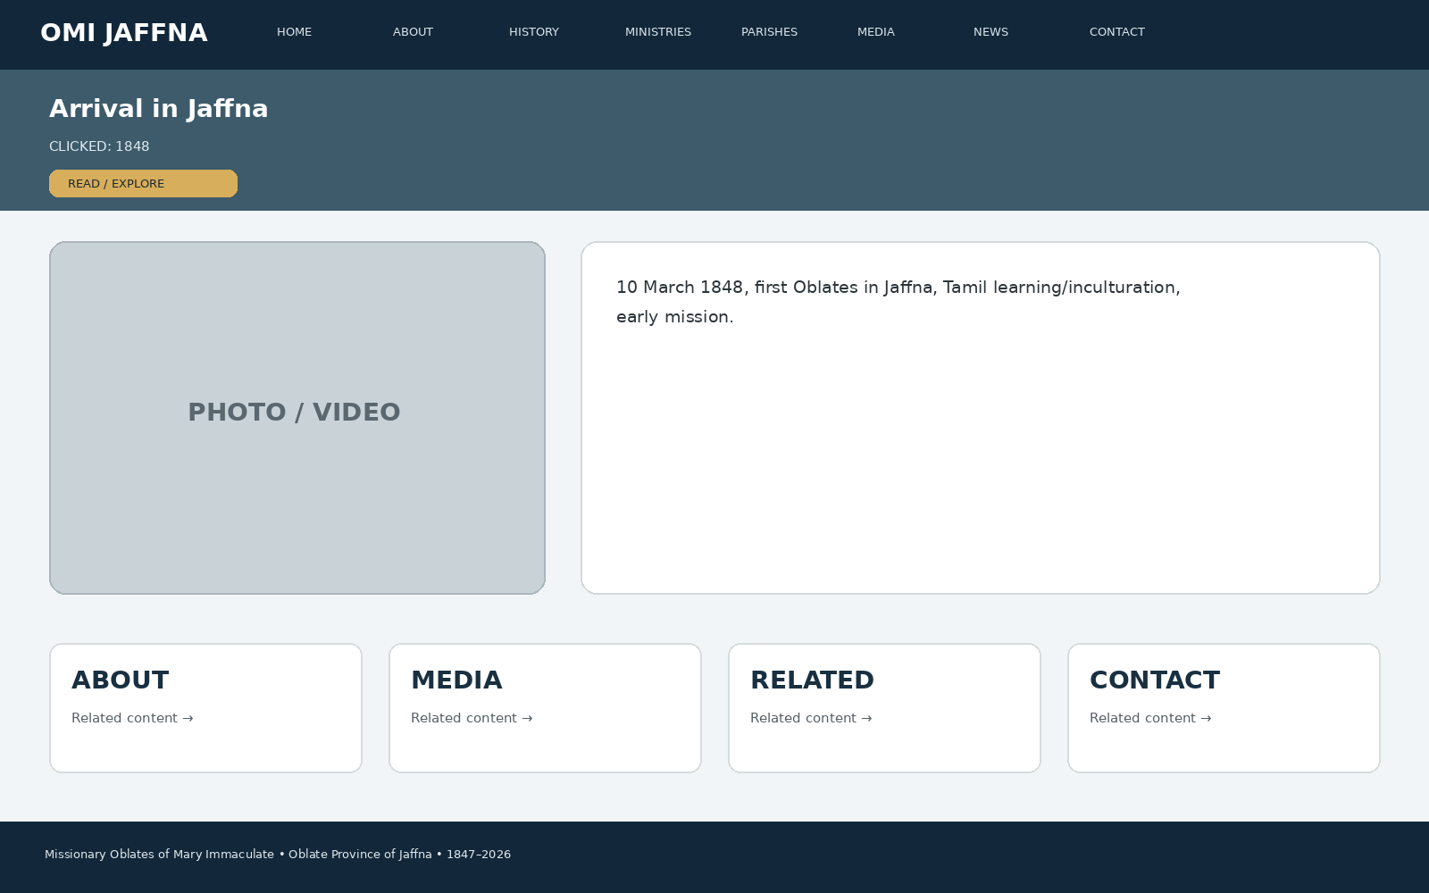
Developer instruction: keep the same header/navigation, show the page title immediately, use approved images/media in the main visual area, present the information in clear cards/sections, and connect the page to related ministries, parishes, media, news or contact information.

12. CLICK → MISSION EXPANSION
When the visitor clicks “MISSION EXPANSION”, this page appears: Jaffna, islands, Mannar, Point Pedro, Mullaitivu and wider Sri Lankan mission development.
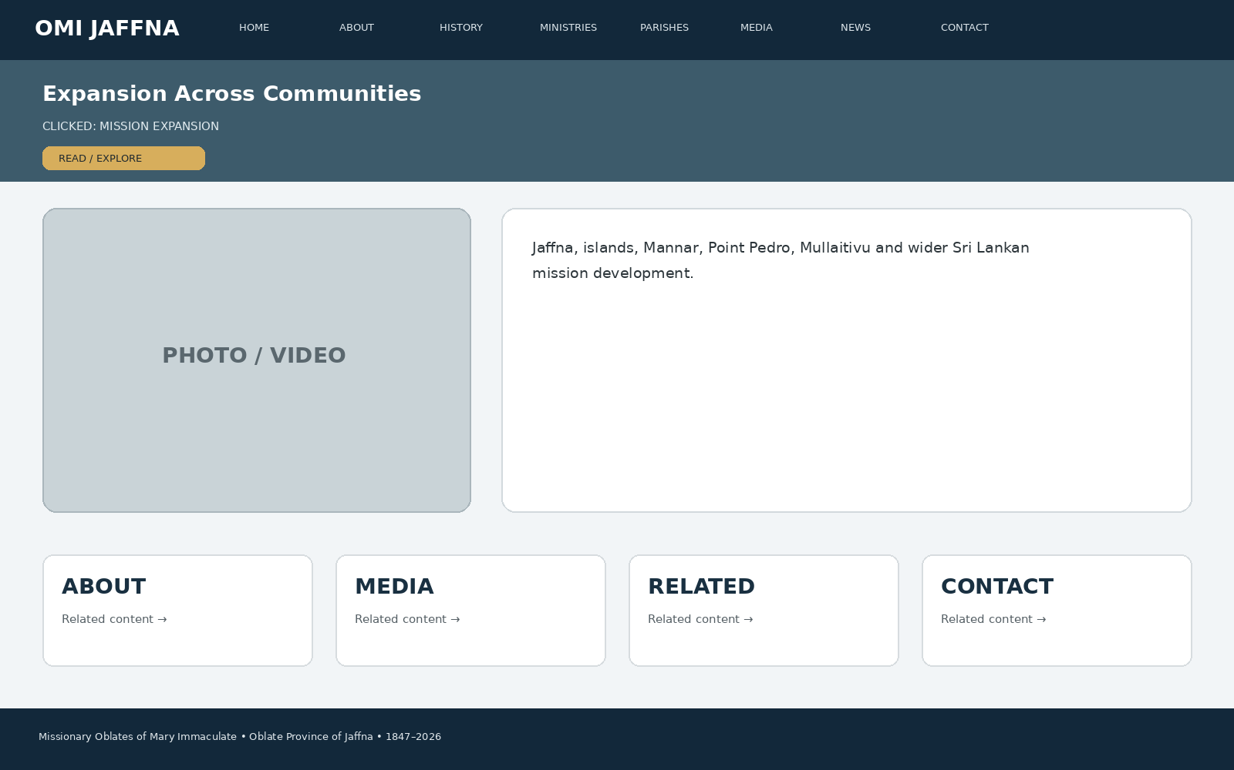
Developer instruction: keep the same header/navigation, show the page title immediately, use approved images/media in the main visual area, present the information in clear cards/sections, and connect the page to related ministries, parishes, media, news or contact information.

13. CLICK → 1988
When the visitor clicks “1988”, this page appears: Why the Jaffna Vice Province was established and the development toward an independent Province.
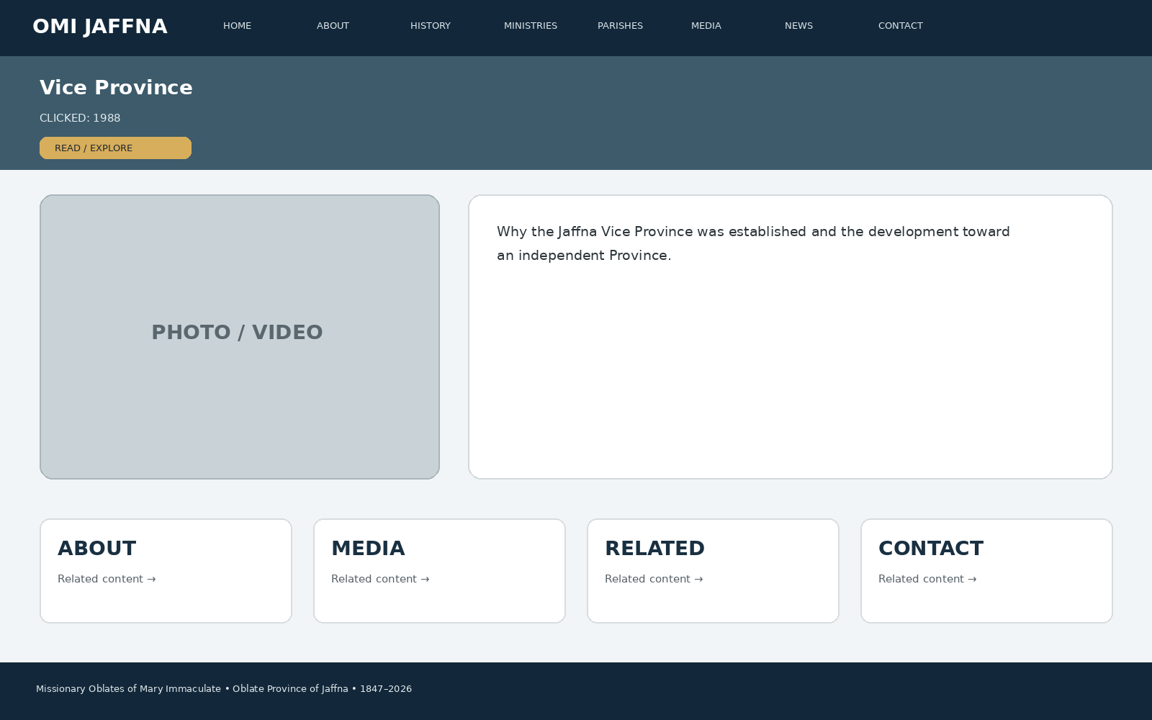
Developer instruction: keep the same header/navigation, show the page title immediately, use approved images/media in the main visual area, present the information in clear cards/sections, and connect the page to related ministries, parishes, media, news or contact information.

14. CLICK → 2001
When the visitor clicks “2001”, this page appears: Jaffna Province milestone, identity, governance and mission development.
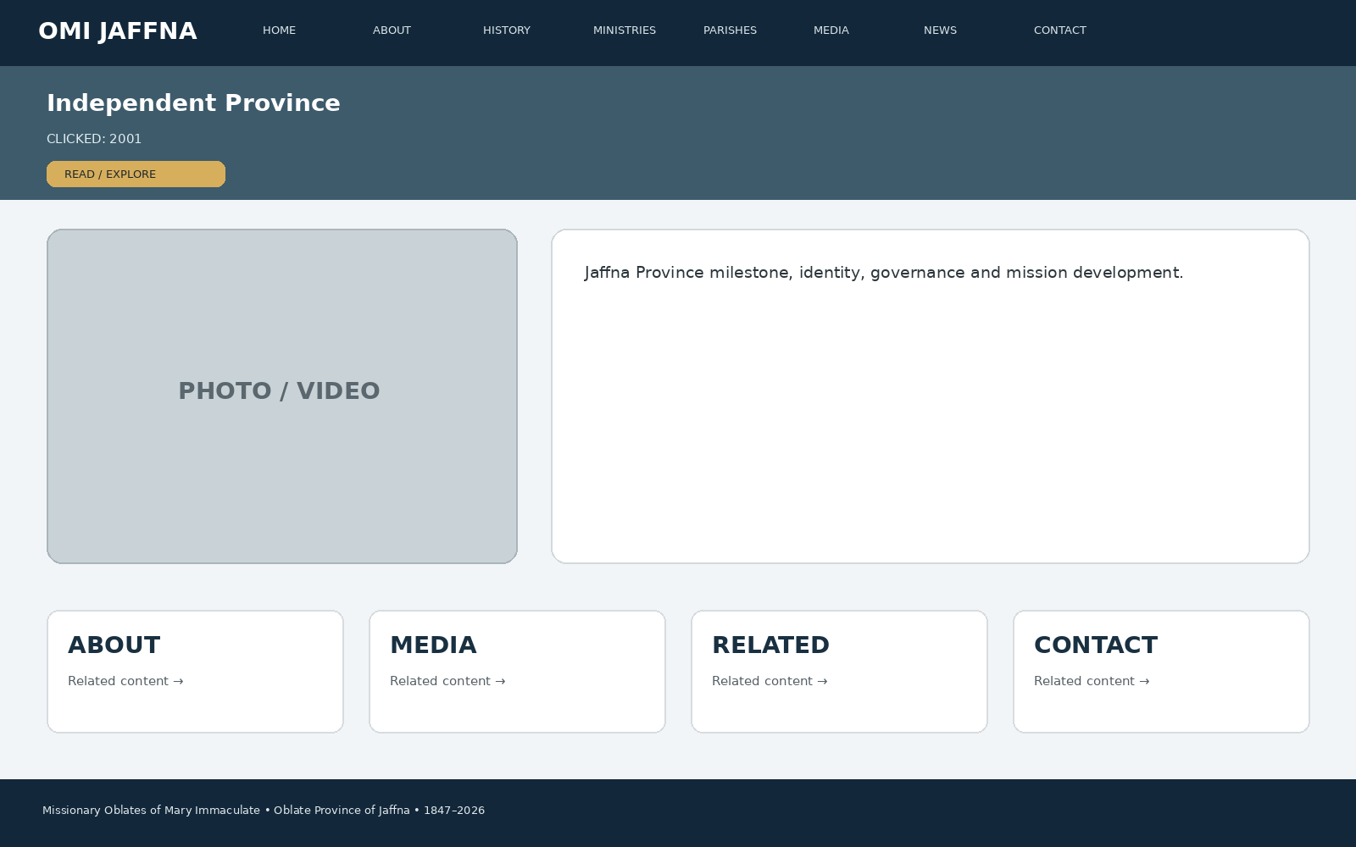
Developer instruction: keep the same header/navigation, show the page title immediately, use approved images/media in the main visual area, present the information in clear cards/sections, and connect the page to related ministries, parishes, media, news or contact information.

15. CLICK → 2026
When the visitor clicks “2026”, this page appears: Present mission, 17 ministries, island-wide service, international mission and digital mission.
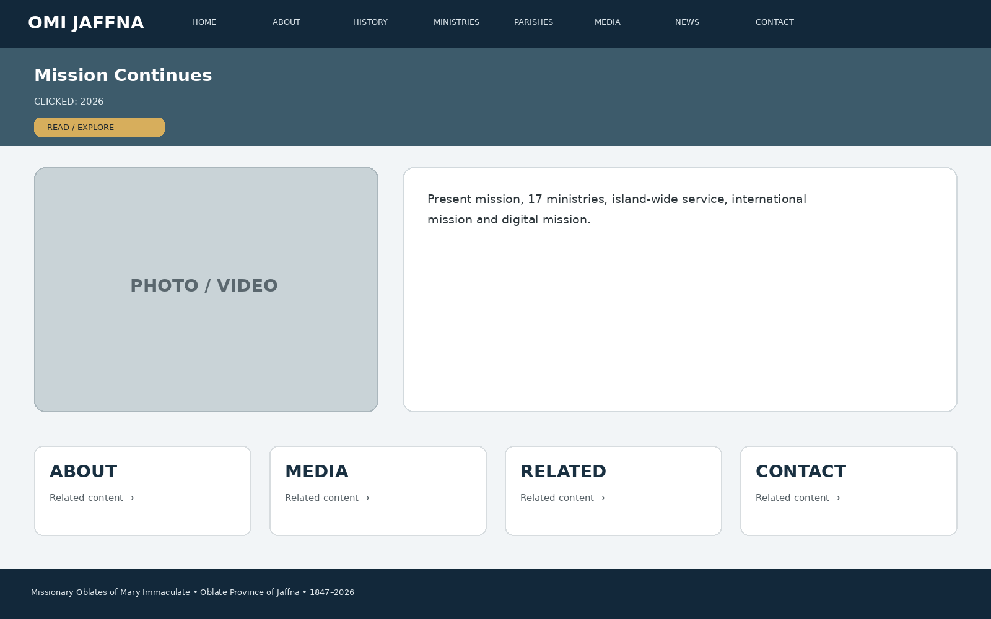
Developer instruction: keep the same header/navigation, show the page title immediately, use approved images/media in the main visual area, present the information in clear cards/sections, and connect the page to related ministries, parishes, media, news or contact information.

16. CLICK → MINISTRIES
When the visitor clicks “MINISTRIES”, this page appears: A visual grid of all 17 ministries; clicking a card opens its dedicated ministry page.
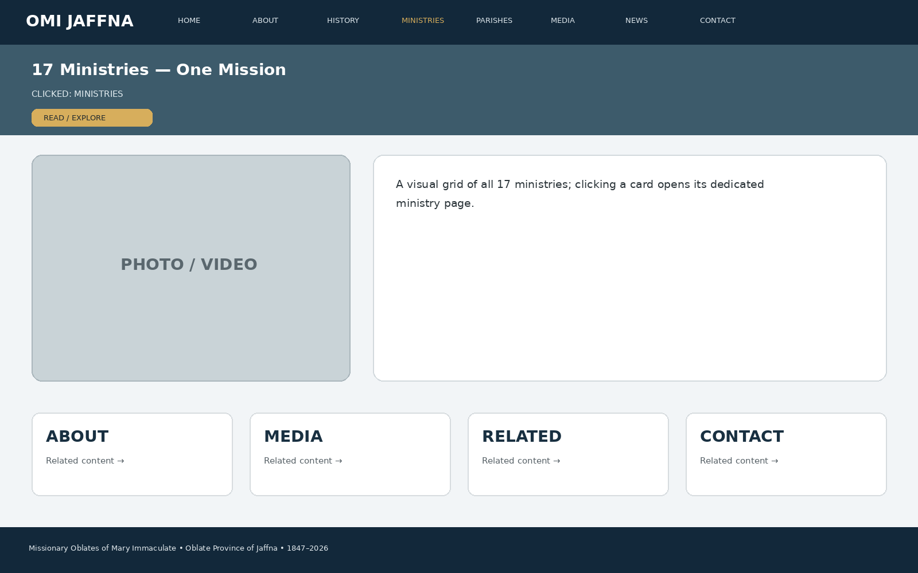
Developer instruction: keep the same header/navigation, show the page title immediately, use approved images/media in the main visual area, present the information in clear cards/sections, and connect the page to related ministries, parishes, media, news or contact information.

17. CLICK → MISSION PREACHING
When the visitor clicks “MISSION PREACHING”, this page appears: Mission preaching, Amathi Aham/Vavuniya and hospital/prison chaplaincy information supported by the source material.
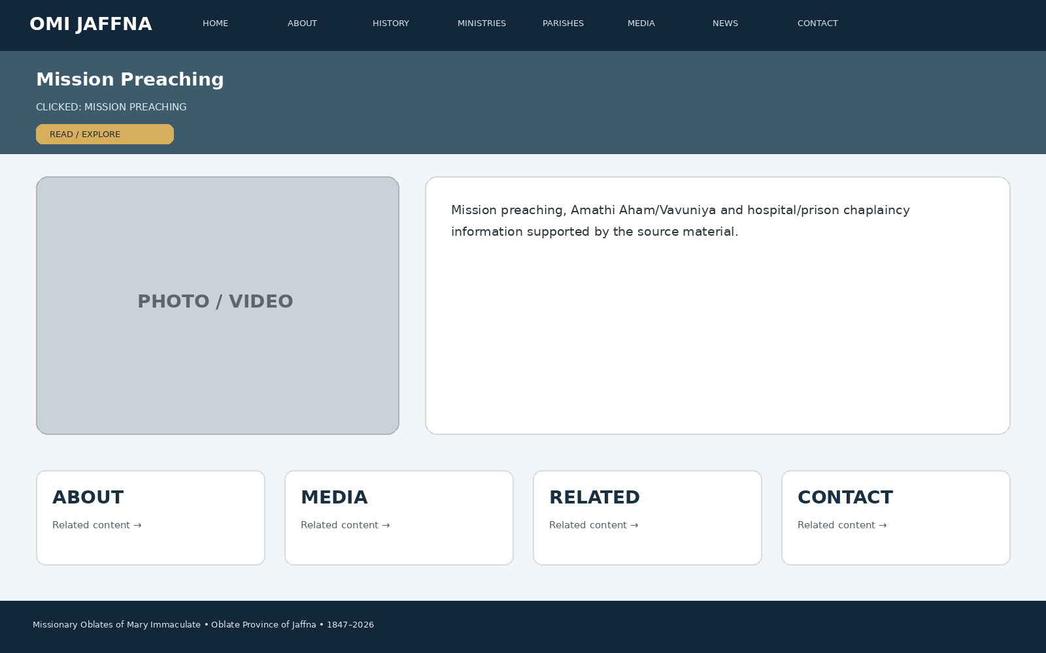
Developer instruction: keep the same header/navigation, show the page title immediately, use approved images/media in the main visual area, present the information in clear cards/sections, and connect the page to related ministries, parishes, media, news or contact information.

18. CLICK → PARISH MINISTRY
When the visitor clicks “PARISH MINISTRY”, this page appears: 12 parish cards, parish photo, priest/mission team information where approved, Mass/sacrament/contact links.
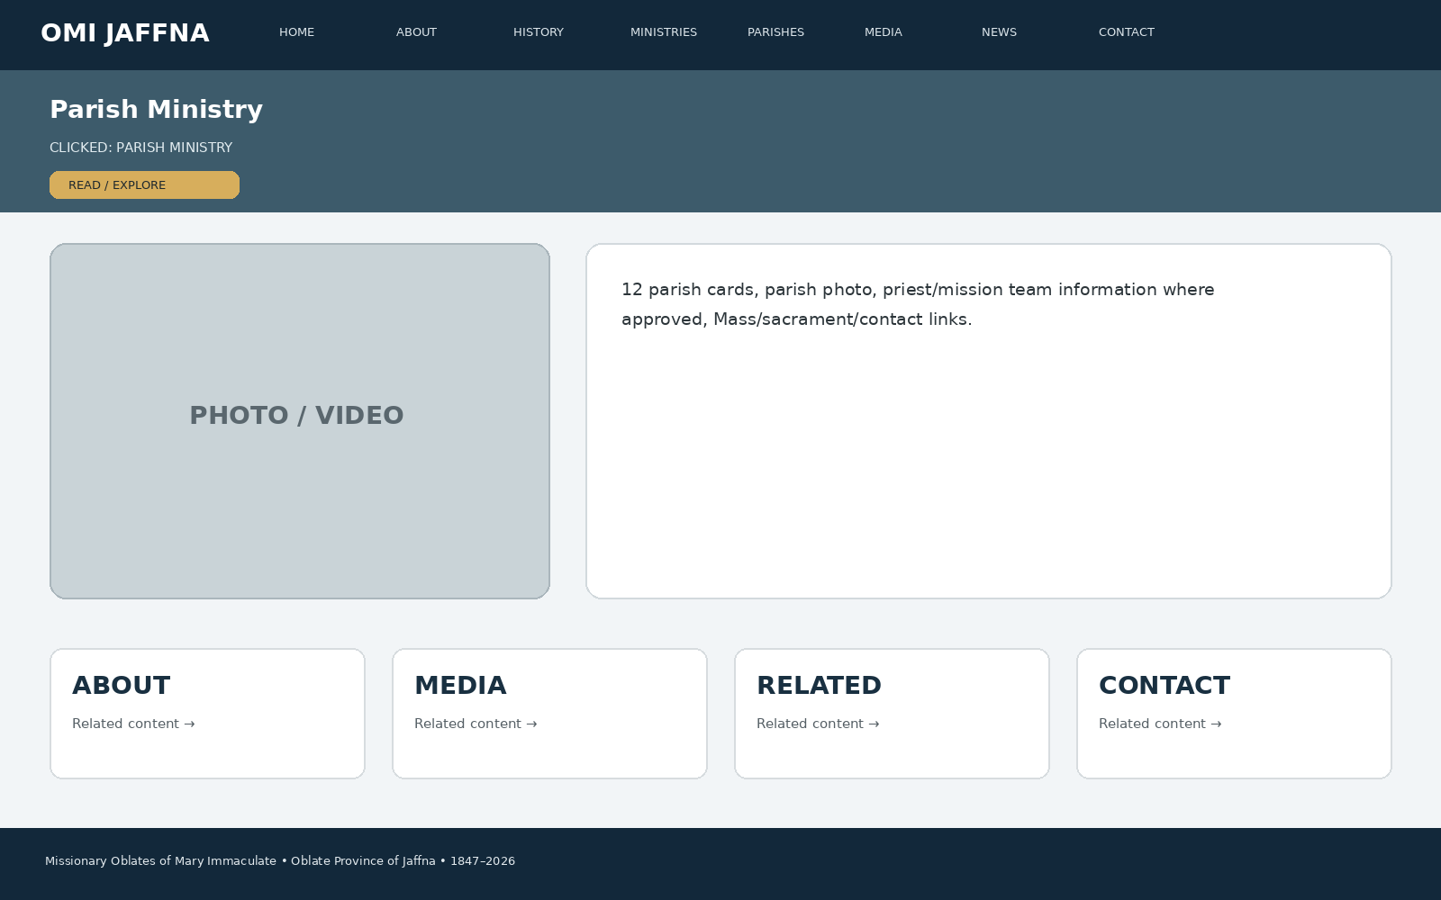
Developer instruction: keep the same header/navigation, show the page title immediately, use approved images/media in the main visual area, present the information in clear cards/sections, and connect the page to related ministries, parishes, media, news or contact information.

19. CLICK → EDUCATION
When the visitor clicks “EDUCATION”, this page appears: Formal education, schools list, school photos, history, current activities and related youth/formation content.
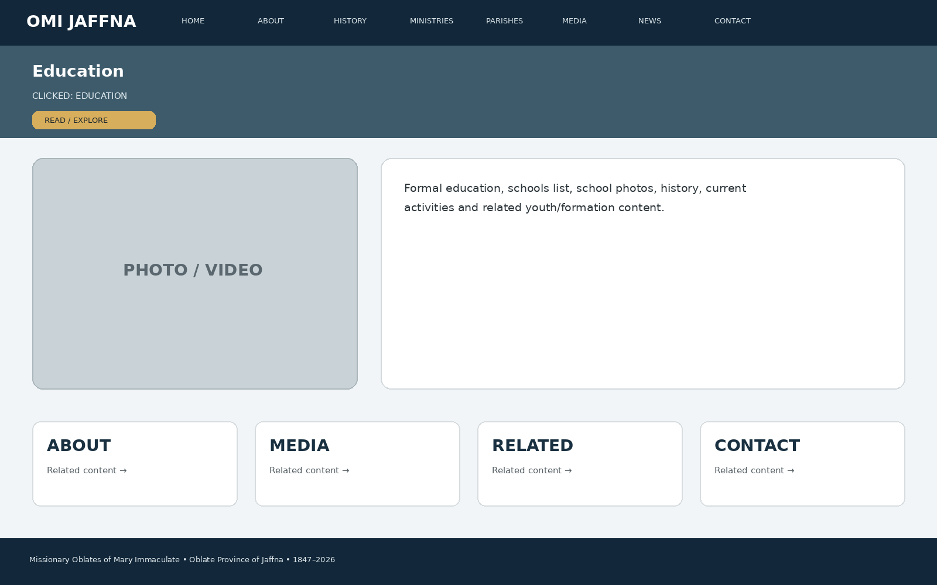
Developer instruction: keep the same header/navigation, show the page title immediately, use approved images/media in the main visual area, present the information in clear cards/sections, and connect the page to related ministries, parishes, media, news or contact information.

20. CLICK → NON-FORMAL EDUCATION
When the visitor clicks “NON-FORMAL EDUCATION”, this page appears: Annai Illam, OBTEC, Amala Uthayam, Anjali Aham and related learning/skills initiatives.
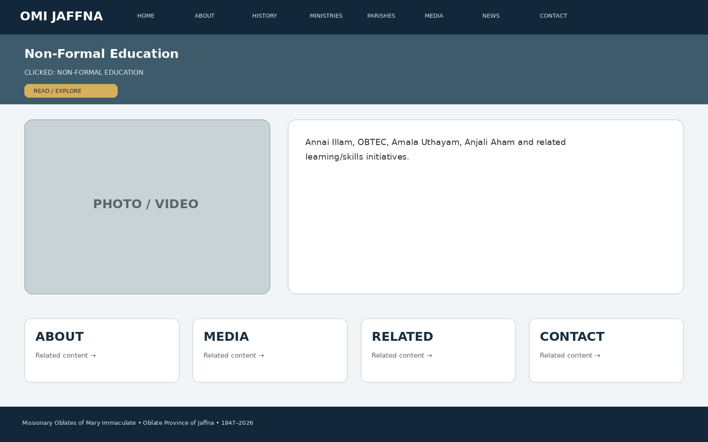
Developer instruction: keep the same header/navigation, show the page title immediately, use approved images/media in the main visual area, present the information in clear cards/sections, and connect the page to related ministries, parishes, media, news or contact information.

21. CLICK → YOUTH ANIMATION
When the visitor clicks “YOUTH ANIMATION”, this page appears: Gnanatheepam Youth Empowerment Centre, youth programmes, leadership, events, photos/videos and stories.
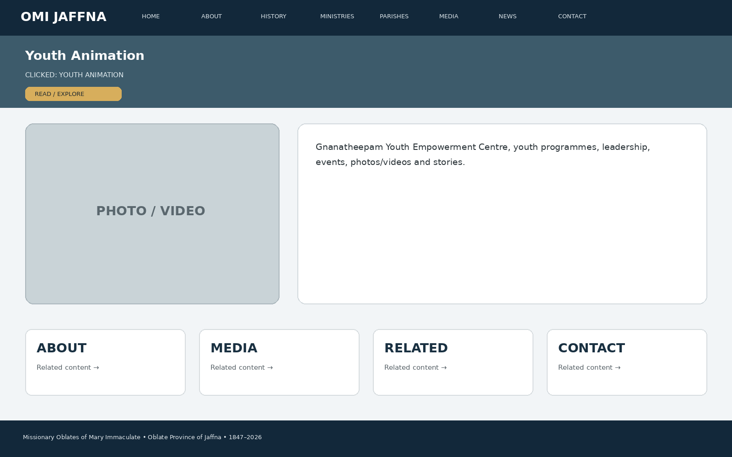
Developer instruction: keep the same header/navigation, show the page title immediately, use approved images/media in the main visual area, present the information in clear cards/sections, and connect the page to related ministries, parishes, media, news or contact information.

22. CLICK → CHILDREN'S ANIMATION
When the visitor clicks “CHILDREN'S ANIMATION”, this page appears: Amala Annai Anpaham, child-focused activities, safe-content gallery, programmes and stories.
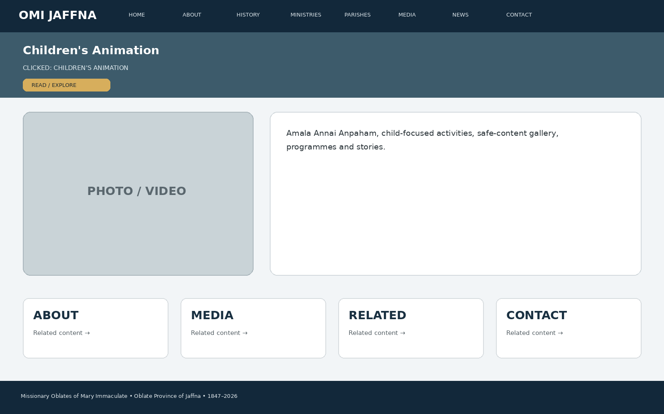
Developer instruction: keep the same header/navigation, show the page title immediately, use approved images/media in the main visual area, present the information in clear cards/sections, and connect the page to related ministries, parishes, media, news or contact information.

23. CLICK → FORMATION
When the visitor clicks “FORMATION”, this page appears: Juniorate, Pre-Novitiate, Scholasticate, formation houses, vocation pathway and vocation enquiry button.
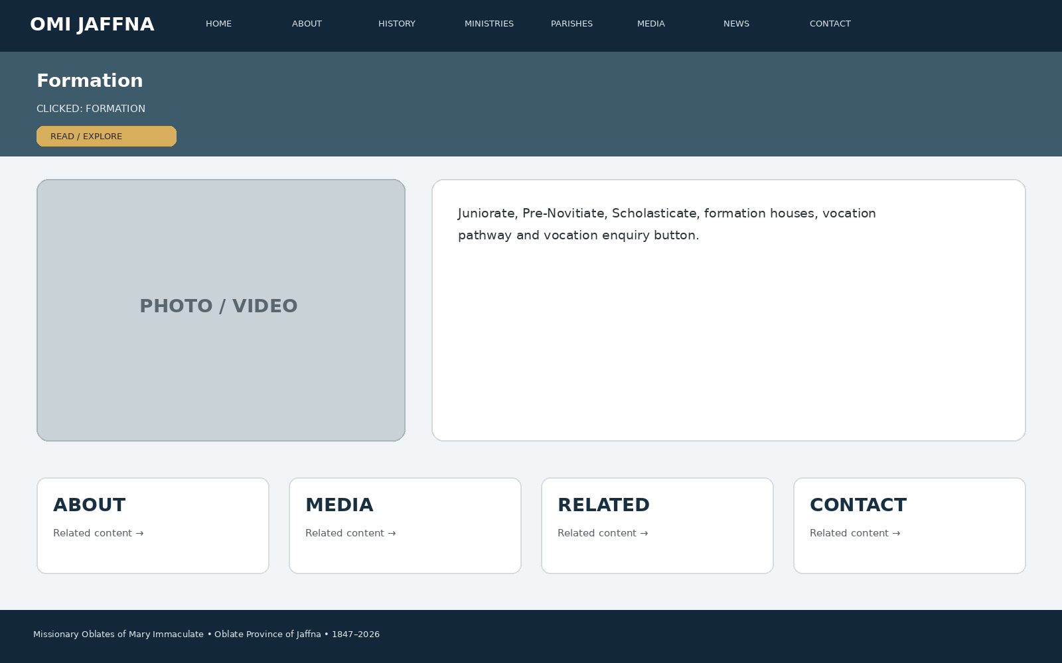
Developer instruction: keep the same header/navigation, show the page title immediately, use approved images/media in the main visual area, present the information in clear cards/sections, and connect the page to related ministries, parishes, media, news or contact information.

24. CLICK → PSYCHO-SOCIAL COUNSELLING
When the visitor clicks “PSYCHO-SOCIAL COUNSELLING”, this page appears: Amaithi Thedral, Valarpirai/ICOF, counselling information, support activities and safeguarding/contact guidance.
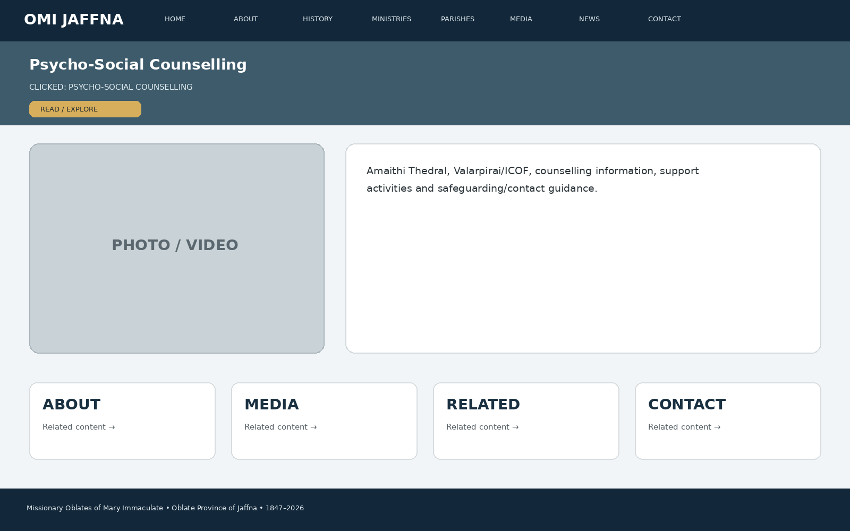
Developer instruction: keep the same header/navigation, show the page title immediately, use approved images/media in the main visual area, present the information in clear cards/sections, and connect the page to related ministries, parishes, media, news or contact information.

25. CLICK → CARING FOR AMPUTEES
When the visitor clicks “CARING FOR AMPUTEES”, this page appears: Amathi Karangal, service model, beneficiary stories, rehabilitation links and photo/video stories.
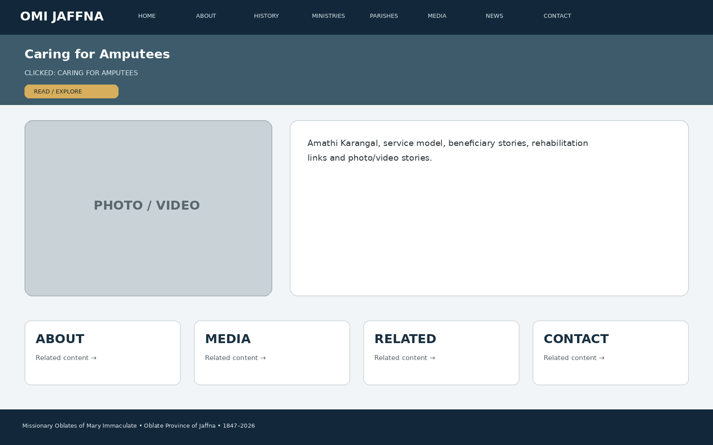
Developer instruction: keep the same header/navigation, show the page title immediately, use approved images/media in the main visual area, present the information in clear cards/sections, and connect the page to related ministries, parishes, media, news or contact information.

26. CLICK → REHABILITATION
When the visitor clicks “REHABILITATION”, this page appears: Thiruppunamai/CRADA, Eugene De Mazenod Home, Nampikai Illam, programmes, stories and support information.
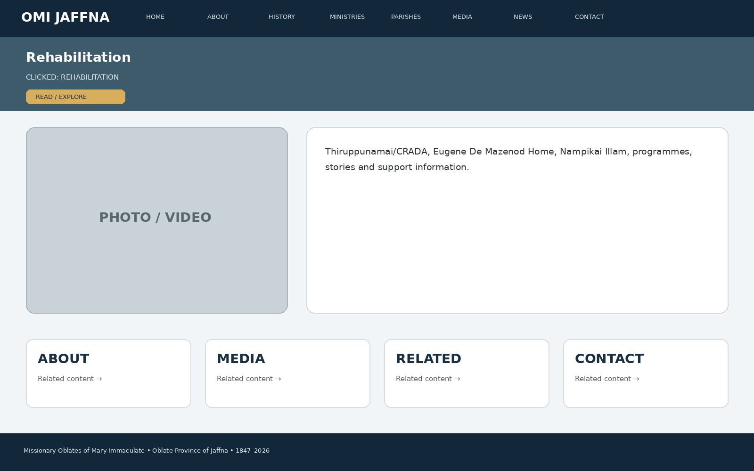
Developer instruction: keep the same header/navigation, show the page title immediately, use approved images/media in the main visual area, present the information in clear cards/sections, and connect the page to related ministries, parishes, media, news or contact information.

27. CLICK → JUSTICE, PEACE & INTEGRITY OF CREATION
When the visitor clicks “JUSTICE, PEACE & INTEGRITY OF CREATION”, this page appears: Centre for Peace and Reconciliation, JPIC themes, advocacy, reconciliation, environment and community initiatives.
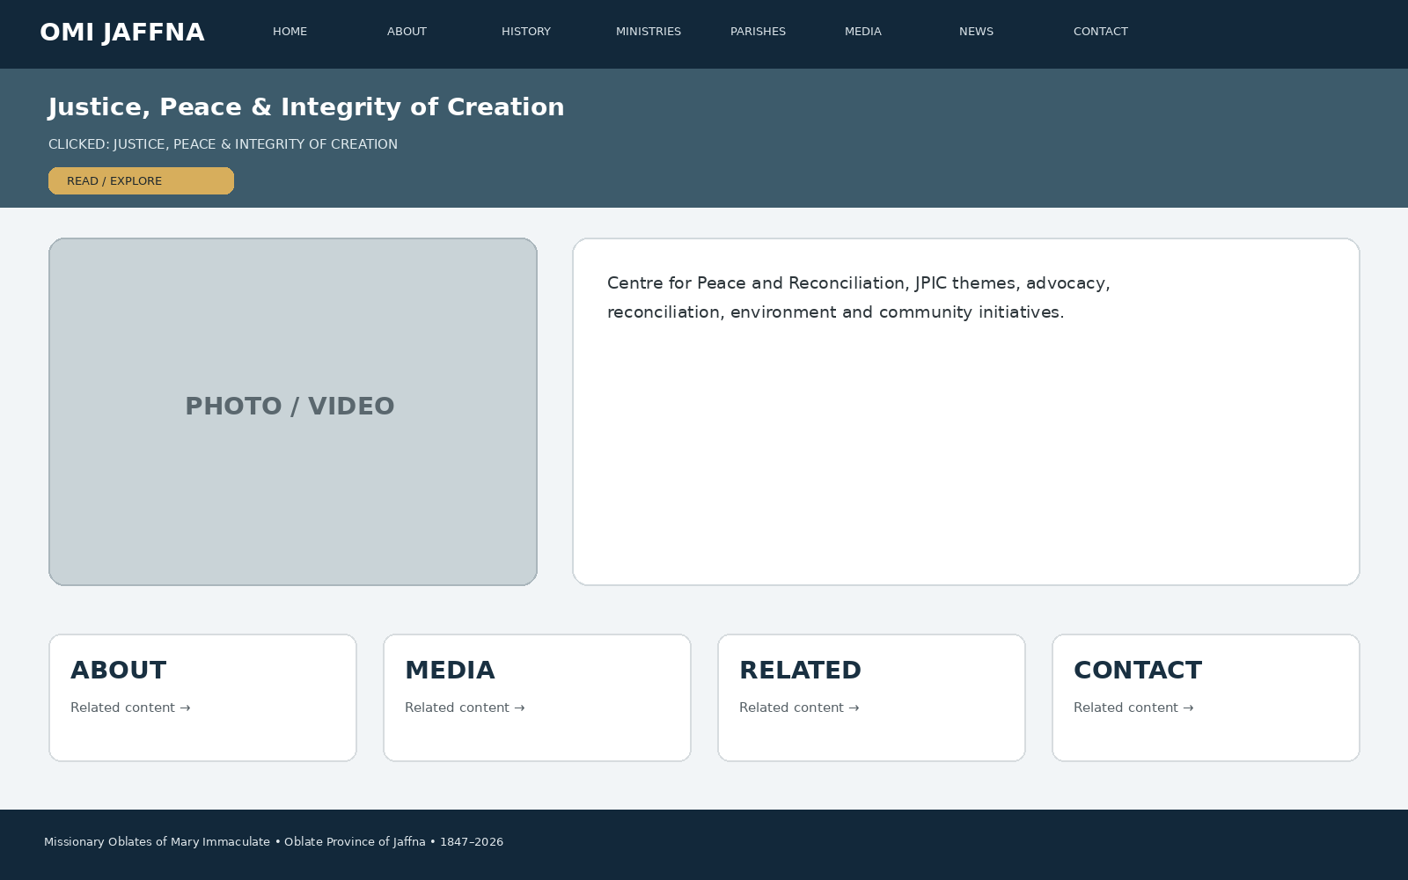
Developer instruction: keep the same header/navigation, show the page title immediately, use approved images/media in the main visual area, present the information in clear cards/sections, and connect the page to related ministries, parishes, media, news or contact information.

28. CLICK → SPIRITUAL RENEWAL & ANIMATION
When the visitor clicks “SPIRITUAL RENEWAL & ANIMATION”, this page appears: Sangamam, retreats, renewal programmes, spiritual resources, event calendar and registrations.
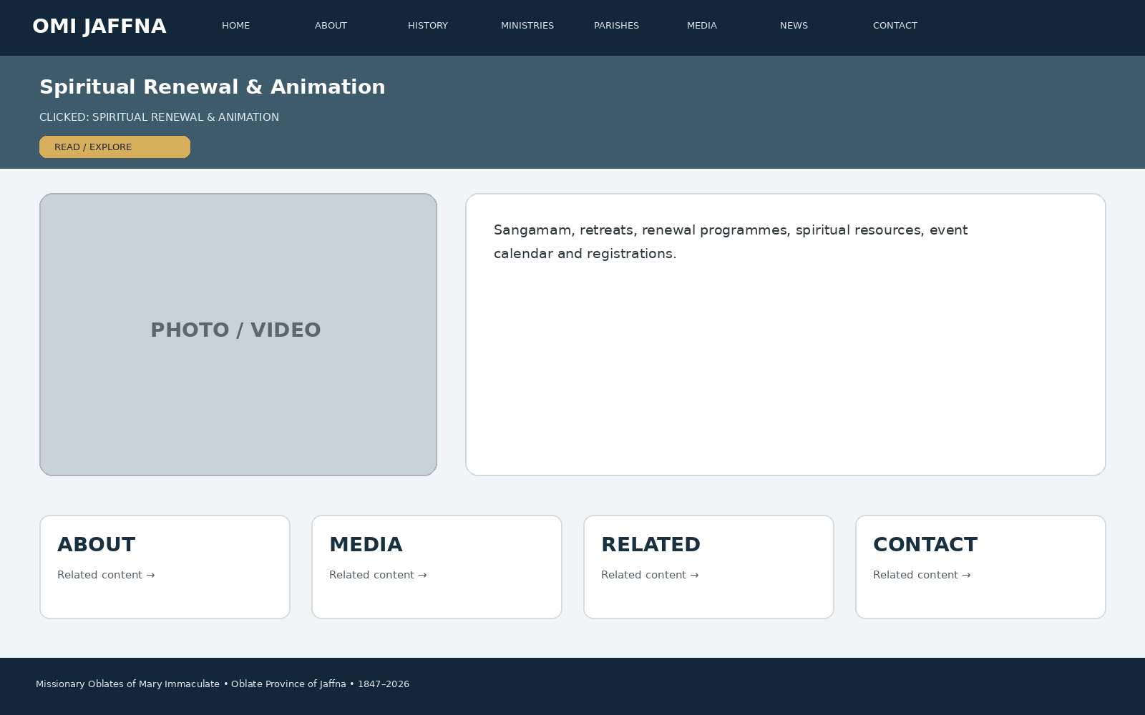
Developer instruction: keep the same header/navigation, show the page title immediately, use approved images/media in the main visual area, present the information in clear cards/sections, and connect the page to related ministries, parishes, media, news or contact information.

29. CLICK → COMMUNITY DEVELOPMENT
When the visitor clicks “COMMUNITY DEVELOPMENT”, this page appears: Nesakarangal, Amathi Vanam, Amathik Kalam, Amala Aruvi, Malarum Mullai, Eugene Nivasa and community stories.
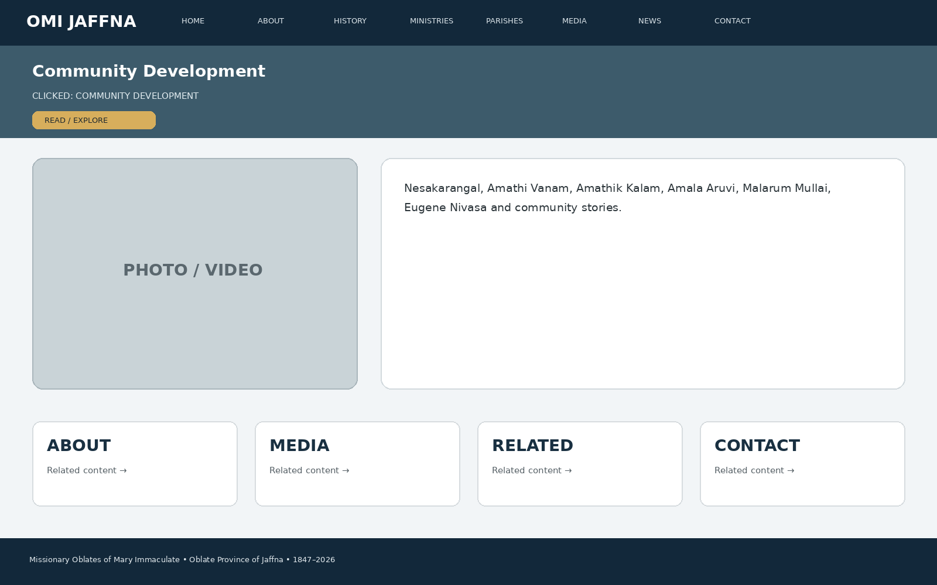
Developer instruction: keep the same header/navigation, show the page title immediately, use approved images/media in the main visual area, present the information in clear cards/sections, and connect the page to related ministries, parishes, media, news or contact information.

30. CLICK → RETIRED OBLATES
When the visitor clicks “RETIRED OBLATES”, this page appears: Care for elderly/retired missionaries, community life, prayer/support and approved photographs.
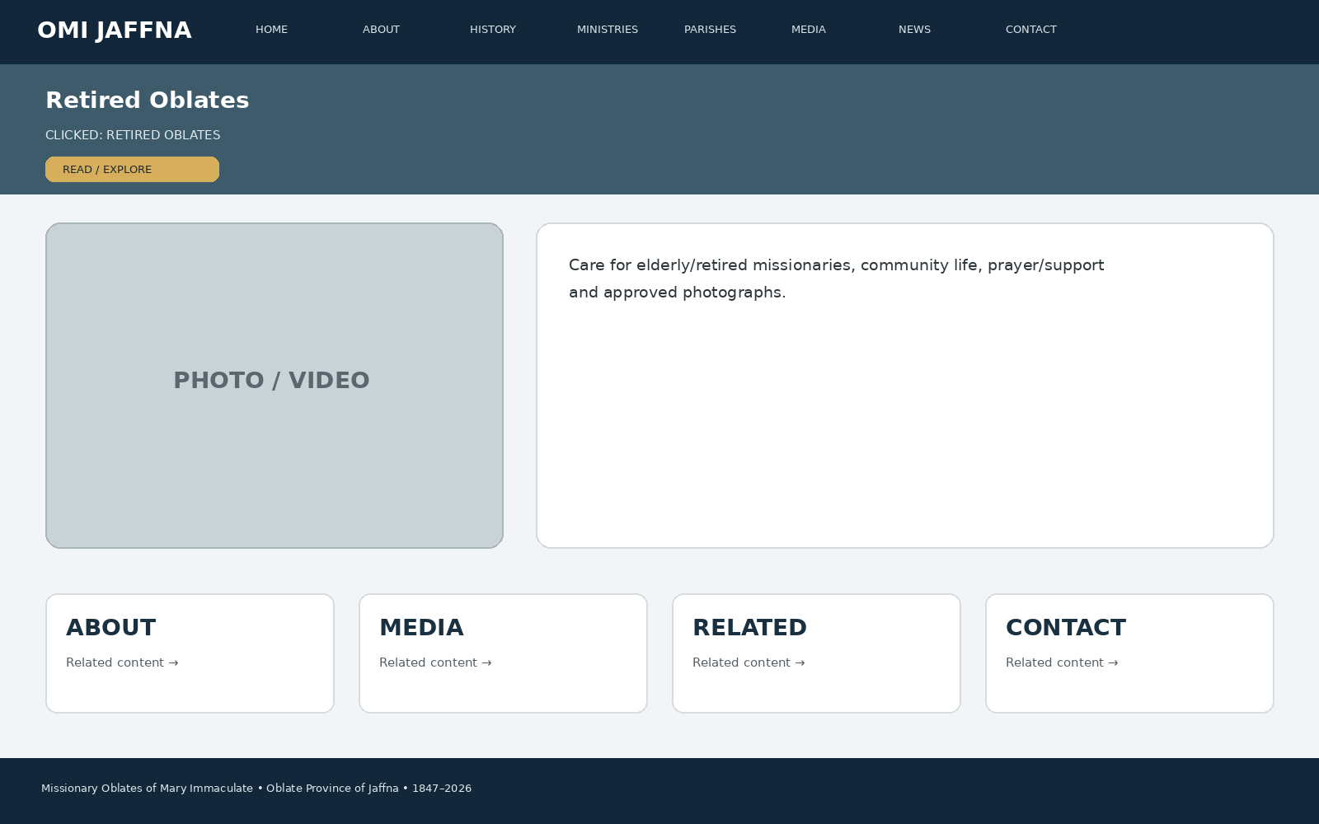
Developer instruction: keep the same header/navigation, show the page title immediately, use approved images/media in the main visual area, present the information in clear cards/sections, and connect the page to related ministries, parishes, media, news or contact information.

31. CLICK → OBLATE HOUSE
When the visitor clicks “OBLATE HOUSE”, this page appears: Community/house information, purpose, location map and approved contact route.
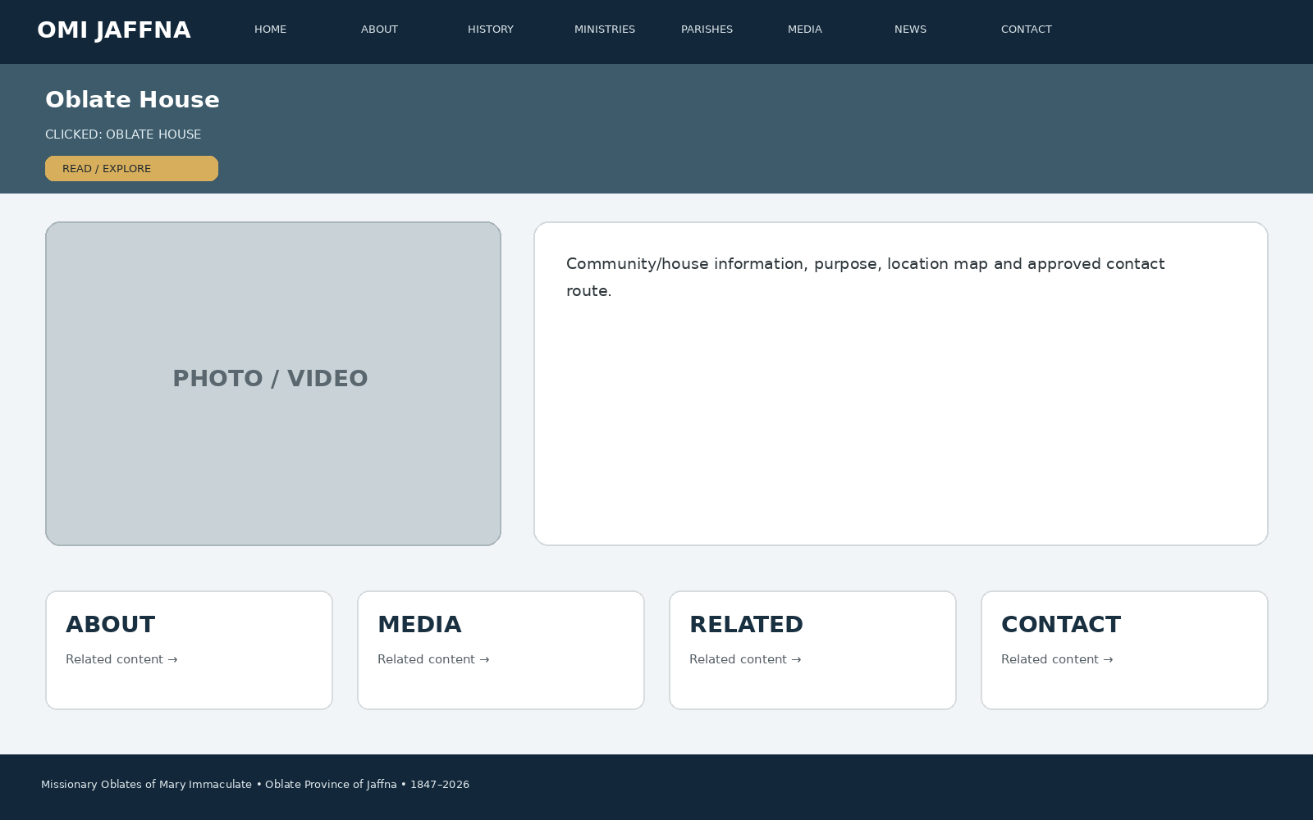
Developer instruction: keep the same header/navigation, show the page title immediately, use approved images/media in the main visual area, present the information in clear cards/sections, and connect the page to related ministries, parishes, media, news or contact information.

32. CLICK → INTERNATIONAL MISSION
When the visitor clicks “INTERNATIONAL MISSION”, this page appears: Countries served, missionary stories, formation beyond Sri Lanka, diaspora chaplaincy and global Oblate links.
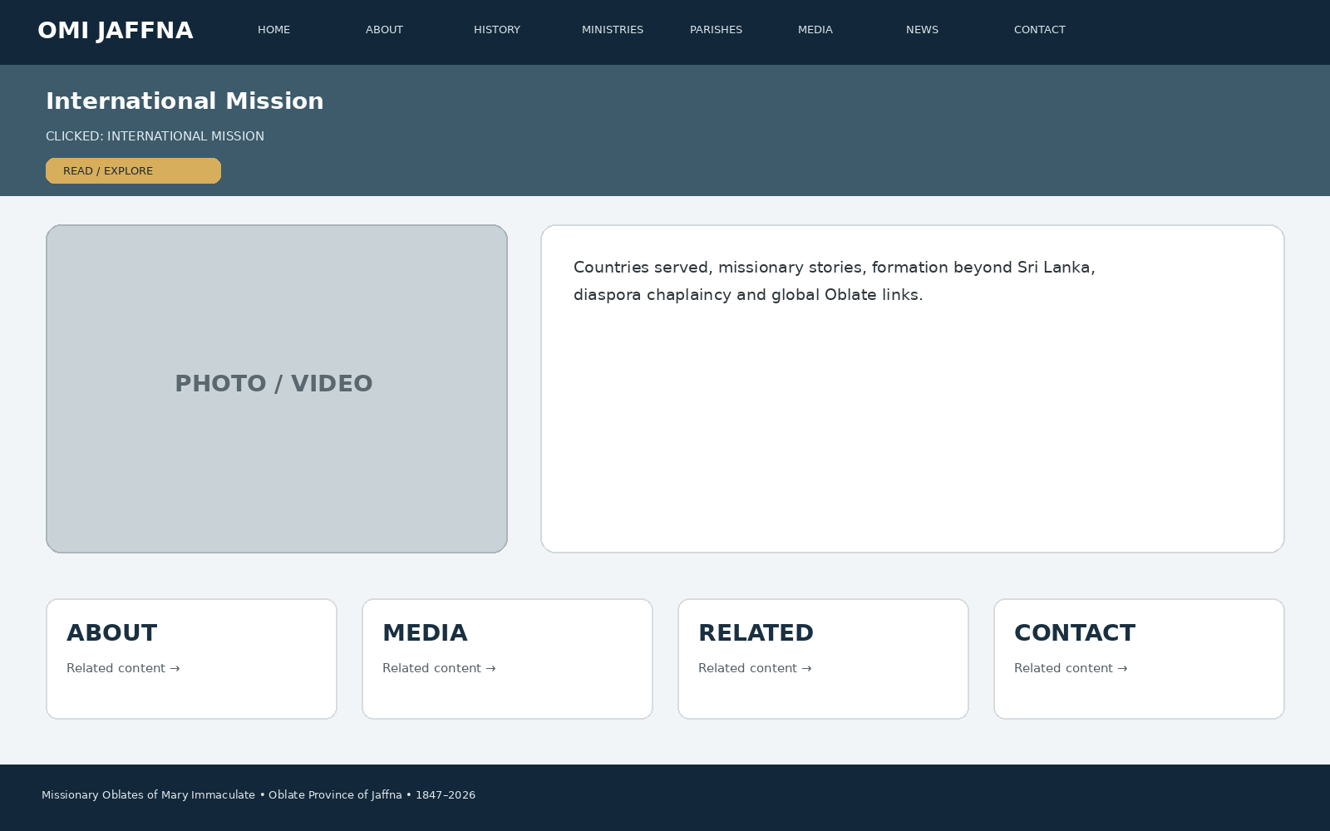
Developer instruction: keep the same header/navigation, show the page title immediately, use approved images/media in the main visual area, present the information in clear cards/sections, and connect the page to related ministries, parishes, media, news or contact information.

33. CLICK → DIASPORA
When the visitor clicks “DIASPORA”, this page appears: Diaspora presence, chaplaincy stories, locations, pastoral activities and media.
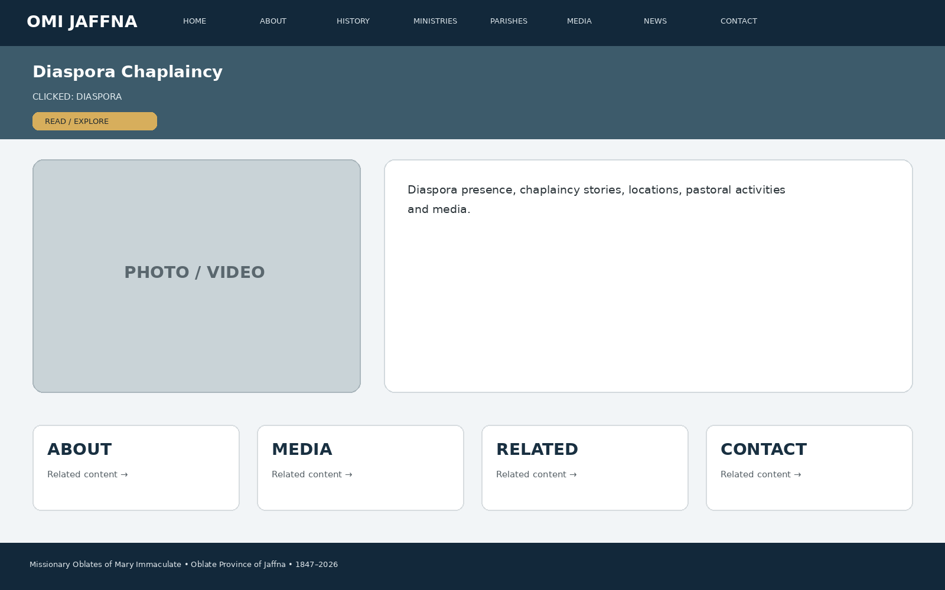
Developer instruction: keep the same header/navigation, show the page title immediately, use approved images/media in the main visual area, present the information in clear cards/sections, and connect the page to related ministries, parishes, media, news or contact information.

34. CLICK → DIGITAL MISSION
When the visitor clicks “DIGITAL MISSION”, this page appears: Website, YouTube/social channels, online evangelization, digital resources and contact/subscribe buttons.
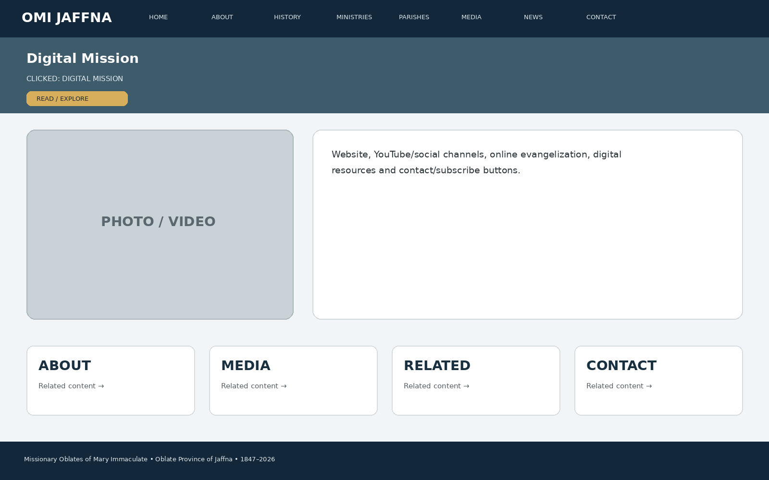
Developer instruction: keep the same header/navigation, show the page title immediately, use approved images/media in the main visual area, present the information in clear cards/sections, and connect the page to related ministries, parishes, media, news or contact information.

35. CLICK → MEDIA
When the visitor clicks “MEDIA”, this page appears: Photos, Videos, Podcasts, Articles, Interviews, Homilies, Testimonials, Publications and Downloads.
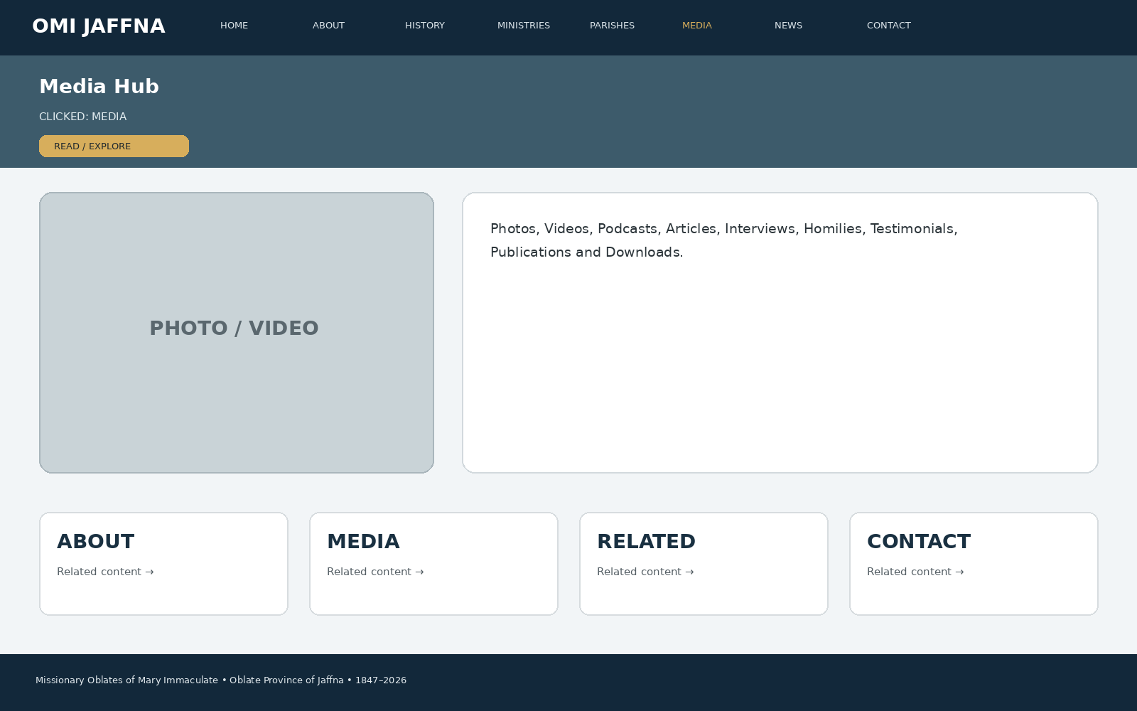
Developer instruction: keep the same header/navigation, show the page title immediately, use approved images/media in the main visual area, present the information in clear cards/sections, and connect the page to related ministries, parishes, media, news or contact information.

36. CLICK → PHOTOS
When the visitor clicks “PHOTOS”, this page appears: Album grid, filters by year/parish/ministry, fullscreen viewer, captions, dates and credits.
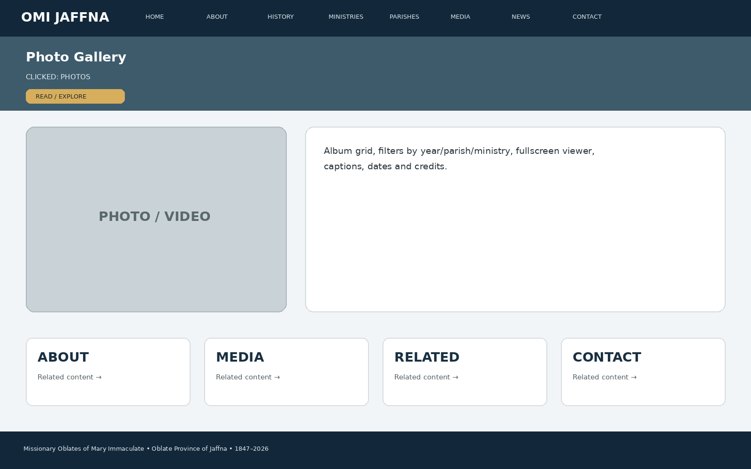
Developer instruction: keep the same header/navigation, show the page title immediately, use approved images/media in the main visual area, present the information in clear cards/sections, and connect the page to related ministries, parishes, media, news or contact information.

37. CLICK → VIDEOS
When the visitor clicks “VIDEOS”, this page appears: Featured video, playlist categories, search/filter, related ministry/parish links and YouTube/video player.
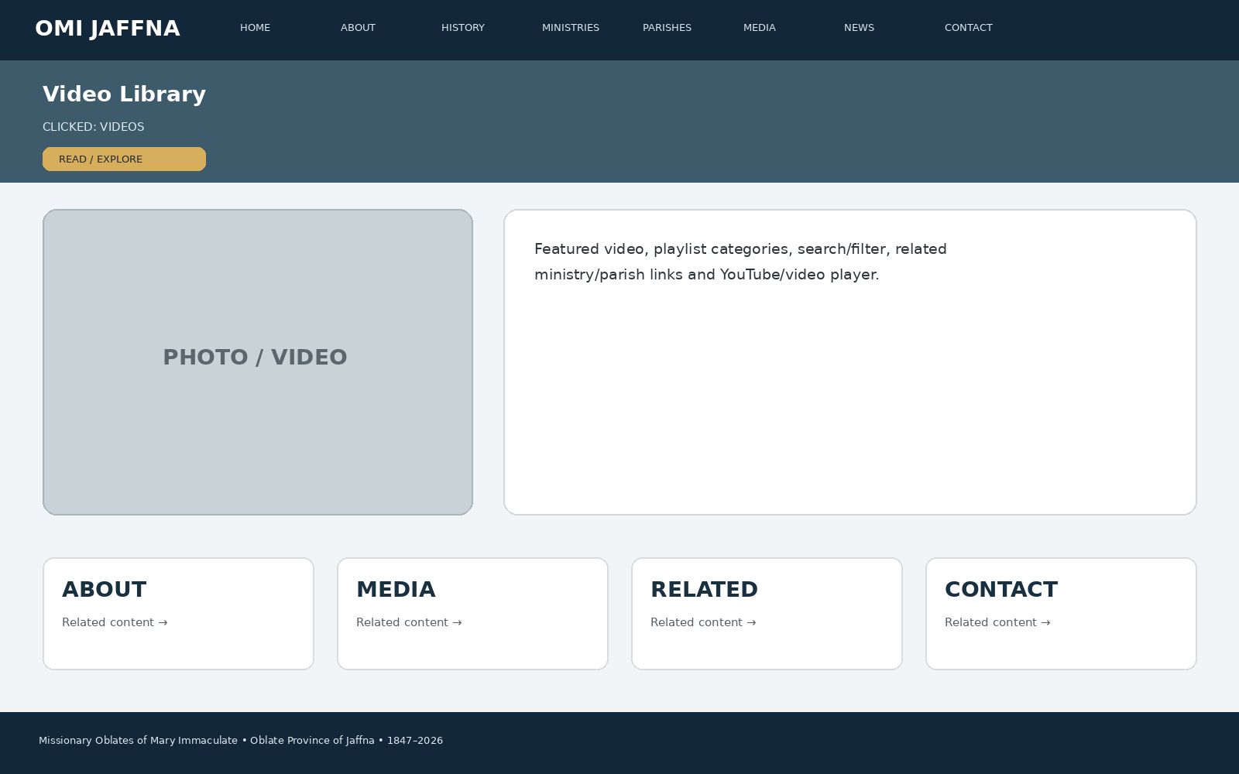
Developer instruction: keep the same header/navigation, show the page title immediately, use approved images/media in the main visual area, present the information in clear cards/sections, and connect the page to related ministries, parishes, media, news or contact information.

38. CLICK → PODCASTS
When the visitor clicks “PODCASTS”, this page appears: Episode cards, player, speaker, date, description, transcript/download and related articles.
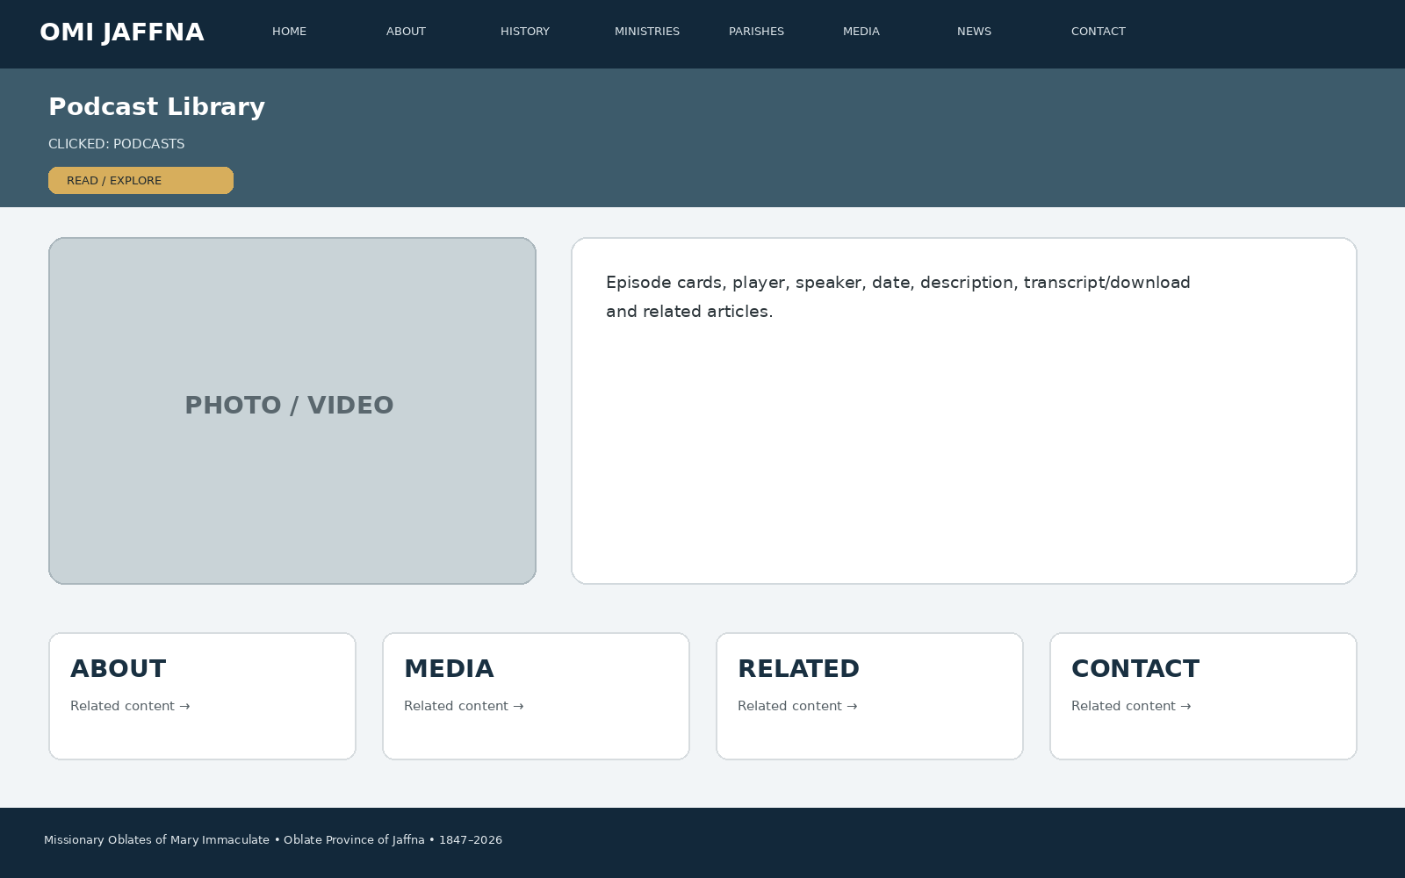
Developer instruction: keep the same header/navigation, show the page title immediately, use approved images/media in the main visual area, present the information in clear cards/sections, and connect the page to related ministries, parishes, media, news or contact information.

39. CLICK → ARTICLES
When the visitor clicks “ARTICLES”, this page appears: Featured article, latest articles, categories, author/date, read-more and related media.
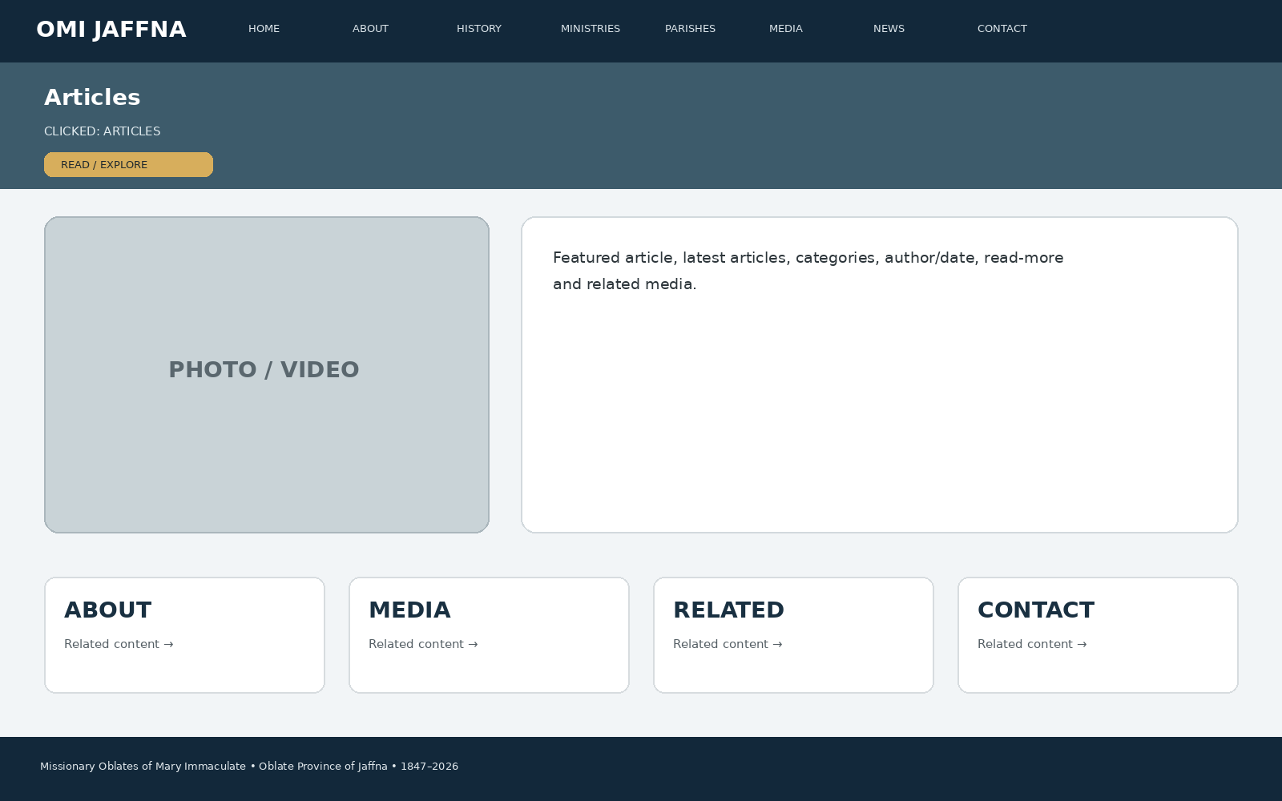
Developer instruction: keep the same header/navigation, show the page title immediately, use approved images/media in the main visual area, present the information in clear cards/sections, and connect the page to related ministries, parishes, media, news or contact information.

40. CLICK → INTERVIEWS
When the visitor clicks “INTERVIEWS”, this page appears: Interview cards, speaker profile, video/audio/article format and related ministry.
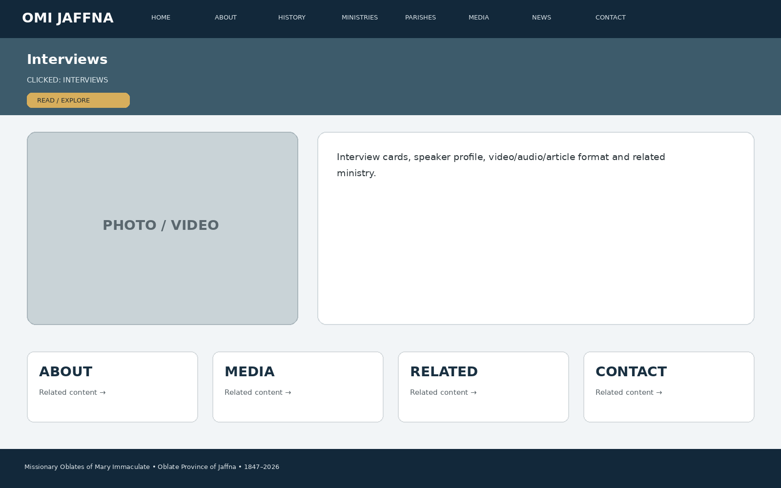
Developer instruction: keep the same header/navigation, show the page title immediately, use approved images/media in the main visual area, present the information in clear cards/sections, and connect the page to related ministries, parishes, media, news or contact information.

41. CLICK → HOMILIES & REFLECTIONS
When the visitor clicks “HOMILIES & REFLECTIONS”, this page appears: Homily/reflection player, speaker, date, liturgical context and related resources.
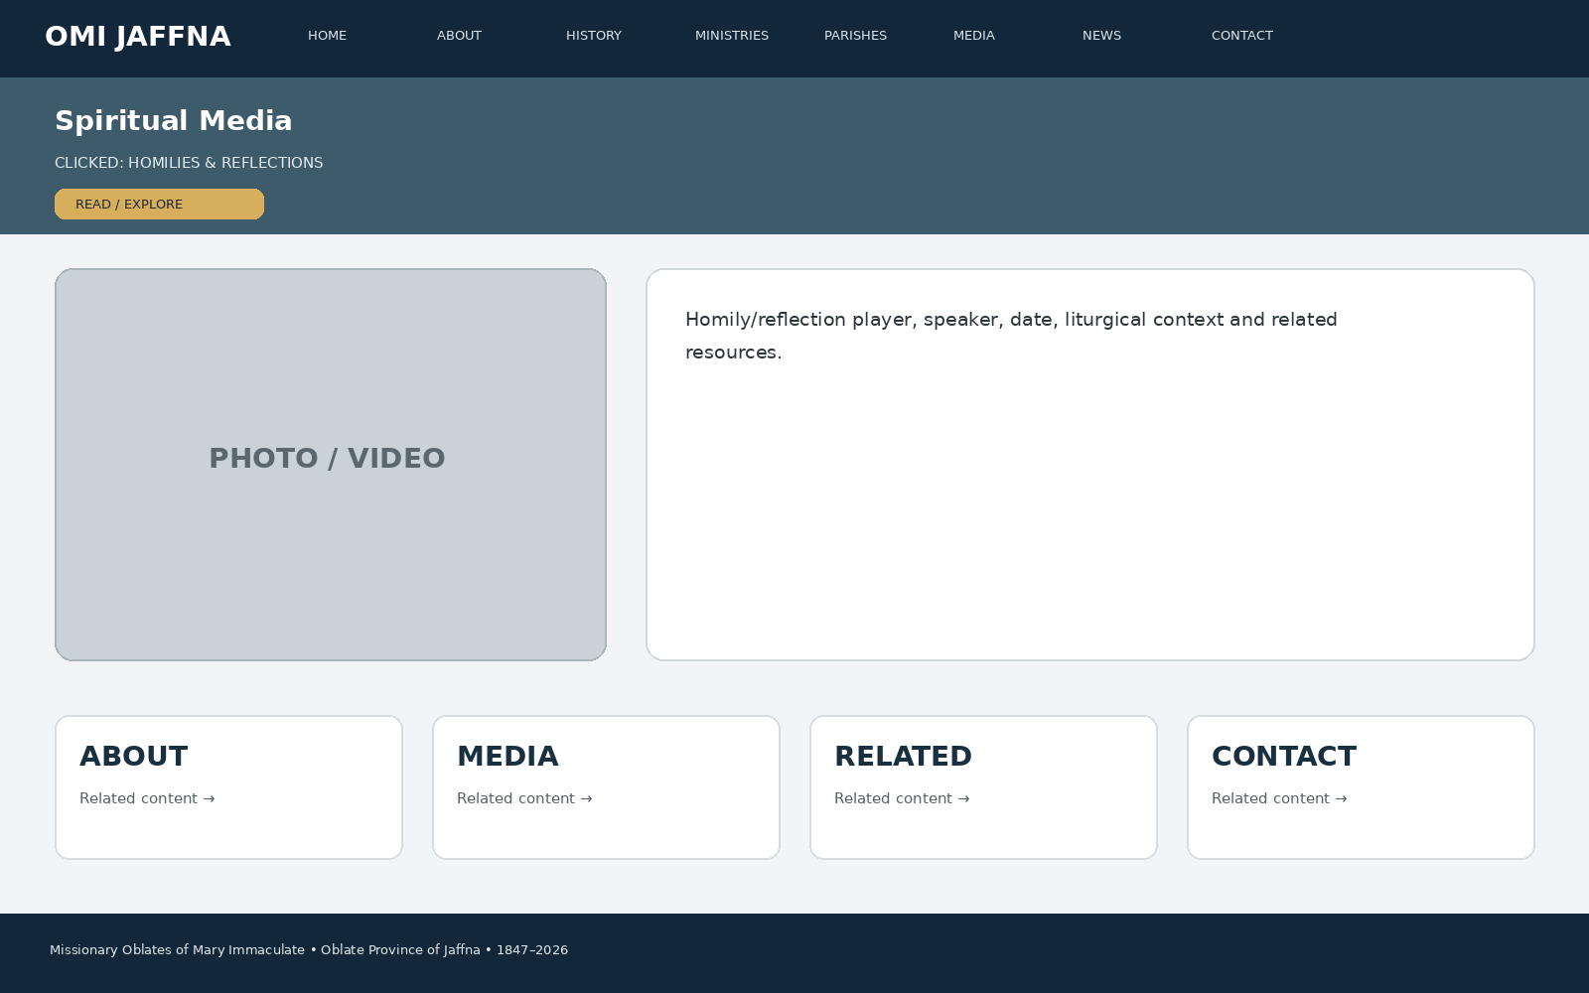
Developer instruction: keep the same header/navigation, show the page title immediately, use approved images/media in the main visual area, present the information in clear cards/sections, and connect the page to related ministries, parishes, media, news or contact information.

42. CLICK → TESTIMONIALS
When the visitor clicks “TESTIMONIALS”, this page appears: Testimonial cards, story detail, photo/video, ministry connection and safeguarding/consent.
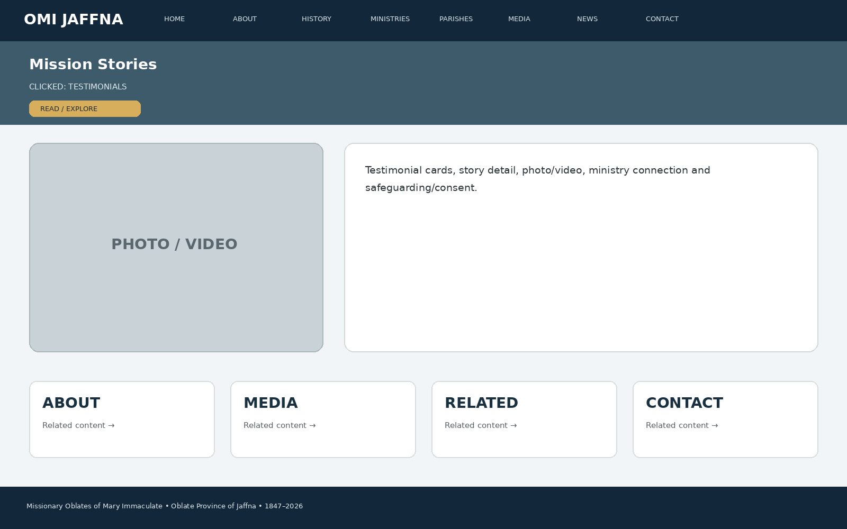
Developer instruction: keep the same header/navigation, show the page title immediately, use approved images/media in the main visual area, present the information in clear cards/sections, and connect the page to related ministries, parishes, media, news or contact information.

43. CLICK → PUBLICATIONS
When the visitor clicks “PUBLICATIONS”, this page appears: Yazha Thoni, Zeal, annual reports, newsletters, brochures and approved PDF downloads.
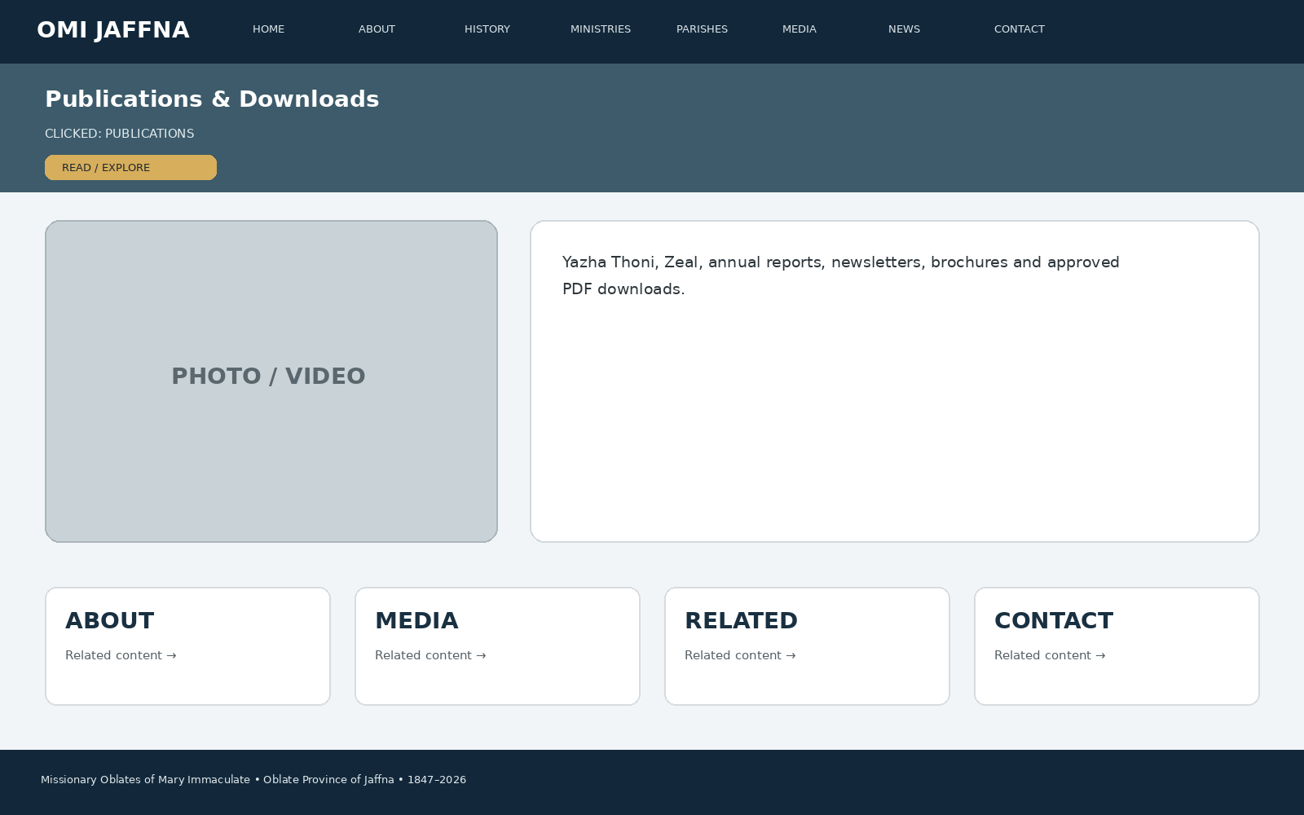
Developer instruction: keep the same header/navigation, show the page title immediately, use approved images/media in the main visual area, present the information in clear cards/sections, and connect the page to related ministries, parishes, media, news or contact information.

44. CLICK → NEWS
When the visitor clicks “NEWS”, this page appears: Latest news cards, events calendar, featured story, archive and filters.
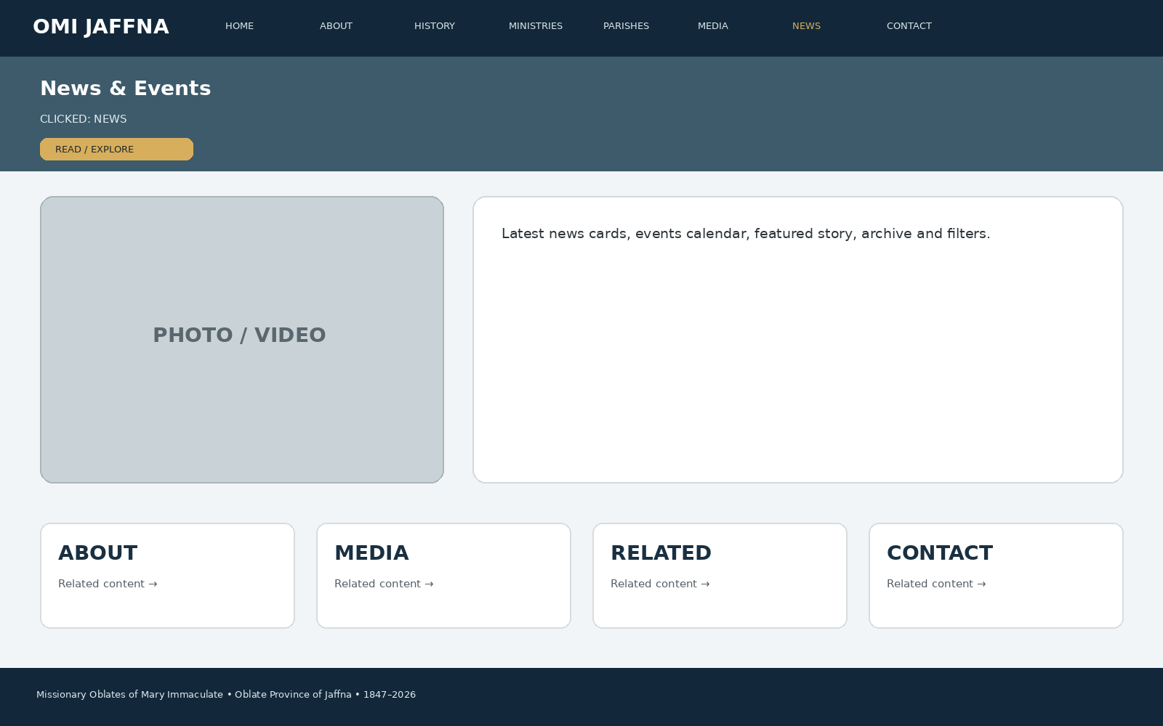
Developer instruction: keep the same header/navigation, show the page title immediately, use approved images/media in the main visual area, present the information in clear cards/sections, and connect the page to related ministries, parishes, media, news or contact information.

45. CLICK → FEASTS & EVENTS
When the visitor clicks “FEASTS & EVENTS”, this page appears: Upcoming feasts/events, date, venue, programme, gallery, video and related parish.
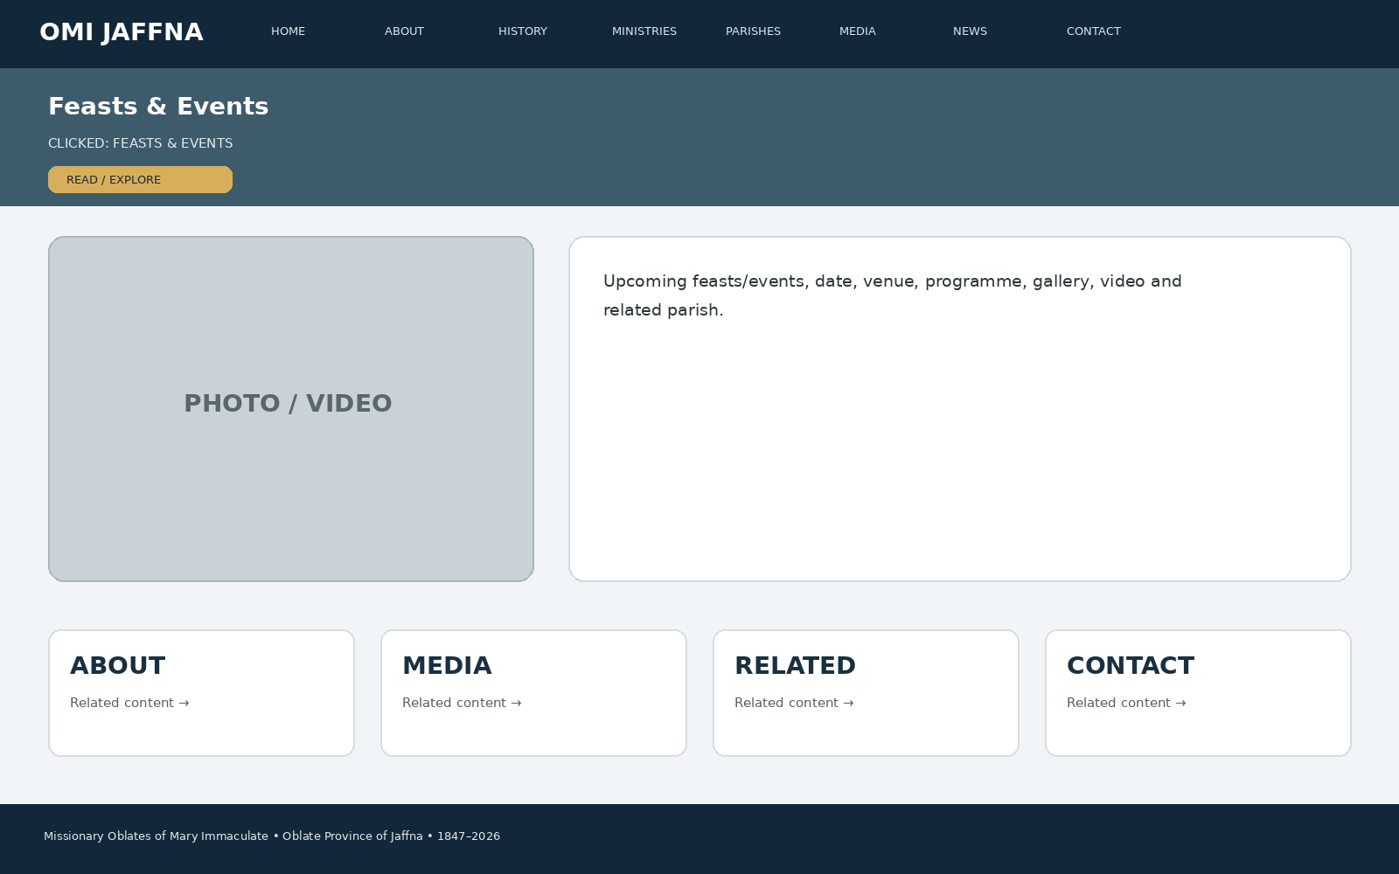
Developer instruction: keep the same header/navigation, show the page title immediately, use approved images/media in the main visual area, present the information in clear cards/sections, and connect the page to related ministries, parishes, media, news or contact information.

46. CLICK → PUBLICATIONS PAGE
When the visitor clicks “PUBLICATIONS PAGE”, this page appears: Publication archive, cover thumbnails, issue/year, description, download/read-online button.
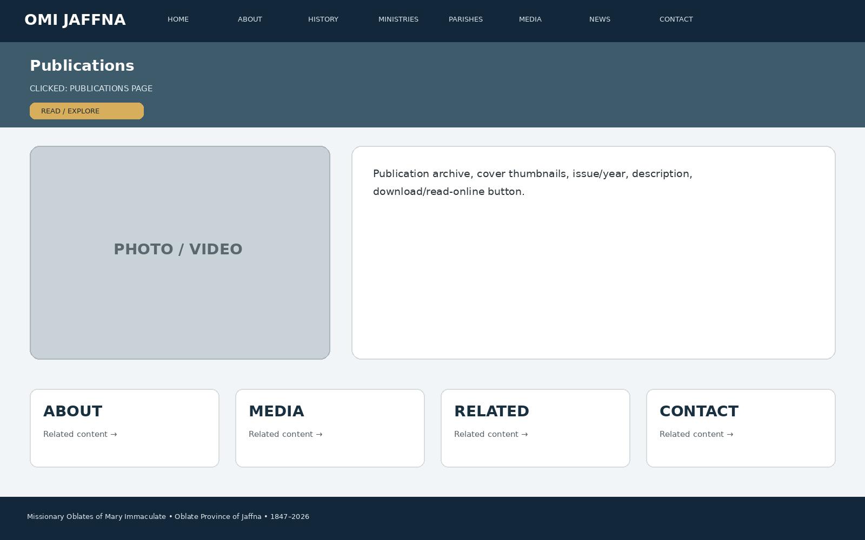
Developer instruction: keep the same header/navigation, show the page title immediately, use approved images/media in the main visual area, present the information in clear cards/sections, and connect the page to related ministries, parishes, media, news or contact information.

47. CLICK → LEADERSHIP
When the visitor clicks “LEADERSHIP”, this page appears: Present Provincial, Provincial Council, Bursar, formation/mission leadership and former Provincials.
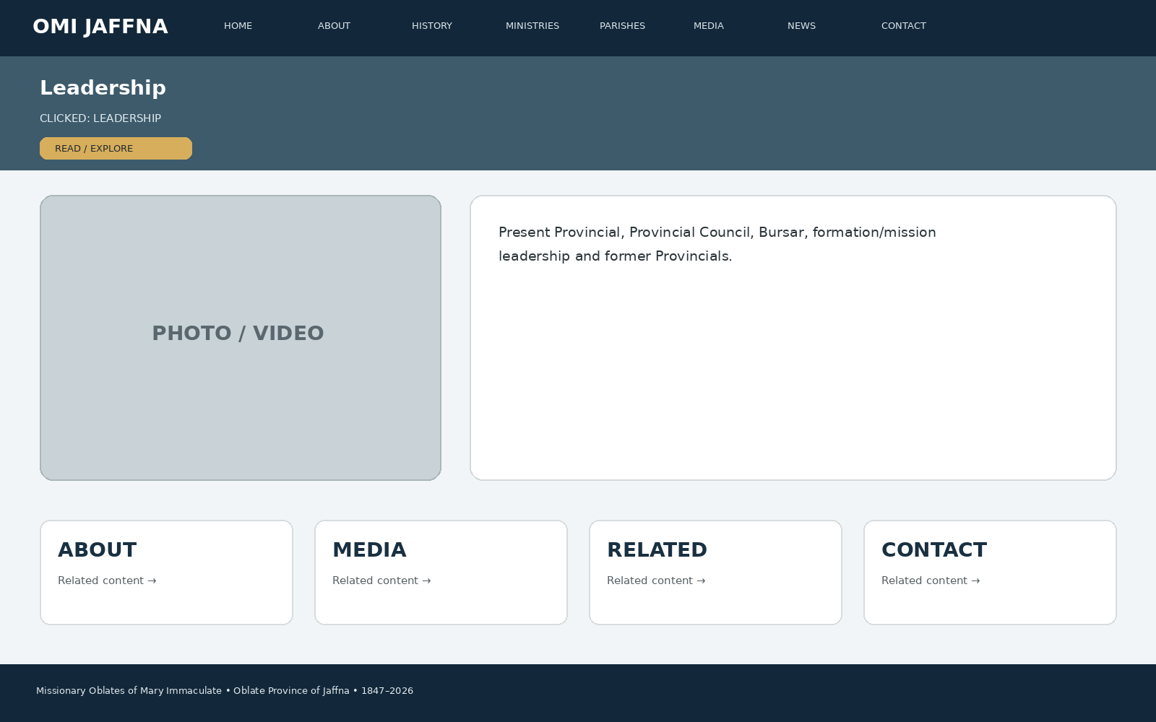
Developer instruction: keep the same header/navigation, show the page title immediately, use approved images/media in the main visual area, present the information in clear cards/sections, and connect the page to related ministries, parishes, media, news or contact information.

48. CLICK → PROVINCIAL SUPERIOR
When the visitor clicks “PROVINCIAL SUPERIOR”, this page appears: Fr. Jeyanthan Pachchek, OMI, 2023–2026; profile, message, photo and official Province contact route.
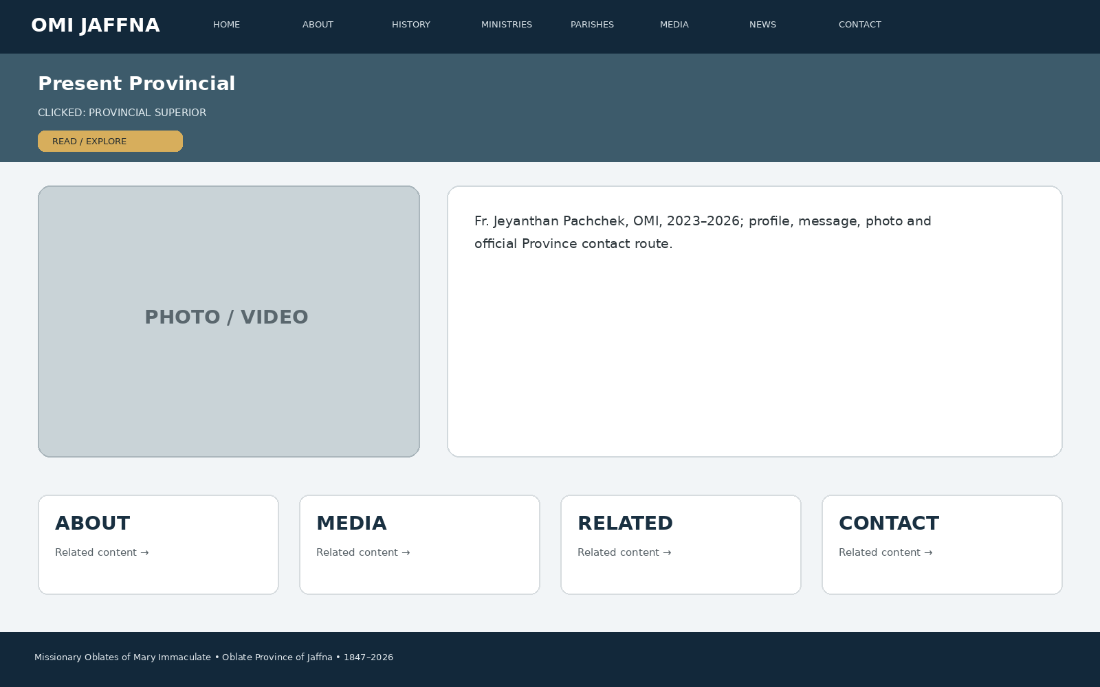
Developer instruction: keep the same header/navigation, show the page title immediately, use approved images/media in the main visual area, present the information in clear cards/sections, and connect the page to related ministries, parishes, media, news or contact information.

49. CLICK → PROVINCIAL COUNCIL
When the visitor clicks “PROVINCIAL COUNCIL”, this page appears: Council member cards, responsibilities/roles where approved, profile photos and related leadership information.
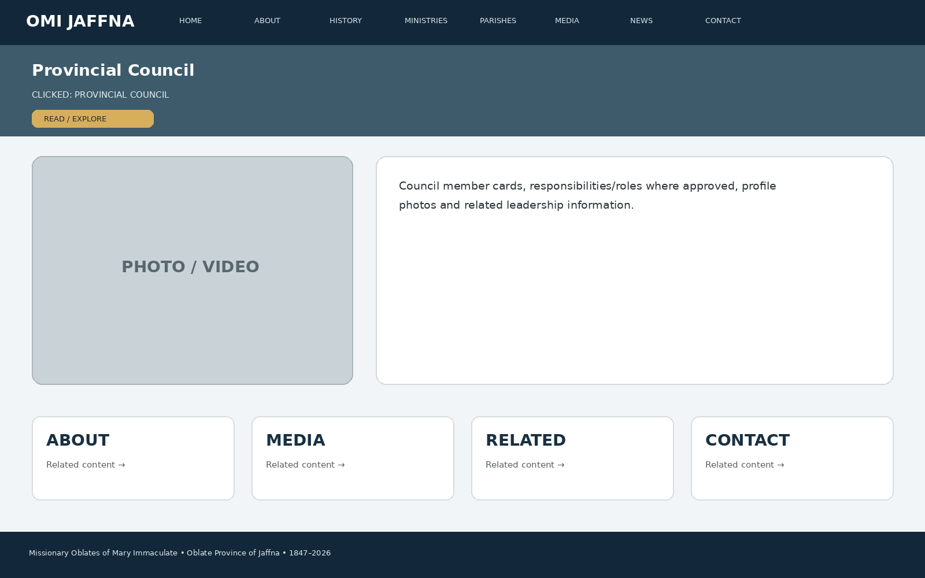
Developer instruction: keep the same header/navigation, show the page title immediately, use approved images/media in the main visual area, present the information in clear cards/sections, and connect the page to related ministries, parishes, media, news or contact information.

50. CLICK → FORMER PROVINCIALS
When the visitor clicks “FORMER PROVINCIALS”, this page appears: Chronological list, tenure and approved historical notes; disputed dates to be verified before publication.
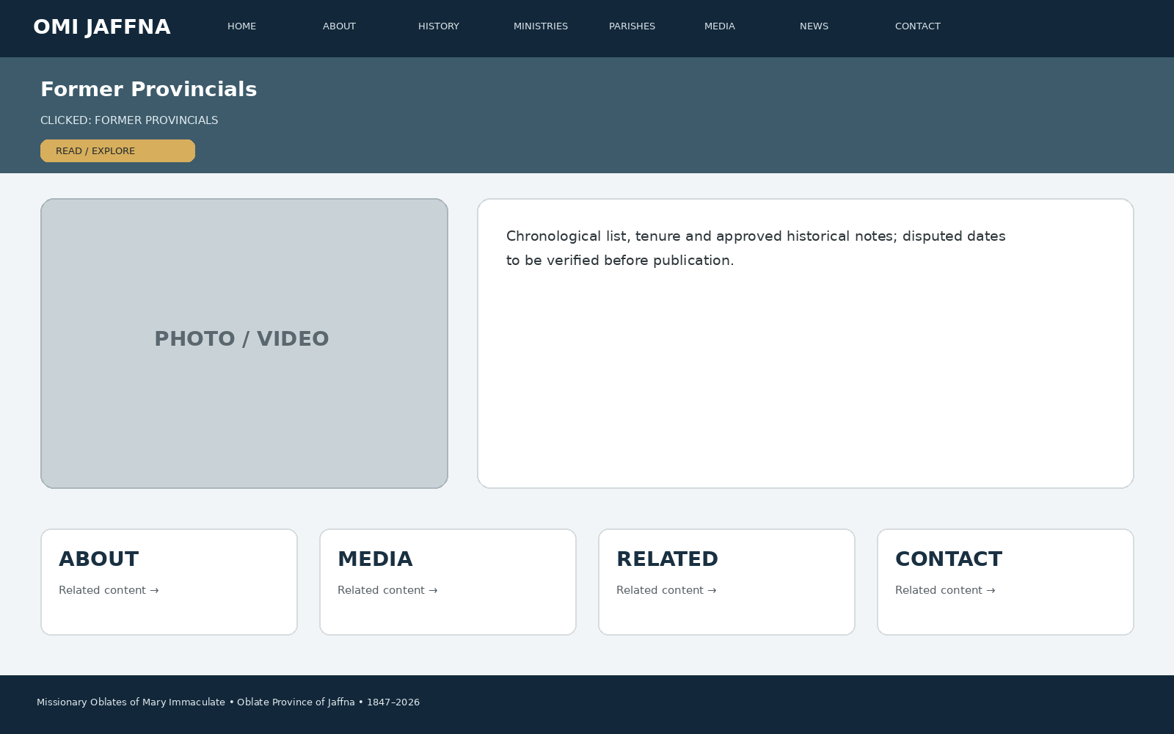
Developer instruction: keep the same header/navigation, show the page title immediately, use approved images/media in the main visual area, present the information in clear cards/sections, and connect the page to related ministries, parishes, media, news or contact information.

51. CLICK → PARISHES
When the visitor clicks “PARISHES”, this page appears: Interactive parish directory: Maniyam Thoddam, Kanakarayankulam, Hapurugala, St Jude Pasara, Muthur, Anthoniyarpuram, Akkarayan, Thachanamadhu, Anninganda, Kokkulai, Thirukovil and Sambalthevu.
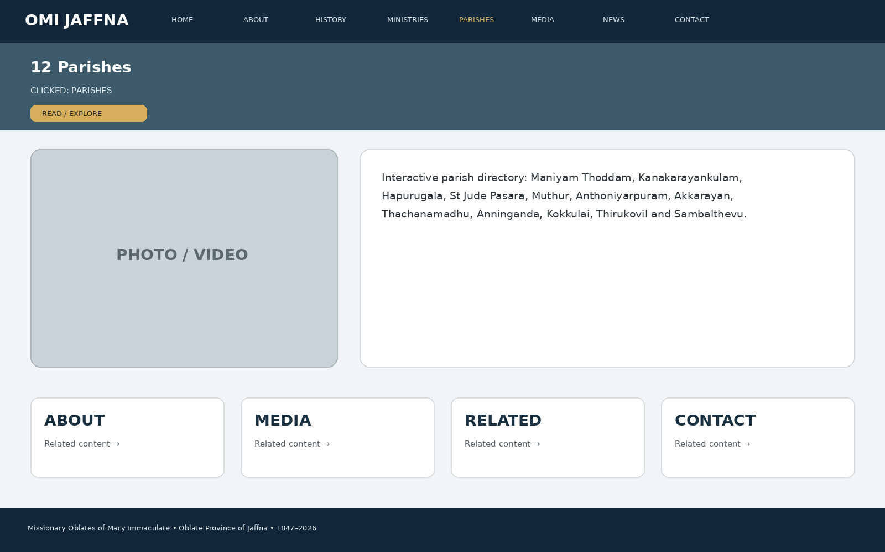
Developer instruction: keep the same header/navigation, show the page title immediately, use approved images/media in the main visual area, present the information in clear cards/sections, and connect the page to related ministries, parishes, media, news or contact information.

52. CLICK → PARISH DETAIL
When the visitor clicks “PARISH DETAIL”, this page appears: Parish hero photo, history, Mass/sacrament information, ministries, location/map, approved contact, gallery, videos and latest events.
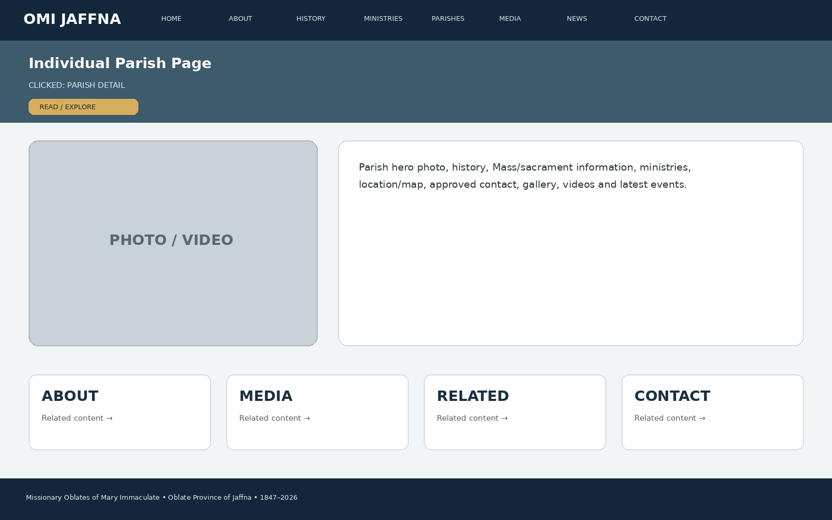
Developer instruction: keep the same header/navigation, show the page title immediately, use approved images/media in the main visual area, present the information in clear cards/sections, and connect the page to related ministries, parishes, media, news or contact information.

53. CLICK → SCHOOLS
When the visitor clicks “SCHOOLS”, this page appears: St Patrick's College, St Anthony's Maha Vidyalayam Muthur, Patima School Mannar, Kalmunai Carmel Fatima College, Fatima Maha Vidyalayam Iranapalai, St Anthony's Vidyalayam Colombo, Kokkulai Sigala Vidyalayam.
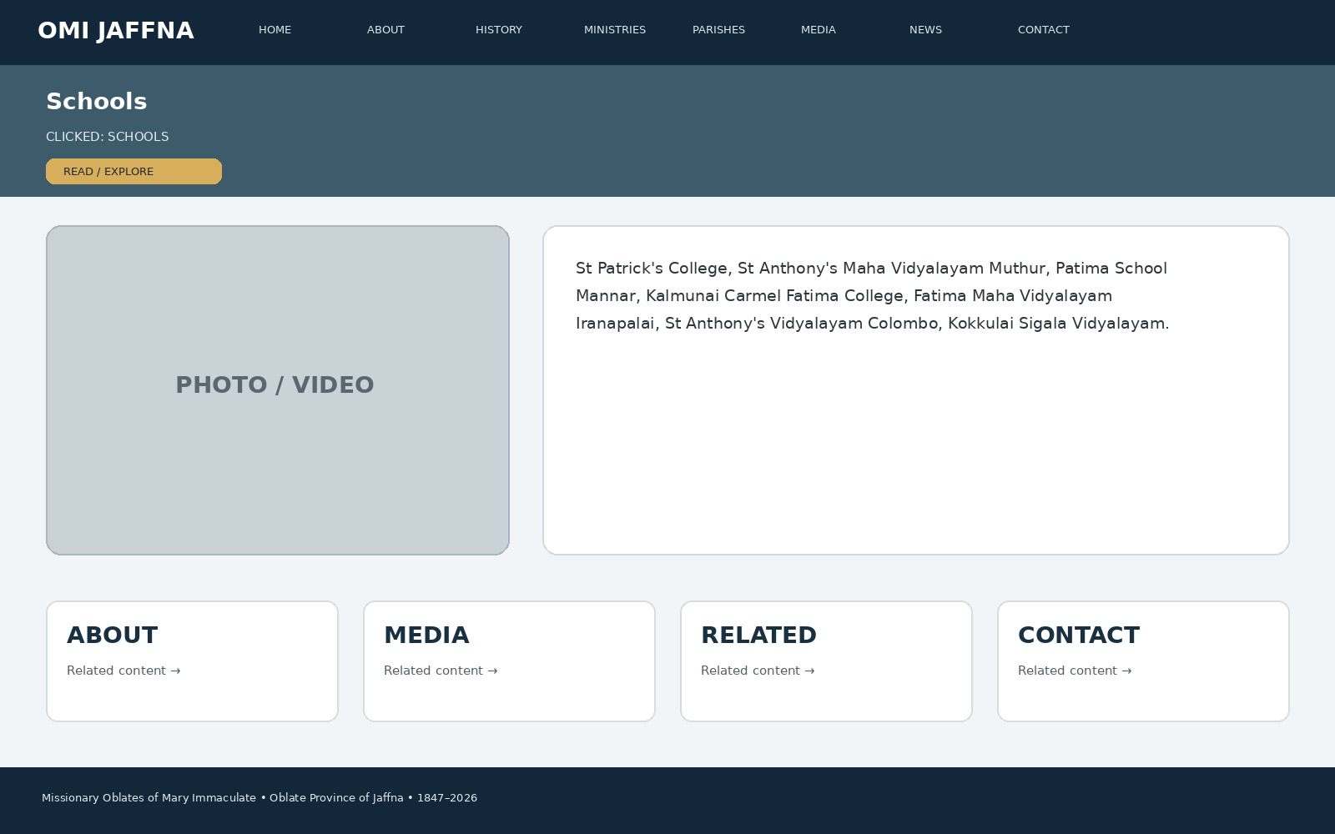
Developer instruction: keep the same header/navigation, show the page title immediately, use approved images/media in the main visual area, present the information in clear cards/sections, and connect the page to related ministries, parishes, media, news or contact information.

54. CLICK → FORMATION & VOCATIONS
When the visitor clicks “FORMATION & VOCATIONS”, this page appears: Formation houses, stages, vocation story, FAQs, prayer, enquiry/contact and media stories.
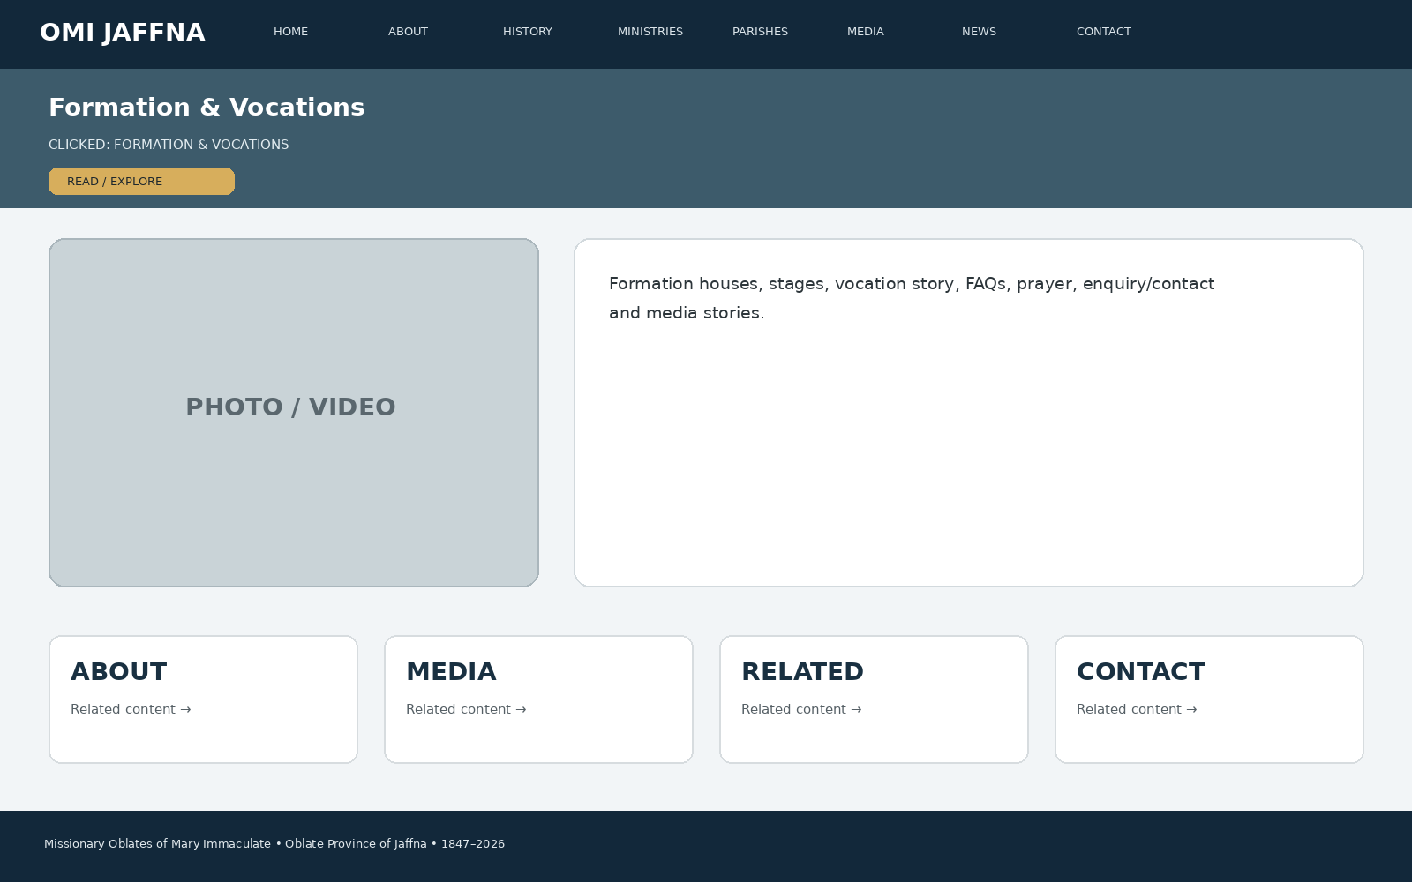
Developer instruction: keep the same header/navigation, show the page title immediately, use approved images/media in the main visual area, present the information in clear cards/sections, and connect the page to related ministries, parishes, media, news or contact information.

55. CLICK → MAP
When the visitor clicks “MAP”, this page appears: Sri Lanka map, location pins, parish/house/ministry filters, directions and accessible list view.
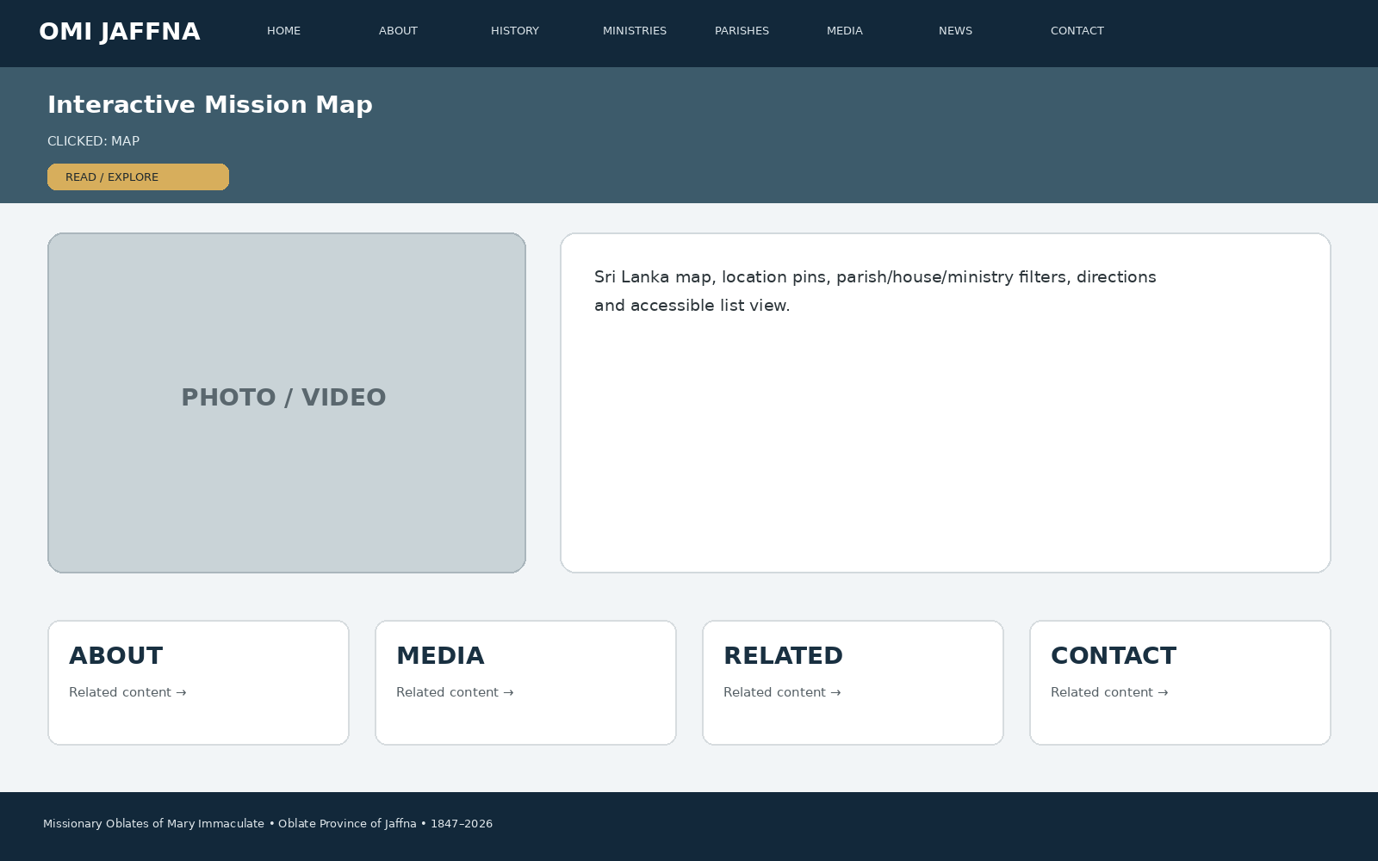
Developer instruction: keep the same header/navigation, show the page title immediately, use approved images/media in the main visual area, present the information in clear cards/sections, and connect the page to related ministries, parishes, media, news or contact information.

56. CLICK → CONTACT DIRECTORY
When the visitor clicks “CONTACT DIRECTORY”, this page appears: One unified Oblate directory with name, phone number and email only; no district division and no priests' addresses.
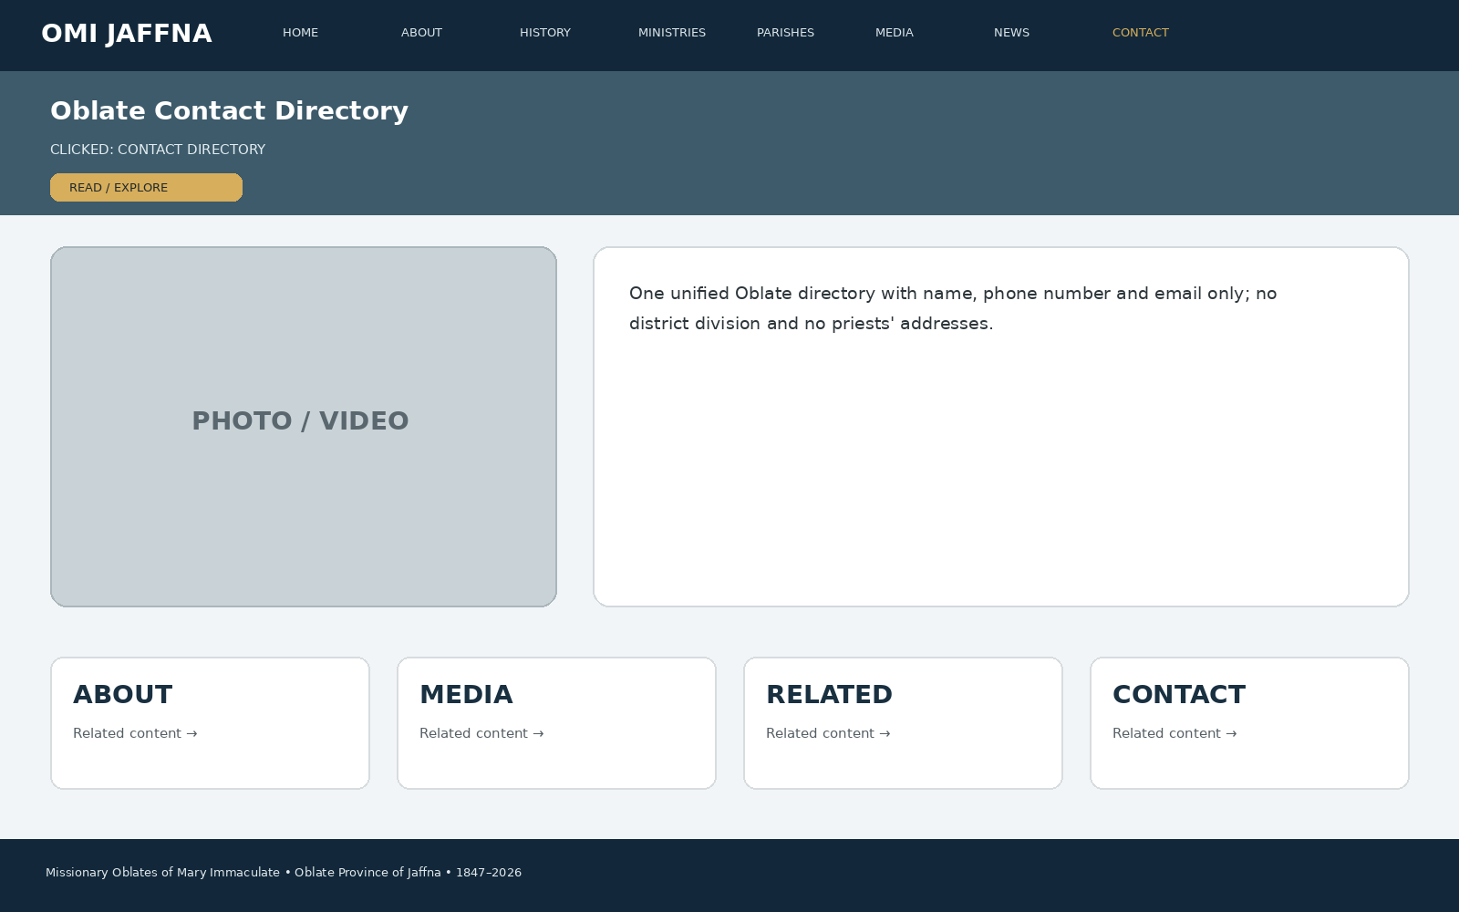
Developer instruction: keep the same header/navigation, show the page title immediately, use approved images/media in the main visual area, present the information in clear cards/sections, and connect the page to related ministries, parishes, media, news or contact information.

57. CLICK → CONTACT
When the visitor clicks “CONTACT”, this page appears: Provincial House contact, general email, phone, directions, enquiry forms and social links.
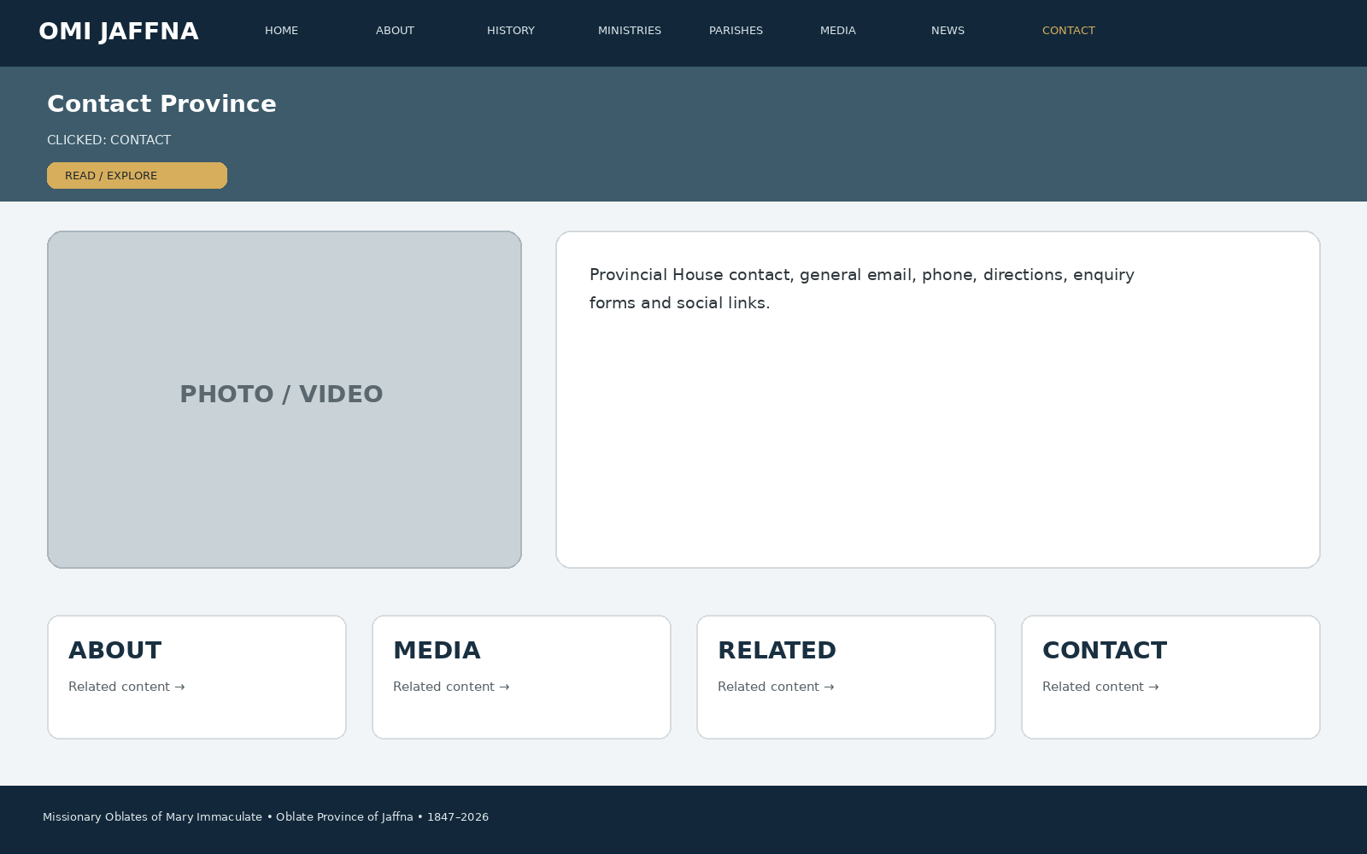
Developer instruction: keep the same header/navigation, show the page title immediately, use approved images/media in the main visual area, present the information in clear cards/sections, and connect the page to related ministries, parishes, media, news or contact information.

58. CLICK → SEARCH
When the visitor clicks “SEARCH”, this page appears: Search bar across history, ministries, parishes, people, media, news, events and publications.
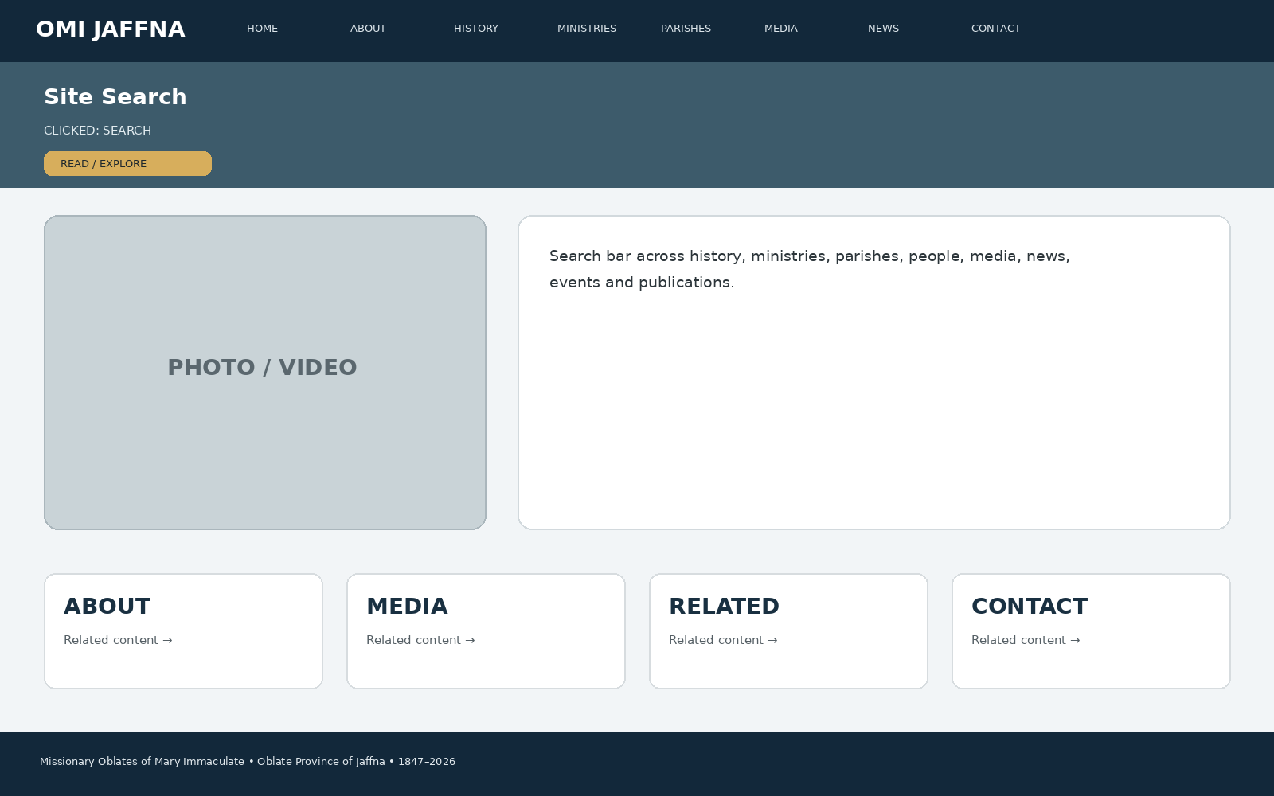
Developer instruction: keep the same header/navigation, show the page title immediately, use approved images/media in the main visual area, present the information in clear cards/sections, and connect the page to related ministries, parishes, media, news or contact information.

59. CLICK → FOOTER
When the visitor clicks “FOOTER”, this page appears: Province identity, quick links, contact, social links, privacy/safeguarding, copyright and website navigation.
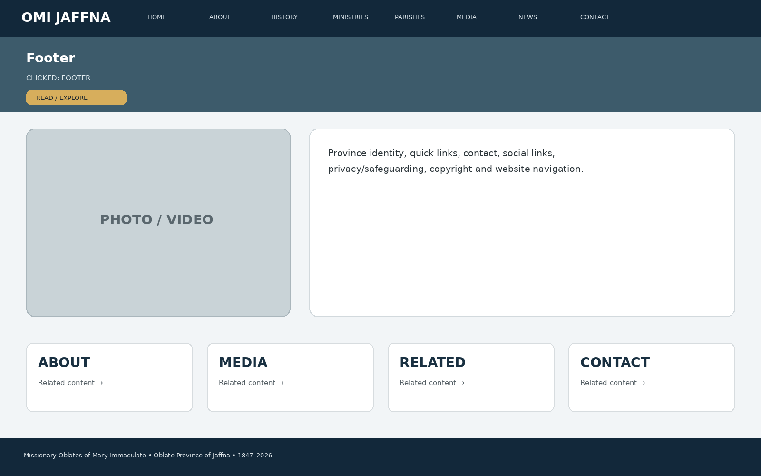
Developer instruction: keep the same header/navigation, show the page title immediately, use approved images/media in the main visual area, present the information in clear cards/sections, and connect the page to related ministries, parishes, media, news or contact information.

MEDIA HUB — CLICK FLOW
The Media Hub is not only a gallery. Every media type opens its own content experience and connects back to the relevant ministry, parish, event or person.

Photos
Media → Photos → Album → Fullscreen Photo → Caption/Date/Credit → Related Parish/Ministry

Videos
Media → Videos → Category → Video Player → Description → Related Ministry/Parish → More Videos

Podcasts
Media → Podcasts → Episode → Audio Player → Speaker → Transcript/Description → Related Article

Articles
Media → Articles → Article → Hero Image → Full Story → Related Photos/Video/Podcast

Interviews
Media → Interviews → Person → Video/Audio → Biography/Role → Related Mission Area

Homilies & Reflections
Media → Homilies → Speaker/Date → Player → Reflection Text → Related Liturgical/Spiritual Content

Testimonials
Media → Testimonials → Person/Community Story → Photo/Video → Mission/Ministry Connection

Publications
Media → Publications → Year/Issue → Cover → Read Online / Download → Related Articles

