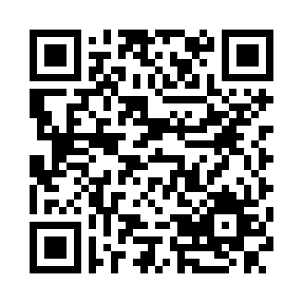 9741728991

http://github.com/sivasharma23

sivacando23@gmail.com

SIVA SHARMA A

|  |  |
| --- | --- |
| Objective | To get a job in the IT industry where my skills are utilized fully and can be developed further and also helping to peoples by using my skills and technology. |
| Education | 2017 Bachelor of Computer Science,  Sacred Heart College, Tirupattur.  **Percentage:60%**  2013 HSC, Government Higher Secondary school, Mittur.  **Percentage: 70%**  2011SSLC, Government Higher Secondary school, Mittur.  **Percentage: 75 %** |
| Skills & Abilities | * **Programming Languages & Technologies: Ethical hacking** PYTHON, C, HTML, CSS, PHP * **IDE:** Netbeans. * **Version Control System:** GitHub |
| EXTRA CURRICULARACTIVITIES | * Part of DEEDS program which helped to share my knowledge with other students. * Organized state level IT MEET in sacred Heart College, Tirupattur***.*** . * Member of ROTARACT club. |
| Interested Domains | * HACKING * Web development * Hardwares and software |
| Personal strengths | * Self-learning * Flexibility * Analytical thinking |
| PROFESSIONAL TRAITSpersonal informations | * Ability to deal with people dramatically. * Smart working * Adaptable to any environment * Discipline & good etiquette * **Father Name** : Mr.J.Anbalagan * **Date of Birth** : 23-06-1995 * **Gender**  : Male * **Marital Status** : Single * **Nationality**  : Indian * **Languages Known** : Tamil & English * **Hobbies**  : Playing indoor and outdoor games, Reading, Listening songs * **Address** : Madrahalli-post, Bargur-tk, Krishnagiri-dt   pin-635203 |
|  |  |

Declaration:

I hereby declare that all of the above stated information is true to my best of knowledge.

Date:

Place: Mathur

[Suresh M]