A picture containing clipart

Description generated with very high confidence

KUBERNETES MODULE 3

Hands-on: 2

[**support@intellipaat.com**](mailto:support@intellipaat.com)

**+91-7022374614**

**US: 1-800-216-8930(Toll Free)**

**Creating a Replication controller**

**Operation 1:** Write a yaml file for the replication controller that you are creating

apiVersion: v1

kind: ReplicationController

metadata:

name: nginx

spec:

replicas: 3

selector:

app: nginx

template:

metadata:

name: nginx

labels:

app: nginx

spec:

containers:

- name: nginx

image: nginx

ports:

- containerPort: 80

**Operation 2:** Go to command line and create a yaml file and paste the above created specs.

**$ nano <file_name>.yaml**

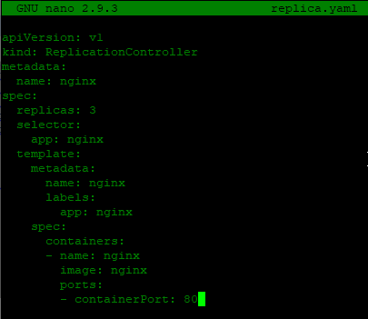

Once done hit Ctrl+s and then Ctrl+x to exit

**Operation 3:** next thing to do is create the pod yaml file.

**$ kubectl create -f <file_name>.yaml**



**Operation 4:** to check if replicas has been made run the following command

**$ kubectl get pods**

