SIMATS ENGINEERING (SAVEETHA SCHOOL OF ENGINEERING)

Department of Computer Science & Engineering ASSESSMENT TOOL 1 – APPLICATION BASED QUESTIONS

Course Code | CSA4315 | Course Title | INTERNET PROGRAMMING
CO Assessed | CO1 | Assessment | Assessment Tool 1: Application Based Questions
Weightage | 40% of CIA | Total Marks | 100
CO1  Statement | Explain the fundamentals of web architecture, client-server communication, Internet protocols, HTTP request and response messages, and configure LAMP/WAMP environments for web application development and deployment. (BL3)
Student Name | B SIVA SHIRISH | Reg. No. | 192324016
Section/Batch | Slot D / AI&DS | Date | 22-10-2026
Code of Conduct:
I AM B SIVA SHIRISH, certify that this submission is my original work and that I have adhered to the guidelines specified for this assessment. I understand that any violation of academic integrity rules will result in disciplinary action.

Signature of the student: 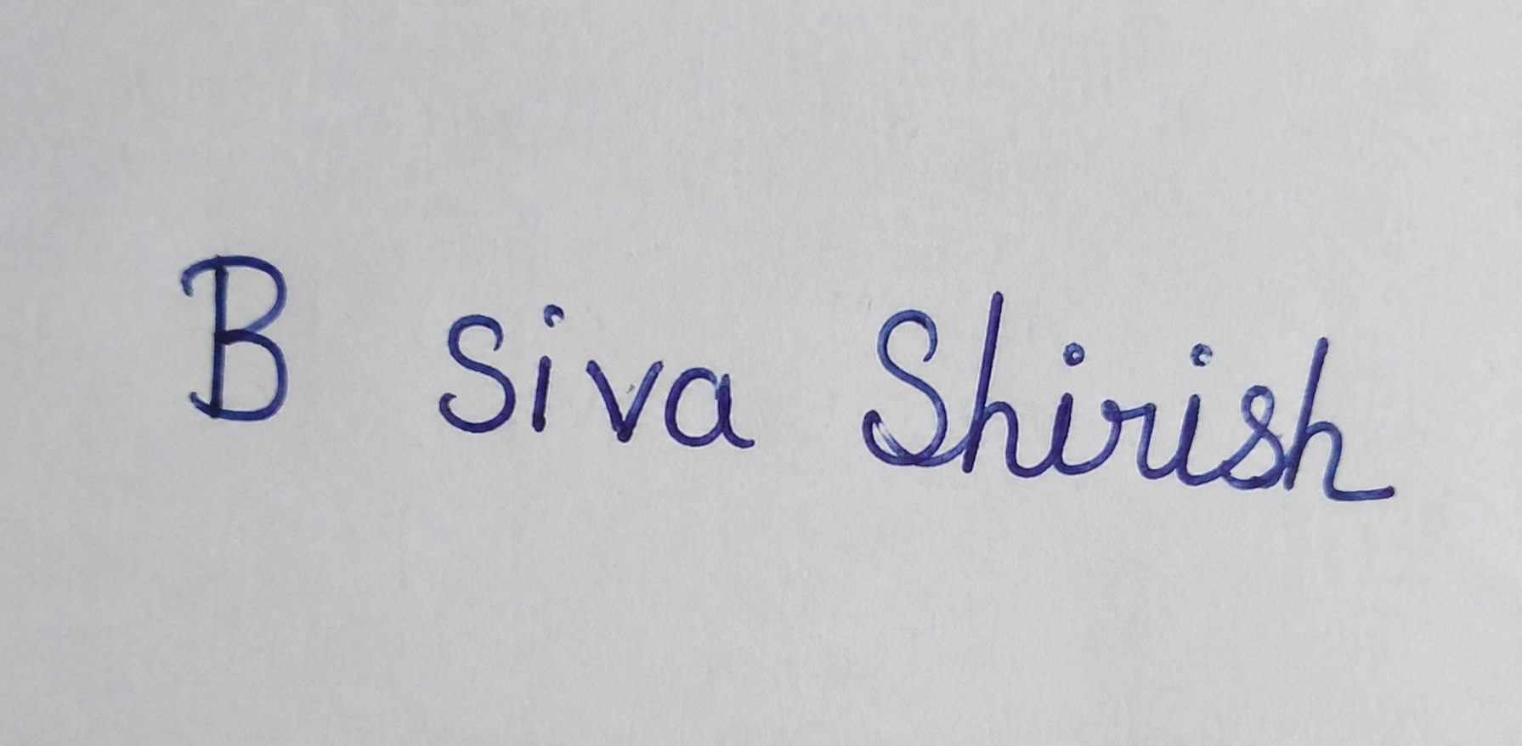

A web server returns HTTP status code 404 Not Found when a user opens a webpage. Explain the meaning of this response and suggest methods to resolve the problem.

The HTTP 404 Not Found Response: Meaning and Resolution
What the status code tells us, why it happens, and how it can be fixed

Introduction
When a user opens a webpage, the browser sends an HTTP request and the web server sends back an HTTP response. The first line of every response carries a three digit status code that tells the browser whether the request worked. The code 404 Not Found is the most familiar failure code on the web: the user asked for a page and the server could not find it. This answer explains what that response means, shows what it looks like on the wire, lists the usual causes and then describes practical methods to resolve the problem, both for the visitor and for the person who runs the server.
The answer uses one running example. A student opens http://portal.example.edu/courses/python.php and gets an error page. The server is assumed to be a LAMP stack (Linux, Apache, MySQL, PHP) as used in this course.

Client-Server Communication and Status Codes
The web follows the client-server model. The client (the browser) sends a request and the server (Apache with PHP) returns one response. HTTP is an application layer protocol that runs over TCP, and over TLS when the address starts with https. HTTP is stateless, so each response must say by itself how the request turned out. It does this with the status line, for example HTTP/1.1 404 Not Found, which holds the protocol version, the numeric code and a short reason phrase.
Status codes are grouped into five classes by their first digit, as Figure 1 shows. The 4xx class means the client made a request the server cannot fulfil, such as a wrong address or missing permission. The 5xx class means the server itself failed. This difference is important in troubleshooting, because a 404 points to the address being requested, not to a crashed server.
1xx
2xx
3xx
5xx

404 belongs to the 4xx class: the request could not be fulfilled because of the address asked for
4xx
Client error 404 Not Found
Server error 500, 503
Redirection 301, 302
Success 200 OK
Informational 100 Continue
Figure 1: The five classes of HTTP status codes, with 404 in the client error class

Meaning of the 404 Not Found Response
A 404 response means that the server was reached and is working, but it has no resource at the requested URL. The server understood the request, looked for the page and found nothing there. RFC 9110 defines it as a client error: the origin server did not find a current representation for the target resource, or is not willing to say that one exists. It does not say whether the page is missing for a moment or for good.
Figure 2 follows the example. The browser sends a GET request for /courses/python.php. Apache maps that path to a file inside its DocumentRoot, finds that the file does not exist and replies with the 404 status line and a small HTML error page.

- GET /courses/python.php HTTP/1.1 (Host: portal.example.edu)

- Maps URL to a file under DocumentRoot
- No such file or route: lookup fails

- HTTP/1.1 404 Not Found (+ HTML error page)

- Browser shows 'Not Found' page (the connection itself worked fine)
Web server (Apache)
Browser (client)

Figure 2: Request and response exchange that ends in a 404 Not Found
Server was reached and answered:
the problem is the address, not the network

The request sent by the browser:
GET /courses/python.php HTTP/1.1 Host: portal.example.edu
Accept: text/html
User-Agent: Mozilla/5.0
The response returned by the server:
HTTP/1.1 404 Not Found
Date: Thu, 22 Oct 2026 09:30:12 GMT
Server: Apache/2.4.58 (Ubuntu)
Content-Type: text/html; charset=iso-8859-1 Content-Length: 196

<h1>Not Found</h1>
<p>The requested URL was not found on this server.</p>
Three points follow from this exchange. First, the network and the server are fine, since a complete HTTP response came back. Second, the failure is attached to one URL, and other pages of the same site may work normally. Third, the status line is what search engines and tools read, so a missing page must really return code 404 and not code 200 with an error message printed in the page (a "soft 404").

How 404 differs from similar codes

Code | Meaning | How it differs from 404
404 Not Found | No resource at this URL (cause unknown or not stated) | The general "page is missing" answer
410 Gone | Resource existed but was removed on purpose and permanently | Stronger than 404; tells crawlers to drop the URL
403 Forbidden | Resource exists but the client may not access it | The server knows the file; access is refused
301 / 302 | Resource has moved to another URL (Location header) | Points to the new address instead of failing
500 Internal Server Error | The server failed while processing a valid request | Server fault such as a PHP error, not a wrong address
Table 1: Comparison of 404 with related status codes

Common Causes of a 404 Error
A 404 appears whenever the path requested and the content stored on the server do not match. Table 2 lists the usual causes together with the example from this answer.

Cause | Example | Side
Mistyped or outdated URL | User types /courses/pyhton.php | Visitor
Page deleted, renamed or moved | python.php renamed to python-intro.php, old links not updated | Server
Broken internal or external link | Menu link or another site still points to the old address | Server / other site
Case sensitivity on Linux | File is Python.php but URL asks for python.php | Both
File in the wrong folder | Uploaded to /var/www/ instead of /var/www/html/courses/ | Server
Wrong rewrite rules or missing .htaccess | Clean URL /courses/python has no mod_rewrite rule | Server
Wrong virtual host or DocumentRoot | Apache serves another folder for portal.example.edu | Server
Deployment or migration error | New site uploaded without all files or the .htaccess file | Server
Table 2: Typical causes of a 404 Not Found response

Methods to Resolve the Problem
Because the cause can lie with the visitor or with the server, the fixes are split into two groups. Figure 3 shows the order in which they are normally tried: the quick visitor checks first and the server checks next.

- Visitor side (quick checks)
1. Check the URL: spelling, case, extension
2. Reload (Ctrl+F5) and clear cache/cookies
3. Go to the home page and use menu or search
4. Report the broken link to the site owner

- Administrator / developer side
1. Read the Apache error.log for the path
2. Confirm the file is
in DocumentRoot, same case
3. Check permissions, vhost and .htaccess rules
4. Restore page, add 301 redirect, custom 404

If the visitor-side checks fail, the cause is on the server side and moves to row B
Figure 3: Troubleshooting workflow for a 404 Not Found response

Methods for the visitor
    - Check the URL. Look for spelling mistakes, extra characters, a wrong extension (.php or .html) and capital letters, since Linux servers treat Python.php and python.php as different files.
    - Reload the page. Use Ctrl+F5 to bypass the cache, and clear cookies or cached files if an old redirect is stored.

    - Go up one level. Remove the last part of the address (for example open /courses/) or start from the home page and use the menu or the site search.
    - Use another source. Try a web archive copy or a search engine result, and report the broken link to the site owner if it came from the site itself.

Methods for the administrator or developer
    - Read the logs. Apache writes the exact missing path to its error log, which is the fastest way to find the cause. The access log also shows how often the URL is requested and from which referring page.
    - Confirm the file exists in the folder that Apache serves, with the same name and letter case.
    - Check permissions and configuration. Files should be readable by the Apache user, the virtual host must point to the right DocumentRoot, and mod_rewrite and .htaccess must be enabled when clean URLs are used.
    - Redirect moved pages. If a page has a new address, send a 301 redirect from the old URL so that old links and bookmarks keep working.
    - Fix or remove broken links inside the site, and update the sitemap so that crawlers do not keep requesting dead URLs.
    - Provide a helpful custom 404 page with a search box and links to the main sections, while still returning the real 404 status code.
Commands and settings used in a LAMP setup:
# 1. Find the missing path in the Apache error log tail -f /var/log/apache2/error.log

# 2. Check the file exists, has correct case and permissions ls -l /var/www/html/courses/
chmod 644 python.php # files readable chmod 755 /var/www/html/courses # folders accessible

# 3. Enable rewrite support, check config, reload sudo a2enmod rewrite
sudo apachectl configtest && sudo systemctl reload apache2
Configuration fixes in the virtual host or .htaccess file:
# Permanent redirect from the old page to the new page Redirect 301 /courses/python.php /courses/python-intro.php

# Custom 404 page
ErrorDocument 404 /errors/404.html

# Clean URLs: send unknown paths to the PHP front controller RewriteEngine On
RewriteCond %{REQUEST_FILENAME} !-f RewriteCond %{REQUEST_FILENAME} !-d RewriteRule ^(.*)$ index.php [L,QSA]
Inside a PHP application, a missing record or route must also set the correct status so that the page is not reported as successful:
<?php
$course = findCourse($_GET['id']); if (!$course) {
http_response_code(404); include 'errors/404.php'; exit;
}
?>
// returns null if not found
// send the real 404 status
// friendly error page

Preventing 404 Errors and Good Practice
- Keep URLs stable. Avoid renaming pages without a redirect, and use lowercase names without spaces.
- Use 301 redirects for permanent moves and 410 for content removed on purpose.
- Test links regularly with a link checker and review the 404 entries in the logs or in Search Console.
- Never return 200 for a missing page. A soft 404 confuses search engines and hides real problems from monitoring.
- Do not reveal internals. A custom error page should not show file paths, server version or stack traces.
- Check after every deployment that all files, the .htaccess file and the virtual host settings were copied correctly.

Conclusion
The HTTP 404 Not Found response means that the server is running and understood the request but has no resource at the requested URL. It belongs to the 4xx client error class, which is why the first things to check are the address, the file name and its letter case, and the server configuration. Visitors can solve most cases by correcting the URL, refreshing the page or navigating from the home page. Administrators solve the rest by reading the Apache error log, placing the file in the right DocumentRoot, fixing permissions and rewrite rules, adding 301 redirects for moved pages and serving a helpful custom page that still returns the true 404 status. Handled this way, a 404 becomes a quick diagnostic message and not a lasting problem for users or for search engine ranking.

Evaluation Rubric

Criteria | Weightage | Level 4 (Exemplary) | Level 3 (Proficient) | Level 2 (Developing) | Level 1 (Beginning) | Marks
HTTP basics and message format | 15 | Clear, correct account of client-server  model, status line and response structure | Mostly correct, minor gaps in HTTP basics | Partly correct, some points missing | Mostly incorrect or very brief
Meaning of 404 explained | 30 | Meaning, status class, raw request and response and comparison with related codes explained with example | Meaning and main points covered, few details missing | Only a short definition, limited explanation | Meaning unclear
Causes and resolution methods | 30 | Detailed, accurate causes with visitor and server side fixes, logs, redirects and configuration | Main causes and fixes covered with some reasons | Few causes or fixes, little explanation | Resolution barely given
Good practice and prevention | 10 | Reasons for 301 vs 410, custom 404 page, soft 404 and monitoring explained | Key points listed with some reasons | Mentioned without explanation | Little or no discussion
Presentation and diagrams | 15 | Well organised, clear language, relevant figures with captions | Organised, few figures or small errors | Average structure, unclear in places | Poorly organised

