Installed ansible on the machine by using epel and yum commands

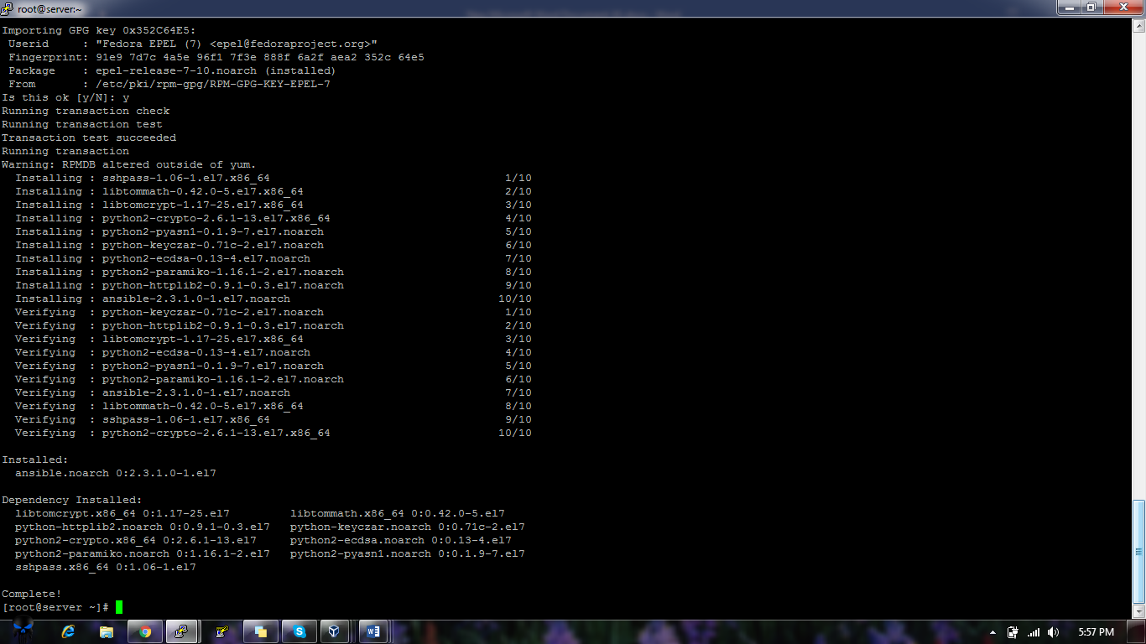

Installed using wget

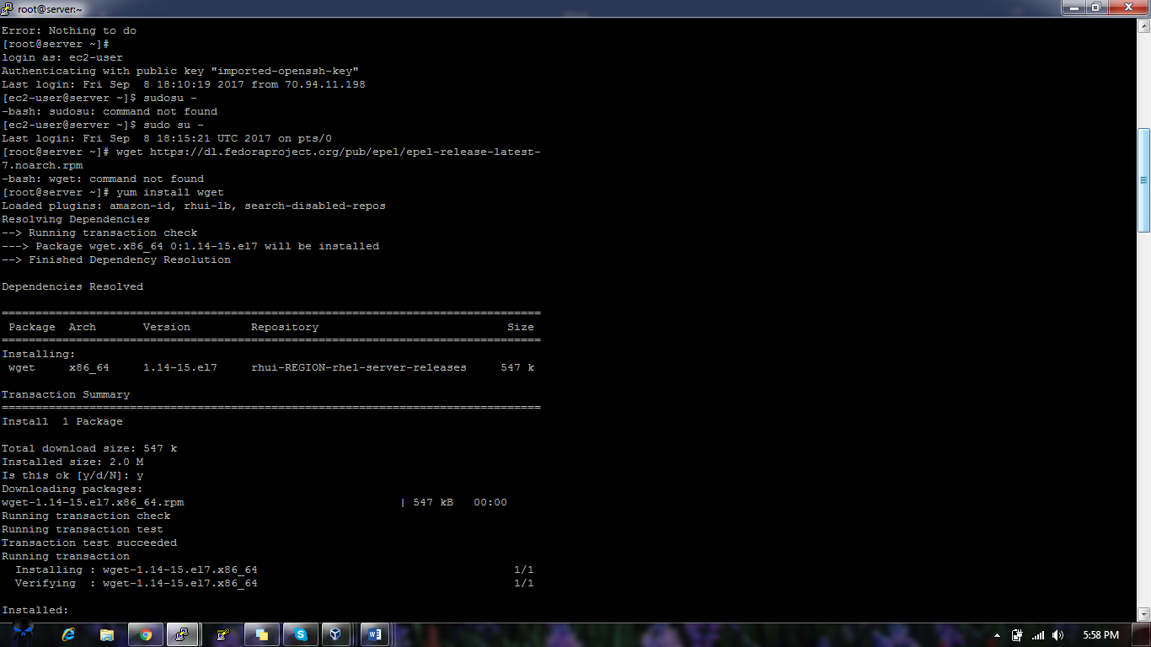

Established the connection between both of the machines by using ssh and by creating public id

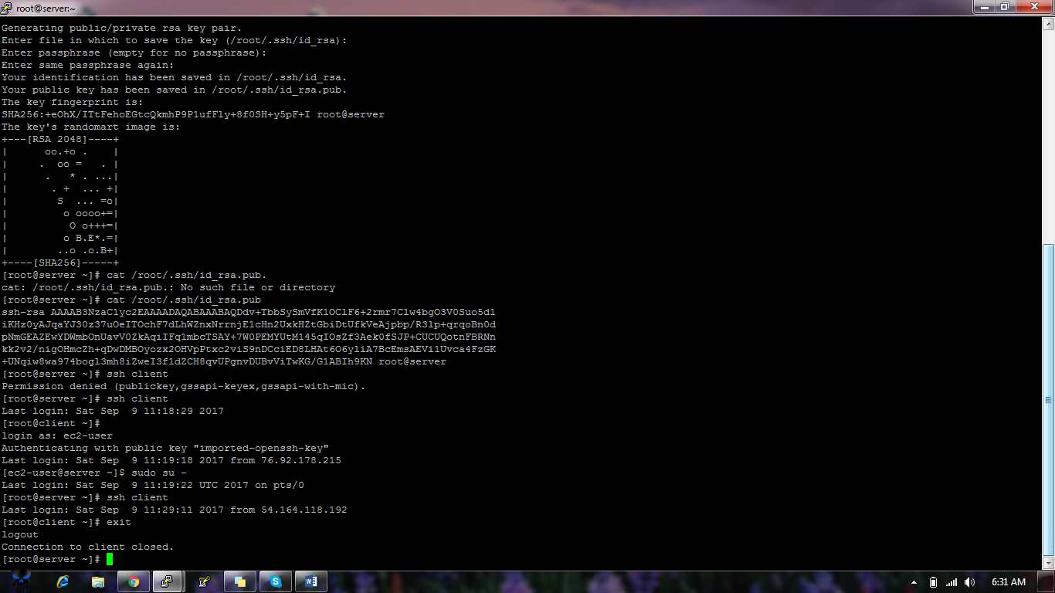

Written a playbook for creating a folder and executed it worked on both the machines

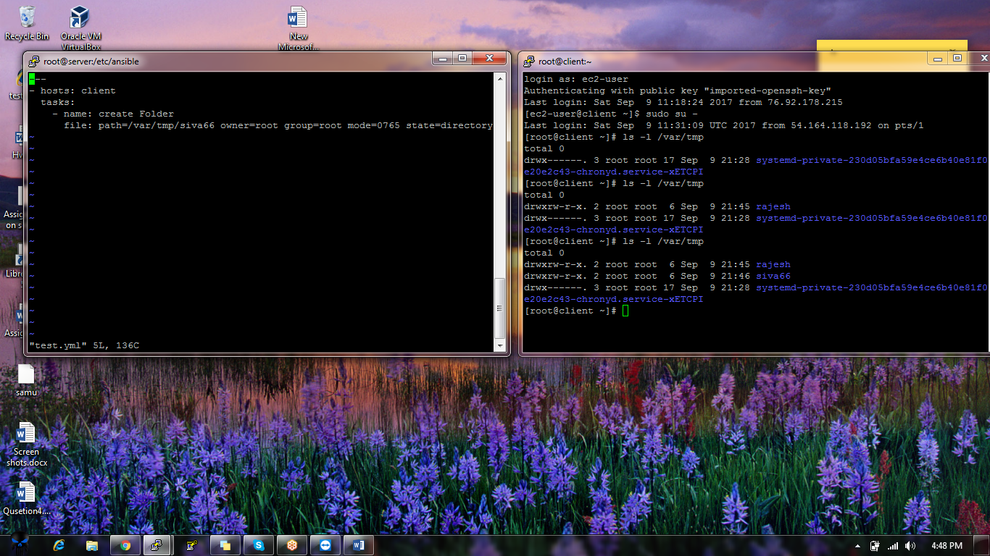

Wriiten a playbook to reboot the machine

