

A Project Report On

**ATM-INTERFACE**

**By**

**Sivasubramanian.T**

**Batch :** 2022 – 7888

**Center : Bangalore - Jayanagar**

Under the Guidance of,

**Chittaranjan Ghosh.**

**Technical -Trainer**

**EduBridge**

(Digital Academy – Certification program in Java Full Stack)

## INTRODUCTION:

The projects while learning a programming language is really fun and exciting. We are going to make a simple ATM machine project using java programming. ATM stands for Automated Teller Machine. It's possible to make a complete functional ATM project and GUI in java. In our simple ATM project, the user can deposit money, withdraw, check account balance, and exit from the ATM program.

**MODULES:**

* **Balance Check Module 🡪** In Balance module , the user can check the bank account balance for the existing account of the user .They can check the balance amount and move further for the next operations.
* **Withdraw Amount Module 🡪** In Withdraw module , the user can withdraw the amount from their bank account through ATM.When the user is having available balance in the account.
* **Deposit Amount Module 🡪** In Deposit module , the user can able to deposit the amount in their account for their needs.

As in the above program, the ATM class is created which contains withdraw(), deposit() and balance() functions. The withdraw() function is used to perform the withdraw operation; this function accepts the balance and the withdrawn amount. Inside the withdraw() function, first check whether the balance is greater than the withdraw amount or not; when it is true, then update the balance by subtracting the withdraw amount from the balance. Next, the function deposit() is used to performs the deposit operation; this function accepts the balance and the deposit amount.

Inside the deposit() function, it updates the balance by adding the deposit amount to the balance. Next, the BalanceEnquiry() function is used to print the balance; it accepts the balance. Then, in the main function, a balance variable of an integer is created. Next, printing the selecting opitons for withdrawing, deposit, balance, and exit operations, depending on the specific option selection the case gets to execute, as we can see in the output.

* **Withdraw:** For withdrawing the funds, gets the withdrawal amount from the user, deduct it from the total balance, and display the message.
* **Deposit:** For depositing the funds, gets the deposit amount from the user to add, add it to the total balance, and display the message.
* **Check the balance:** For checking the balance, display the user’s total balance.
* **Exit:** Return the user to the home page or initial screen by exiting the current Transaction mode.

**SOFTWARE REQUIREMENT:**

**Backend :** MySQL Workbench 8.0 C E , Java 8.0

**Browser :** Google Chrome

**Operating system :** Windows 10

**MySQL :**

* 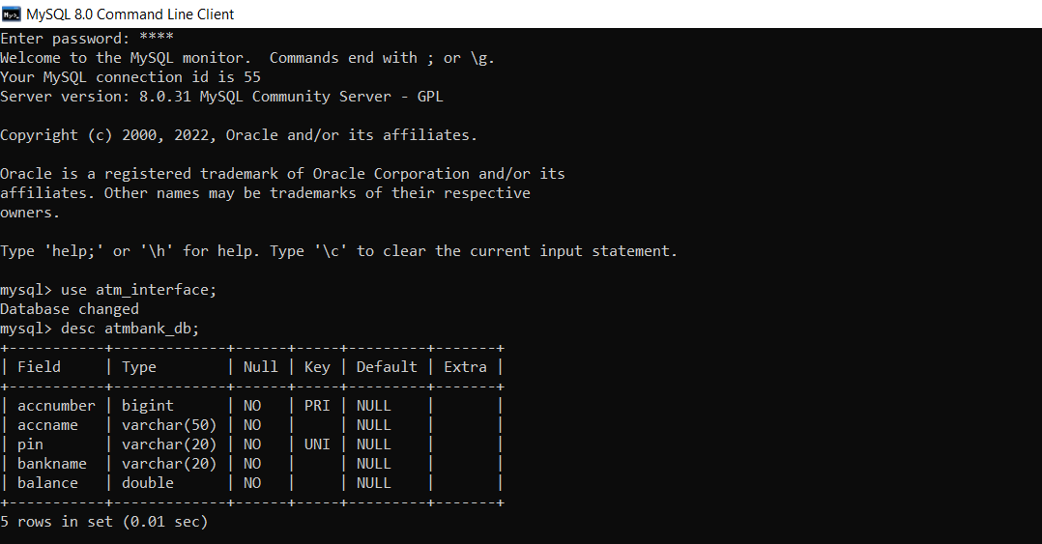Create database atm_interface;

**Module Test Cases :**

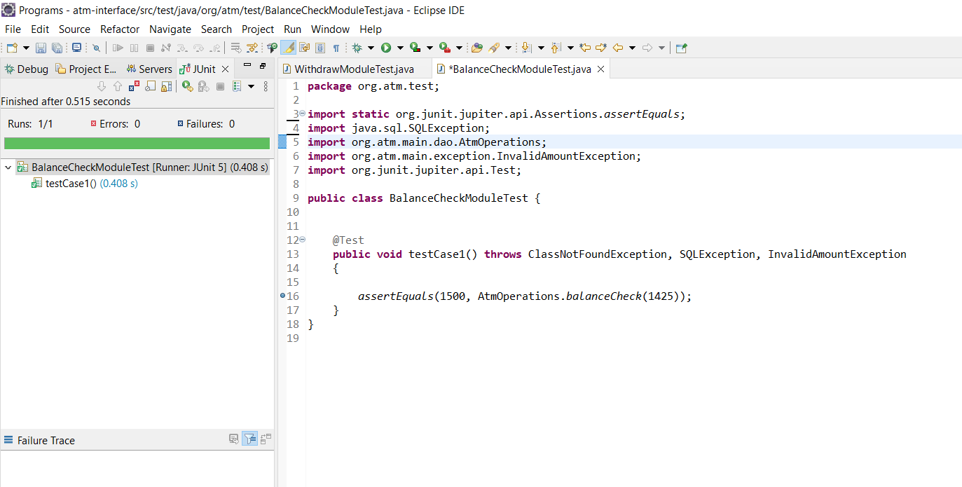**1. Balance Check Module -**

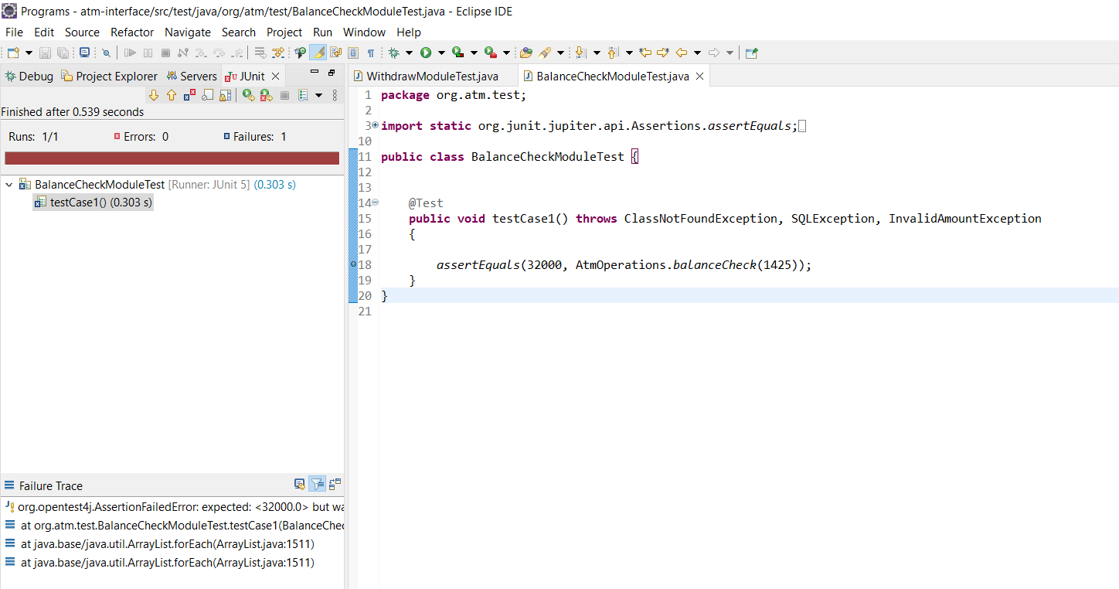

**2.Withdraw Module -**

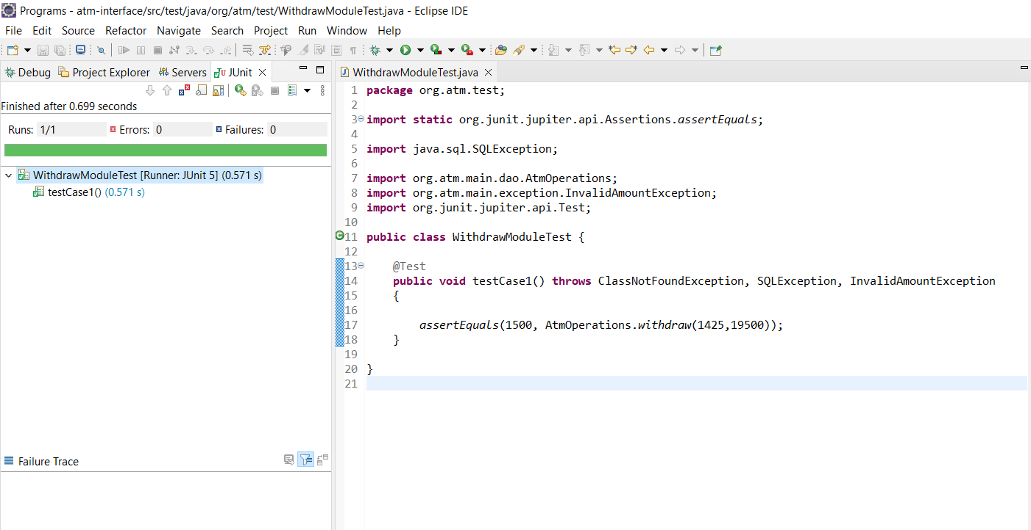

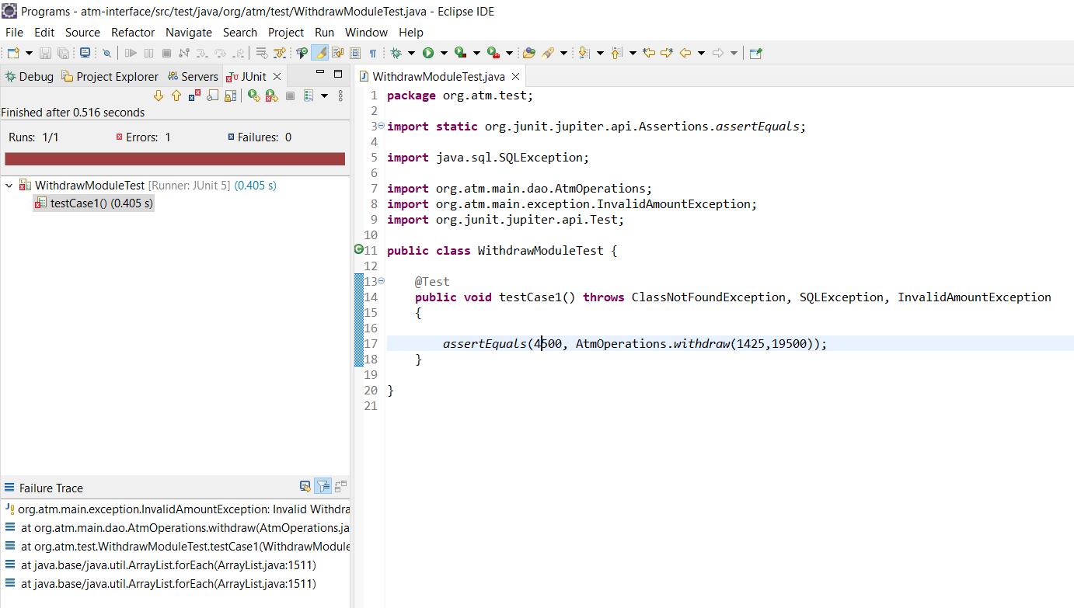

**3.Deposit Module -**

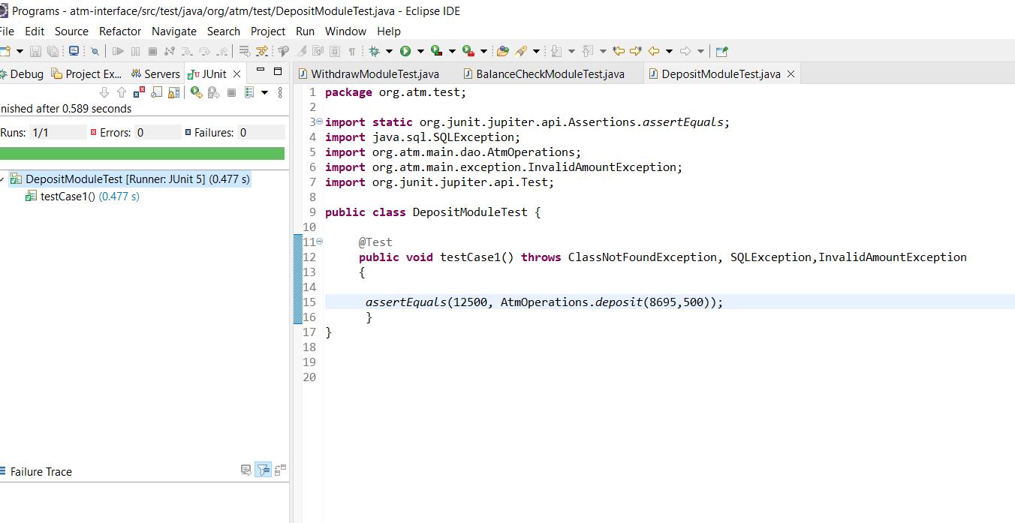

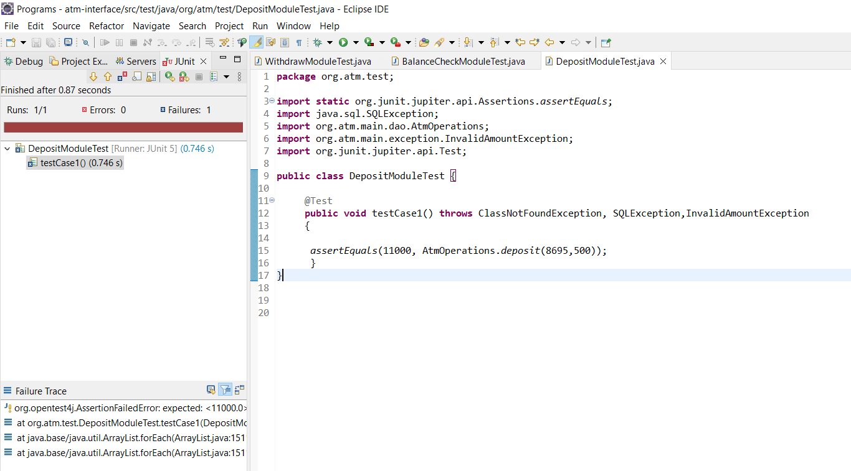

**CONSOLE OUTPUT:**

**Entering ATM:**

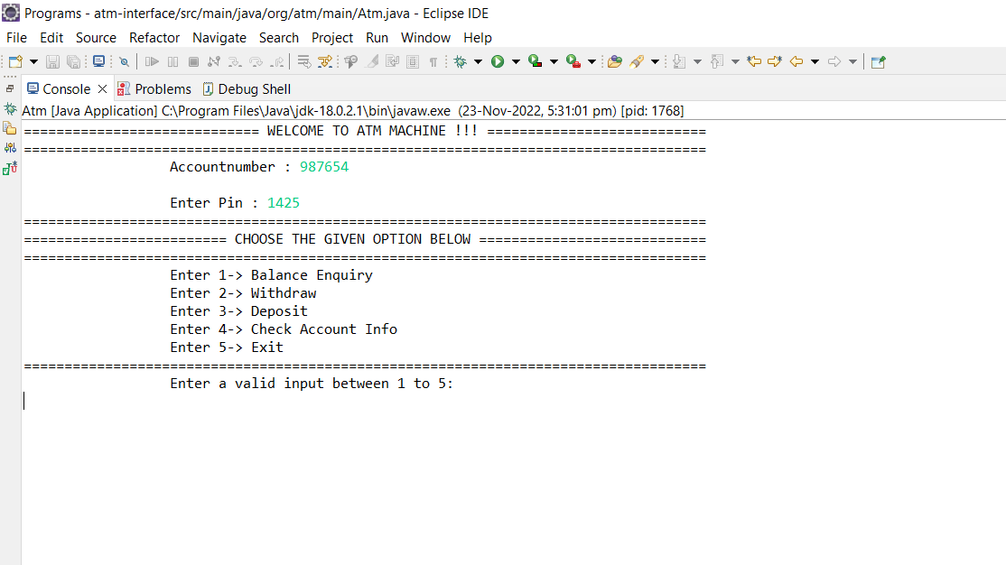

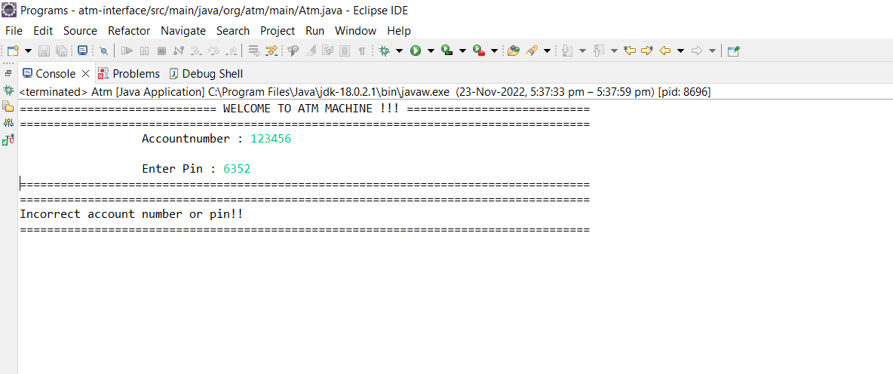

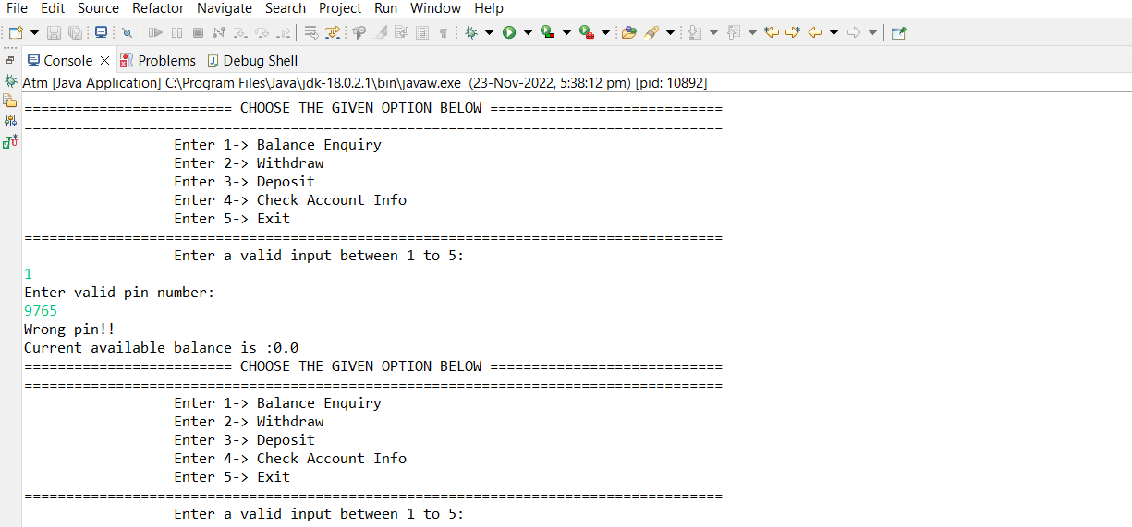

**Balance Enquiry:**

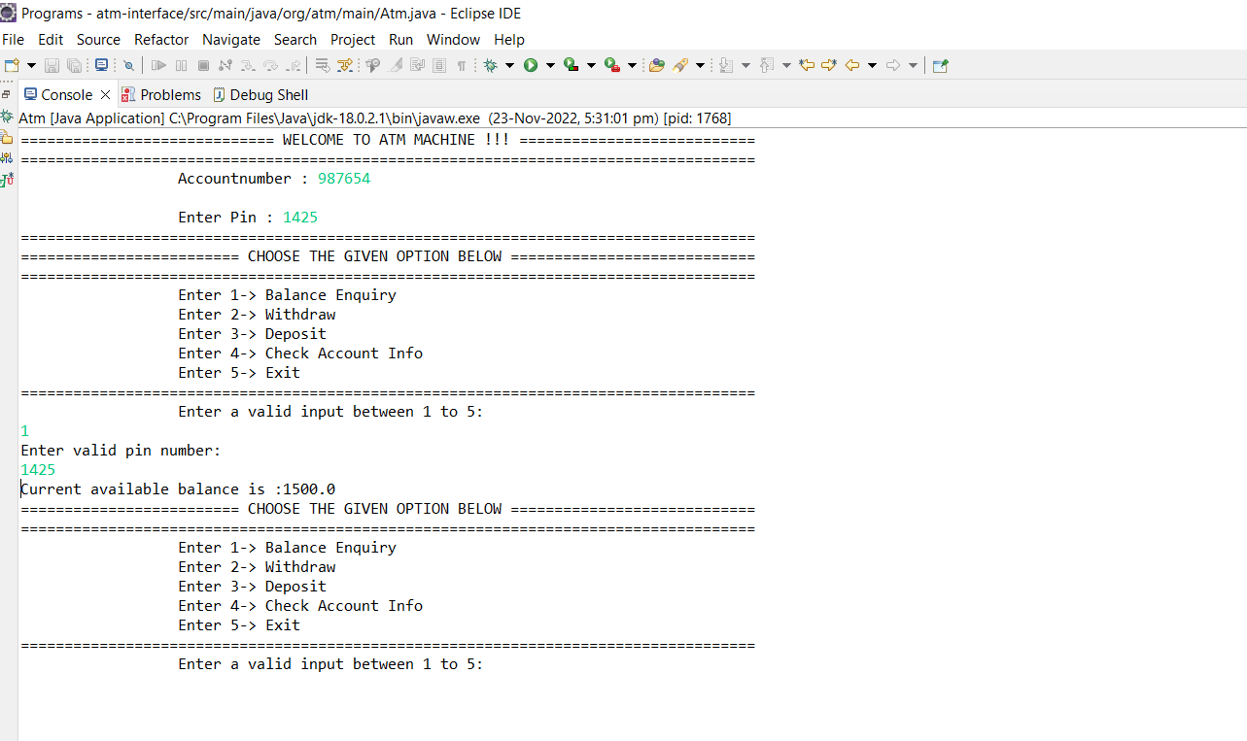

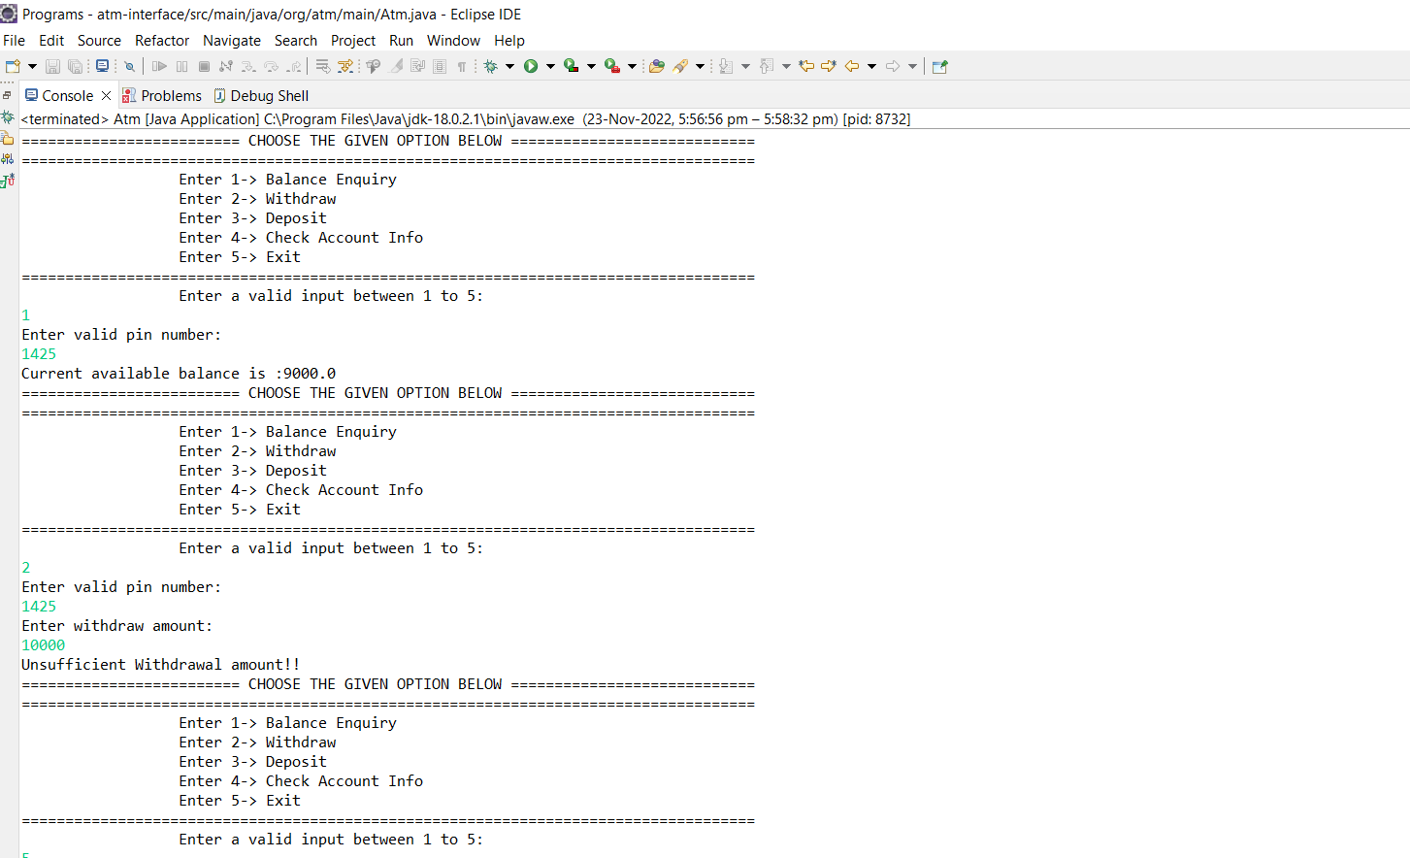

**Withdraw Amount:**

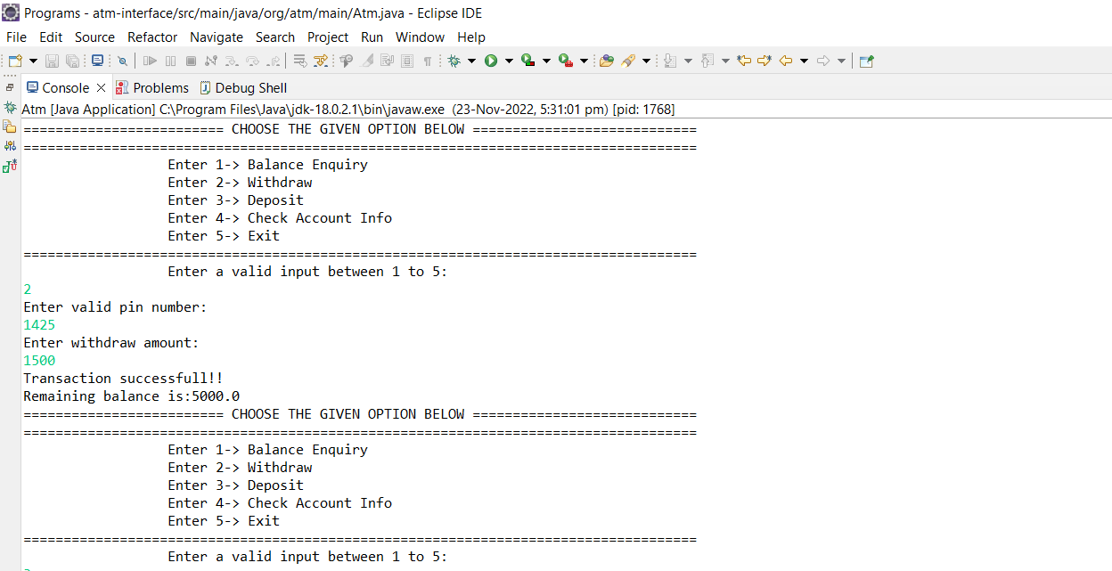



**Deposit Amount:**



**Check Account:**

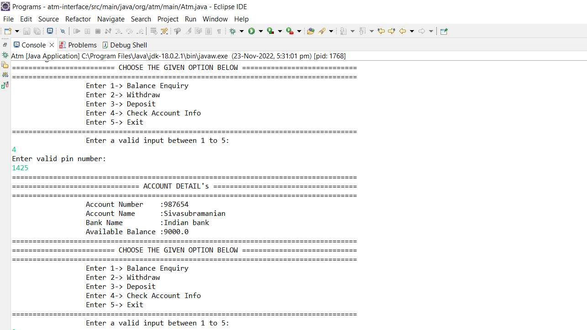

**Exit:**

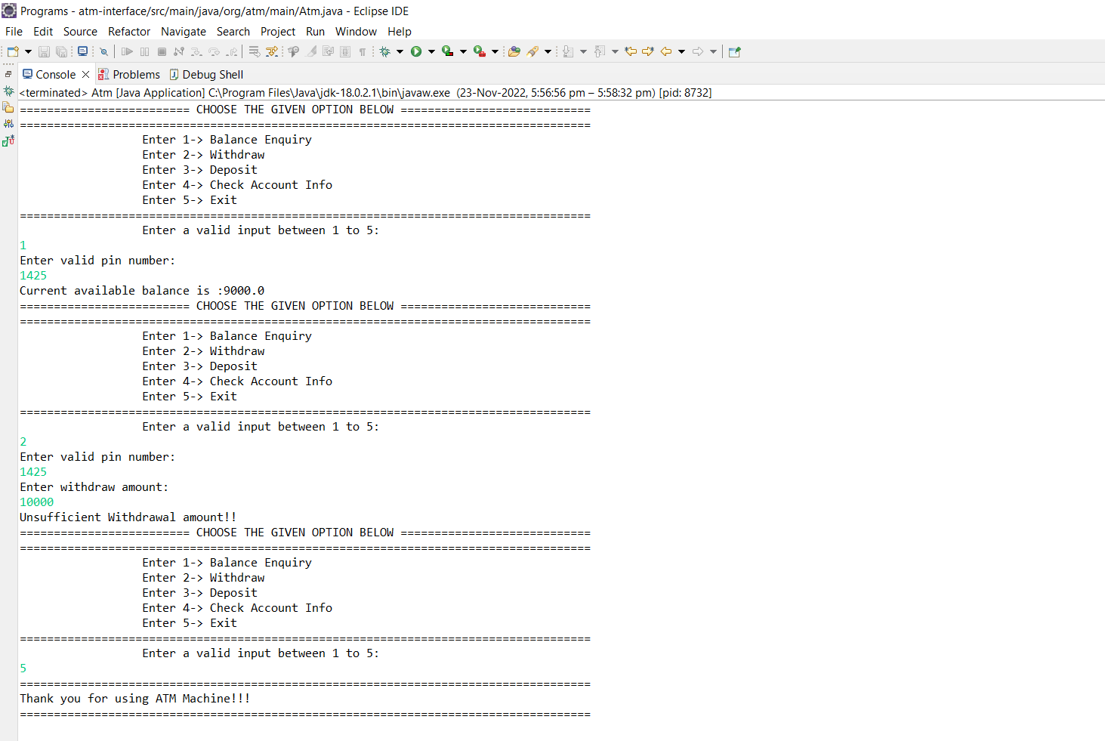

**CONCLUSION:**

ATM program in Java to display ATM transactions, and the user can withdraw money, deposit money, check balance, and exit from the ATM.