**ELNINO RESTAURANT**

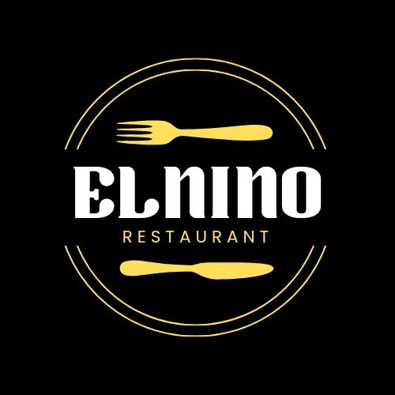

**BLOG LINK :**

[**https://elninorestaurantfoodie.blogspot.com**](https://elninorestaurantfoodie.blogspot.com)