HOSPITAL ANALYTICS SYSTEM

ID: FT0001
Name: Siva K
College: Kongu Engineering College
GitHub URL: https://github.com/sivasks2004/Hospital_Analytics_System.git

Table Schema:
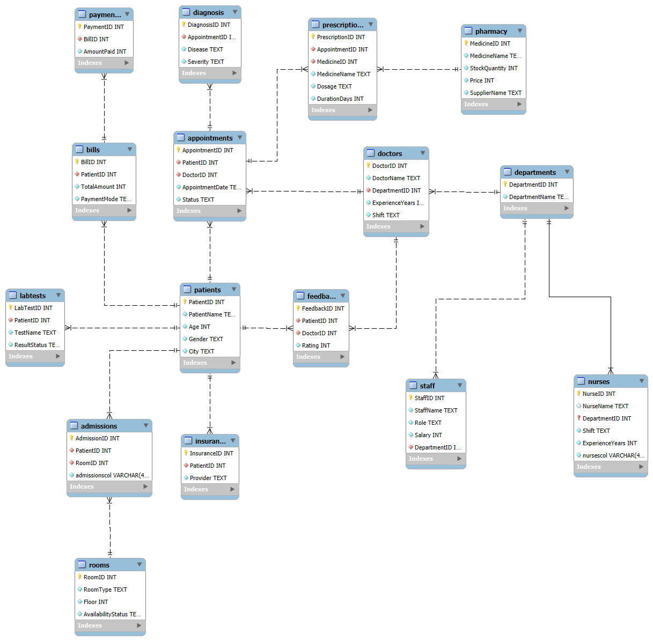

BASIC LEVEL

-- Write a query to find all patients whose age is above 65.
-- Retrieve all appointments scheduled for today.
-- Find the total number of patients available in each city.
-- Display all doctors working in the Cardiology department.
-- Find the total number of appointments handled by each doctor.
-- Retrieve patients who do not have insurance records.
-- Find all bills where the total amount exceeds ₹50,000.
-- Display the top 10 highest payment amounts.
-- Find the total number of rooms available floor-wise.
-- Retrieve all appointments with status = 'Cancelled'.
-- Find the average patient age grouped by gender.
-- Retrieve doctors having more than 10 years of experience.
-- Find the total number of lab tests conducted for each patient.
-- Display all medicines with stock quantity below 100.
-- Find all patients who visited more than once.
-- Retrieve departments having more than 20 doctors.
-- Find all feedback ratings below 3.
-- Display the latest 20 admission records.[Admission Date column missing]
-- Find the total hospital revenue generated through bills.
-- Retrieve the count of appointments month-wise.

INTERMEDIATE LEVEL

-- Find the top 5 doctors who handled the highest number of appointments.
-- Retrieve patients who have appointments in multiple departments.
-- Find the department generating the maximum revenue.
-- Display patients who underwent more than 3 lab tests.
-- Find the most prescribed medicine in the hospital.
-- Retrieve doctors whose average feedback rating is above 4.5.
-- Retrieve the second highest billed patient.
-- Find doctors whose appointments are mostly cancelled.
-- Retrieve the average bill amount generated by each department.
-- Find the top 10 cities generating maximum hospital revenue.
-- Display medicines that are prescribed by more than 5 doctors.
-- Find patients who never provided feedback after appointments.
-- Retrieve all duplicate patient records based on name and phone number.
-- Find the percentage contribution of each doctor to total hospital revenue.
-- Find the percentage contribution of each department to total hospital revenue.
-- Display doctor performance rank using: Total appointments, Revenue generated, Average feedback rating

ADVANCED SQL (STORED PROCEDURE, TRIGGERS)

-- Write a query to identify suspicious payments where payment amount exceeds bill amount.
-- Find patients who revisit the hospital within 7 days for the same disease.
-- Detect duplicate insurance claims for the same patient and diagnosis.

-- Payment status automation
delimiter //
create trigger paymentAutomation
after insert on payments
for each row
begin

declare totalAmt int;
declare paidAmt int;

select totalAmount into totalAmt
from bills where billID=new.BillID;

select coalesce(sum(amountPaid),0) into paidAmt
from payments where billID=new.BillID;

if TotalAmt = paidamt then
update bills set status="Paid" where billId=new.BillID;
elseif TotalAmt<paidAmt then
update bills set status="suspicious" where billId=new.BillID;
else
update bills set status="Partially paid" where billId=new.BillID;
end if;

end //
delimiter ;

-- Duplicate insurance prevention
drop procedure if exists DIP;

delimiter //
create procedure DIP
(IN p_InsuranceID int,
IN p_PatientID int,
IN p_Disease text,
IN p_Provider text)
begin
declare CountInsurance int;

select count(i.insuranceID) into CountInsurance
from insurance i inner join appointments a on i.patientID=a.patientID
inner join diagnosis d on a.appointmentID=d.appointmentID
where i.patientID=p_PatientID and d.disease=p_Disease;

if countInsurance>1 then
signal SQLState '45000'
SET MESSAGE_TEXT = 'Prohibited: Duplicate Entry';
else
insert into insurance(insuranceID,patientID,Provider) values(p_InsuranceID,p_PatientID,p_Provider);
end if;

end//
delimiter ;
call DIP(1,3597,'Allergy','LIC');

-- show procedure status like 'DIP';

-- Room Booking
drop procedure if exists ARB;
delimiter //
create procedure RB(in p_roomID int)
begin
declare rStatus text;
declare rID int;

select roomID, AvailabilityStatus into rID, rStatus from rooms where roomID=p_roomID;

if rID is null then
signal sqlstate '45000'
set MESSAGE_TEXT ='Room Not Available';
elseif rStatus='Available' then
update rooms set AvailabilityStatus='Occupied' where roomID=p_roomID;
else
signal SQLState '45000'
SET MESSAGE_TEXT = 'Prohibited: Duplicate Entry';
end if;

end //
delimiter ;

