Back up Raj Dental Database:

1. click wamp server icon then select phpmyadmin

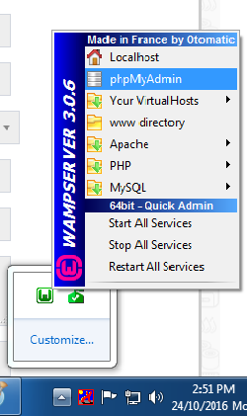

2. window open in web browser like this,then click **Export**

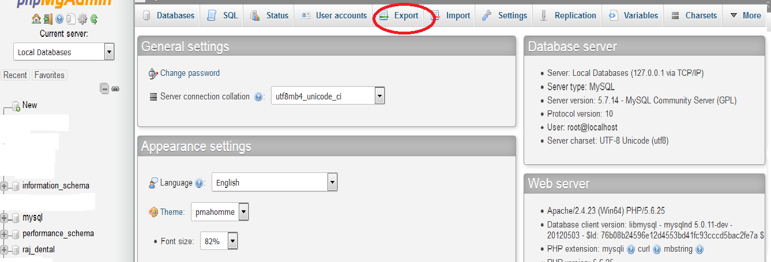

3. then click **custom**, and then select database name like **Raj dental**

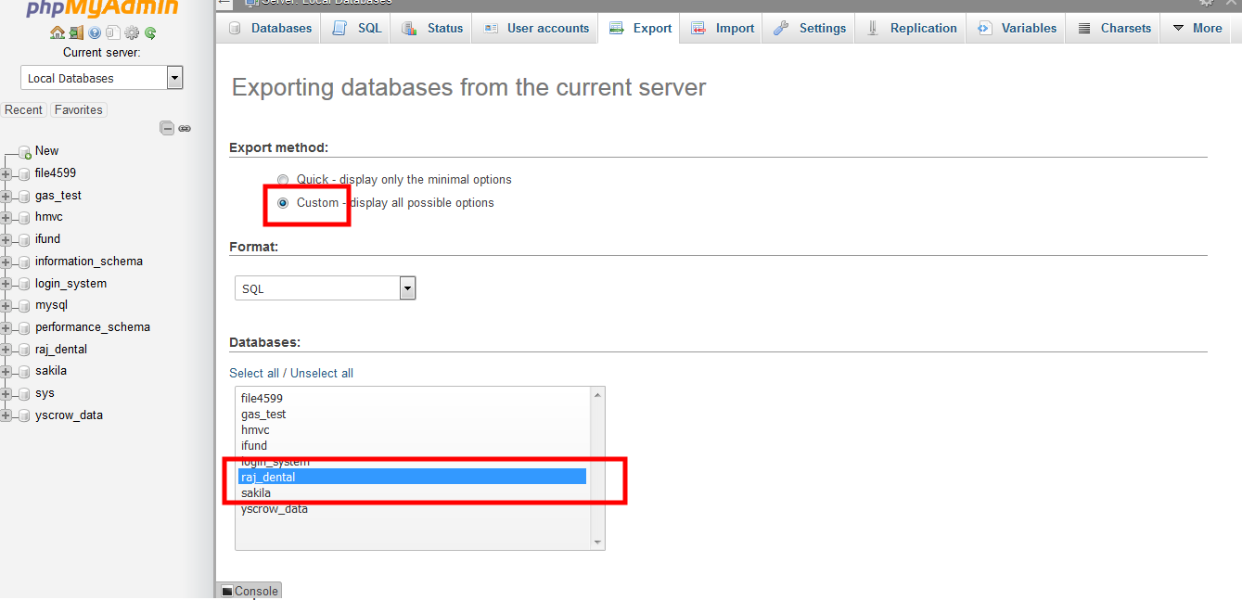

4. Scroll down same page, finally click **go button**

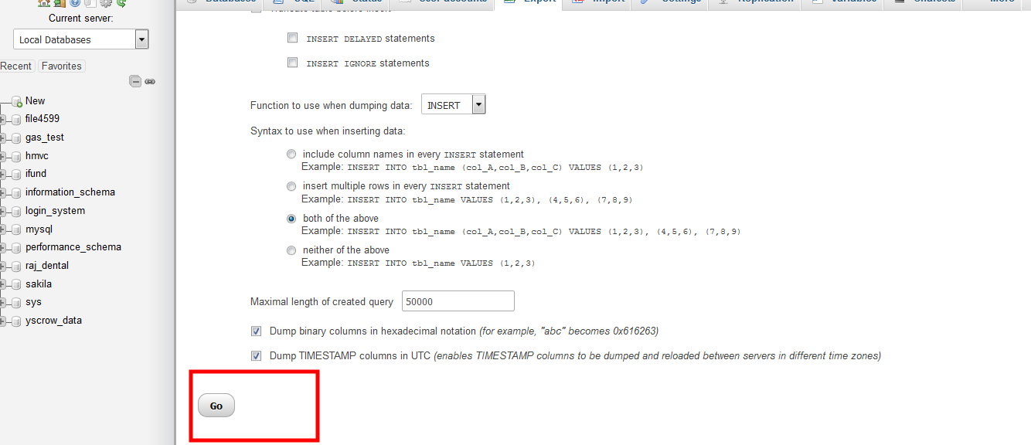

5. once clicked Go button it will ask save, click save. It may be saved in browser default download folder.

