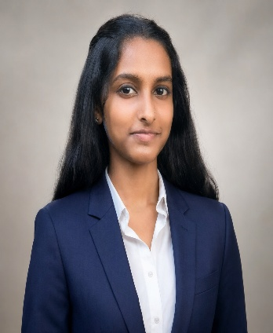

SIVARANJANI S
BE ELECTRONICS AND COMMUNICATION ENGINEERING
9597663511 | sivasrinivasan2009@gmail.com | Coimbatore, Tamil Nadu

PROFILE / CAREER OBJECTIVE
First-year Electronics and Communication Engineering Student
With an interest in electronics, embedded systems and hardware. Interested in developing technical skills through projects, courses and practical learning

EDUCATION
B.E. ELECTRONICS AND COMMUNICATION ENGINEERING
KPR INSTITUTE OF ENGINEERING AND TECHNOLOGY
2026-2030

CLASS XII - GOVERNMENT GIRLS HIGHER SECONDARY SCHOOL
PERCENTAGE: 90.8%
CLASS X - GOVERNMENT GIRLS HIGHER SECONDARY SCHOOL
PERCENTAGE: 93.2%

TECHNICAL SKILLS
- Programming: C (Basic)
- Electronics: Basic electronics components and circuits
- Tools: MS Word, PowerPoint, Excel
- Others: Basic problem solving and communication

PROJECTS
- Earthquake Vibration Detector Alarm
- Full-Wave Bridge Rectifier

AREA OF INTEREST
- Electronics & Hardware
- Embedded & systems
- Innovation and Research

DECLARATION
I hereby declare that the information provided above is true and correct to the best of my knowledge and belief – Sivaranjani S

