**OUTPUT: Week 1**

Exercise 1: Implementing the Singleton Pattern



Exercise 2: Implementing the Factory Method Pattern

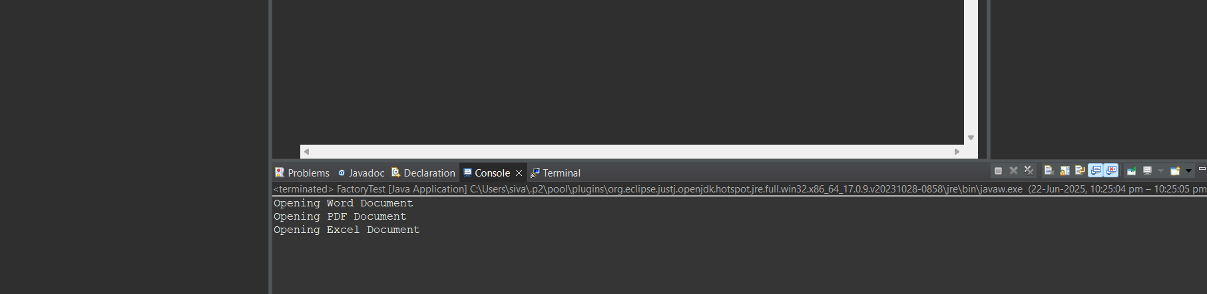

Exercise 2: E-commerce Platform Search Function

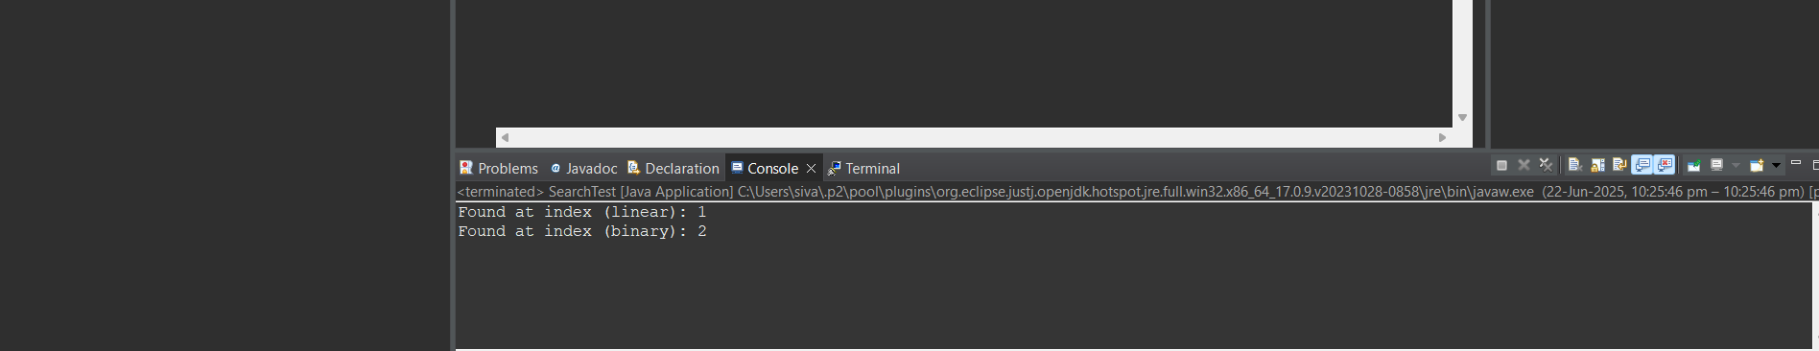

Exercise 7: Financial Forecasting

