Swag Labs Bug Report (Column Format)
Bug_ID: | BUG_001
Bug Title: | User is unable to update product quantity in cart page
Module: | Cart Page
Description: | On the cart page of the Swag Labs application, the user is unable to update the quantity of a product after adding it to the cart. The quantity is displayed as a fixed value ("1") and there is no option (such as an input field, dropdown, or increment/decrement buttons) to modify it. This limits the user from adjusting the number of items before proceeding to checkout, affecting the overall shopping experience.
Steps to Reproduce: | 1. Login to application  2. Click the cart icon  3. Try to edit the quantity field
Expected Result: | User should be able to modify the quantity (increasing/decrease the quantit)
Actual Result: | Quantity is fixed “1”, User is not able to modify the quantity
Severity/Priority: | Low
Status: | New/Open
Screenshot: | 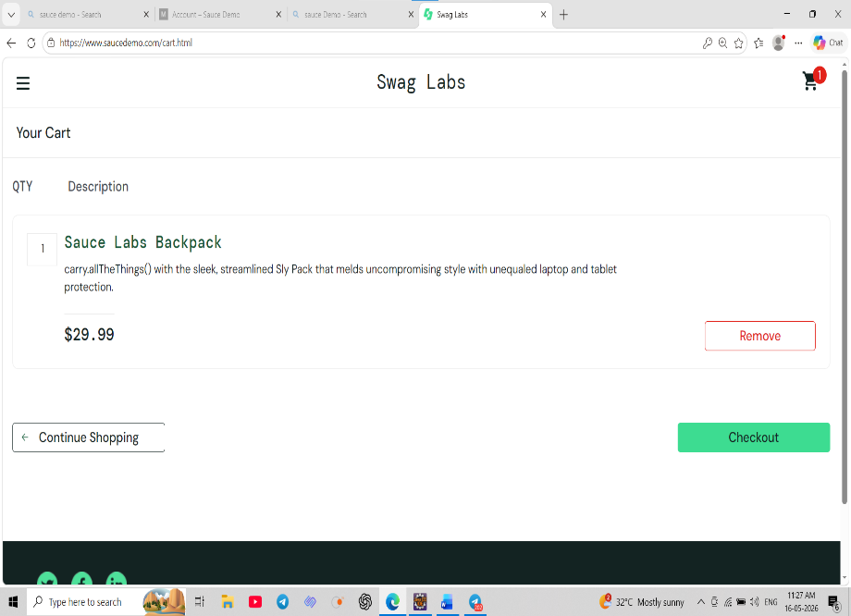

Bug_ID: | BUG_002
Bug Title: | No confirmation message displayed after removing product
Module: | Cart Page
Description: | When the user removes a product from the cart in the Swag Labs application, the item is deleted successfully, but no confirmation message or feedback is displayed. The absence of a confirmation or success message may confuse users, as they are not explicitly informed that the product has been removed from the cart.
Steps to Reproduce: | 1. Login to application  2. Click the cart icon  3. Remove one product
Expected Result: | A confirmation message such as 'Product removed successfully' should be displayed.
Actual Result: | Procduct is removed from the cart,  No confirmation message or alert is to displayed to user.
Severity/Priority: | High
Status: | New/Open
Screenshot: | 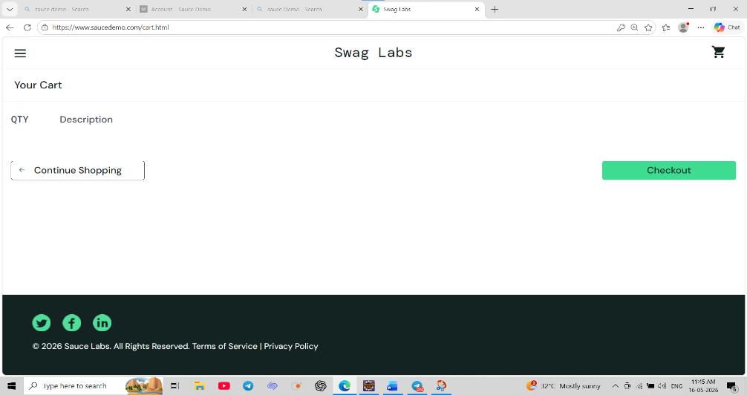

Bug_ID: | BUG_003
Bug Title: | Checkout form accepts invalid input data without validation.
Module: | Checkout
Description: | The checkout form does not validate user inputs properly. Even when invalid data such as numbers, special characters, or incorrect formats are entered in mandatory fields, the system allows the user to proceed without displaying any error messages. This can lead to incorrect or unusable data being submitted, affecting data integrity and overall application reliability.
Steps to Reproduce: | 1. Login to application  2. Go to checkout page  3. Enter invalid data in First Name, Last Name, and Postal Code
Expected Result: | System should validate input fields  First Name & Last Name should accept only alphabets  Postal Code should follow proper format (numeric / valid pattern)  Error messages should be shown for invalid inputs  User should not proceed until valid data is entered.
Actual Result: | Form accepts invalid inputs  User is allowed to proceed to the next step  No validation error messages are displayed
Severity/Priority: | High
Status: | 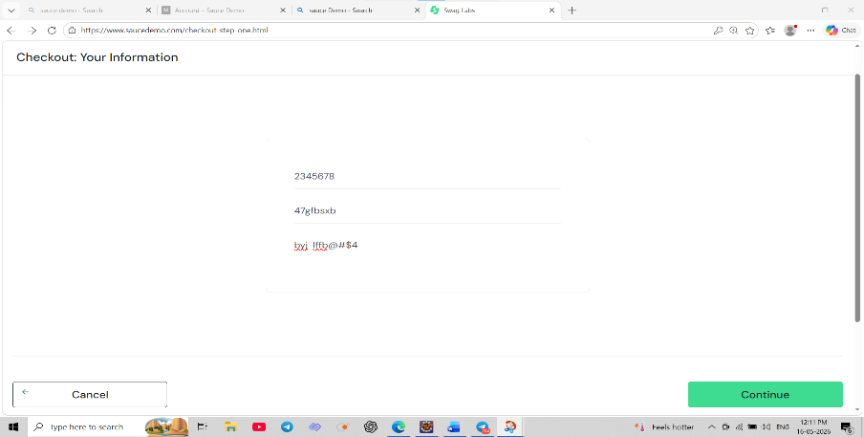  New/Open
Screenshot:
Bug_ID: | BUG_004
Bug Title: | Product color displayed as 'Red' but image shows Orange color
Module: | Product Listing Page (Inventory)
Description: | There is a mismatch between the product description and the displayed image on the inventory page. The product is labeled as "Test.allTheThings() T-Shirt (Red)", but the image shows an orange-colored t-shirt. This inconsistency may confuse users and affect their purchase decisions.
Steps to Reproduce: | 1. Login to the application  2.Navigate to the Products (Inventory) page  3.Locate the product: “Test.allTheThings() T-Shirt (Red)”  4.Observe the product image and description
Expected Result: | Product image color should match the product description (Red)  OR  Product name should be updated to match the actual color (Orange)
Actual Result: | Product name mentions “Red”  But the product image appears Orange in color
Severity/Priority: | High
Status: | 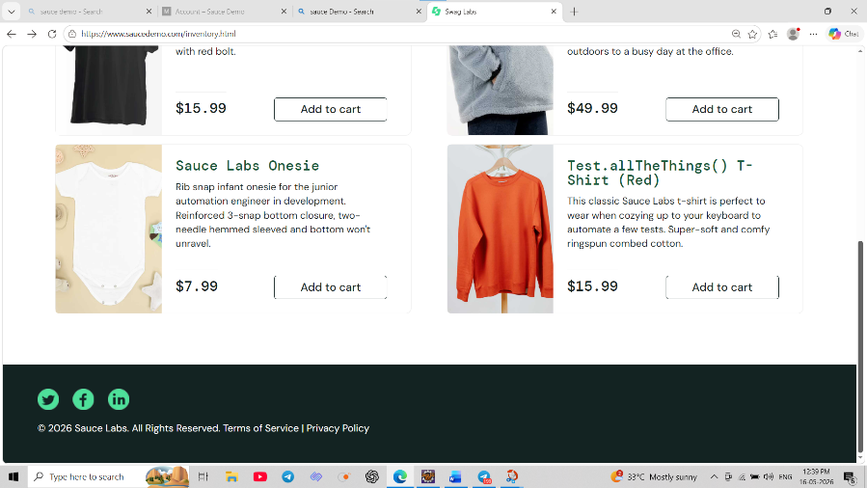  New/Open
Screenshot:

Bug_ID: | BUG_005
Bug Title: | Reset App State clears cart count but does not update product button state
Module: | Inventory / Cart / Menu
Description: | When the user clicks on "Reset App State", the cart data is partially cleared. While the cart icon count and cart page are updated correctly, the product listing page still shows the previously added item as "Remove" instead of resetting it to "Add to cart". This creates inconsistent UI behavior and indicates that the application state is not fully synchronized across components
Steps to Reproduce: | 1.Login to the application  2.Add a product to the cart  3.Verify cart icon count is updated  4.Click on menu three dout  5.Click "Reset App State"  Observe:  Cart icon  Cart page  Product button (Add to Cart / Remove)
Expected Result: | Cart icon count should reset  Cart page should be empty  Product button should change back to "Add to cart"
Actual Result: | Cart icon count is reset (removed)  Cart page appears empty  But product button still shows "Remove" instead of "Add to cart"
Severity/Priority: | High
Status: | New/Open
Screenshot: | 