**Ex.No : 12**

**Sql statement with exists,any,all**

**Questions**

Find the courses which have taken by students

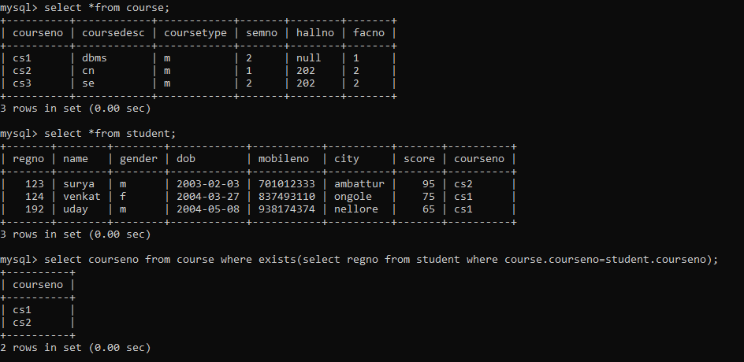

2.Find the Faculties to whom courses are assigned

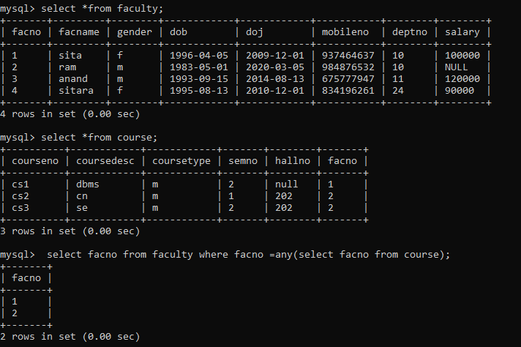

3.Find the d1 dept employess whose salary is greater than all the d2 dept employees salaries

