**Ex.No : 6**

**SELECT with various clause – GROUP BY, HAVING, ORDER BY**

**Questions:**

**Questions**:

**GROUP BY - HAVING**

1. Display the courseno and the number of students registered in each course if no of students registered is>1.

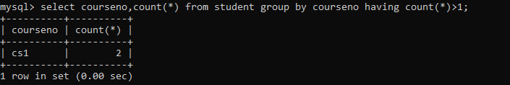

1. Display the facno whose department is getting average salary greater than 25000

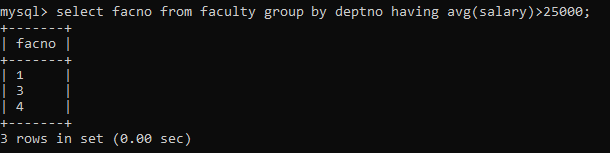

**ORDER BY**

1. Retrieve Name, Gender, MobileNo of all the students in ascending order of RegNo.

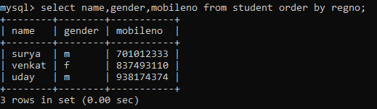

1. List the faculty members in the order of older faculty first.

