**Ex.No : 7**

**SubQuery& Correlated Query**

**QUESTIONS:**

**Sub-Query and Correlated Sub-Query:**

1. Which of the student’s score is greater than the avg score?

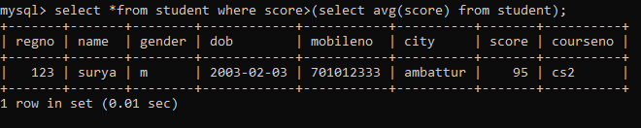

1. Display the course description of the course in the descending order of the no. of students registered.

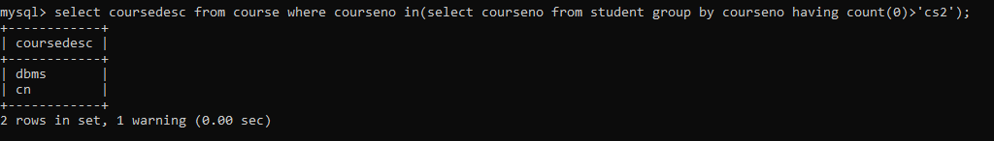

1. Which faculty has joined recently.



1. List the course and score of assessments that have the value more than the average score each Course

