**Ex.No : 8**

**Joins – EquiJoin, InnerJoin, OuterJoin**

**QUESTIONS**:

1. List the departments where the faculty members are working.

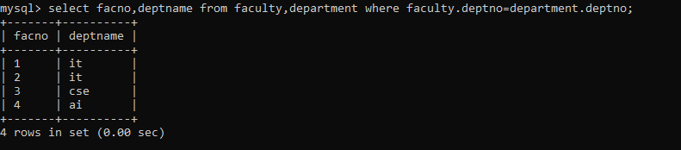

1. Find the student who has no score in any of the courses. List student name and course number.

