**Ex.No : 9**

**VIEW, INDEX, SEQUENCE**

**Question:**

1.Create a view with name ‘std_view’ using STUDENT table which holds the value of register number, name and DOB of student.

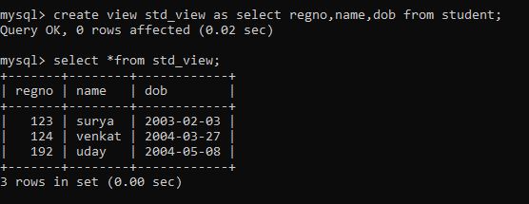

2. create an index on courseno of student and analyze the performance

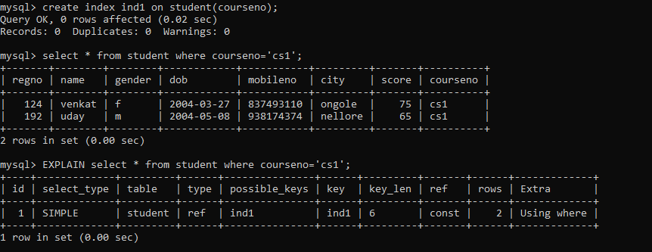

3.Create an example sequence

