DATA266 - HW1
Author: sivasurya.chandran@sjsu.edu
SID4 = 3215 | SEED = 3215 | SLICE = 215 | HP_ID = 5 (Schedule-long) | CLS_A = 5 | CLS_B = 2
CLS_A/CLS_B are derived per Section 0.1 but are not referenced by any HW1 task, so they are unused below.

1. What are autoregressive models? (5 points)
An autoregressive (AR) model generates or predicts data one element at a time, where each new element is conditioned on the sequence of elements produced (or observed) so far. Formally, for a sequence x1, x2, ..., xT, an autoregressive model factorizes the joint distribution using the chain rule of probability: p(x1, ..., xT) = product over t of p(xt | x1, ..., x{t-1}). Instead of modeling the joint distribution directly, the model only needs to learn the conditional distribution of "the next value given everything before it," and generation proceeds sequentially: sample or predict x1, feed it back in to predict x2, and so on. Classical statistical AR models (AR(p), ARIMA) predict a numeric value as a linear combination of previous values; modern deep autoregressive models replace the linear function with a neural network (RNN, causal CNN, or a Transformer with causal/masked self-attention) but keep the same left-to-right, condition-on-the-past factorization.

Real-world examples
- GPT-family large language models (GPT-2/3/4, Claude, Llama): generate text one token at a time, each token conditioned on all previously generated tokens via masked self-attention.
- WaveNet: generates raw audio waveforms sample-by-sample, conditioning each sample on previously generated samples; used for text-to-speech synthesis.
- PixelRNN / PixelCNN: generate images pixel-by-pixel (raster-scan order), each pixel's color distribution conditioned on previously generated pixels.
- Classical time-series forecasting (AR/ARIMA): e.g. forecasting next-day electricity demand or stock prices as a function of the previous p observed values.
- Autoregressive image/video token generation (e.g. early DALL-E, VideoGPT): generate discrete visual tokens sequentially, each conditioned on tokens generated so far.

2. Diabetes Dataset: Neural Network Implementation (10 points)

2.1 Preprocessing
diabetes.csv (759 rows, 8 numeric features + binary Outcome) arrives already min-max scaled to roughly [-1, 1] with no header row; we attach the standard Pima column names and verify there are no NaN values. The correlation matrix (Figure 1) shows Outcome is negatively correlated with Glucose (-0.49); since higher glucose is a strong positive predictor of diabetes in the standard Pima dataset, this indicates Outcome in this CSV is encoded as 1 = no diabetes / 0 = diabetes (inverted relative to the usual convention), consistent with the observed class counts (496 vs 263, the reverse of the usual ~500/268 split). This does not change the modeling task but is noted as an EDA finding. Feature distributions (Figure 2) show spikes at the scaled-zero point for SkinThickness, Insulin, BloodPressure, and Age, consistent with the well-known Pima issue of missing values originally recorded as 0.

Figure 1: Correlation matrix
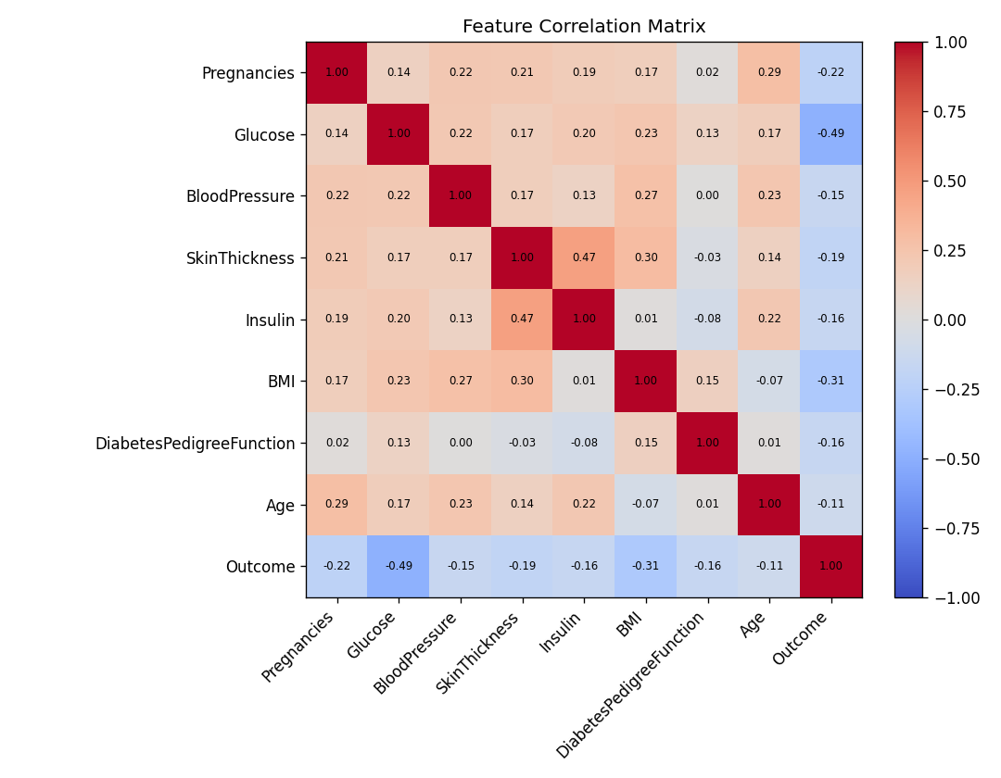

Figure 2: Feature distributions
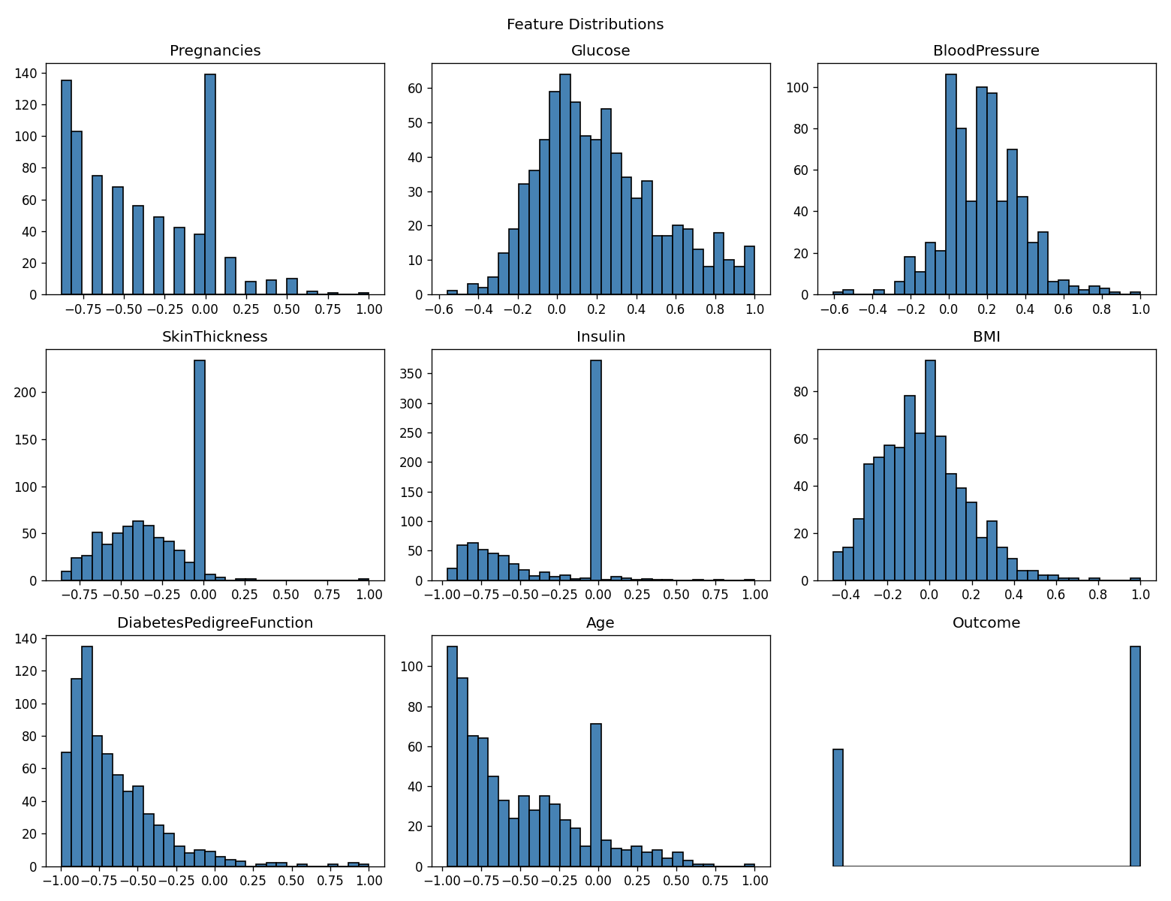

2.2 Split and model configurations
Data is split 70% / 15% / 15% into train/validation/test with random_state=SEED (3215), stratified on Outcome, and this exact split is reused for every model/framework combination. Features are standardized using statistics fit on the training split only.
Model | Hidden layers | Learning rate | Epochs
Baseline (both frameworks) | [64, 32] | 0.001 | 30
Modified (HP_ID=5, Schedule-long) | [64, 32] | 0.001 | 60

Per the assignment, for HP_ID 2-5 the architecture may be left unchanged and only the training setting varies; HP_ID=5 doubles the epoch budget from 30 to 60 with everything else identical.

2.3 Results: test accuracy, mean +/- std over 3 training seeds
Framework | Model | Seed 3215 | Seed 3216 | Seed 3217 | Mean | Std
PyTorch | Baseline | 0.7632 | 0.7544 | 0.7105 | 0.7427 | 0.0230
PyTorch | Modified | 0.7719 | 0.7719 | 0.7719 | 0.7719 | 0.0000
TensorFlow | Baseline | 0.7193 | 0.7544 | 0.7632 | 0.7456 | 0.0189
TensorFlow | Modified | 0.7719 | 0.7895 | 0.7807 | 0.7807 | 0.0072

Reproducibility: all 12 values above are bit-identical between the initial local run (Windows 11, CPU-only, torch 2.13.0+cpu / tensorflow-cpu 2.21.0) and the later Google Colab run (Ubuntu, Tesla T4 runtime). Fixing the split with random_state=SEED and seeding each training run with torch.manual_seed / tf.keras.utils.set_random_seed was sufficient for exact reproducibility across both operating systems and hardware.

Figure 3: Loss curves (PyTorch, SEED=3215 run)
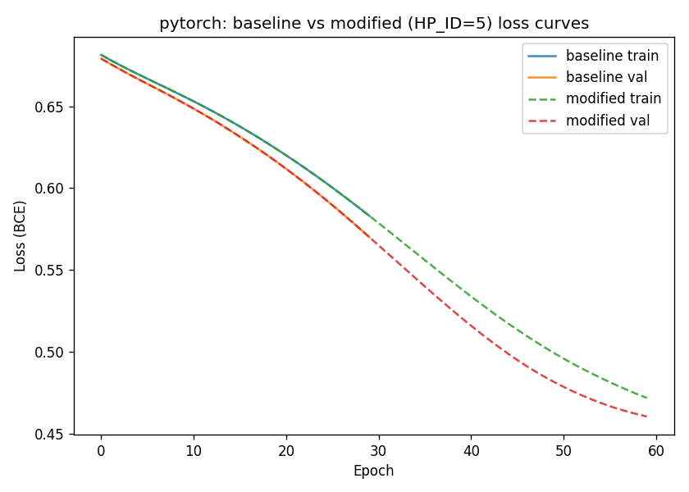

Figure 4: Loss curves (TensorFlow, SEED=3215 run)
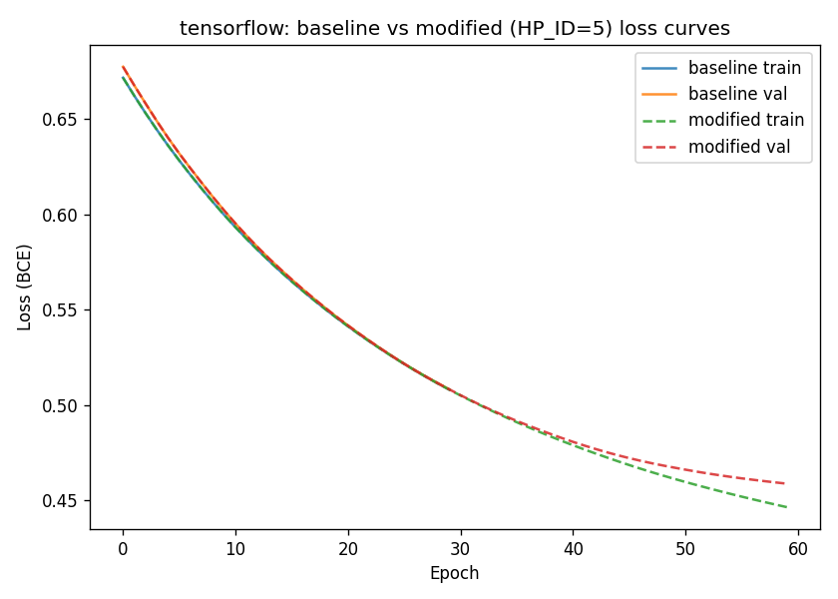
Reading the curves: in both frameworks the modified model (60 epochs) is identical to the baseline for the first 30 epochs (same architecture and learning rate) and then keeps descending smoothly for 30 more epochs. Train and validation loss track each other closely throughout in both frameworks -- the gap does not widen -- so the extra 30 epochs is not causing overfitting; the network is simply still converging at epoch 30 and benefits from the longer schedule. The modified model is better, not just different: it reaches lower loss and higher mean test accuracy in both frameworks, with no sign of underfitting or overfitting.

2.4 Conclusion
HP_ID=5 (Schedule-long: hidden layers [64, 32], lr 0.001, 60 epochs vs. the 30-epoch baseline) consistently improved mean test accuracy over 3 training seeds in both frameworks (PyTorch: 0.743 -> 0.772; TensorFlow: 0.746 -> 0.781) and also reduced run-to-run variance (PyTorch std: 0.023 -> ~0.000; TensorFlow std: 0.019 -> 0.007). The loss curves confirm this is convergence, not overfitting: training and validation loss decrease together at essentially the same rate all the way to epoch 60. At 30 epochs the model had simply not finished converging -- full-batch Adam at lr=0.001 on this dataset needs more than 30 steps to reach its low-loss region -- so the longer schedule helping is consistent between PyTorch and TensorFlow, evidence the effect is a property of the optimization problem rather than a framework-specific artifact. Even though the modified model outperforms the baseline here, per the assignment instructions it is reported regardless of direction -- a worse-performing modified configuration would have been equally valid to report.

3. CUDA Matrix Multiplication (5 points)
Implemented in matmul.cu as a tiled CUDA kernel (TILE = 16x16), benchmarked against a naive single-threaded CPU triple-loop baseline, timed with cudaEvent for H2D transfer, kernel execution, and D2H transfer separately. Executed on Google Colab: NVIDIA Tesla T4 (compute capability sm_75, 15360 MiB), driver 580.82.07, CUDA 13.0, compiled with nvcc release 12.8 V12.8.93 at -O3 -arch=sm_75. A warm-up kernel launch is excluded from all timings.

3.1 Blocks and threads
Each CUDA thread computes exactly one output element C[row][col]. Threads are grouped into 2D thread blocks of size TILE x TILE = 16 x 16 = 256 threads. The grid is a 2D array of blocks sized as ceil(N/TILE) x ceil(N/TILE), so that gridDim * blockDim covers the full N x N output matrix. Each block cooperatively loads a TILE x TILE tile of A and of B into __shared__ memory once per iteration over the K dimension, reusing that tile across all 256 threads in the block before advancing (with __syncthreads() calls to guard the shared-memory read/write ordering). This reduces global-memory traffic by roughly a factor of TILE relative to a naive kernel where every thread re-reads full rows/columns of A and B directly from global memory. The measured launch geometry scales exactly as expected: 65,536 threads at N=256, 1,048,576 at N=1024, and 16,777,216 at N=4096.

3.2 Timing results
Matrix size | Grid x Block (threads) | CPU (ms) | GPU kernel (ms) | H2D+D2H (ms) | End-to-end (ms) | Speedup
256 | (16,16) x (16,16) = 65,536 | 23.236 | 0.113 | 1.473 | 1.586 | 14.65x
1024 | (64,64) x (16,16) = 1,048,576 | 3663.505 | 5.808 | 5.034 | 10.842 | 337.90x
4096 | (256,256) x (16,16) = 16,777,216 | skipped | 196.829 | 76.655 | 273.484 | ~857x (est.)

The naive single-threaded O(N^3) CPU baseline is skipped at N=4096 in matmul.cu (ranCpu = N <= 2048); at that size it would take roughly 234 s (about 64x the N=1024 time, since 4096^3/1024^3 = 64). The ~857x figure for N=4096 is extrapolated from that estimate and is NOT a measured value. Correctness was verified against the CPU result at every measured size: max absolute difference 2.29e-05 at N=256 and 9.16e-05 at N=1024, both reported as (OK), consistent with float32 accumulation-order differences rather than a logic error.

3.3 Profiler output separating kernel time from transfer time
Profiler used: nvprof (legacy CUDA profiler). Nsight Systems (nsys) is NOT installed in the current Colab image -- the notebook reported "nsys: command not found" -- so it fell back to nvprof, which ran successfully and produced the required kernel-vs-transfer breakdown. Nsight Compute (ncu) also ran; its report is saved as matmul_1024_ncu.ncu-rep.
nvprof ./matmul 1024
Type Time(%) Time Calls Avg Min Max Name
GPU activities: 78.80% 11.586ms 2 5.7929ms 5.7892ms 5.7965ms matMulTiled(...)
10.71% 1.5741ms 1 1.5741ms 1.5741ms 1.5741ms [CUDA memcpy DtoH]
10.50% 1.5432ms 2 771.61us 740.21us 803.02us [CUDA memcpy HtoD]
API calls: 90.58% 182.89ms 3 60.962ms 59.553us 182.76ms cudaMalloc
2.87% 5.8001ms 2 2.9000ms 2.7600us 5.7973ms cudaEventSynchronize
2.87% 5.7913ms 1 5.7913ms 5.7913ms 5.7913ms cudaDeviceSynchronize
2.40% 4.8534ms 3 1.6178ms 969.02us 2.9039ms cudaMemcpy
0.12% 252.20us 2 126.10us 13.353us 238.84us cudaLaunchKernel
This cleanly separates the two components: the kernel accounts for 78.80% of GPU activity (11.586 ms over 2 launches -- the warm-up plus the timed launch, about 5.79 ms each, matching the 5.808 ms cudaEvent measurement in the table), while the memory copies account for the remaining 21.21% (DtoH 1.5741 ms + HtoD 1.5432 ms = 3.117 ms of pure device-side copy time). Note that cudaMalloc dominates the API-call column at 182.89 ms; that is one-time CUDA context and allocation setup, not per-operation cost, and is excluded from the cudaEvent timings.
Caveat on the ncu run: Nsight Compute reports a kernel time of 1714.722 ms for the same N=1024 kernel. That is NOT the real kernel time -- ncu replays the kernel 9 times per launch to collect hardware counters ("9 passes" in its output), inflating the measurement by roughly 300x. The un-instrumented ./matmul 1024 and nvprof figures (about 5.8 ms) are the correct ones and are what the table above reports.

3.4 Crossover discussion
The GPU is already the better choice at the smallest size measured: at N = 256 the end-to-end GPU path (1.586 ms, including both transfers) beats the 23.236 ms CPU baseline by 14.65x, so the crossover lies somewhere below N = 256 in these measurements. The crossover is not at size zero because the GPU path pays costs the CPU path does not: at N=256, 1.473 ms of H2D+D2H PCIe transfer is 93% of the entire 1.586 ms end-to-end time, while the kernel itself is only 0.113 ms -- plus per-launch overhead and one-time context/cudaMalloc setup that nvprof measures at 182.89 ms. Those costs are fixed or grow only as O(N^2) with data volume, whereas the compute they displace grows as O(N^3), so at very small N the transfer and launch overhead dominates and the GPU cannot win. By N=1024 the arithmetic has grown 64x faster than the transfers and the speedup jumps from 14.65x to 337.90x. The gap between kernel-only and end-to-end speedup at N=256 (206x vs 14.65x) is exactly this effect: the kernel is enormously faster, but at that size the result spends most of its wall-clock time crossing the PCIe bus rather than being computed.

