IOT BASED ENVIRONMENTAL MONITORING SYSTEM

A Project report submitted in partial fulfilment of the

Requirement for the degree of B.TECH in Information technology

Engineering

By

s.swetha (513221205021)

Under the supervision of professor & HOD department of

Information Technology

Innovation in Environmental Monitoring with Remote Sensing Techniques

PHASE2:

* Background/Objectives:

Large or remote areas of land are often challenging and expensive to monitor using traditional ground-based methods. Remote monitoring techniques (i.e., satellite and drone imagery) is becoming a prevalent part of environmental monitoring and characterization. Recent developments in computer vision and artificial intelligence, combined with knowledge in ecological characterization, allow for the rapid analysis of large volumes of rapidly compiled remote sensing data for relevant signals and can provide unparalleled site understanding. These new data sources and methods applied to age old challenges around groundwater seep identification and contaminated site management require a range of demonstrated use cases. This presentation will focus on a brief introduction to how satellites, drones, and cloud-computing based artificial intelligence are changing the way environmental monitoring takes place. Following the technical introduction into these technologies, we will present a case study of remote sensing techniques utilized at a large (several hundred squarekilometer) alumina refinery in which the goal of the project was to understand environmental impacts sitewide and protecting sensitive habitat. The purpose of Ramboll’s work with this project was to help the client rapidly assess the changing conditions of vegetation at its facility, and to better understand the impact of specific variables

* Approach/Activities:

To accomplish this, Ramboll’s Galago team analyzed a variety of data sources including high-resolution satellite and aerial imagery to document sitewide trends related to vegetation health and tree dieback. A temporal analysis of satellite imagery was completed to evaluate the region-wide impact of climatic variables, such as drought, on vegetation health using the Normalized Difference Vegetation Index (NDVI). High-resolution aerial imagery and a deep learning model were used to identify specific locations of tree dieback not visible in satellite imagery. Aerial imagery was analyzed using a convolutional neural network model to classify sections of the imagery as tree dieback. Multiple captures per year of aerial imagery allows for site-wide dieback monitoring throughout the year and help capture changes throughout the site. The analysis produced from this project enables an additional line of evidence to support other site investigation and monitoring activities and creates the possibility to deploy an advanced habitat monitoring system in an accurate, repeatable, and cost-effective manner.

* Results/Lessons Learned:

The success of this project is in its ability to quickly garner information about sitewide trends in vegetation, to supplement and focus ground-based investigations, and to provide an ability to compare the site with reference areas. The satellite imagery analysis provided a region-wide view of vegetative health and showed that the site was impacted by drought in a similar way to reference areas. The aerial imagery analysis showed that it’s possible to quickly train and deploy a deep learning model for analysis of vegetation in high-resolution imagery. The advantage of creating a model to identify dieback is that it can be scaled across large areas and applied to new imagery as it becomes available. Overall, the client can now better understand drought impacts on sensitive habitats and will have the ability to measure vegetation dieback rates across the entire site and reference areas. Having this information allows a more efficient and effective implementation of remedial plans, and minimizes environmental impacts to sensitive habitats.

**Types of Environmental Monitoring:**

* Air Quality Monitoring
* Water Sampling and Analysis
* Noise level Testing
* Soil Quality Testing
* Energy monitoring
* **Air Quality Monitoring:**

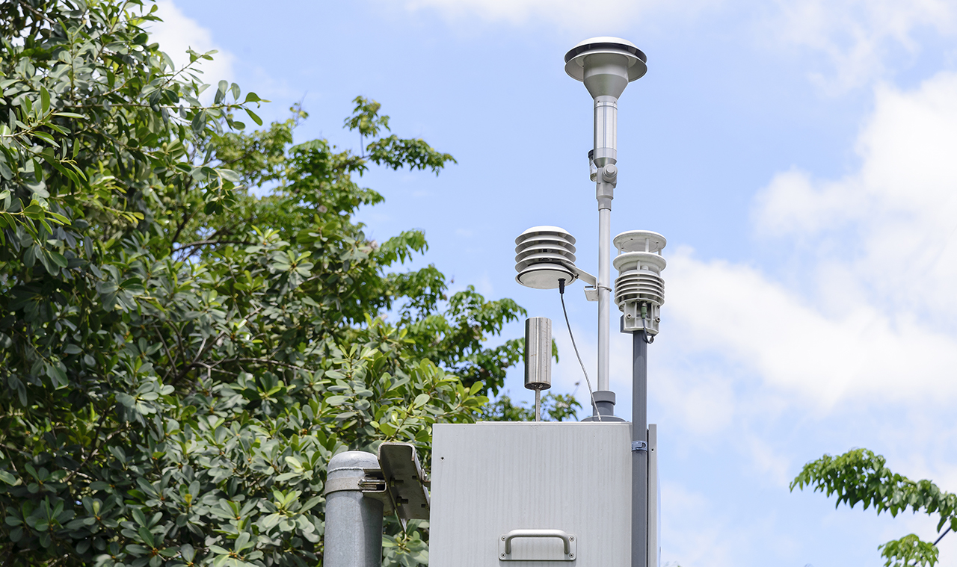

Industrial processes emit organic compounds like carbon monoxide, hydrocarbons, and chemicals (“greenhouse gases”) into the air. And as we know, exhaust from vehicles and methane from cattle impact the quality of our air and impact our planet.  
  
*With air quality monitoring, science and industry can create change*. These critical industrial operations to mitigate their impact, and for entire auto makers to continually improve designs to reduce emissions. Even [deploying IoT to manage traffic flow in metrics deliver the insights for municipalities to make decisions for urban planning, for cities](https://www.digi.com/customer-stories/new-york-city-dot-deploys-digi-solutions) can massively reduce vehicle emissions and support cleaner air.  
  
Some real-world examples of air quality monitoring include:

* Carbon monoxide monitoring in homes and buildings
* Methane monitoring in agriculture and waste management
* WATER OUALITY MONITORING

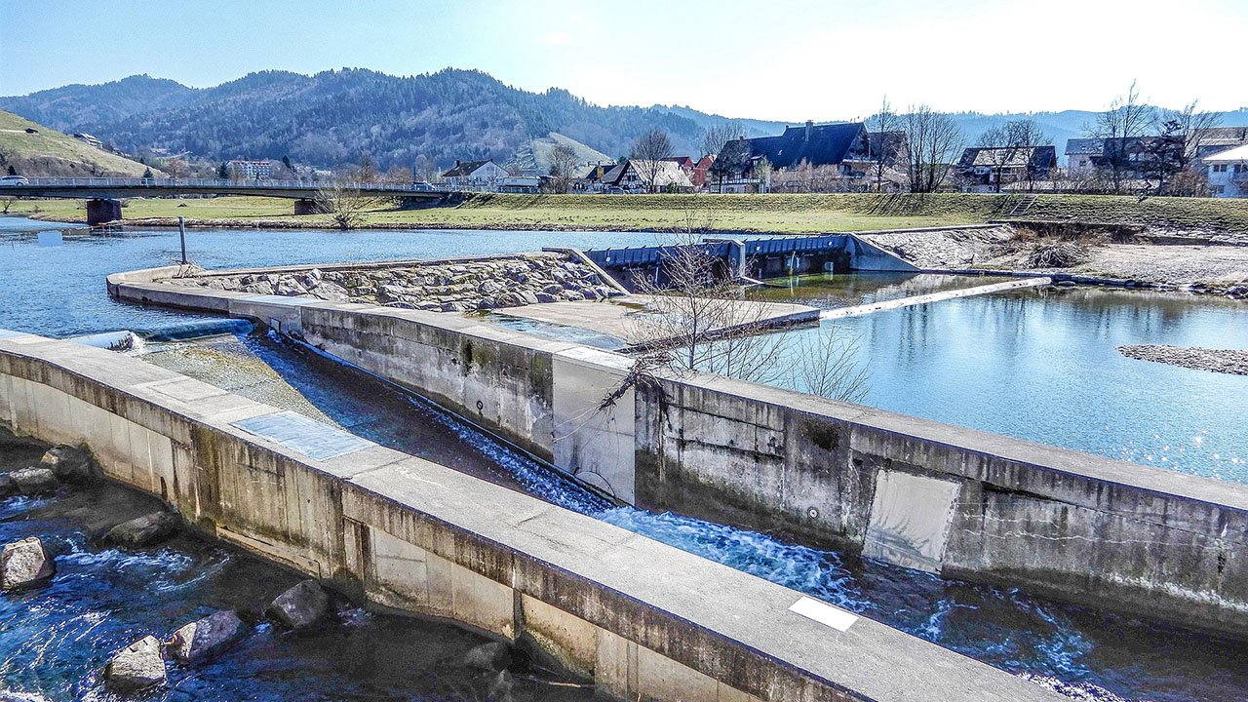

Water is a vital source for the health of the planet and its people, and today, technology is needed to support clean water management and conservation. Water quality monitoring using IoT-based systems helps to [control contamination and support management](https://www.digi.com/customer-stories/brown-and-caldwell-uses-digi-to-help-monitor-water) of this valuable resource. Using IoT systems allows water to be analyzed in buildings, water and wastewater plants, irrigation systems and industrial processes.   
  
These advanced [smart water monitoring systems using IoT](https://www.digi.com/customer-stories/digi-connect-sensor-help-nobel-water-systems) technologies enable accurate measurements of contaminants, oxygen levels, additional factors, and pH levels. IoT technology allows the detection of harmful substances public it reaches homes and buildings. The innovative technology helps us to sustain our health and wellness.  
Some examples include:

* Municipal water treatment monitoring
* Stormwater and groundwater monitoring
* Agricultural irrigation monitoring and control

**City water and drinking water quality monitoring**

* **Energy Monitoring:**

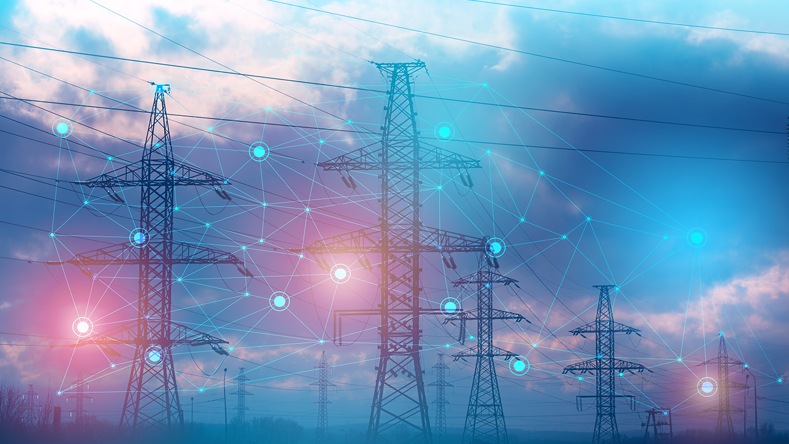

With our limited global energy resources, energy monitoring is essential to conservation. [IoT-based technologies](https://www.digi.com/customer-stories/cas-tecnologia" \t "_self) can provide both the management tools and the insights to improve how we use energy.  
  
[Leading energy providers](https://www.digi.com/customer-stories/oil-gas-operation-monitors-devices-with-digi-rm) today are rapidly integrating a wide range of IoT monitoring and [mitigation techniques to reduce usage](https://www.digi.com/customer-stories/smart-clean-energy-solution-from-e-gear), as well as clean energy solutions to reduce energy consumption and promote sustainability. In the process, these techniques can also [save money for everyone relying on the electric grid](https://www.digi.com/customer-stories/efficiencies-save-thousands-for-electricities).  
   
Energy monitoring supports numerous *energy management goals*:

* Reduction in the use of fossil fuels in homes and businesses.
* Stabilizing the power grid.
* Preventing spikes in energy usage, and associated equipment failures and service disruption.
* SOIL OUALITY MONITORING:

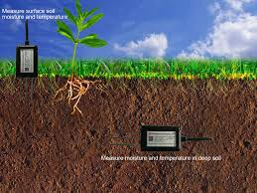

Soil quality defines whether soils are in good condition for their current land use activity. Because soils have developed from different parent materials and have been influenced by a range of soil-forming factors, soils display a variety of physical, chemical and biological characteristics.

* NOICE OUALITY MONITORING:

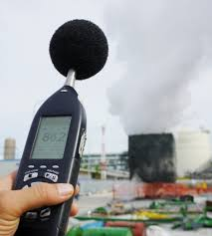

Noise monitoring refers to the systematic process of measuring, recording, and assessing sound levels in various environments to understand the extent of noise pollution and its potential impact on human health and the surrounding ecosystem.