**IOT BASED ENVIRONMENTAL MONITARING SYSTEM**

A Project report submitted in partial fulfilment of the requirements for the degree of B.TECH in

Information Technology Engineering

By

**S.SWETHA (513221205021)**

Under the supervision of professor &HOD department of Information technology

Environmental monitoring

PHASE1: Problem Definition and Design Thinking

* Problem statement
* Design Thinking Approach

Problem statement

That is, the problem statement is quite focused. In general, it has to talk about three aspects regarding the problem: the current state, the desired or ideal state, and the solutions or suggestions you will make through your research that will help attain this ideal state

Flowchart

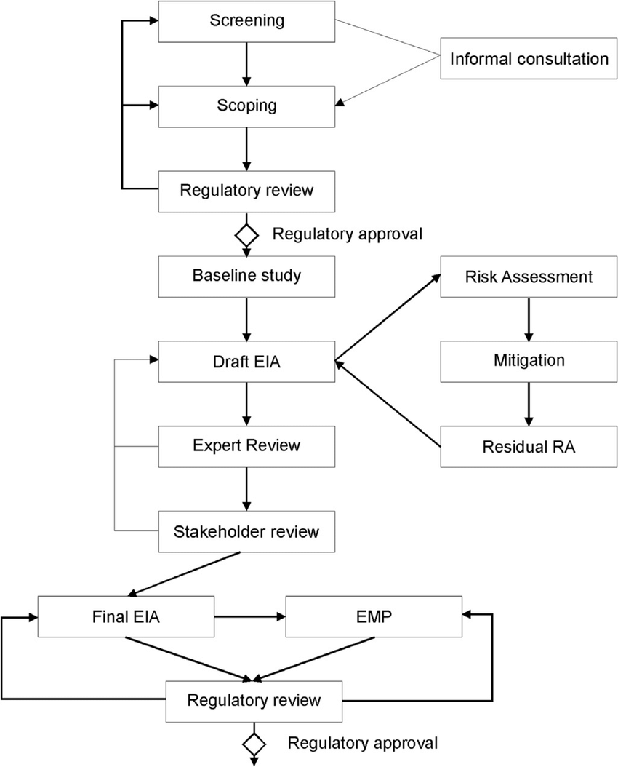

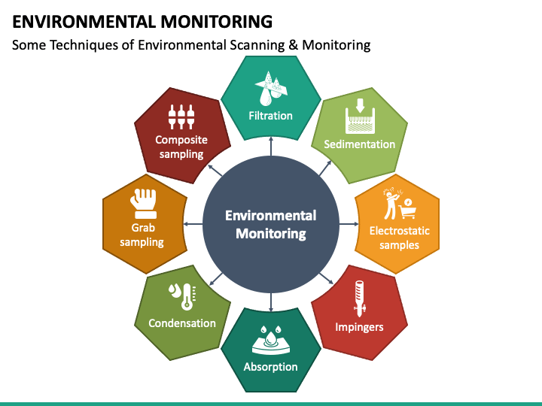

Design thinking approach

Design thinking is **an iterative, non-linear process which focuses on a collaboration between designers and users**. It brings innovative solutions to life based on how real users think, feel and behave. This human-centered stages design process consists of five core Empathize, Define, Ideate, Prototype and Test.