CO1
ASSESSMENT -1

1. Online Symposium Portal

1. Identify appropriate HTML5 semantic elements missing in the structure.
The given form lacks HTML5 semantic tags. The missing elements are:
- <header> – Displays the website title.
- <main> – Contains the main content.
- <section> – Groups the registration form.
- <article> (optional) – For independent content.
- <footer> – Displays copyright or contact information.
- Modify the structure to make it standards-compliant.
<!DOCTYPE html>
<html lang="en">
<head>
<meta charset="UTF-8">
<meta name="viewport" content="width=device-width, initial-scale=1.0">
<title>Symposium Registration</title>
</head>
<body>
<header>
<h1>Online Symposium Registration</h1>
</header>
<main>
<section>
<form action="/register" method="POST">
<label for="name">Name:</label>
<input type="text" id="name" name="name" required>
<label for="email">Email:</label>
<input type="email" id="email" name="email" required>
<button type="submit">Submit</button>
</form>
</section>
</main>
<footer>
<p>&copy; 2026 Symposium Portal</p>
</footer>
</body>
</html>
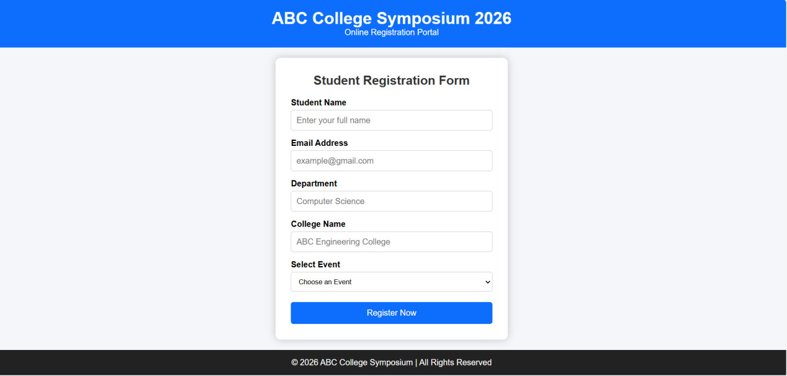

3. Interpret the HTTP request generated during form submission.
- Browser sends an HTTP POST request.
- URL: /register
- Request contains:
  - Name
  - Email
- Request headers include:
  - Host
  - Content-Type

4. Analyze the HTTP response cycle.
- Browser sends POST request.
- Server receives and validates data.
- Data is stored in the database.
- Server generates HTTP response.

5. Suggest improvements for usability and accessibility.
- Use <label> for every input field.
- Add required validation.
- Use placeholders.
- Provide meaningful error messages.

2. Cross-Browser Compatibility Issue

1. Identify improper nesting and missing closing tags.
Errors:
- Missing </h1>
- Missing </p>
- Missing </body>
- Missing </html>

2. Analyze browser interpretation.
Different browsers use different rendering engines.
- Chrome may automatically close missing tags.
- Firefox may display slightly differently.
- Safari and Edge may produce layout inconsistencies.
This causes inconsistent webpage appearance.

3. Identify missing semantic elements.
Missing elements:
- <header>
- <main>
- <section>
- <footer>
These improve readability and SEO.

4. Correct W3C-compliant HTML structure.
<!DOCTYPE html>

<html lang="en">
<head>
<title>Company</title>
</head>
<body>
<header>
<h1>Welcome</h1>
</header>
<main>
<section>
<p>About us</p>
</section>
</main>
<footer>
<p>Copyright 2026</p>
</footer>
</body>
</html>
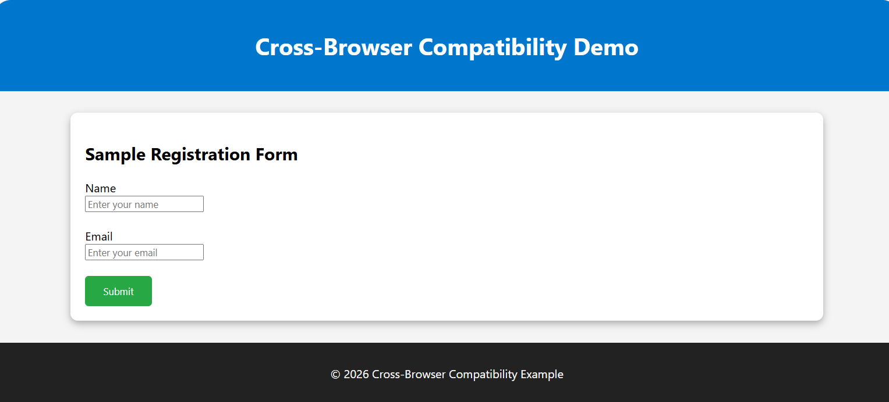

5. Techniques for cross-browser compatibility.
- Validate HTML using W3C Validator.
- Use CSS Reset.
- Use modern HTML5 tags.
- Avoid browser-specific code.

3. Form Submission Failure

1. Identify issues in the form configuration.
Problems:
- method="GET" sends sensitive data in URL.
- Login button uses type="button" instead of type="submit".
- Password is not securely transmitted.

2. Analyze why HTTP request is not triggered.
type="button" performs no default action.

3. Interpret the role of GET method.
GET:
- Sends data in URL.
- Used for searching or retrieving information.
- Not suitable for passwords.
- Data can be cached and bookmarked.
4. Correct implementation.
<form action="/submit" method="POST">
<label>Username</label>
<input type="text" name="username" required>
<label>Password</label>
<input type="password" name="password" required>
<button type="submit">Login</button>
</form>
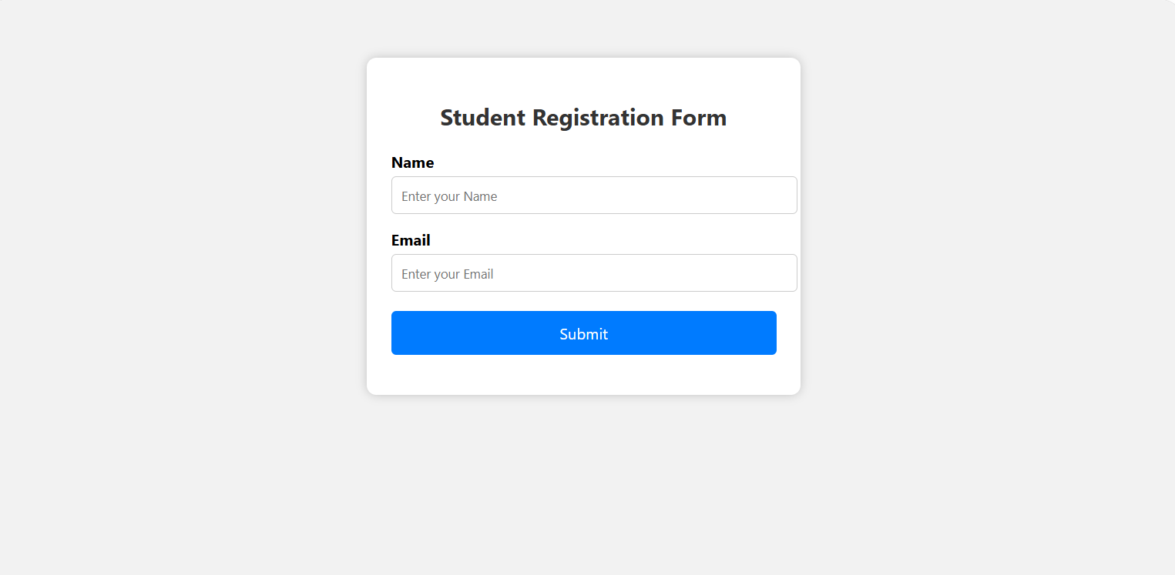

5. Suggest improvements for secure data transmission.
- Use POST instead of GET.
- Enable HTTPS (SSL/TLS).
- Validate inputs on both client and server.
- Encrypt passwords before storing them.
- Use secure session management.
- Implement authentication and authorization.

