CO1
ASSESSMENT -2

QUESTION 1: HTTP Response Analysis

A web server returns the following HTTP response header:
HTTP/1.1 200 OK
Date: Mon, 01 Apr 2026 10:00:00 GMT
Content-Type: text/html
Content-Length: -150
Connection: keep-alive

1. Identify any incorrect or invalid fields
The main error in the header is:
- Content-Length: -150 is invalid because the content length cannot be a negative value.
- Content-Length should contain a non-negative integer that represents the size of the response body in bytes.
- The other fields such as 200 OK, Date, Content-Type, and Connection are valid.

2. Analyze the issue with Content-Length and its impact
The Content-Length header tells the client the exact size of the response body.
Here, the value is -150, which is not allowed because a response body cannot have a negative size.
Impact:
- The HTTP response may be considered invalid or malformed.
- The client may not correctly process the response body.
- It can cause data transfer or communication errors.
- The server should provide the actual size of the response body.

3. Determine whether the status code matches the response correctness
The status code 200 OK indicates that the server successfully received and processed the request.
- The 200 OK status code is correct if the requested HTML resource was successfully returned.
- However, the response is not completely valid because of the incorrect Content-Length value.
- The status code does not need to be changed if the resource itself was successfully processed.

4. Suggest corrections for the identified errors
The server should replace the negative Content-Length value with the actual size of the response body.
For example:
HTTP/1.1 200 OK
Date: Mon, 01 Apr 2026 10:00:00 GMT
Content-Type: text/html
Content-Length: 150
Connection: keep-alive
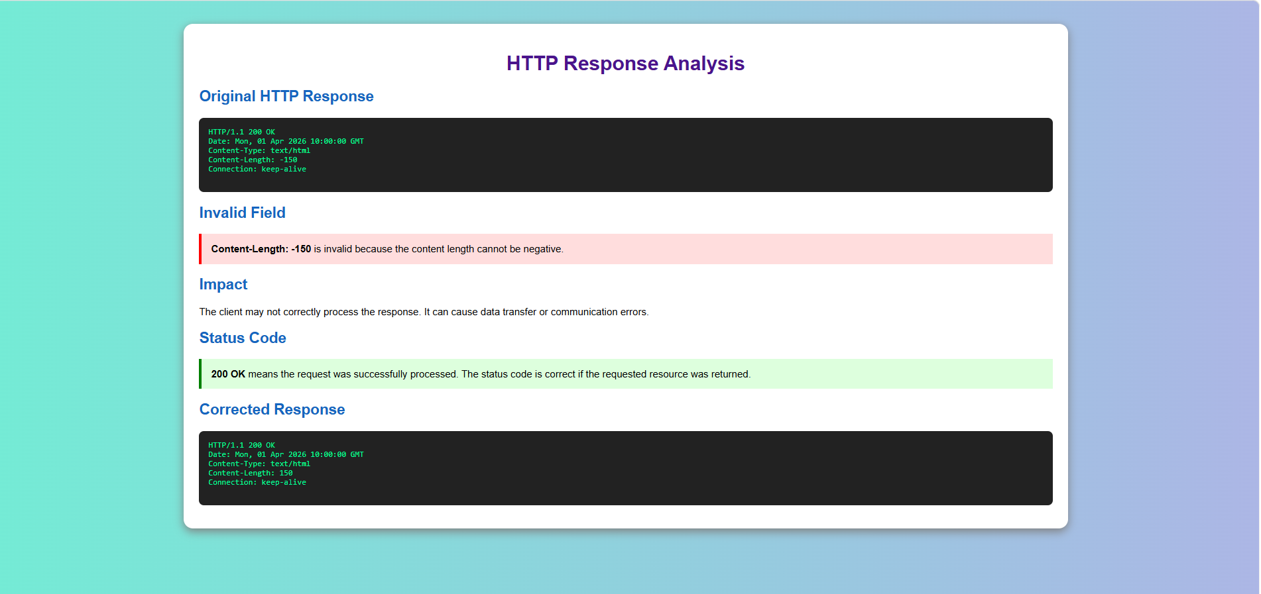

Conclusion
The main error in the given HTTP response is Content-Length: -150, because the content length cannot be negative. The server must replace it with the actual non-negative size of the response body. The 200 OK status code can remain unchanged if the requested resource was successfully processed. Thus, correcting the Content-Length field makes the HTTP response properly formatted and allows the client to correctly process the response body.
2: DOM Structure Analysis

Consider the following DOM tree representation:

<html>
<head>
<title>TestPage</title>
</head>
<body>
<div>
<p>HelloWorld
</div>
</body>
</html>

1. Identify missing or improperly closed elements.
- The <p> tag is missing its closing </p> tag.
- The <p> element should be closed before the </div> tag.
- This results in improper nesting of HTML elements.

2. Analyze how the browser will interpret this structure.
- The browser will try to automatically correct the missing closing tag.
- It may insert the missing </p> tag while parsing the HTML.
- The webpage may still be displayed, but the DOM structure may be different from the original code.

3. Determine the impact on rendering and layout.
- The text HelloWorld may still be displayed correctly.
- Improper nesting may cause unexpected spacing or layout issues.
- It can also affect CSS styling and JavaScript DOM operations.

4. Suggest corrections to make the DOM valid.
- Add the missing </p> closing tag before </div>.
Corrected code:
<div>
<p>HelloWorld</p></div>

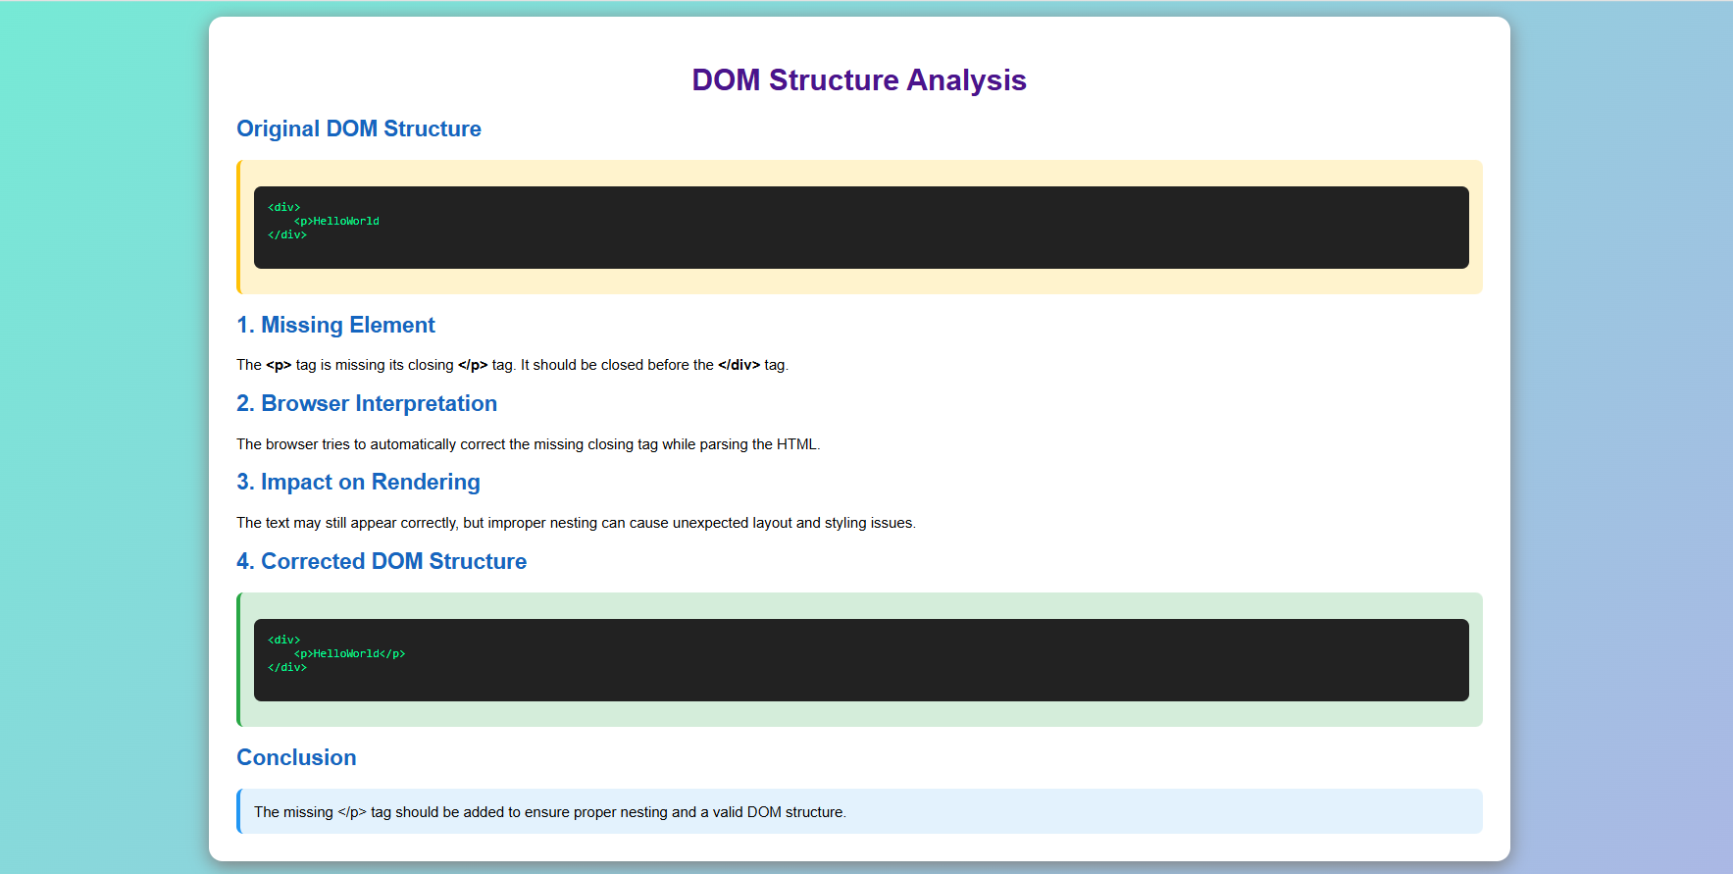
Conclusion: The main error is the missing </p> tag. Adding the closing tag ensures proper nesting and makes the DOM structure valid.

3. GET vs POST in Login System
A login system uses two different methods:
Method | URL Example | Data Visibility | Security Level
GET | /login?user=admin&pass=1234 | Visible in URL | Low
POST | /login | Hidden in request body | Moderate

1. Interpret the differences in data transmission between GET and POST.
- GET sends login data as part of the URL.
- The username and password can be visible in the browser address bar, browser history, and logs.
- POST sends the data in the request body, so it is not directly visible in the URL.
- POST is more suitable for sending sensitive form data.

2. Analyze which method is more suitable for login and why.
- POST is more suitable for login systems.
- It does not expose login details in the URL.
- It reduces the chance of sensitive data being stored in browser history or URL logs.
- However, POST alone does not provide complete security; HTTPS is also required.

3. Identify security risks in using GET for authentication.
Using GET for login can:
- Expose usernames and passwords in the URL.
- Store sensitive information in browser history.
- Expose credentials in server or proxy logs.
- Allow sensitive URLs to be shared or bookmarked accidentally.

4. Suggest best practices for secure login implementation.
- Use POST for login form submission.
- Always use HTTPS (SSL/TLS).
- Validate user input on both client and server sides.
- Store passwords securely using strong password hashing.
- Use secure session management after login.
- Implement authentication and authorization properly.


Conclusion
POST is preferred over GET for login systems because login data is sent in the request body instead of the URL. For secure authentication, use POST with HTTPS, secure password storage, input validation, and proper session management.

4. HTML Code Inspection
Given HTML code:

<!DOCTYPE html>

<html>

<head>

<title>Sample</title>

</head>

<body>

<h1>Welcome

<p>This is a paragraph

<img src="image.jpg">

</body>

</html>

1. Identify missing closing tags.
- The <h1> tag is missing its closing </h1> tag.
- The <p> tag is missing its closing </p> tag.
- These tags should be properly closed to maintain correct HTML structure.

2. Analyze issues with the <img> tag.
- The <img> tag does not have an alt attribute.
- The alt attribute provides alternative text if the image cannot be displayed and improves accessibility.
- The image path image.jpg must be correct for the image to load.

3. Determine how browsers will handle these errors.
- Browsers usually try to automatically correct missing closing tags.
- The webpage may still display the heading, paragraph, and image.
- However, improper HTML structure can cause unexpected rendering or layout issues.

4. Suggest a corrected version of the code.
<!DOCTYPE html>
<html>
<head>
<title>Sample</title>
</head>
<body>

<h1>Welcome</h1>
<p>This is a paragraph</p>
<img src="image.jpg" alt="Sample Image">

</body>
</html>


Conclusion: The main issues are the missing </h1> and </p> tags and the missing alt attribute in the <img> tag. Adding these corrections makes the HTML code more valid, accessible, and reliable.

5. Browser-Server Communication Flow
The following sequence describes a web request:
- User enters a URL in the browser.
- DNS lookup occurs.
- HTTP request is sent.
- Server processes the request.
- Response is returned.
- Browser renders the page.

1. User enters a URL in the browser.
- The user enters a website URL, such as www.example.com, into the browser.
- The browser starts the process of accessing the requested webpage.

2. DNS lookup occurs.
- The browser performs a DNS lookup to find the IP address of the web server.
- DNS converts the domain name into an IP address that the browser can use to contact the server.

3. HTTP request is sent.
- After finding the server's IP address, the browser sends an HTTP request to the web server.
- The request asks the server for the required webpage or resource.

4. Server processes the request.
- The web server receives the HTTP request.
- It processes the request and finds or generates the required webpage or data.

5. Response is returned.
- The server sends an HTTP response back to the browser.
- The response contains the requested webpage or other required information.

6. Browser renders the page.
- The browser receives and processes the server's response.
- It interprets the HTML, CSS, and other resources and displays the webpage to the user.
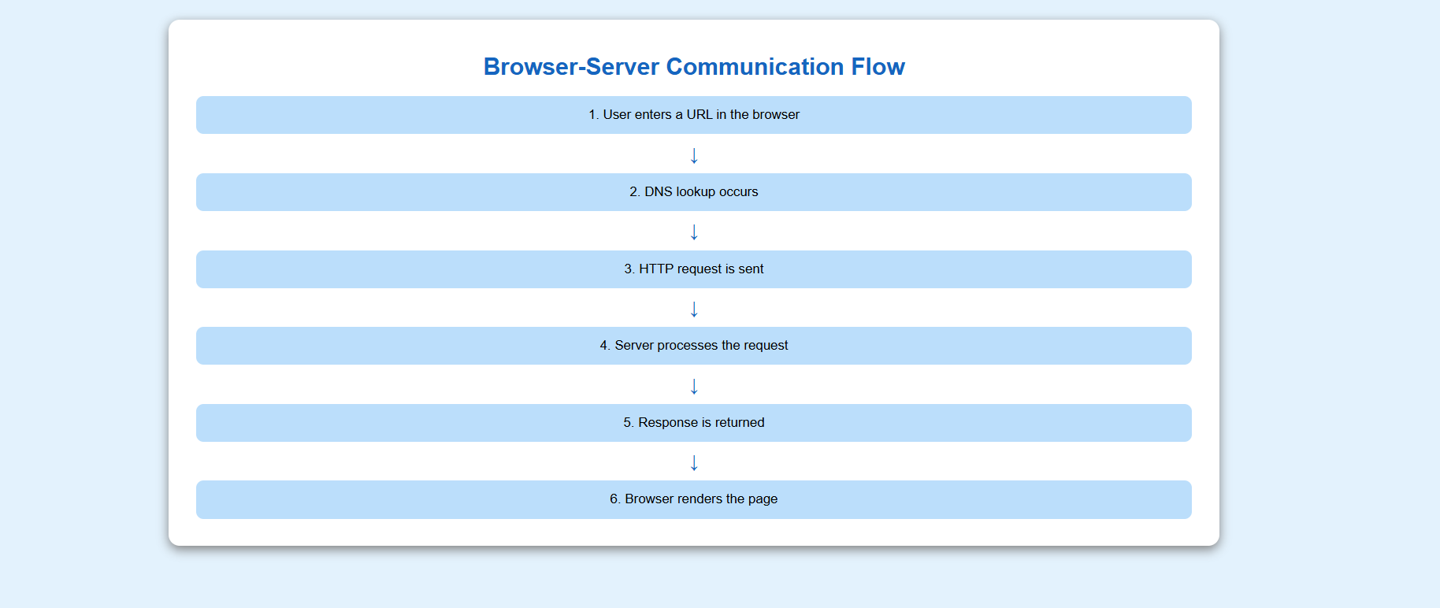

Conclusion
The browser-server communication process follows the sequence URL Entry → DNS Lookup → HTTP Request → Server Processing → HTTP Response → Page Rendering. This process allows users to access and view webpages through a web browser.

