CO1
ASSESSMENT -3

Scenario: Web Development Standards Implementation

Introduction
A startup is developing a modern web application that requires proper use of HTML, HTTP methods, semantic HTML, XML, and web protocols. The following answers identify the correct options with suitable justifications.

1. Correct HTML Tag for Video Embedding

Answer: B. <video src="video.mp4" controls></video>
The <video> tag is the standard HTML5 element used to embed video content on a webpage. The src attribute specifies the video file, and controls provides play, pause, and volume controls.
- A. <media> – Not a standard video element.
- B. <video> – Correct HTML5 video element.
- C. <movie> – Not a standard HTML element.
- D. <vid> – Not a standard HTML element.
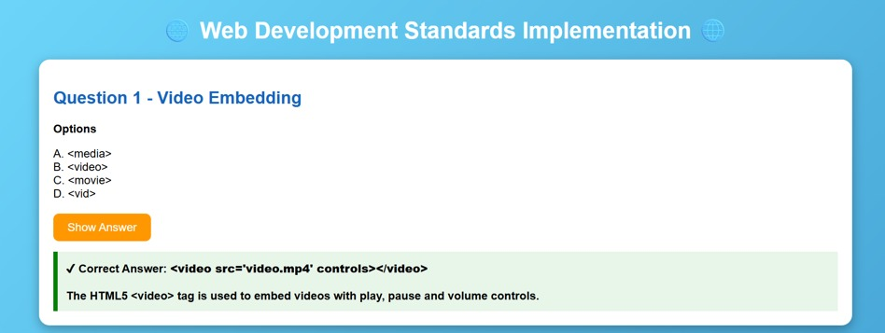

2. Appropriate HTTP Method for Form Submission

Answer: B. POST
The POST method is suitable for submitting registration data to the server. It sends the data in the request body instead of displaying it directly in the URL.
Advantages:
- Suitable for registration forms.
- Does not expose data in the URL.
- Appropriate for sending data to the server.
For secure transmission, HTTPS should be used along with POST.
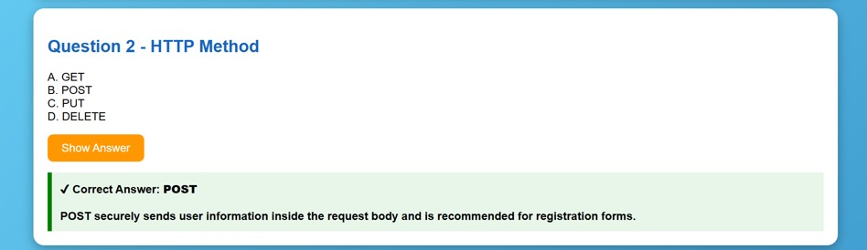

3. Proper Semantic Element for Navigation

Answer: B. <nav>
The <nav> element is specifically designed for navigation links such as Home, About, Services, and Contact.
It provides meaningful structure to the webpage, follows semantic HTML standards, and improves accessibility.
- <div> – General container.
- <nav> – Correct element for navigation.
- <section> – Used for thematic content.
- <header> – Used for introductory content.
Therefore, <nav> is the correct choice.
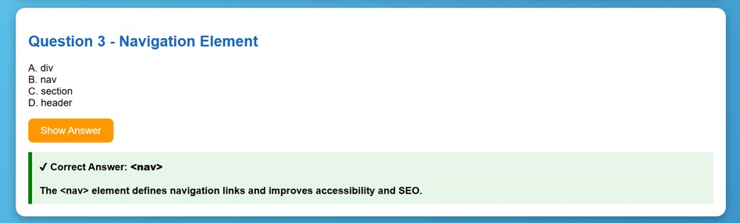

4. Correct XML Syntax

Answer: B. <note><to>User</to><from>Admin</from></note>
Option B is correct because all XML elements are properly opened and closed.
- A: </note> closing tag is missing.
- B: Correct XML syntax.
- C: <to> is incorrectly closed with </from>.
- D: The closing > is missing from </note>.

Correct XML:
<note>
<to>User</to>
<from>Admin</from>
</note>

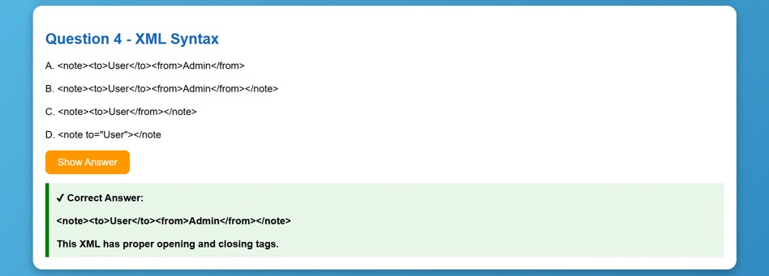

5. Correct Protocol for Web Communication

Answer: B. HTTP
HTTP (Hyper Text Transfer Protocol) is used for communication between a web browser and a web server.
The basic process is:
Browser → HTTP Request → Web Server
Browser ← HTTP Response ← Web Server
- FTP – File transfer.
- HTTP – Web communication.
- SMTP – Email communication.
- SNMP – Network management.
For secure web communication, HTTPS should be used.
