SIMATS ENGINEERING

ASSESSMENT TOOL 1: Analytical Problem Solving

COURSE NAME: | Cloud Computing and  Big Data Analytics | COURSE CODE: | CSA1508

COURSE OUTCOME COVERED
CO2: Analyze virtualization architectures to identify performance and security issues in cloud computing environments. (BL3)

Dave's Taxonomy: Manipulation (Level 2)  Question Count: 5 | Total Marks: 50

Code of Conduct
I L.SIVA TEJA(192311073)(Name / Reg No) certify that this submission is my original work and that I have adhered to the guidelines specified for this assessment.

I understand that any violation of academic integrity rules will result in disciplinary action. Signature of the student: L.SIVATEJA

Assessment Tasks Analytical Problem Solving
- A cloud data center experiences frequent live migrations of VMs during peak hours, leading to increased latency and service degradation. Analyze the impact of live migration on CPU, memory, and network resources. Propose strategies to optimize migration without affecting application performance.

Workflow Diagram

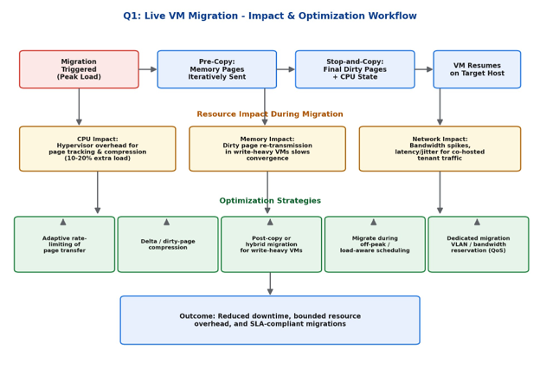
Figure 1: Live migration process, resource impact points, and optimization workflow

Analysis of Resource Impact
Live migration (typically using pre-copy) moves a running VM's memory, CPU state, and device state to a new host with minimal downtime. This process stresses three resources simultaneously:
- CPU: The hypervisor consumes extra CPU cycles for dirty-page tracking, checksumming, and optional compression, typically adding 10-20% overhead on both source and destination hosts, which competes with co-located VMs for cycles during peak load.
- Memory: In the iterative pre-copy phase, memory pages modified faster than they can be transferred (high write-intensity VMs) cause repeated re-transmission, delaying convergence and prolonging the window of degraded performance.
- Network: Migration traffic can consume a large share of available bandwidth, causing latency spikes and jitter for other tenant traffic sharing the same physical NIC/uplink, and increasing the risk of SLA breaches during peak hours.

Recommended Optimization Strategies
- Adaptive bandwidth throttling: Dynamically limit migration traffic rate based on current network load so production traffic is not starved.
- Delta / dirty-page compression: Reduce the volume of data retransmitted for write-heavy VMs.
- Post-copy or hybrid migration: Switch strategy for high write-rate VMs to shorten total migration time.
- Load-aware scheduling: Schedule non-urgent migrations during off-peak windows; prioritize based on SLA sensitivity.
- Dedicated migration network / QoS: Use a separate VLAN or bandwidth-reserved path for migration traffic so it does not compete with application traffic.

- Multiple tenants are running high-performance workloads on shared infrastructure, causing resource contention and SLA violations. Analyze the role of virtualization in resource allocation and contention. Recommend techniques such as scheduling policies or resource isolation methods to resolve the issue.
Scenario: Multiple tenants run high-performance workloads on shared infrastructure, causing resource contention and SLA violations.

Workflow Diagram

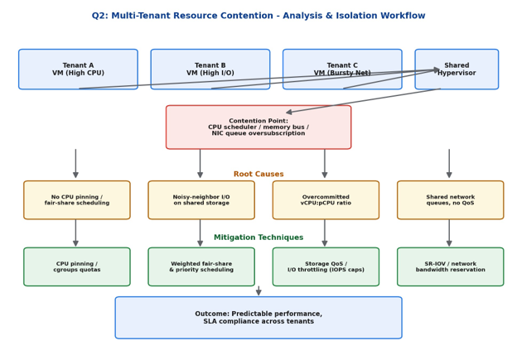

Figure 2: Contention pathway from tenant VMs through the shared hypervisor to mitigation controls.

Role of Virtualization in Resource Allocation

The hypervisor abstracts physical CPU, memory, storage, and network resources and shares them across tenant VMs using schedulers and allocation policies. When multiple high-performance workloads compete for the same physical resources without adequate isolation, 'noisy neighbor' effects occur: one tenant's workload can starve another's CPU cycles, memory bandwidth, storage IOPS, or network throughput, directly causing SLA violations.

Root Causes

Lack of CPU pinning or fair-share scheduling, allowing one VM to monopolize physical cores.

Shared storage back-ends without I/O throttling, letting one tenant's I/O burst degrade others.

Overcommitted vCPU-to-pCPU ratios beyond safe thresholds.

Shared NIC queues without traffic shaping or bandwidth guarantees.

Recommended Scheduling & Isolation Techniques

CPU pinning / cgroups quotas: Bind vCPUs to physical cores and enforce hard CPU limits per tenant.

Weighted fair-share scheduling: Allocate CPU proportionally based on tenant SLA tier/priority.

Storage QoS (IOPS/throughput caps): Enforce per-tenant I/O ceilings to prevent storage contention.

Network bandwidth reservation / SR-IOV: Guarantee minimum bandwidth per VM and isolate NIC

- A cloud environment using storage virtualization reports slow data access and high latency during peak operations. Analyze the possible causes related to storage virtualization layers. Suggest improvements in architecture or configuration to enhance storage performance.
Scenario: A cloud environment using storage virtualization reports slow data access and high latency during peak operations.

Workflow Diagram

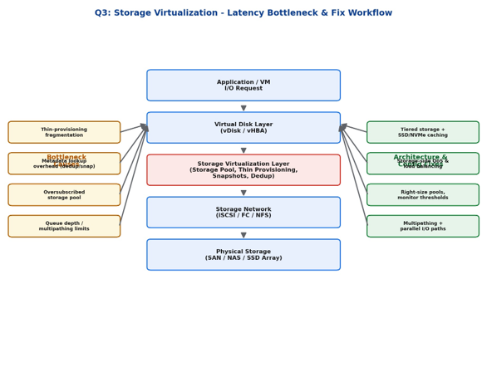

Figure 3: Storage virtualization stack showing bottleneck causes and corresponding fixes.

Possible Causes in the Storage Virtualization Layer

Thin-provisioning fragmentation: Logical blocks scattered across physical disks increase seek overhead and metadata lookups.

Metadata overhead from deduplication/snapshots: Every I/O may require extra metadata traversal, adding latency under heavy load.

Oversubscribed storage pools: Too many virtual disks mapped to limited physical IOPS capacity.

Queue depth and multipathing limits: Insufficient parallel I/O paths create queuing delays during peak concurrent access.

Architecture & Configuration Improvements

Tiered storage with SSD/NVMe caching for hot data to reduce average latency.

Storage-side QoS and load balancing across pools to prevent hotspot formation.

Right-sizing storage pools and proactive capacity/performance monitoring with alert thresholds.

Multipathing and parallel I/O paths to increase effective queue depth and throughput.

Scheduled maintenance (defragmentation, dedup consolidation) during off-peak hours.

- A software-defined network (SDN)-based cloud experiences a Distributed Denial of Service (DDoS) attack targeting virtual switches. Analyze how network virtualization components are affected by such attacks. Propose mitigation strategies using SDN security controls and traffic management techniques.
Scenario: An SDN-based cloud experiences a DDoS attack targeting virtual switches.

Workflow Diagram
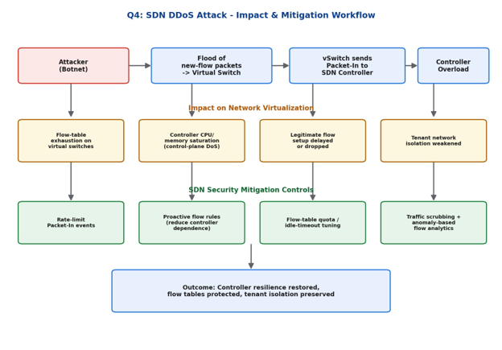
Figure 4: Attack propagation from botnet to controller overload, and corresponding SDN security controls.
Impact on Network Virtualization Components
- Flow-table exhaustion: Flooding virtual switches with new/spoofed flows fills limited flow-table entries, degrading forwarding for legitimate traffic.
- Controller overload (control-plane DoS): Every unmatched flow triggers a Packet-In to the SDN controller; a flood can saturate controller CPU/memory, a single point of failure in centralized SDN.
- Delayed flow setup: Legitimate new connections experience high setup latency or drops.
- Weakened tenant isolation: Overloaded virtual switches/controllers may fail to correctly enforce per-tenant network policies, risking cross-tenant leakage.
Mitigation Strategies Using SDN Security Controls
- Packet-In rate limiting at the switch/controller interface to cap control-plane load.
- Proactive (pre-installed) flow rules for known traffic patterns to reduce reliance on reactive controller lookups.
- Flow-table quota and idle-timeout tuning to evict stale/malicious flow entries quickly.
- Traffic scrubbing and anomaly-based flow analytics (e.g., entropy-based detection of spoofed flows) to identify and drop attack traffic before it reaches the controller.

- A company is choosing between containers and virtual machines for deploying micro services in a cloud environment. Analyze performance, scalability, and security trade-offs between containers and VMs. Justify which approach is more suitable for dynamic workloads with strict security requirements.

Scenario: A company is choosing between containers and VMs for deploying microservices with dynamic, strict-security workloads.
Workflow / Architecture Diagram

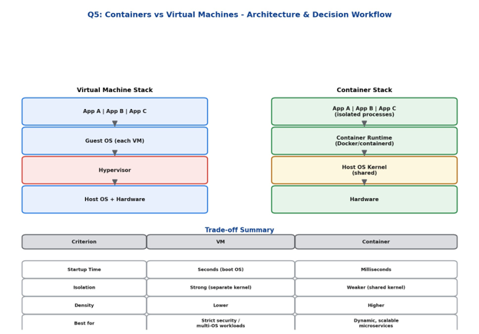

Figure 5: Architectural comparison of VM and container stacks with trade-off summary.

Performance, Scalability, and Security Trade-offs
Criterion | Virtual Machines | Containers
Startup time | Seconds (full OS boot) | Milliseconds (process start)
Resource overhead | Higher (guest OS per VM) | Lower (shared host kernel)
Isolation strength | Strong - separate kernel per VM | Weaker - shared kernel, namespace-based
Density (per host) | Lower | Much higher
Scalability / elasticity | Slower to scale out | Very fast to scale out/in
Attack surface | Smaller shared surface (hypervisor only) | Larger shared surface (kernel exploits affect all)

Justification / Recommendation

For dynamic microservice workloads requiring rapid scaling and high deployment density, containers are architecturally superior due to lightweight footprint and fast startup. However, since the scenario also demands strict security requirements, pure containers (which share the host kernel) present a larger attack surface than VMs.

The recommended approach is a hybrid model: run containers inside lightweight, per-workload VMs or use hardened container runtimes (e.g., Kata Containers, gVisor, or Firecracker microVMs). This combines the elasticity, density, and CI/CD-friendly nature of containers with VM-grade kernel isolation, satisfying both the scalability and strict security requirements of the microservices deployment.

Analytical Problem Solving Rubric

Criteria | Weightage | Level 4 - Exemplary | Level 3 – Proficient | Level 2 - Developing | Level 1 - Beginning
Problem Interpretation | 20% | Interprets all technical  requirements accurately | Interprets most requirements correctly | Partial interpretation | Misinterprets the problem
Analytical Reasoning | 25% | Strong reasoning with clear cause-  effect analysis | Good reasoning with minor gaps | Basic analysis only | Weak or no analysis
Method Selection | 20% | Chooses highly appropriate virtualization and  security concepts | Chooses mostly suitable concepts | Partially suitable concepts | Inappropriate approach
Solution Quality | 20% | Provides feasible  and technically sound solution | Reasonable  solution with minor issues | Basic solution with limitations | Unclear or invalid solution
Presentation of Analysis | 15% | Well-structured  and technically precise | Generally clear | Somewhat unclear | Difficult to follow

