

GENETIC SEQUENCE MOTIF FINDER
A PROJECT REPORT
Submitted in partial fulfillment of the requirements for the award of the degree of

MASTER OF TECHNOLOGY
in
COMPUTER SCIENCE AND ENGINEERING
By

GURALA SIVA TEJA REDDY
Student ID: 2601050128

under the supervision of
Dr. RAJU ANITHA
Professor
Department of Computer Science and Engineering



Koneru Lakshmaiah Education Foundation (KLEF)
Vaddeswaram, Andhra Pradesh, India
2026

DECLARATION
I hereby declare that the project report entitled “Genetic Sequence Motif Finder” is prepared for academic purposes under the guidance of Dr. RAJU ANITHA, Professor, Department of Computer Science and Engineering, Koneru Lakshmaiah Education Foundation. The report describes a Python-based application for identifying recurring patterns in DNA and protein sequences, recording motif positions and frequencies, comparing sequences, and evaluating sequential and parallel execution.
The report is based on the supplied project documentation and reference dataset. It describes k-mer hashing, divide-and-conquer scanning, multiprocessing, Longest Common Subsequence (LCS), and Smith–Waterman local alignment. Reported example results and test outcomes are reproduced from the project documentation; they are not presented as independent laboratory measurements performed while preparing this report.
I acknowledge the sources used for the theoretical foundations and related-work discussion. Any proposed extensions or validation steps are identified as future work rather than as completed implementation. This report is submitted in accordance with the institution’s academic-integrity requirements.

Place: Vaddeswaram
Signature of the Student: GURALA SIVA TEJA REDDY (2601050128)

ACKNOWLEDGEMENT
I express my sincere gratitude to Dr. RAJU ANITHA, Professor, Department of Computer Science and Engineering, Koneru Lakshmaiah Education Foundation, for the guidance and academic support associated with this project.
I thank the Department of Computer Science and Engineering and Koneru Lakshmaiah Education Foundation for providing an environment in which concepts from algorithms, operating systems, concurrency, and distributed systems could be applied to a practical sequence-analysis problem.
I also acknowledge the researchers whose work on motif discovery, k-mer indexing, sequence alignment, and parallel computation informs the theoretical discussion in this report. The supplied CSV reference collection was used to organize the literature review and references. Finally, I thank everyone who contributed suggestions or encouragement during the development and documentation of the Genetic Sequence Motif Finder.

Project Guide: Dr. RAJU ANITHA
Signature of the Student: GURALA SIVA TEJA REDDY (2601050128)
Place: Vaddeswaram

INDEX
S. No. | Topics | Page No.
1 | Introduction and Problem Definition | 6–8
2 | Literature Review and Theoretical Foundations | 9–11
3 | Proposed Methodology and System Architecture | 12–17
4 | Implementation and Interface Design | 18–20
5 | Experimental Setup, Results and Discussion | 21–25
6 | Conclusion, Limitations and Future Scope | 26–27
7 | References | 28–29

LIST OF TABLES
No. | Table Name | Page
2.1 | Comparison of related approaches | 10
3.1 | Software requirements | 12
3.2 | System architecture layers | 13
3.3 | Complexity of implemented modules | 17
4.1 | Project file organization | 18
4.2 | Worked k-mer indexing example | 17
4.3 | Interface and API operations | 19
4.4 | Implementation walkthrough | 20
5.1 | Documented experiment configuration | 20
5.2 | Bundled motif example results | 21
5.3 | Synthetic planted-motif results | 21
5.4 | Testing coverage | 22
8.1 | Glossary of terms | 24

LIST OF FIGURES
Figure | Caption | Page
Figure 1.1 | Conceptual motif repeated across DNA sequences | 6
Figure 3.1 | End-to-end system architecture | 12
Figure 3.2 | Motif-search workflow | 14
Figure 3.3 | Use case diagram | 15
Figure 3.4 | Sequence diagram | 15
Figure 3.5 | Activity diagram | 16
Figure 3.6 | Level-1 data flow diagram | 16
Figure 5.1 | Top recurring motifs in the synthetic example | 22
Figure 5.2 | LCS similarity matrix | 23

ABSTRACT
DNA and proteins are represented as sequences of symbols. Short recurring patterns in these sequences, commonly called motifs, can be useful clues for investigating binding sites, conserved regions, restriction sites, and other biological signals. As datasets grow, manual inspection becomes impractical; an analysis tool must identify repeated substrings, preserve their locations, compare sequences, and expose its computation in a reproducible manner.
This project presents the Genetic Sequence Motif Finder, a Python application that searches collections of DNA or protein sequences for recurring k-mers. The input pipeline parses FASTA data, normalizes residue case and whitespace, removes permitted formatting characters, detects the sequence alphabet, and validates records. The motif engine indexes substrings of configurable lengths using hash tables and position lists. A divide-and-conquer strategy recursively partitions valid k-mer start positions, while chunk-based multiprocessing allows independent regions to be scanned concurrently. Partial maps are merged into a unified motif index; configurable thresholds then filter and rank candidate motifs.
For sequence comparison, the system computes Longest Common Subsequence (LCS) similarity and uses Smith–Waterman local alignment to identify a high-scoring conserved region. Results can be inspected through a command-line interface or a local browser dashboard, and exported in CSV or JSON form. The project also includes a benchmark that compares sequential and process-pool execution on repeatable workloads and checks result equivalence.
The supplied documentation reports 20 passing unit tests. In the bundled three-sequence example, ATGCGT is reported five times across three sequences, while related recurring substrings are also identified. In a synthetic dataset of 30 DNA sequences of 1,000 residues each, the documented search recovered planted motifs including ATGCGTAC (51 occurrences across 25 sequences) and CGCGAATT (40 occurrences across 21 sequences). These figures describe the supplied example outputs and should not be interpreted as biological validation or universal performance guarantees. Limitations include memory growth with distinct k-mers, quadratic alignment cost, simple gap scoring, and process overhead for small inputs. The project provides an inspectable educational framework for combining string algorithms, indexing, concurrency, and sequence comparison.
Keywords: DNA sequence analysis, protein sequence, motif discovery, k-mer, hashing, divide and conquer, multiprocessing, LCS, Smith–Waterman, FASTA.

1 INTRODUCTION

1.1 Background
Genomic and proteomic data are strings over finite alphabets. DNA sequences use the nucleotide symbols A, C, G, and T, with ambiguity symbols appearing in some biological datasets; protein sequences use letters representing amino-acid residues. A short sequence pattern that appears repeatedly may indicate a conserved region or a candidate functional signal. Motif discovery is therefore an important exploratory task in computational biology, although a repeated string alone does not prove biological function [1], [2].
A sequence of length n contains n − k + 1 overlapping substrings of length k, provided n ≥ k. These substrings are called k-mers. Enumerating and counting k-mers offers a transparent baseline for exact motif discovery: each distinct k-mer can be associated with the sequence identifiers and start positions where it appears. Hash tables make average-case insertion and lookup efficient, while storing positions supports traceability and visualization [3], [4].
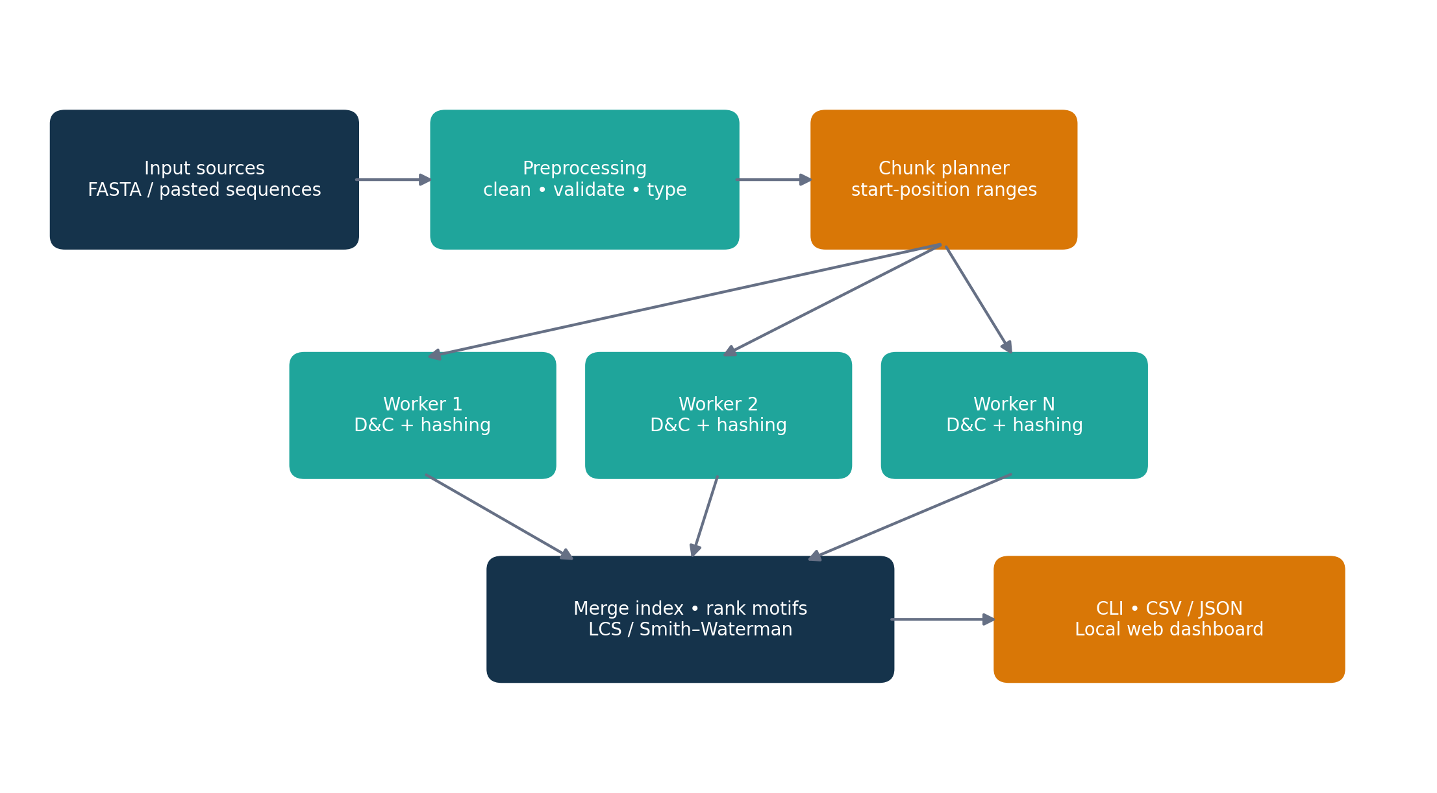
Figure 1.1: Conceptual processing pipeline for sequence motif discovery.
Motif discovery and sequence alignment answer related but different questions. Exact k-mer counting identifies repeated strings without allowing substitutions or gaps. LCS measures the longest ordered subsequence shared by two strings, while Smith–Waterman local alignment finds a high-scoring local correspondence under a scoring scheme. Combining these views allows the application to report both exact recurrence and approximate sequence similarity [5], [6].

1.2 Problem Definition
Given a collection of DNA or protein sequences, the system must identify recurring patterns over a configurable k range, report each pattern’s total occurrences and per-sequence positions, rank motifs according to user-selected criteria, compare sequences, and do so efficiently enough for medium-sized educational datasets. The input may be supplied as FASTA records or through the dashboard. Invalid alphabets, empty sequences, duplicate identifiers, and chunk boundaries must be handled predictably.
The central engineering challenge is to preserve exact counts and positions while partitioning the search. Splitting raw sequence text without overlap can lose motifs that cross chunk boundaries. The implementation therefore partitions valid start positions and extends chunk text by up to kmax − 1 residues where required, so each k-mer is assigned to the chunk in which it starts. Parallel and sequential execution must use the same search semantics and produce equivalent outputs.

1.3 Project Objectives
- Find recurring exact motifs across multiple DNA or protein sequences using configurable k-mer lengths.
- Record all motif occurrences per sequence using 1-based positions in reports.
- Filter and rank motifs by occurrence count, number of sequences, length, and optional maximal-motif criteria.
- Compare sequence pairs using LCS-derived similarity and Smith–Waterman local alignment.
- Scale independent scans through divide-and-conquer partitioning and multiprocessing.
- Provide command-line and local web interfaces, structured exports, validation, and automated tests.
- Benchmark sequential and parallel runs using identical tasks and verify result equality.

1.4 Scope
The current project is an offline analysis prototype. It processes user-provided or synthetic FASTA data and presents results through a CLI and a local dashboard. It does not retrieve sequences from public biological databases, infer motif function, perform statistical enrichment against a background model, or replace established production tools. The reported planted-motif dataset is synthetic and is useful for checking recovery behavior, not for demonstrating clinical or biological validity.

1.5 Existing System
A manual workflow may use text searches, spreadsheet counts, or separate bioinformatics utilities. Such approaches can work for small examples but become difficult to reproduce when multiple motif lengths, many sequences, and exact position reporting are required. A simple whole-file scan may also repeat work, while ad hoc parallel scripts can accidentally lose boundary-spanning k-mers or combine duplicate results incorrectly.
Specialized motif discovery systems often incorporate probabilistic models, background distributions, sequence logos, biological priors, or optimized indexes. These methods can be more suitable for particular scientific questions but may require external packages, reference databases, or more complex configuration. The project intentionally implements exact k-mer recurrence and standard alignment methods using Python’s standard library, keeping the algorithmic behavior inspectable and portable.

1.6 Proposed System
The proposed system uses a staged pipeline: parse and validate input; plan chunks over k-mer start positions; scan each region with recursive divide and conquer and hash indexing; merge partial motif maps; apply filters and ranking; optionally calculate LCS similarities and Smith–Waterman alignments; and export the results. The same core engine is called from the command-line interface and the local HTTP dashboard, reducing the chance that the interfaces behave differently.

1.7 Advantages and Applications
- Provides exact occurrence counts and auditable 1-based positions.
- Supports both DNA and protein alphabets through preprocessing and validation.
- Separates indexing, parallel scheduling, alignment, analysis, and presentation into modules.
- Offers reproducible sequential-versus-parallel comparisons with equality checks.
- Useful for algorithm education, exploratory sequence analysis, conserved-region inspection, and synthetic-data experiments.

1.8 Organization of the Report
Chapter 2 reviews related research and the algorithmic foundations. Chapter 3 describes requirements, architecture, data flow, and algorithms. Chapter 4 explains the software modules, interfaces, and implementation decisions. Chapter 5 presents documented examples, tests, and performance interpretation. Chapter 6 concludes the report and discusses limitations and future work. References and appendices follow.

2 LITERATURE REVIEW AND THEORETICAL FOUNDATIONS

2.1 Introduction
Sequence motif discovery has evolved from direct pattern searches toward probabilistic motif models, compressed indexes, colored k-mer structures, and parallel sequence-analysis pipelines. The supplied reference collection includes work on motif discovery, exact k-mer indexing, multiple sequence alignment, LCS, and accelerated Smith–Waterman computation. This chapter uses those works to position the present project as a compact educational integration rather than a new biological discovery algorithm.

2.2 Motif Discovery Approaches
Hash-based exact counting is attractive when the target is a literal substring and the desired outputs include all positions. It avoids the need to compare every candidate against every sequence independently: a hash map maps each k-mer to its observed locations. Its main cost is memory, because the number of distinct k-mers can approach the number of scanned windows. The review by Hashim, Mabrouk, and Al-Atabany surveys multiple motif-finding approaches and highlights that the choice of method depends on motif assumptions and data characteristics [1].
STREME focuses on accurate and versatile motif discovery and is designed for statistical motif analysis rather than simple exact counting [2]. SEA addresses motif enrichment analysis, a related task that asks whether a motif is over-represented relative to a background [3]. These approaches are complementary to the project: the current engine identifies repeated exact substrings, while statistical discovery and enrichment would be logical future modules.

2.3 K-mer Indexing and Data Structures
K-mers are a common abstraction for indexing sequencing datasets. Marchet et al. discuss data structures for querying large collections of sequencing data, and BLight studies an efficient exact associative structure for k-mers [4], [5]. Themisto uses a scalable colored k-mer index to support sensitive pseudoalignment across many datasets [6]. The masked Burrows–Wheeler-transform-based FMSI work targets space-efficient indexing for unconstrained k-mer sets [7]. These systems emphasize that index representation strongly affects memory, query speed, and scale.
The current project uses Python dictionaries because they are simple, available in the standard library, and suitable for a teaching implementation. It stores the actual positions required for explanatory output, which can consume more memory than a membership-only or compressed index. Rolling hashes, succinct structures, and disk-backed indexes could reduce memory pressure, but they introduce complexity and are not part of the current implementation.

2.4 Sequence Alignment and Similarity
LCS is a dynamic-programming formulation that finds the longest ordered subsequence shared by two strings. It permits skipped characters but does not directly model biological substitution scores. A normalized similarity measure, 2 × LCS(A,B) / (|A| + |B|), lies between zero and one and is useful as a compact comparison score. Prior work has explored memory-efficient and parallel LCS computation, including dynamic MPI-based frameworks and adaptive large-scale algorithms [8], [9].
Smith–Waterman local alignment uses a scoring recurrence that allows alignment to restart at zero and reports the best-scoring local region. This is useful when sequences share a conserved segment but differ elsewhere. Parallel tiled implementations and more recent actor-based implementations investigate accelerating this dynamic program [10], [11]. The present project uses a simple match/mismatch/gap scoring scheme and is intended to explain the recurrence and traceback rather than compete with optimized libraries.

2.5 Parallel Search and Heterogeneous Computation
Parallel sequence processing is effective when tasks are independent and the cost of distributing them is lower than the saved computation time. Research on rapid parallel protein search and FPGA-accelerated chromosome mapping demonstrates the importance of matching data partitioning and compute architecture to the workload [12], [13]. Parallel multiple-sequence alignment methods similarly aim to exploit independence and reduce the cost of large comparisons [14].
The project uses multiprocessing with one task per sequence chunk. This avoids relying on Python threads for CPU-bound parallelism, but it introduces process startup, task serialization, scheduling, and merge costs. As a result, a parallel run is not guaranteed to be faster for small inputs. A valid benchmark reports end-to-end timing and checks output equality rather than assuming that additional workers always improve throughput.

2.6 Related Work Comparison
Approach | Strength | Limitation | Relationship to this project
Exact k-mer hashing | Simple; returns exact counts and locations | Memory grows with distinct k-mers | Core motif index
Statistical motif discovery | Can model motif patterns and background | More assumptions and configuration | Future comparison / extension
Compressed or colored indexes | Improved scale and query efficiency | Complex index construction and representation | Potential optimization
LCS dynamic programming | Interpretable sequence similarity | O(nm) time and memory in full table | Implemented similarity measure
Smith–Waterman | Finds best local alignment | Scoring choice affects results; O(nm) baseline | Implemented local alignment
Multiprocessing | Uses multiple CPU cores for independent tasks | Overhead may exceed benefit | Implemented optional execution mode

Table 2.1: Comparison of related approaches.

2.7 Research Gap and Project Positioning
The supplied literature spans sophisticated indexing and alignment methods, but an educational implementation benefits from making the full pipeline visible: parsing, exact indexing, safe partitioning, parallel merge, ranking, alignment, and export. The project’s practical gap is therefore pedagogical integration and reproducibility. It demonstrates how several standard techniques cooperate and provides a common code path for sequential and multiprocessing execution.

2.8 Theoretical Foundations
For a sequence S of length n and a fixed k, valid start positions are 0 through n − k. If 1-based output positions are required, internal index i is reported as i + 1. For each k-mer, the index stores a mapping from sequence identifier to an ordered list of start positions. Frequency is the sum of all position-list lengths; sequence support is the number of sequence identifiers with at least one occurrence.
Divide and conquer splits a valid start-position interval into smaller intervals. A leaf scans its assigned positions; the merge operation combines maps while preserving sorted positions. This partitioning is correct when each valid start position is owned by exactly one leaf. Text overlap is used only to make the residues needed for the largest k available at the end of a chunk; overlapping text must not cause the same start position to be counted twice.
For LCS, let L[i,j] be the length of the longest common subsequence of prefixes A[0:i] and B[0:j]. If characters match, L[i,j] = L[i−1,j−1] + 1; otherwise it is max(L[i−1,j], L[i,j−1]). Smith–Waterman replaces the count recurrence with a local score recurrence and includes zero as a candidate, ensuring that negative-scoring prefixes are discarded.

2.9 Chapter Summary
The literature supports the use of k-mer indexing for exact recurrence and dynamic programming for sequence comparison, while also showing opportunities for compressed indexes, statistical motif models, richer scoring matrices, and specialized parallel execution. The present project selects transparent baseline methods and emphasizes correctness, explainability, and repeatable outputs.

3 PROPOSED METHODOLOGY AND SYSTEM ARCHITECTURE

3.1 Methodology Overview
The system is organized as a data-processing pipeline with preprocessing, chunk planning, motif search, result combination, analysis, alignment, and reporting stages. A single core implementation is shared by the CLI and web dashboard. This modular design isolates algorithmic correctness from user-interface behavior and allows the engine to be tested without starting the HTTP server.
Figure 3.1: End-to-end architecture of the Genetic Sequence Motif Finder.

3.2 Hardware and Software Requirements

3.2.1 Hardware Requirements
- A modern laptop or desktop processor; multiple CPU cores are useful for multiprocessing experiments.
- Sufficient RAM for the input sequences, distinct k-mer index, occurrence lists, and alignment tables.

3.2.2 Software Requirements
Component | Technology | Purpose
Programming language | Python 3.9+ | Core algorithms and orchestration
Dependencies | Python standard library | Portable parsing, hashing, multiprocessing, HTTP and exports
Input format | FASTA / pasted sequences | Sequence records with identifiers
Frontend | HTML, CSS, JavaScript | Dashboard controls and visualizations
Server | Standard-library HTTP server | Local JSON API and static page
Testing | Unittest | Algorithm, boundary, API and equivalence tests
Output | Console, CSV, JSON | Readable and reusable analysis results

Table 3.1: Software requirements.

3.3 Functional Requirements
- FR-1 Input ingestion: read FASTA records or accept sequence text from the dashboard.
- FR-2 Preprocessing: normalize case and whitespace, handle digits/gaps as documented, detect DNA versus protein alphabet, and reject invalid or empty records.
- FR-3 Motif search: scan a configurable inclusive range from kmin to kmax and index all exact k-mer positions.
- FR-4 Parallel execution: distribute independent chunks to worker processes and merge partial results without losing or duplicating occurrences.
- FR-5 Analysis: filter by minimum occurrences and sequence support; sort results and optionally retain maximal motifs.
- FR-6 Alignment: compute LCS similarity and Smith–Waterman local alignment for selected sequences.
- FR-7 Reporting: show tables and plots, expose CSV/JSON exports, and summarize run parameters.
- FR-8 Benchmarking: compare sequential and parallel timings and verify output equality.

3.4 Non-Functional Requirements
Correctness requires exact counts, valid positions, consistent sequential/parallel results, and alignment scores that follow the stated recurrence. Usability requires clear input labels and informative validation errors. Portability is supported by standard-library-only implementation. Maintainability comes from separating preprocessing, search, alignment, analysis, CLI, server, and benchmark modules. Performance should be measured with representative inputs because both memory consumption and process overhead depend on dataset shape and machine configuration.
Security and reliability considerations include restricting the dashboard to local use by default, limiting input sizes for untrusted requests, validating numeric parameters before expensive computation, and avoiding assumptions that uploaded data is trustworthy. The educational server is not described as a hardened public production service.

3.5 System Architecture Layers
Layer | Components | Responsibility
Input / presentation | CLI, dashboard, FASTA upload/paste | Collect data and analysis options
Preprocessing | FASTA parser, normalizer, alphabet detector | Validate and standardize records
Search engine | k-mer hash index, divide-and-conquer scanner | Find exact motifs and preserve positions
Execution | Sequential loop, multiprocessing pool | Schedule independent chunk tasks
Analysis | Frequency filters, ranking, maximal-motif filter | Select and order reportable motifs
Alignment | LCS, Smith–Waterman | Compare sequences and recover local regions
Output | Console, CSV, JSON, browser views | Present results and support reuse

Table 3.2: System architecture layers.

3.6 Data Flow
The user selects or provides a dataset and sets kmin, kmax, minimum occurrence count, minimum sequence support, sorting criteria, and execution mode. Preprocessing creates normalized sequence records. The planner creates tasks over valid start positions, retaining enough trailing residues to construct k-mers near chunk boundaries. Each worker returns a partial map keyed by motif and sequence. The combiner merges and sorts position lists; the analyzer computes counts, applies filters, and produces ranked rows. If alignment is enabled, a selected set of sequences is passed to the LCS and Smith–Waterman routines. Finally, results are rendered and can be exported.

3.7 Motif Search Workflow
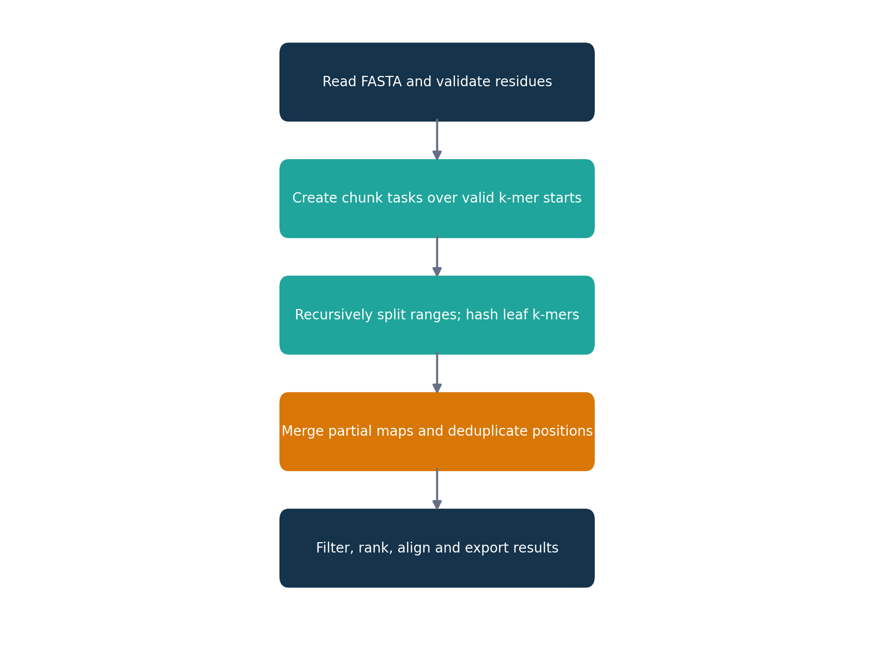
Figure 3.2: Workflow from validated input to motif reports.

3.8 Use Case Diagram
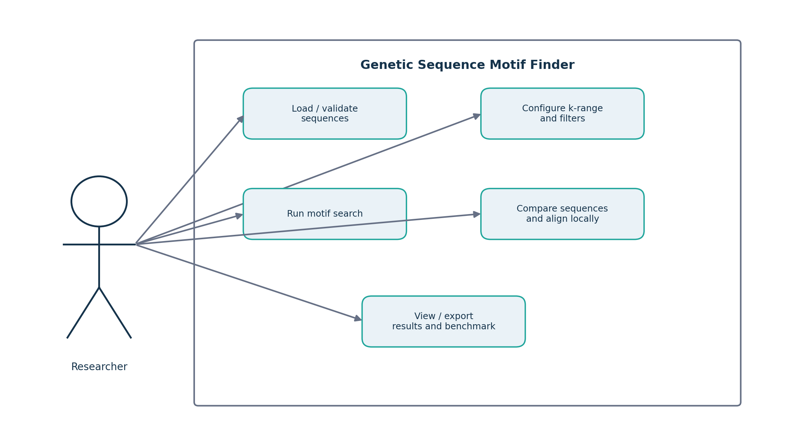
Figure 3.3: Use cases available to a researcher using the application.

3.9 Sequence Diagram
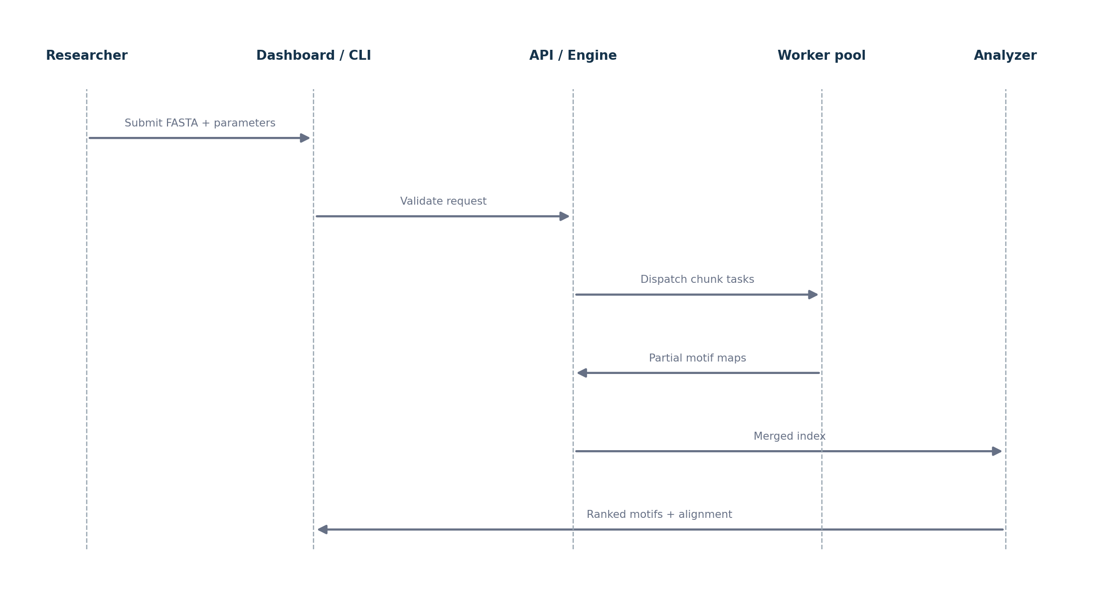
Figure 3.4: Sequence of interactions for a motif-search request.

3.10 Activity Diagram
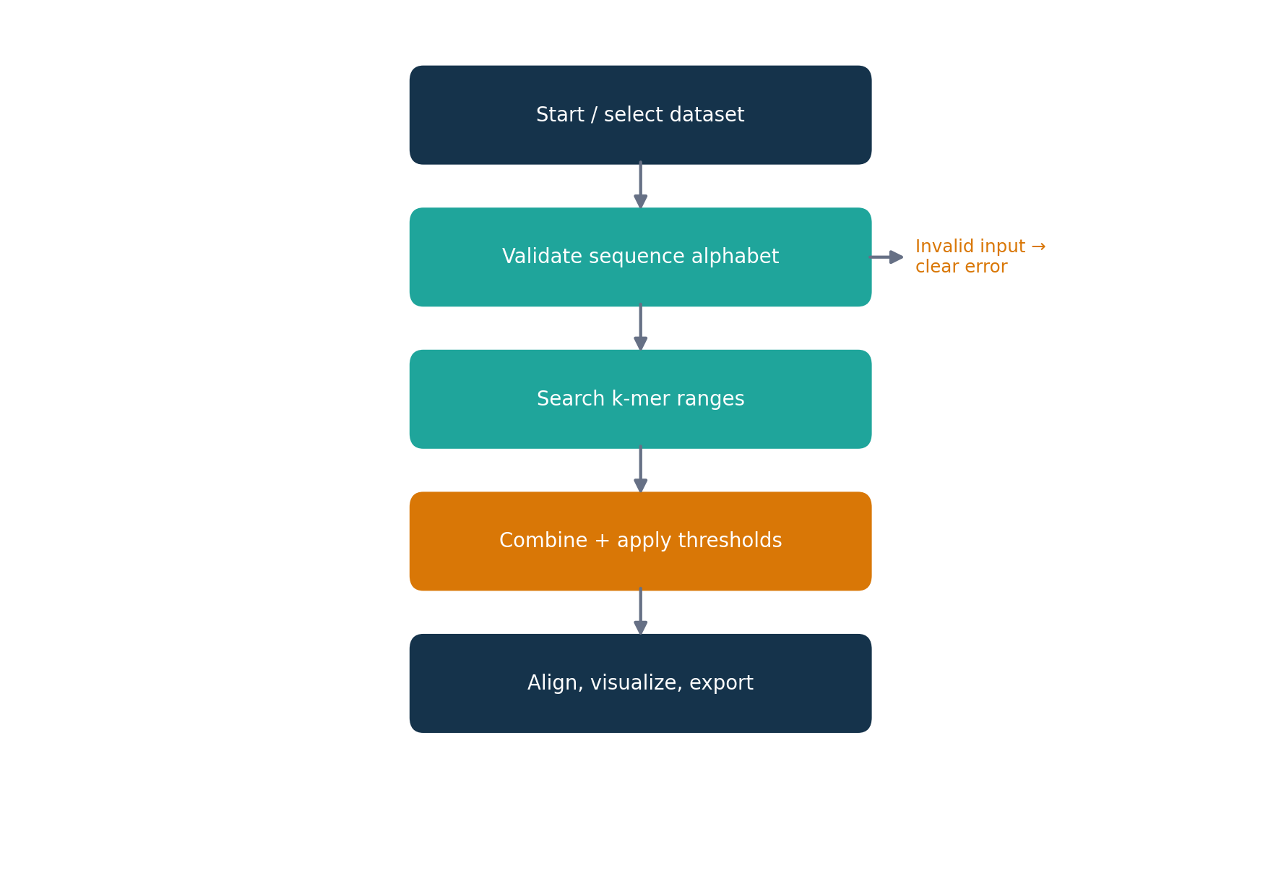
Figure 3.5: Activity flow including input-validation failure handling.

3.11 Data Flow Diagram
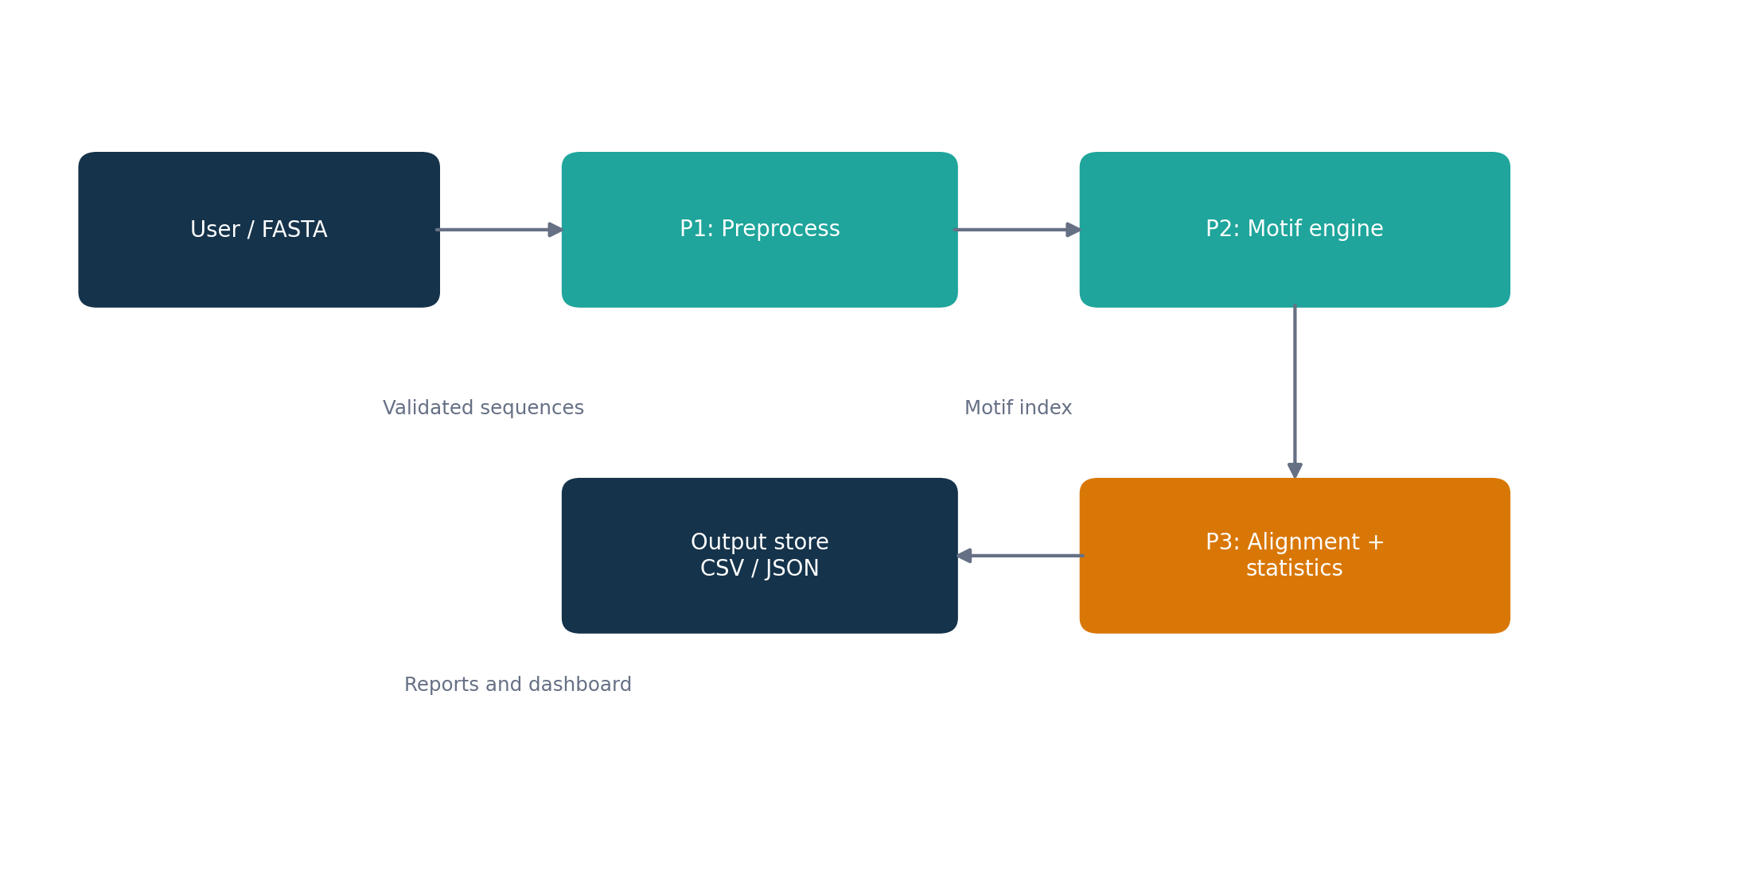
Figure 3.6: Level-1 data flow from input records to exported results.

3.12 Algorithm Design

3.12.1 K-mer Hashing
For each valid start position i and each requested k, the engine extracts S[i:i+k] and appends the position to the motif’s list. Hash-map insertion is average O(1), excluding substring construction and list growth. Scanning one sequence for a single k takes O(n) window operations; scanning a range of lengths performs work proportional to the number of valid windows across all k values.

3.12.2 Divide and Conquer
The recursive scanner receives a half-open range of valid start positions. If the range is at or below base_size, it scans directly. Otherwise, it splits the interval into two smaller intervals and merges their maps. Because the ranges are disjoint, each start position is counted once. The sequence text itself is not naively split without overlap, which would miss motifs spanning a split.

3.12.3 Multiprocessing
Chunk tasks are independent and can be scheduled across a process pool. Worker results are partial motif indexes. The parent process merges those indexes using the same combination logic as sequential mode. The benchmark uses the same task set in both modes and reports Tseq / Tpar as speedup; efficiency is speedup divided by the number of workers. These values are workload-specific.

3.12.4 Complexity Summary
Module | Time complexity (baseline) | Space complexity | Notes
k-mer scan | O(n × K) windows for K requested lengths | O(U + P) | U distinct k-mers; P stored positions
Divide and conquer | Same total scan work plus merge overhead | O(U + P) plus recursion | Partitioning does not change exact results
Multiprocessing | Useful work / workers + overhead | Worker partial maps + merged map | Speedup is not guaranteed
LCS | O(nm) | O(nm) full table | Can be reduced with rolling rows if only length is needed
Smith–Waterman | O(nm) | O(nm) for traceback table | Scoring scheme influences alignment
Ranking | O(M log M) | O(M) | M candidate motifs

Table 3.3: Complexity of the principal modules. K denotes the number of requested k lengths, U the number of distinct motifs, P the number of stored occurrences, and M the number of candidate motifs.

4 IMPLEMENTATION AND INTERFACE DESIGN

4.1 Implementation Environment
The project is implemented in Python 3.9 or later and uses the standard library, according to the supplied documentation. This keeps installation simple and makes the program suitable for local demonstrations. The implementation is organized into focused modules, with a command-line entry point, a lightweight local HTTP server, and a test suite. No claim is made here that the program has been deployed as a public or clinical service.

4.2 Project File Organization
File / directory | Responsibility
preprocessing.py | Parses FASTA, cleans residue strings, detects DNA/protein alphabets, validates records and handles duplicate IDs.
motif_search.py | Implements k-mer hashing primitives and scans a range of valid start positions.
divide_conquer.py | Recursively partitions start positions and merges partial maps.
multiprocessing_search.py | Builds chunk tasks, runs sequential/process-pool scans and combines results.
sequence_alignment.py | Implements LCS length/string, similarity matrix, Smith–Waterman local alignment and traceback.
analysis.py | Filters and ranks motifs, applies maximal-motif logic, formats tables and exports CSV/JSON.
main.py | Command-line interface and optional alignment workflow.
server.py + static/ | Local web dashboard, JSON API and browser interaction.
benchmark.py + generate_data.py | Sequential-versus-parallel timing and synthetic FASTA generation with planted motifs.
tests/ | Unit tests for parsing, search correctness, boundaries, alignment and API behavior.

Table 4.1: Project file organization based on the supplied project documentation.

4.3 Preprocessing Module
Preprocessing reads FASTA records and associates each sequence with an identifier. It normalizes case and removes whitespace; the documented implementation also strips digits and gap characters according to its input-cleaning rules. It detects whether the sequence is DNA or protein and validates the permitted alphabet. Empty records and invalid symbols should produce clear errors rather than silently entering the search stage. Duplicate identifiers require a deterministic handling rule so that results remain attributable to the correct record.

4.4 Motif Search and Index Construction
For each sequence, the search engine enumerates requested k lengths and records every valid occurrence. The logical index can be described as motif → sequence identifier → list of 1-based positions. Internally, scanning may use zero-based offsets, converting only when formatting results. Position lists are sorted after merging, ensuring stable output and reproducible exports. Overlapping occurrences are included: a motif can begin at consecutive positions if the sequence supports it.

k-mer | Positions in ATGCGTATG (k = 3) | Interpretation
ATG | [1, 7] | Two occurrences
TGC | [2] | One occurrence
GCG | [3] | One occurrence
CGT | [4] | One occurrence
GTA | [5] | One occurrence
TAT | [6] | One occurrence

Table 4.2: Worked k-mer indexing example. Positions are 1-based, consistent with report output.

4.5 Divide-and-Conquer Scanner
The divide-and-conquer implementation recursively splits a valid start-position interval until the interval reaches a configurable leaf size. Leaf regions are scanned directly. The partial dictionaries are merged as recursion unwinds. This structure demonstrates decomposition and aggregation while retaining the same exact scan semantics as a straightforward loop. The correctness-critical detail is that chunk ownership is based on start positions rather than arbitrary non-overlapping text slices.

4.6 Multiprocessing Search
The multiprocessing module creates tasks from sequence/chunk pairs. Each task can run independently and returns a partial map. The parent combines the maps, preserving per-sequence position lists. A sequential mode follows the same task definitions but executes tasks one after another; this provides a useful reference implementation for correctness checks and timing comparisons. Since workers must serialize task inputs and return potentially large maps, multiprocessing is expected to help only when the work per task is sufficiently large.

4.7 Sequence Alignment Module
The LCS component calculates the longest common subsequence length and, where required, reconstructs an LCS string. Pairwise similarity is normalized as 2L/(|A|+|B|), where L is the LCS length. The Smith–Waterman implementation uses match +2, mismatch −1, and gap −2, with a floor of zero in each dynamic-programming cell. Traceback from the highest-scoring cell identifies the best local region. These settings are simple and transparent; they are not equivalent to a domain-specific protein scoring matrix.

4.8 Analysis and Export
The analysis layer computes total occurrences and the number of distinct sequences containing each motif. It supports minimum occurrence and minimum sequence-support thresholds, sorting, and an optional maximal-motif filter. The filter is intended to reduce redundant reports where a shorter motif’s occurrence pattern is fully represented by a longer motif extension under the implementation’s rule. CSV is convenient for spreadsheets and downstream scripts; JSON preserves nested position structures and can be consumed by other applications.

4.9 Interfaces and API Operations
Interface / operation | Input | Output / purpose
CLI: main.py --align | Bundled example or default input | Console motif table and optional alignment
CLI: custom FASTA | Input path, kmin/kmax, filters and sort | Ranked motif results
CLI: benchmark.py | Benchmark configuration | Sequential/parallel time, speedup and equality
Web: /api/analyze | Dataset/FASTA, k range, filters, execution mode | Analysis result in JSON
Web: /api/benchmark | Scenario count and worker configuration | Timing, speedup, efficiency and result-match status
Dashboard export | Current analysis result | Downloadable CSV or JSON

Table 4.3: Interfaces and API operations described in the supplied documentation.

4.10 Implementation Walkthrough
Step | Operation | Correctness / design detail
1. Preprocess | Parse FASTA; normalize and validate | Reject empty or invalid records
2. Chunk | Assign start-position ranges | Extend accessible text by up to kmax − 1 residues
3. Search | Scan requested k lengths recursively | Leaf size controls recursion depth
4. Combine | Merge partial motif maps | Sort positions; preserve sequence identity
5. Analyze | Apply thresholds and rank | Optional maximal-motif reduction
6. Align | Compute LCS and local alignment | Limit alignment size to control O(nm) cost
7. Report | Render table and export data | CLI, CSV, JSON and dashboard

Table 4.4: Implementation walkthrough.

4.11 Input Validation and Error Handling
Validation should occur before CPU-intensive work. The input stage checks that kmin is positive, kmax is not smaller than kmin, sequences are non-empty, and requested positions fit the sequence length. The web API must check required fields and numeric types before invoking the engine. Extreme input sizes or very large k ranges can lead to high memory use, so a deployed service should enforce explicit limits. The supplied documentation describes input-validation tests for the web API.

4.12 Reproducibility
Reproducibility is supported by deterministic synthetic data, fixed benchmark scenario seeds, stable output ordering, a shared sequential/parallel code path, and automated tests. A report of any new timing experiment should record the processor, Python version, operating system, sequence count, total residues, k range, filters, chunk size, worker count, and whether process startup is included. The current supplied documentation does not provide a complete hardware specification for the cited timing examples.

5 EXPERIMENTAL SETUP, RESULTS AND DISCUSSION

5.1 Evaluation Goals
The evaluation described in the supplied project documentation addresses four questions: whether the engine finds the expected repeated patterns; whether it reports positions and sequence support correctly; whether alignment routines produce interpretable similarity outputs; and whether parallel execution preserves the sequential result. Benchmark timing is workload- and machine-dependent, so performance numbers are interpreted as observations rather than guarantees.

5.2 Test Environment and Parameters
Parameter | Documented configuration / note
Language | Python 3.9+
Dependencies | Standard library only
Test framework | Unittest
Unit tests | 20 tests reported as passing in supplied documentation
Small example | Three DNA sequences used in the project brief
Synthetic example | 30 DNA sequences × 1,000 residues = 30,000 residues
Motif search range | k = 4 to 8 for planted-motif example
Filters | Maximal motifs; minimum sequence support of 10
Benchmark modes | Sequential and multiprocessing process pool
Machine caveat | Documentation notes a single-core test machine for one verification context

Table 5.1: Test environment and parameters. Hardware-specific timing details are not fully specified in the supplied project documentation.

5.3 Bundled Example: Motif Frequency and Position
The project documentation gives a worked example containing three short DNA sequences. In this example, the motif ATGCGT appears five times across the three sequences. The same output includes GCGT with five occurrences and GATG with three occurrences. The result table below reproduces the selected rows from the project documentation and uses 1-based positions.
Motif | Occurrences | Sequences found | Positions (sequence:position)
ATGCGT | 5 | 3 | Sequence_1:1, Sequence_1:10, Sequence_2:3, Sequence_3:3, Sequence_3:11
GCGT | 5 | 3 | Sequence_1:3, Sequence_1:12, Sequence_2:5, Sequence_3:5, Sequence_3:13
GATG | 3 | 3 | Sequence_1:9, Sequence_2:2, Sequence_3:10

Table 5.2: Selected results from the bundled three-sequence example.
These rows show why storing positions is valuable: a total count alone does not reveal whether a motif is distributed across records or repeated within only one record. Sequence support and position lists make the output easier to verify and interpret.

5.4 Synthetic Planted-Motif Experiment
The supplied documentation reports a synthetic dataset of 30 random DNA sequences, each 1,000 residues long. Four motifs were planted: ATGCGTAC, GGATCC, TATAAT, and CGCGAATT. The search used k values from 4 through 8, maximal-motif filtering, and a minimum support threshold of ten sequences. The documentation reports that ATGCGTAC appeared 51 times across 25 sequences and CGCGAATT appeared 40 times across 21 sequences. Shifted overlapping strings such as TATGCGTA, TGCGTACT, and TGCGTACC also ranked among the leading results.
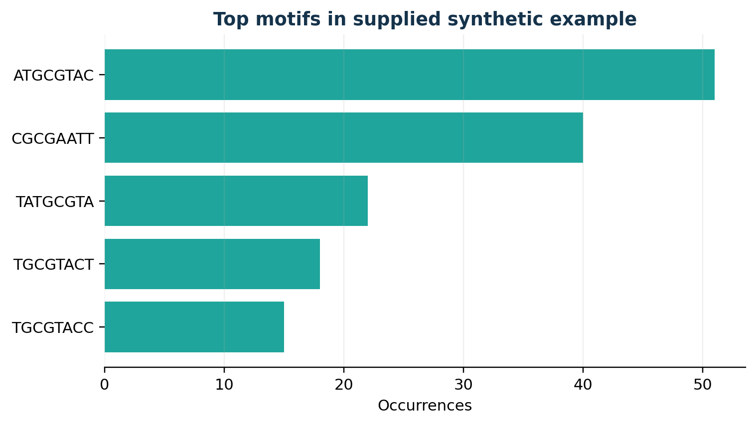
Figure 5.1: Top motifs and occurrence counts reproduced from the documented synthetic example.
Motif | Occurrences | Sequences found / note
ATGCGTAC | 51 | 25 sequences
CGCGAATT | 40 | 21 sequences
TATGCGTA | 22 | Overlapping/shifted form
TGCGTACT | 18 | Overlapping/shifted form
TGCGTACC | 15 | Overlapping/shifted form

Table 5.3: Selected top entries from the synthetic planted-motif experiment.
The recovery of planted patterns demonstrates the basic behavior expected from exact k-mer indexing. Shifted or overlapping strings can also be frequent because the planted motif contributes windows that share many residues. This is not necessarily a false positive in exact counting; it reflects the distinction between counting repeated substrings and inferring one canonical biological motif.

5.5 Sequence Similarity and Local Alignment
The supplied documentation reports an LCS similarity matrix for the three-sequence example with off-diagonal values 0.73, 0.84, and 0.65. The values indicate relative similarity under the chosen normalized LCS metric; they are not probabilities that two sequences share a biological function. The diagonal is 1.00 because each sequence is identical to itself.
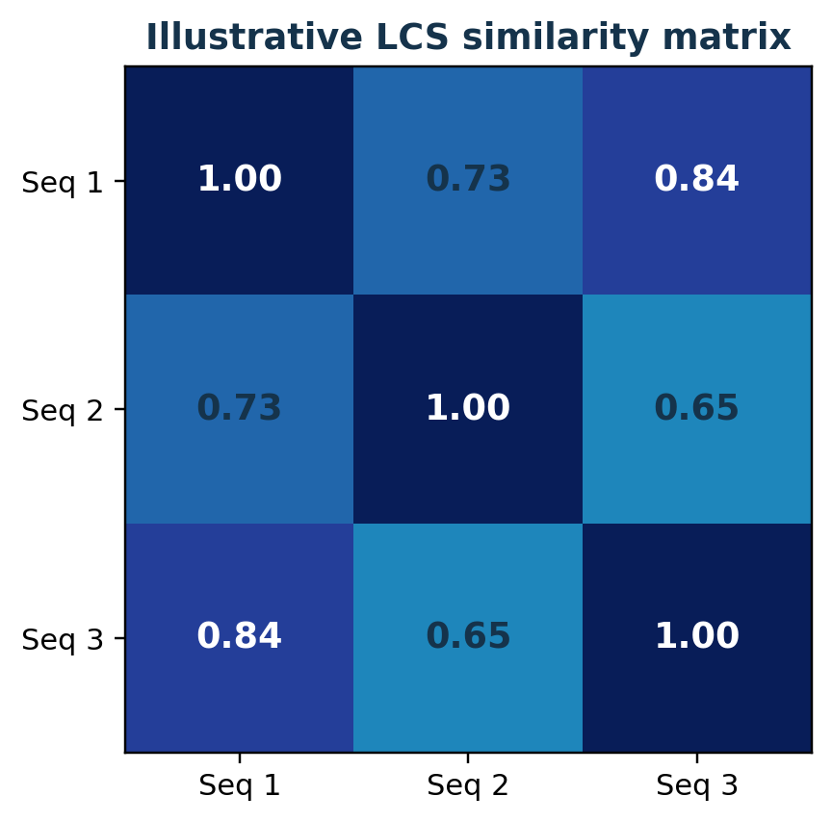
Figure 5.2: LCS similarity matrix from the supplied project documentation.
For the documented local alignment between Sequence_1 and Sequence_3, Smith–Waterman produced score 23 and reported 87% identity, with LCS similarity 0.84. The documentation also notes a shared stretch GATGCGT between Sequence_2 and Sequence_3 with 100% identity for that local segment. Alignment output depends on the match, mismatch, and gap scores, and percentages should be interpreted in the context of the aligned region rather than the full-length sequences.

5.6 Sequence Map and Dashboard Interpretation
The dashboard’s sequence map marks positions where a selected motif occurs across records. It supports visual inspection of whether occurrences cluster near particular regions or are distributed across the sequence. The dashboard also includes summary cards, a top-motif bar chart, a sortable motif table, alignment results, and a benchmark view. These are described in the project documentation as interface features; the report does not claim that a new live dashboard session was executed during document generation.
The web interface runs locally through server.py and exposes JSON endpoints for analysis and benchmarking. Its use of the same engine as the command-line tool is a maintainability advantage. Exporting results to CSV or JSON allows downstream filtering, plotting, and archival without copying values manually.

5.7 Testing Strategy
The supplied project documentation states that 20 unit tests pass. The listed coverage includes FASTA parsing and validation, equality between divide-and-conquer and plain scanning for multiple base sizes, chunk-boundary handling with small chunks, sequential/parallel result equivalence, the bundled worked example, LCS and Smith–Waterman correctness, and web API behavior. These test claims are attributed to the supplied documentation; they have not been rerun independently for this report.
Test category | Expected property | Documented coverage
FASTA parsing | Valid records parsed; invalid/empty records rejected | Included
Search equivalence | Divide-and-conquer counts match plain scan | Included across base sizes
Boundary handling | No k-mer lost or duplicated at chunk edges | Included with tiny chunks
Parallel equivalence | Sequential and parallel indexes match | Included
Worked example | Known motif counts and positions reproduced | Included
LCS / Smith–Waterman | Lengths, scores and traceback are consistent | Included
Web API | Validation, benchmark rows and sample listing | Included

Table 5.4: Testing coverage reported in the supplied project documentation.

5.8 Performance Analysis
The benchmark evaluates identical chunk tasks sequentially and through a process pool, then reports elapsed time, worker count, speedup, efficiency, and result equality. Speedup is calculated as Tseq/Tpar; efficiency is speedup divided by the number of workers. A speedup above one means the parallel run was faster for that particular experiment. A value below one means overhead outweighed the benefit.
The documentation explicitly warns that a single-core test machine is expected to show slower parallel execution and recommends measuring on a multi-core computer with a larger input. Process startup, serialization, scheduling, and merging can dominate small workloads. Consequently, this report does not invent timing values or claim a general speedup. A valid comparison requires repeated trials on a stated machine and should distinguish search time from total end-to-end time.

5.9 Threats to Validity
- Synthetic data has known planted motifs but does not reproduce the distribution, mutation patterns, repeats, or ambiguity of real biological data.
- Exact k-mer recurrence is not the same as statistical motif discovery or biological functional validation.
- Performance depends on CPU, memory, Python version, process start method, chunk size, and the number of stored positions.
- Alignment results depend on sequence selection, truncation limits, scoring parameters, and the metric used.
- The supplied documentation reports tests and results, but the report-generation process did not independently rerun the project executable.

5.10 Discussion
The examples support the intended educational outcomes: the program can enumerate exact recurring strings, report their locations, recover known planted patterns in a synthetic dataset, compare short sequences, and check parallel output against sequential output. The system’s strongest contribution is the integration of several standard techniques into one inspectable workflow. Its main constraints are memory growth, quadratic alignment cost, and the limited biological interpretation of exact recurrence. Further evaluation on curated real datasets would be needed before drawing scientific conclusions.

6 CONCLUSION, LIMITATIONS AND FUTURE SCOPE

6.1 Conclusion
The Genetic Sequence Motif Finder demonstrates how hashing, divide and conquer, multiprocessing, and dynamic programming can be combined in a practical sequence-analysis pipeline. It accepts DNA or protein sequences, validates and normalizes the input, indexes k-mers with their positions, merges partial results, ranks recurring motifs, compares sequences using LCS similarity, and produces a local Smith–Waterman alignment. CLI and browser-based interfaces make the engine accessible for demonstrations, while CSV and JSON exports support downstream inspection.
The supplied documentation reports 20 passing unit tests and gives reproducible examples, including the ATGCGT motif in a three-sequence dataset and planted motifs in a synthetic dataset of 30 sequences. These results illustrate expected behavior, but do not establish biological significance or guarantee performance on arbitrary datasets. Parallel execution is a measured option rather than an automatic improvement.

6.2 Advantages
- Clear modular separation between preprocessing, indexing, execution, alignment, analysis and presentation.
- Exact occurrence positions and sequence support make motif reports auditable.
- Configurable motif length, thresholds, ranking and optional maximal-motif filtering.
- Sequential and multiprocessing modes share search semantics and can be checked for output equality.
- Uses Python’s standard library, reducing installation complexity.
- Includes automated tests and synthetic-data generation to support repeatable demonstrations.

6.3 Limitations
- Memory usage increases with distinct k-mers and stored positions; broad k ranges on large data can be expensive.
- LCS and Smith–Waterman use O(nm) dynamic-programming tables in the baseline implementation, so alignment is limited to selected or truncated sequences.
- Exact k-mer recurrence does not account for substitutions, gaps, probabilistic motif models, or background enrichment.
- Smith–Waterman uses simple linear scoring; protein-specific matrices such as BLOSUM are not included.
- Multiprocessing may be slower for small workloads because task management and result transfer add overhead.

6.4 Future Enhancements
- Implement rolling-hash or packed k-mer encodings to reduce substring-allocation cost.
- Add streaming or external-memory indexing for datasets that do not fit comfortably in RAM.
- Integrate statistically grounded motif discovery and enrichment, with explicit background models and significance estimates.
- Support IUPAC ambiguity symbols and configurable policies for ambiguous residues.
- Add BLOSUM/PAM scoring for protein alignment and affine gap penalties.
- Explore optimized libraries, tiled dynamic programming, GPU kernels, or cluster execution for large-scale workloads.
- Improve benchmarking with repeated trials, confidence intervals, hardware metadata, memory measurements, and workload-size sweeps.
- Add structured logs, request limits, clearer downloadable reports, and a hardened deployment configuration.
- Validate findings on curated biological datasets and compare against established tools using sensitivity, precision, and runtime metrics.

6.5 Final Remarks
The project is a useful foundation for learning string processing and parallel algorithm design through a domain-relevant problem. Its outputs are most appropriately used for exploration, teaching, and testing algorithmic behavior. Extending it toward scientific use requires statistical validation, larger real-world benchmarks, domain-aware scoring, and careful interpretation by qualified researchers.

REFERENCES
[1] Jeremy W. Schroeder, Vivian Ramirez, Michael B. Wolfe, L. Freddolino, “ShapeME: A tool and web front-end for de novo discovery of structural motifs underpinning protein-DNA interactions,”, Journal of molecular biology, 2026. doi: 10.1016/j.jmb.2026.169810.
[2] Reza Rafati Bonab, A. Jamali, Kyle Klenk, Mohammad Mahdi Moayeri, Raymond J. Spiteri, “SW-actors: accelerating the Smith–Waterman algorithm via actors,”, Bioinformatics Advances, 2025. doi: 10.1093/bioadv/vbaf173.
[3] O. Sladký, P. Veselý, K. Břinda, “FroM Superstring to Indexing: a space-efficient index for unconstrained k-mer sets using the Masked Burrows-Wheeler Transform (MBWT),”, Bioinformatics Advances, 2025. doi: 10.1093/bioadv/vbaf290.
[4] S. Singh, Dharanya T, Aarthi N, N. S, “A Dynamic MPI-Based Memory-Efficient Framework for Longest Common Subsequence Computation on Massive DNA Sequence,”, International Journal of Innovative Science and Research Technology, 2025. doi: 10.38124/ijisrt/25may1297.
[5] Z. Kong, Shiwei Wei, Wen-Ming Huang, Rui Yang, Zhenrong Deng, “An Efficient Parallel and Adaptive Algorithm for Large-Scale Multiple Longest Common Subsequence Problems,”, IEEE Access, 2026. doi: 10.1109/access.2026.3659505.
[6] Jie-Fu Li, Zi-Yuan Wang, Xuwei Fan, Ruijie Yao, Guoqing Zhang, Rui Fan, Ze-Feng Wang, “Rapid multiple protein sequence search by parallel and heterogeneous computation,”, Bioinformatics, 2024. doi: 10.1093/bioinformatics/btae151.
[7] Subhankar Roy, A. Mukhopadhyay, “A Randomized Optimal k-mer Indexing Approach for Efficient Parallel Genome Sequence Compression.,”, Gene, 2024. doi: 10.1016/j.gene.2024.148235.
[8] Yanming Wei, Quan Zou, Furong Tang, Liang Yu, “WMSA: a novel method for multiple sequence alignment of DNA sequences,”, Bioinformatics, 2022. doi: 10.1093/bioinformatics/btac658.
[9] Jarno N. Alanko, Jaakko Vuohtoniemi, T. Mäklin, S. Puglisi, “Themisto: a scalable colored k-mer index for sensitive pseudoalignment against hundreds of thousands of bacterial genomes,”, Bioinformatics, 2023. doi: 10.1093/bioinformatics/btad233.
[10] C. Marchet, Mael Kerbiriou, A. Limasset, “BLight: efficient exact associative structure for k-mers,”, Bioinformatics, 2021. doi: 10.1093/bioinformatics/btab217.
[11] T. Bailey, Charles E. Grant, “SEA: Simple Enrichment Analysis of motifs,”, bioRxiv, 2021. doi: 10.1101/2021.08.23.457422.
[12] R. Lebsir, Abdesslem Layeb, F. Tahi, “A Greedy Clustering Algorithm for Multiple Sequence Alignment,”, Int. J. Cogn. Informatics Nat. Intell., 2021. doi: 10.4018/ijcini.20211001.oa41.
[13] Arpan Kumar, Sarbajit Manna, “Graphic user interface based implementation of longest common subsequence problem in DNA sequencing,”, SEVENTH INTERNATIONAL SYMPOSIUM ON NEGATIVE IONS, BEAMS AND SOURCES (NIBS 2020), 2021. doi: 10.1063/5.0057916.
[14] T. Bailey, “STREME: Accurate and versatile sequence motif discovery,”, bioRxiv, 2020. doi: 10.1101/2020.11.23.394619.
[15] C. Marchet, C. Boucher, S. Puglisi, P. Medvedev, Mikaël Salson, R. Chikhi, “Data structures based on k-mers for querying large collections of sequencing data sets,”, Genome Research, 2019. doi: 10.1101/866756.
[16] Fatma A. Hashim, Mai S. Mabrouk, W. Al-Atabany, “Review of Different Sequence Motif Finding Algorithms,”, Avicenna Journal of Medical Biotechnology, 2019. Available: https://consensus.app/papers/review-of-different-sequence-motif-finding-algorithms-hashim-mabrouk/673c310efc12506c8e78cdf6c152ce19/
[17] M. Pałkowski, W. Bielecki, “Parallel Tiled Codes Implementing the Smith–Waterman Alignment Algorithm for Two and Three Sequences,”, Journal of Computational Biology, 2018. doi: 10.1089/cmb.2018.0006.
[18] F. N. Muhamad, R. Ahmad, S. M. Asi, M. Murad, “Performance Analysis Of Needleman-Wunsch Algorithm (Global) And Smith-Waterman Algorithm (Local) In Reducing Search Space And Time For Dna Sequence Alignment,”, Journal of Physics: Conference Series, 2018. doi: 10.1088/1742-6596/1019/1/012085.
[19] Asmaa G. Seliem, Hesham F. A. Hamed, Wael Abouelwafa, “MapReduce Model Using FPGA Acceleration for Chromosome Y Sequence Mapping,”, IEEE Access, 2021. doi: 10.1109/access.2021.3085997.

