Infosys Springboard Virtual Internship 6.0 Completion Report

Team Details:

Batch Number: 6 SmartStock Inventory Optimization for Retail Stores
Start date : 10-11-2025
Names:
- Sivateja Somisetty
- Hephzibai E
- Vaishnavi Potu
- Sahithya kedala
Internship Duration: 8 Weeks

1. Project Title
SmartStock Inventory Optimization for Retail Stores

2. Project Objective
SmartStock Management System is to design and develop a data-driven inventory and sales monitoring platform that helps retailers efficiently manage stock levels, analyze sales performance, and support informed decision-making.
- Centralized Inventory Management
  - To maintain a centralized system for managing product details, categories, stock levels, and reorder thresholds across multiple stores and cities.
- City and Store-based Sales Analysis
  - To enable filtering of sales data based on city and store, allowing managers to analyze regional performance and store-specific trends.
- Real-time Stock Monitoring
  - To identify low-stock and overstock products in real time, reducing stockouts and minimizing excess inventory.
- Category-wise Inventory Insights
  - To visualize inventory distribution across product categories such as Groceries, Toys, and Electronics using interactive charts.
- Sales Performance Visualization
  - To present sales summaries through graphical dashboards for better understanding of demand patterns and product movement.
- Decision Support System
  - To assist store managers and business owners in making data-backed decisions regarding restocking, pricing strategies, and inventory optimization.
- Scalable & User-friendly Web Application
  - To build a responsive and scalable application using the MERN stack (MongoDB, Express.js, React.js, Node.js) with an intuitive user interface.

3. Project description in detail
The SmartStock Management System is a web-based application developed to efficiently manage inventory and analyze sales data across multiple stores and cities. The system addresses common challenges in traditional inventory management, such as stock shortages, overstocking, lack of real-time insights, and difficulty in analyzing regional sales performance.
The application provides a centralized platform where product details, inventory levels, sales transactions, and demand-related information are stored and managed securely. By integrating sales and inventory data, the system enables businesses to monitor product movement, identify trends, and optimize stock management strategies.
The frontend of the system is built using React.js, offering a responsive and user-friendly dashboard with interactive charts and filters. Users can view category-wise inventory levels, track low-stock and overstock products, and analyze sales performance using city and store-based filters. Data visualization tools such as bar charts enhance understanding and support quick decision-making.
The backend is developed using FastAPI and Python, which handles API requests, business logic, and data processing. MySQLis used as the database to store product, sales, and store information, ensuring scalability and efficient data retrieval. RESTful APIs enable smooth communication between the frontend and backend.
Overall, the SmartStock Management System acts as a decision support tool that improves operational efficiency, reduces inventory-related losses, and supports data-driven business decisions. The system is scalable and can be extended in the future to include features such as demand forecasting, automated reorder alerts, supplier integration, and advanced analytics.
4. Timeline Overview
Week | Activities Planned | Activities Completed
Week 1 | Requirement analysis, problem identification, use-case mapping | Problem definition finalized, system objectives identified
Week 2 | Technology stack selection, system architecture planning | TECH stack finalized, high-level architecture designed
Week 3 | Dataset collection and understanding, data preprocessing plan | Sales & inventory dataset cleaned and structured
Week 4 | Database schema design, MongoDB collections setup | Product, store, sales schemas created
Week 5 | Backend API development (CRUD operations) | APIs for inventory and sales implemented
Week 6 | Authentication & role-based access (Admin / Store Manager) | Secure login and role-based dashboard access enabled
Week 7 | Frontend UI wireframes, dashboard layout design | Core React UI integrated with backend APIs
Week 8 | Data visualization (charts, tables, filters) | Category-wise and city-wise dashboards functioning
Week 9 | Inventory analysis logic (low stock, overstock alerts) | Stock status indicators and alerts implemented
Week 10 | Advanced filtering (city, store, category), UI polishing | Dynamic filters and responsive UI completed
Week 11 | Testing (functional, UI, data accuracy), debugging | End-to-end testing completed with sample data
Week 12 | Documentation, report writing, future enhancements planning | Project finalized and ready for evaluation

5a. Key Milestones
Milestone | Description | Date Achieved
Project Kickoff | Defined project objectives, scope, functional requirements, system architecture, and success criteria for the SmartStock inventory and sales dashboard. | 10 Nov 2025
Prototype / First Draft | Developed the initial working prototype including product management, city/store-based filtering, backend API integration, and basic dashboard UI. | 18 Nov 2025
Mid-Term Review | Conducted a progress review to evaluate inventory logic, sales summary calculations, data visualization accuracy, and implemented required refinements. | 30 Nov 2025
Final Submission | Completed and submitted the fully functional SmartStock system with inventory tracking, sales analytics, responsive UI, and project documentation. | 24 Dec 2025
Final Presentation | Delivered final demonstration showcasing system architecture, real-time dashboard insights, filtering capabilities, and overall project outcomes. | 31 Dec 2025

5b. Project execution details
The execution of the SmartStock Inventory and Sales Management System followed a structured and iterative development approach to ensure accuracy, scalability, and usability.
The project commenced with requirement analysis, where the problem of inefficient inventory tracking and limited sales visibility was studied. Functional and non-functional requirements were identified, including product management, city and store-based filtering, real-time stock monitoring, and sales analytics. Sample sales and inventory datasets were collected to simulate real-world retail scenarios.
Next, the backend development phase was initiated using python, FastAPI, and MySQL. Database schemas were designed to store product details, city-wise and store-wise sales data, and inventory quantities. RESTful APIs were implemented to support CRUD operations, dynamic filtering by city and store, and aggregated sales summaries required for dashboard visualization.
Parallelly, the frontend development was carried out using React and Tailwind CSS. Core UI components such as dashboards, filter dropdowns, summary cards, and charts were developed. Recharts was integrated to visualize category-wise inventory levels and sales performance through bar charts, enabling clear analytical insights.
The business logic layer focused on calculating inventory metrics such as total products, low-stock alerts based on reorder levels, and overstock identification. Category-wise stock aggregation and sales summaries were dynamically generated based on user-selected filters, ensuring accurate and responsive data representation.
The system then underwent iterative testing and debugging, where API responses, data binding, and UI interactions were validated. Issues related to filtering, missing data, and visualization consistency were resolved. Performance testing ensured smooth rendering of charts and seamless interaction across filters.
Finally, the project was refined and documented, with enhancements such as theme support, responsive design, and user-friendly navigation. The completed system was demonstrated, showcasing its ability to provide real-time inventory insights, improve sales decision-making, and support efficient stock management across multiple cities and stores, thereby fulfilling the project objectives.

6. Snapshots / Screenshots
Step 1: Go to GitHub and clone the SmartStock – Inventory Optimization for Retail Stores repository to your local system.
Open the project folder in VS Code for execution and development. https://github.com/HEPHZIBAI/SmartStock-Inventory-Optimization-for-Retail-Stores
Step 2: Start the backend server by navigating to the backend folder and running:
- Install dependencies
- Run the server using npm start
This will start the backend API using Node.js, Express, and MongoDB.
Step 3: Start the frontend application by navigating to the frontend folder and running:
- Install dependencies
- Start the React application using npm start
The application will open in the browser at localhost:3000.
Step 4: This is the Landing Page of SmartStock, which includes:
- Basic navigation
- Login option
- Overview of inventory optimization features
- AI-powered chatbot access for assistance
Step 5: After clicking on Login, the user must authenticate based on their role:
- Admin Login
- Store Manager Login
Role-based authentication ensures secure access to data.
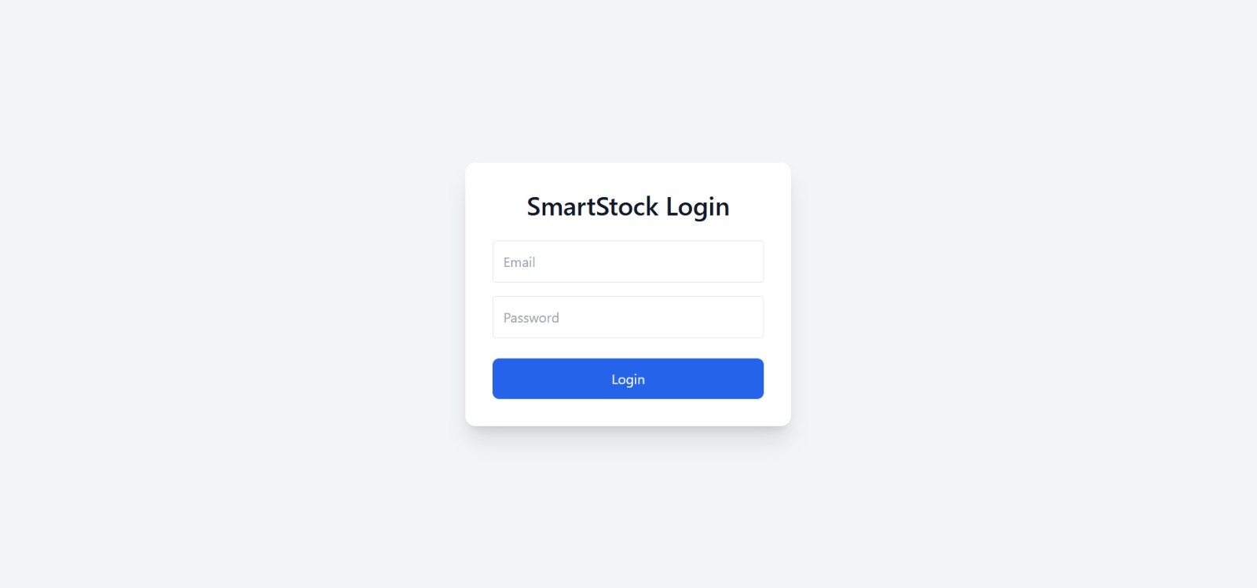
Step 6: Once logged in:
- Admin is redirected to the Admin Dashboard
- Store Manager is redirected to the Store Dashboard
Each dashboard displays data relevant to the user’s role.
Step 7: In the Store Dashboard, the Store Manager can view:
- Total products
- Low stock items
- Overstock items
- Category-wise stock visualization using charts
This helps monitor store-level inventory efficiently.
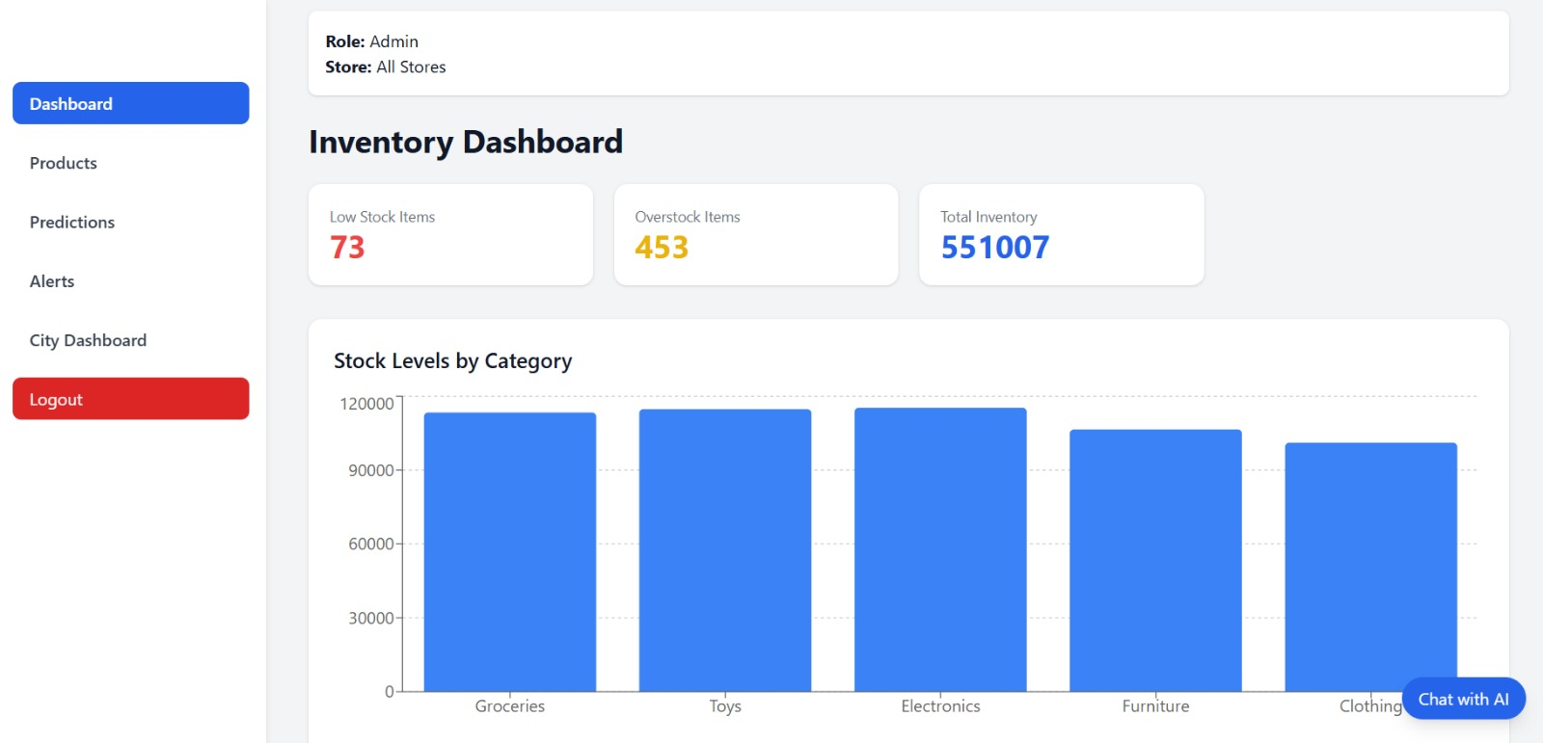
Step 8: In the Products section, Store Managers can:
- View product details
- Track inventory levels
- Identify low stock and reorder points
This ensures smooth inventory control at the store level.
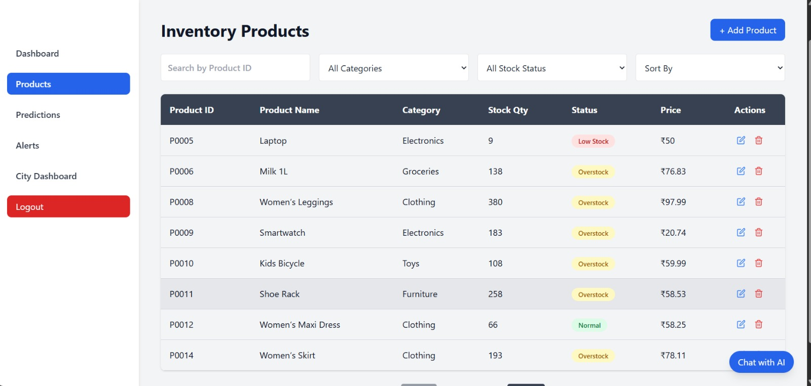
Step 9: The Predictions tab provides:
- Demand forecasting
- Stock status (Understock / Balanced / Overstock)
- AI-driven insights based on historical sales data
This helps in proactive inventory planning.
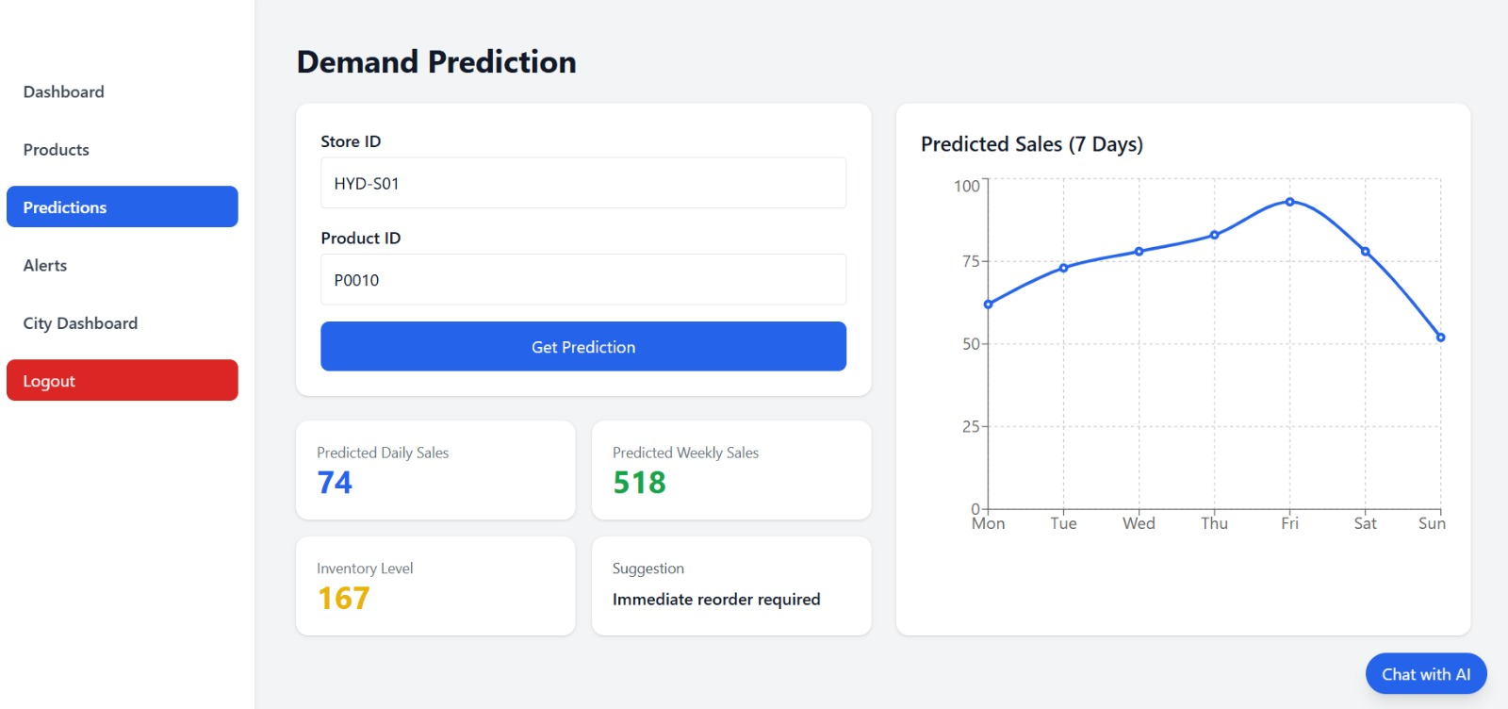
Step 10: The City Dashboard (Admin View) displays:
- City-wise total sales
- Inventory distribution
- Number of stores per city
- Graphical representation using bar charts
Admins can analyze performance across multiple cities.
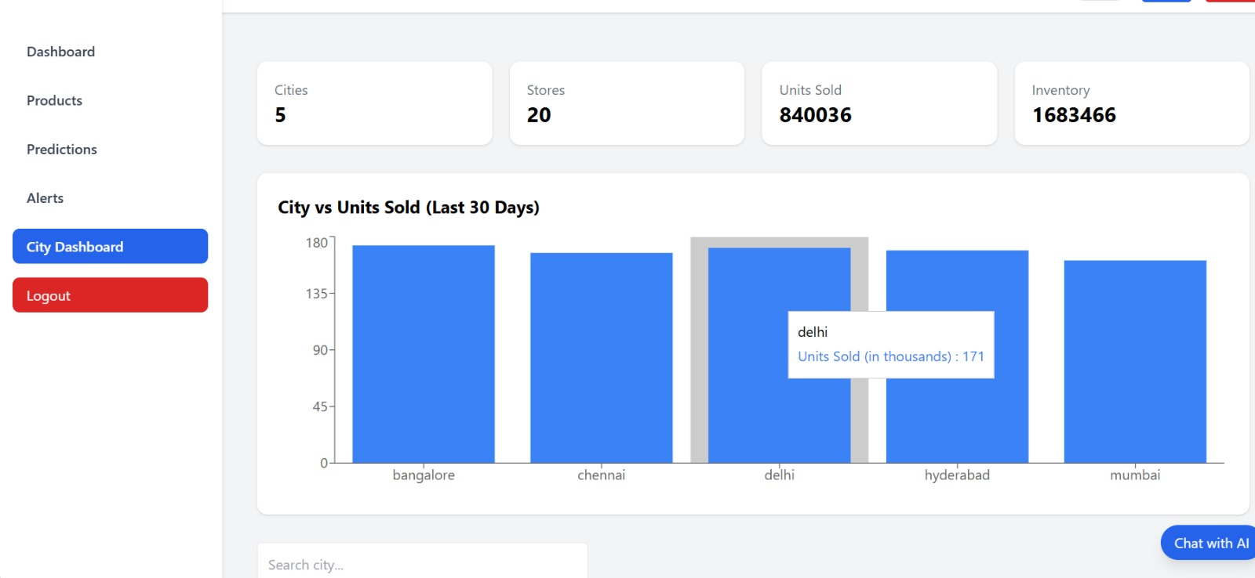

You can search and select any city to see the store details of that city

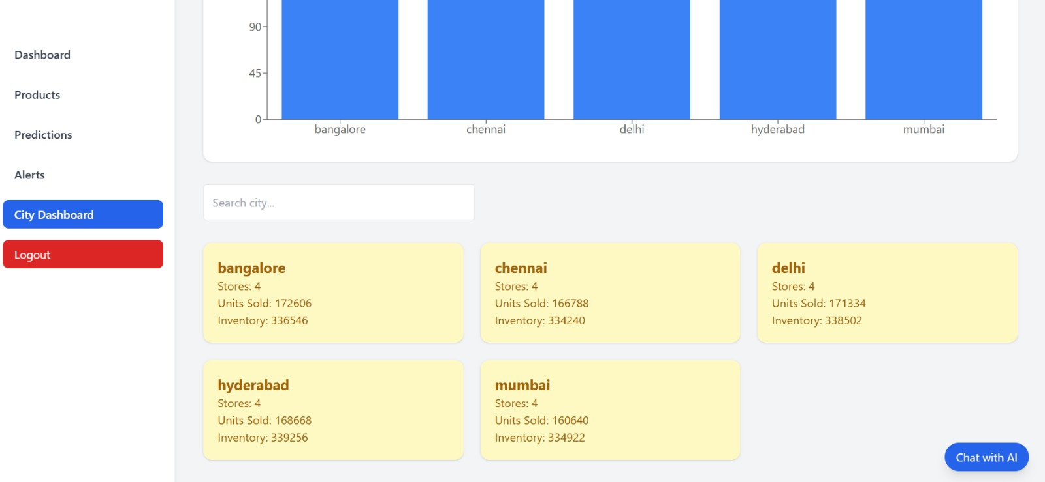
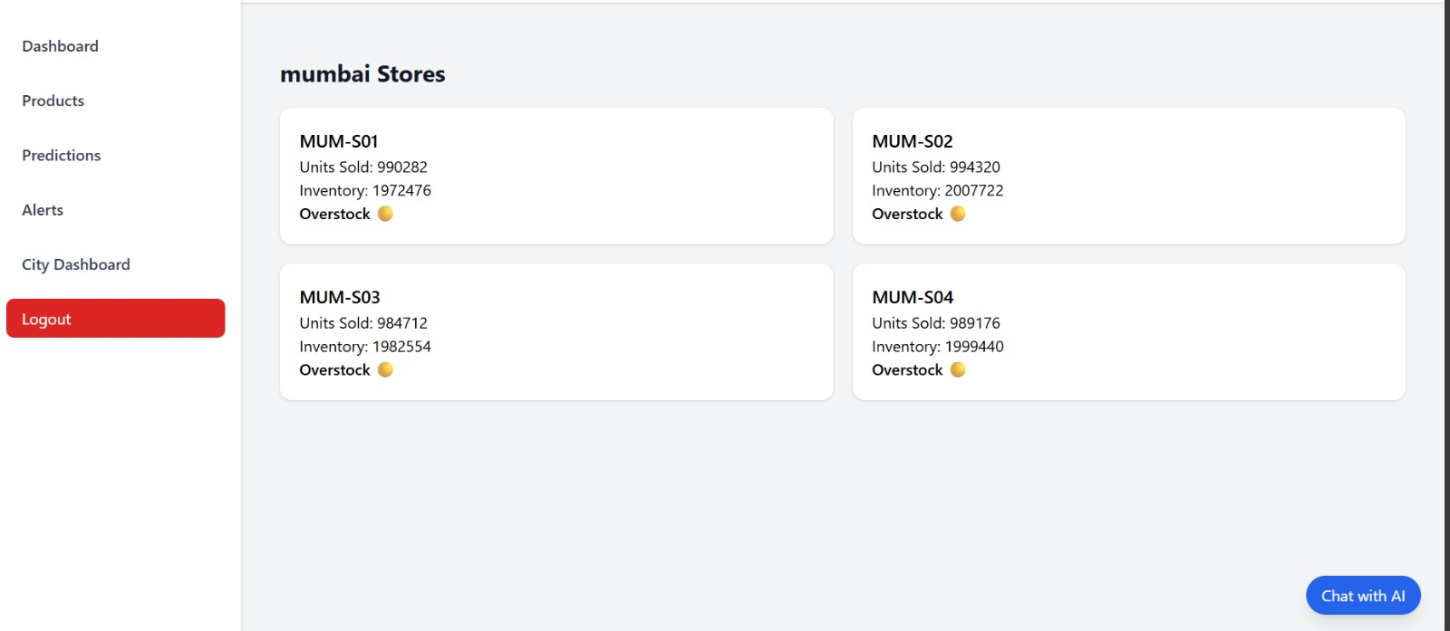
Step 11: The Alerts section highlights:
- Low stock warnings
- Overstock notifications
- Critical inventory conditions
This enables quick decision-making and timely restocking.
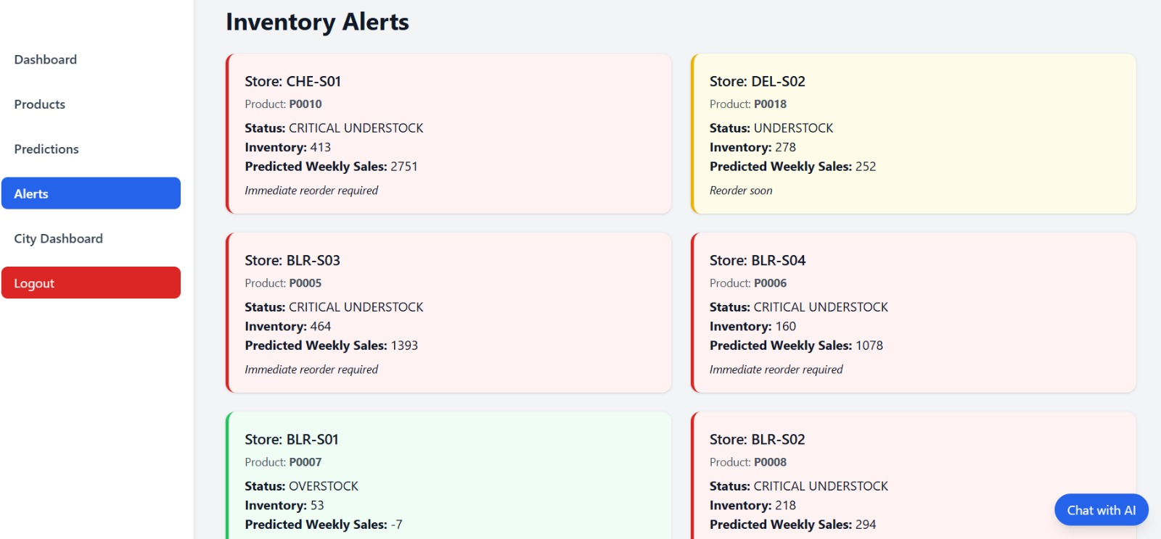
Step 12: Using the AI-powered Chatbot, users can ask questions like:
- “How much stock is left?”
- “Which items are low in stock?”
- “Which category has overstock?”
The chatbot provides instant inventory-related assistance.
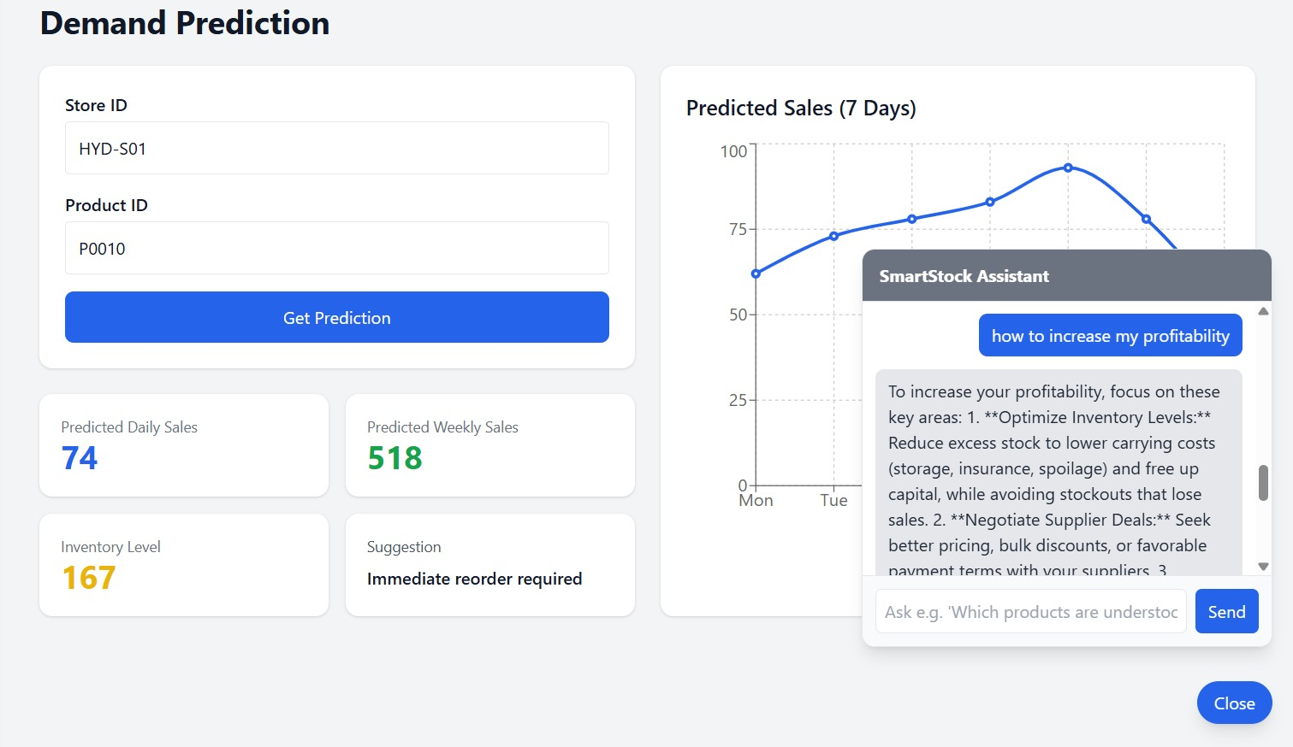

7. Challenges Faced
1. Data Consistency Issues
Sales and inventory data contained missing values and inconsistent formats. Data cleaning and normalization were required to ensure accurate processing without losing information.
2. City and Store Mapping
Mismatch between city and store identifiers caused filtering errors. The data structure was refined to maintain correct city–store relationships.
3. Dynamic Filtering Logic
City-wise and store-wise filters initially returned incorrect or empty results. This was resolved by improving state handling and API query logic.
4. API Integration Errors
Frequent 404 errors occurred due to mismatched frontend requests and backend routes. Careful verification of endpoints and parameters fixed the issue.
5. Data Aggregation Accuracy
Sales summaries and inventory metrics required optimized aggregation logic. Multiple iterations were needed to produce accurate dashboard values.
6. Visualization Rendering Issues
Charts sometimes failed to render due to empty or delayed data. Conditional rendering and data validation checks were added.
7. UI Responsiveness & Theme Handling
Maintaining layout consistency across devices and themes was challenging. Tailwind CSS adjustments ensured responsive and theme-compatible UI.
8. Testing & Validation
Testing multiple cities, stores, and categories was time-consuming. Repeated validation ensured reliable analytics and correct filtering behavior.

8. Learnings & Skills Acquired
• Full-Stack Development Skills – Gained practical experience in building end-to-end web applications using React.js for frontend, FastAPI for backend, XGBoost for demand prediction and MySQL for data storage
• API Design & Integration – Learned to design FastAPIs and integrate them with frontend dashboards for real-time data fetching and filtering.
• Data Handling & Processing – Improved ability to clean, structure, and aggregate inventory and sales data for analytics and reporting.
• Dashboard & Data Visualization – Developed interactive dashboards using Recharts to visualize inventory levels, category-wise stock, and sales trends.
• State Management & Filtering Logic – Enhanced skills in managing React state and implementing dynamic filters for city-wise and store-wise analytics.
• Error Handling & Debugging – Strengthened debugging skills by resolving API errors, data mismatches, and frontend-backend integration issues.
• UI/UX Design & Responsiveness – Learned to build responsive, user-friendly interfaces using Tailwind CSS with dark/light theme support.
• Testing & Validation – Gained experience in validating application behavior with different datasets to ensure consistency and reliability.
• Problem-Solving Skills – Developed structured approaches to identifying issues, optimizing logic, and improving system performance.
• Project Management & Documentation – Improved planning, documentation, and reporting skills through phased development and milestone tracking.

9. Testimonials from team
Team Member 1:
"This project enhanced my understanding of machine learning models for text similarity and helped me learn how to extract meaningful insights from unstructured data."

Team Member 2:
"I gained hands-on experience in resume parsing, skill recommendation systems, and building interactive dashboards, which strengthened both my technical and practical skills."

Team Member 3:
"Smartstock taught me how to work collaboratively, manage project timelines, and integrate AI solutions into a functional web application."

Team Member 4:
"The project improved my knowledge in NLP, data preprocessing, and visualization techniques, and also boosted my confidence in handling real-world AI applications."

10. Conclusion
The SmartStock Management System was successfully designed and implemented to provide an efficient solution for monitoring inventory and analyzing sales performance across multiple cities and stores. The system enables real-time visibility into product availability, low-stock alerts, overstock identification, and category-wise inventory distribution through an intuitive dashboard.
By integrating a full-stack architecture using React.js, FastAPI, and MySQL, the project demonstrates effective data handling, API-driven communication, and interactive visualization. City-wise and store-wise filtering enhances decision-making by allowing users to analyze sales trends and stock movement at different levels.
Overall, the project achieves its objectives of improving inventory control, reducing manual effort, and supporting data-driven business decisions. The system is scalable, user-friendly, and can be further enhanced with advanced analytics, forecasting, and role-based access to meet real-world enterprise requirements.

11. Acknowledgements
Thank the organization, mentor, and any team members who supported your internship journey.
I would like to express my sincere gratitude to Infosys for providing me the opportunity to work on the SmartStock Inventory Optimization for Retail Stores and gain hands-on experience in AI and ML applications.
I am especially thankful to my mentor, shakthi Gopalakrishnan, for their constant guidance, support, and valuable insights throughout the internship. Their mentorship helped me overcome challenges and grow both technically and professionally.
I would also like to thank my team members for their collaboration, encouragement, and efforts in successfully executing this project. Their teamwork made the internship journey smooth and enriching.Finally, I appreciate everyone who contributed directly or indirectly to my learning and the completion of this project.

