Infosys Springboard Virtual Internship 6.0 Completion Report

Team Details <Do not mention any personally identifiable information like email ID, institute details, mobile phone number etc.>

Batch Number: SmartStock Inventory Optimization for Retail Stores

Start date : 10-Nov-2025

Names:

- Sivateja Somisetty
- Sahithya Kedala
- Hephzibai E
- Vaishnavi Potu

Internship Duration: 40-day ( 12 Weeks )

- Project Title
SmartStock Inventory Optimization for Retail Stores

- Project Objective

SmartStock is a full-stack AI-powered inventory optimization platform tailored for retail environments. Its primary goals are to:

  - Forecast product demand using machine learning models trained on historical sales data..
  - Optimize stock replenishment by calculating reorder points and ideal quantities.

  - . Maintain structured inventory data using MySQL for scalable storage.

  - Provide backend APIs for data ingestion, forecasting, and optimization logic via FastAPI.

  - .Deliver a responsive frontend dashboard using React and Tailwind CSS for visual insights.

  - Minimize stockouts and overstock through predictive analytics and smart recommendations
  - Empower store managers with real-time alerts, insights, and decision support tools.
SmartStock replaces manual inventory guesswork with data-driven, automated, and scalable solutions.

3.Project description in detail
The SmartStock Inventory Optimization for Retail Stores platform is a full‑stack AI-powered web application designed to automate and enhance inventory management workflows for retail businesses.
The system allows store managers to upload or connect sales and stock data alongside supplier information, after which it:
- Stores and organizes inventory records in a relational database for structured access.
- Performs data preprocessing and feature engineering to capture seasonality, promotions, and holidays.
- Generates demand forecasts using machine learning models such as ARIMA, Prophet, and LSTM.
- Computes optimal reorder points and replenishment quantities, producing actionable recommendations.
Highlights:
- Real-time stock levels and demand predictions.
- Alerts for low-stock and overstock situations.
- Smart purchase suggestions with supplier lead-time adjustments.
- Interactive dashboards presenting results visually using:
  - Line and bar charts for demand trends
  - Donut indicators for stock health
  - Color-coded alerts for inventory status
- Enhanced usability through dark/light mode switching and chatbot support scope.
This project simultaneously supports retailers (via faster, data-driven inventory decisions) and customers (via improved product availability), aligning AI-driven forecasting with practical business operations.

.

Week | Activities Planned | Activities Completed
Week 1 | Requirement study, use-case mapping | Problem definition refined, objectives finalized
Week 2 | Tech stack evaluation, architecture planning | FastAPI + MySQL + React setup completed
Week 3 | Database schema design | Product, sales, supplier tables created in MySQL
Week 4 | Data ingestion module | CSV/POS data upload verified, stored in DB
Week 5 | Data preprocessing pipeline | Cleaning, normalization, feature engineering implemented
Week 6 | Demand forecasting model | ARIMA baseline + Prophet integration
Week 7 | Advanced ML (LSTM | LSTM demand prediction tested
Week 8 | Backend API endpoints | Forecast + optimization APIs exposed
Week 9 | Frontend wireframe | Core UI integrated with backend
Week 10 | Visualization (charts, alerts) | Interactive dashboards functioning
Week 11 | Recommendation engine | Smart purchase suggestions displayed
Week 12 | Documentation, report writing, future enhancements | Integrated testing with sample datasets, project ready for evaluation

5a. Key Milestones

Milestone | Description | Date Achieved
Project Kickoff | Defined project objectives, scope, responsibilities, and success criteria. | 10 Nov 2025
Prototype / First Draft | Initial working prototype with DB + backend + ML | 21 Nov 2025
Mid-Term Review | Initial working prototype with DB + backend + ML | 05 Dec 2025
Final Submission | Fully functional SmartStock system with reporting | 19 Dec 2025
Final Presentation | Demonstration of architecture, functionality, results, and impact | 02 Jan 2025

5b. Project execution details

The execution of the SmartStock system followed a structured and iterative development approach.
The project commenced with requirement analysis, defining objectives, problem scope, and mapping AI/ML applicability to inventory optimization. Sample retail datasets containing product sales, stock levels, and supplier information were collected to simulate real-world store scenarios.
Next, data ingestion and preprocessing modules were implemented. Sales and stock records were uploaded, normalized, and stored in a relational database. Supplier details were analyzed to identify lead times and performance metrics. Data cleaning, transformation, and feature engineering techniques such as seasonality detection, holiday tagging, and promotion mapping were applied to enhance forecasting accuracy.
A demand forecasting engine was built using ARIMA, Prophet, and LSTM models, which quantified expected demand patterns across products. This engine was integrated with an optimization module that calculated reorder points, safety stock, and replenishment quantities. A recommendation system was added to suggest purchase orders and supplier adjustments dynamically.
Parallelly, a user-friendly web interface was developed using React and Tailwind CSS, enabling managers to visualize inventory insights. Dashboards displayed demand trends, stock health indicators, and alerts for low-stock or overstock situations. Usability features such as dark/light theme switching and chatbot support scope were incorporated to improve accessibility and interaction.
The system underwent iterative testing with multiple datasets to validate forecasting accuracy, optimization alignment, and UI experience. Errors were debugged, feedback loops were integrated, and enhancements—such as dynamic alerts and improved chart visualizations—were added.
Finally, the project was refined, documented, and presented, demonstrating its ability to support retailers with automated inventory decisions and customers with improved product availability, achieving its intended outcomes.

- Snapshots / Screenshots
Opening the project folder containing all the main files such as app.py, package.json, templates, and static.
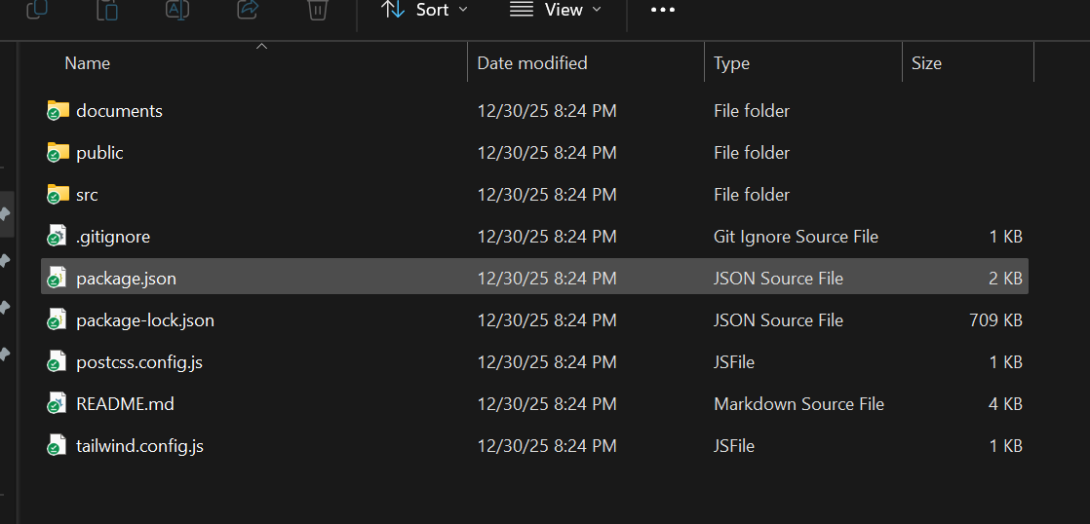

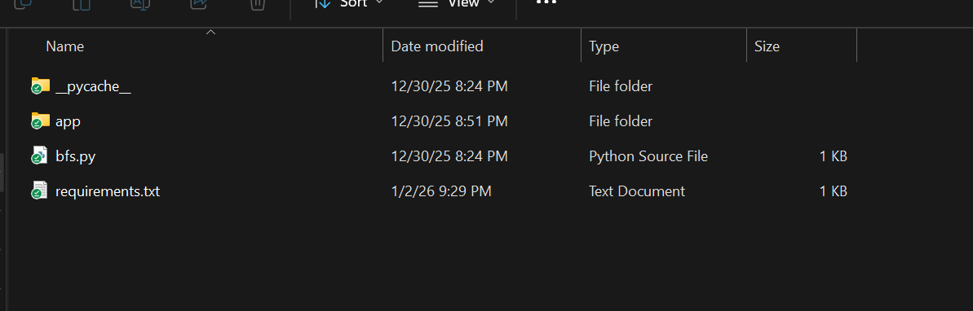

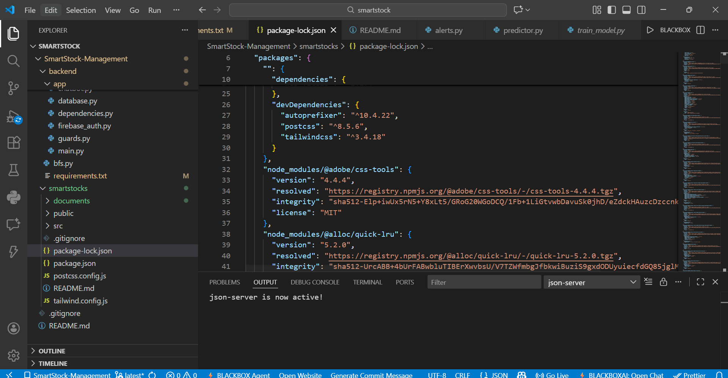Opening the app.py file in VS Code to view the main Flask application code.
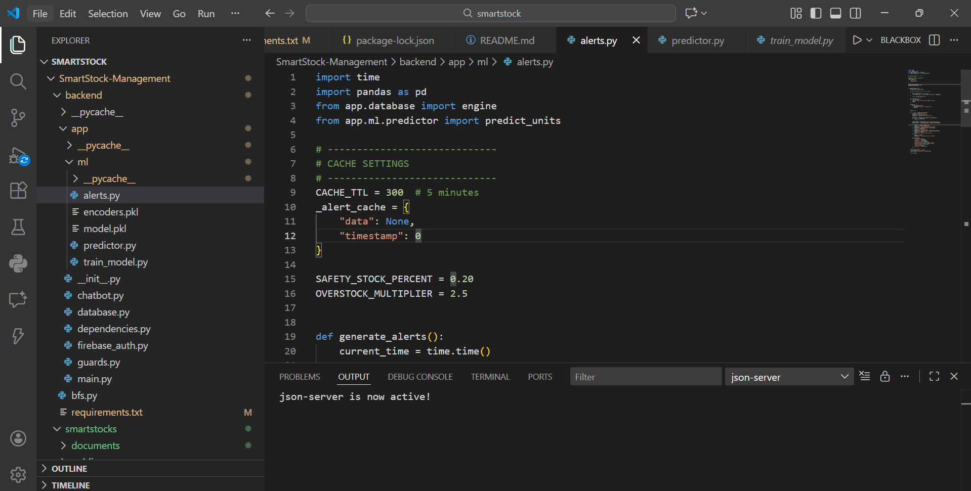

Running the Flask app using the command python app.py in the terminal.

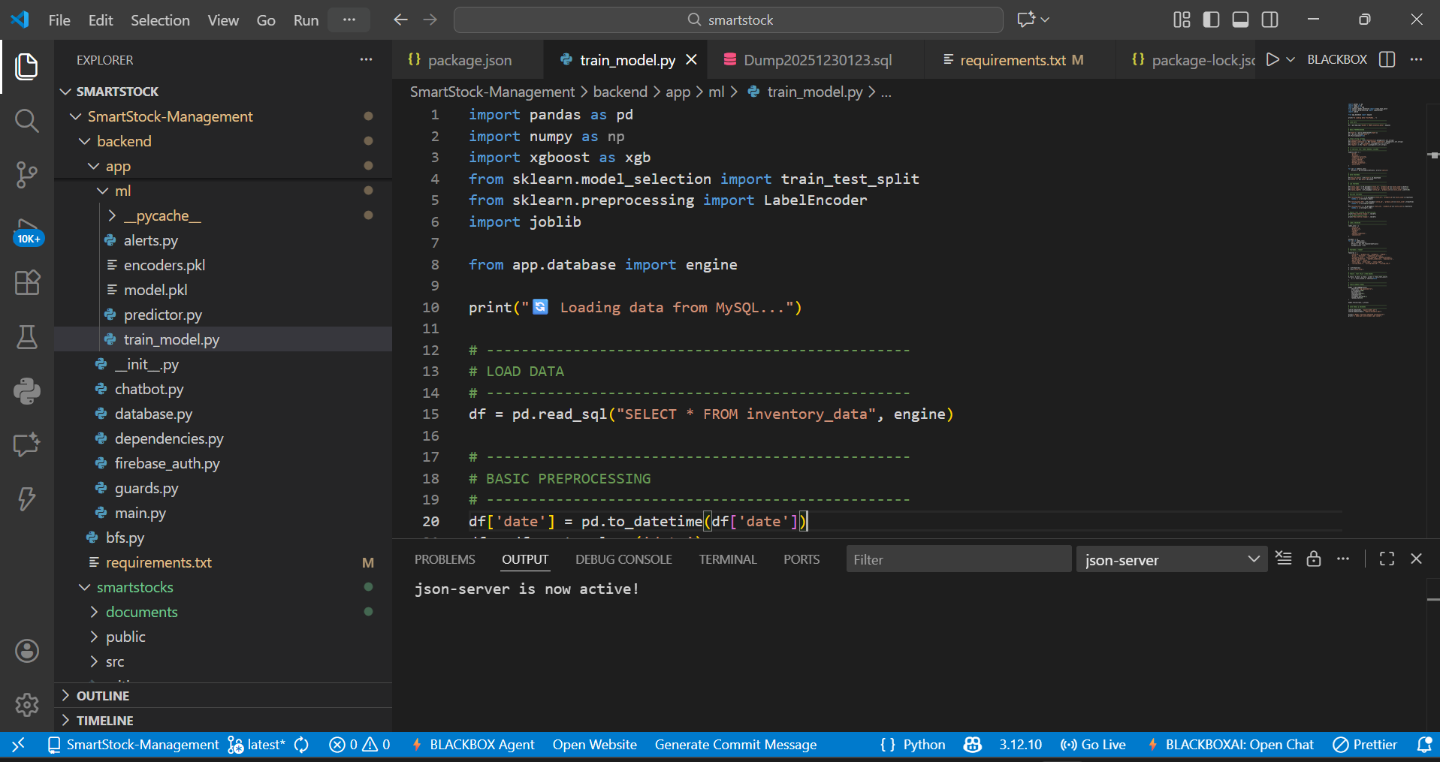

The home page of the SmartStock Inventory Optimization for Retail Stores web application appears on the browser.

This is Smart Stock Login page

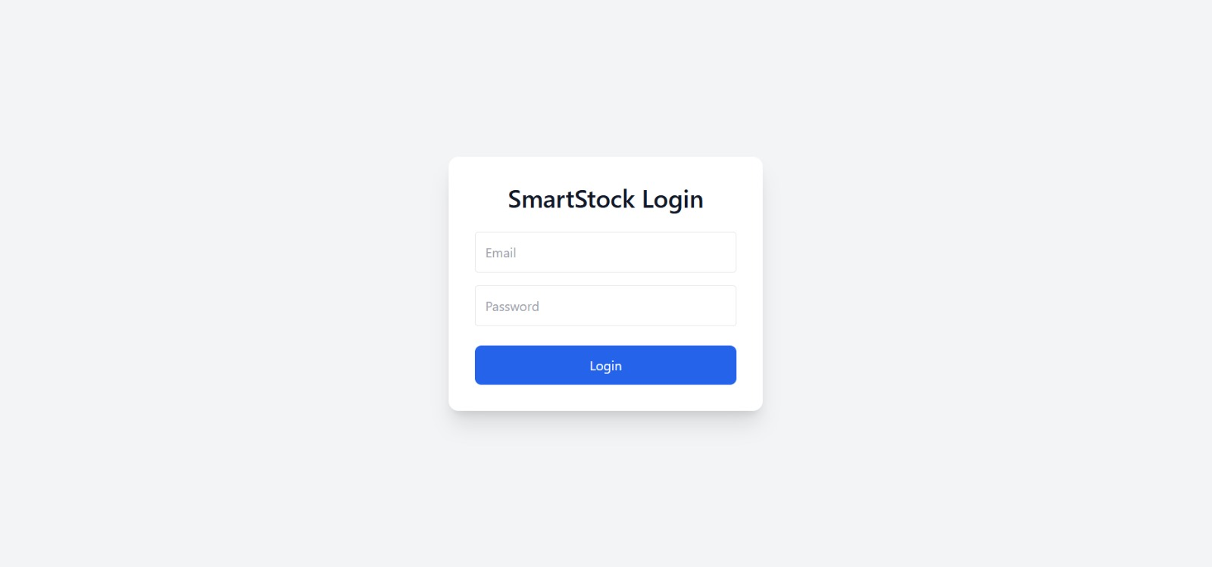

This is Dashboard page we can see the stock level Category and Inventory Dashboard over there
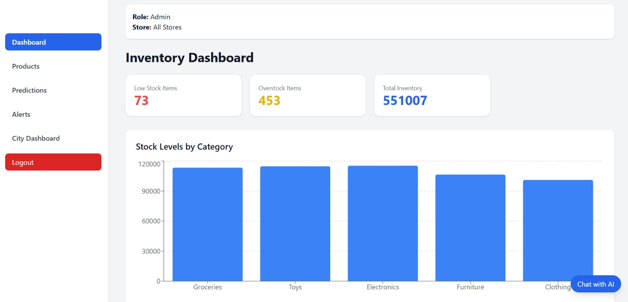

This is the products page we can see the store products .So we can add and remove the products

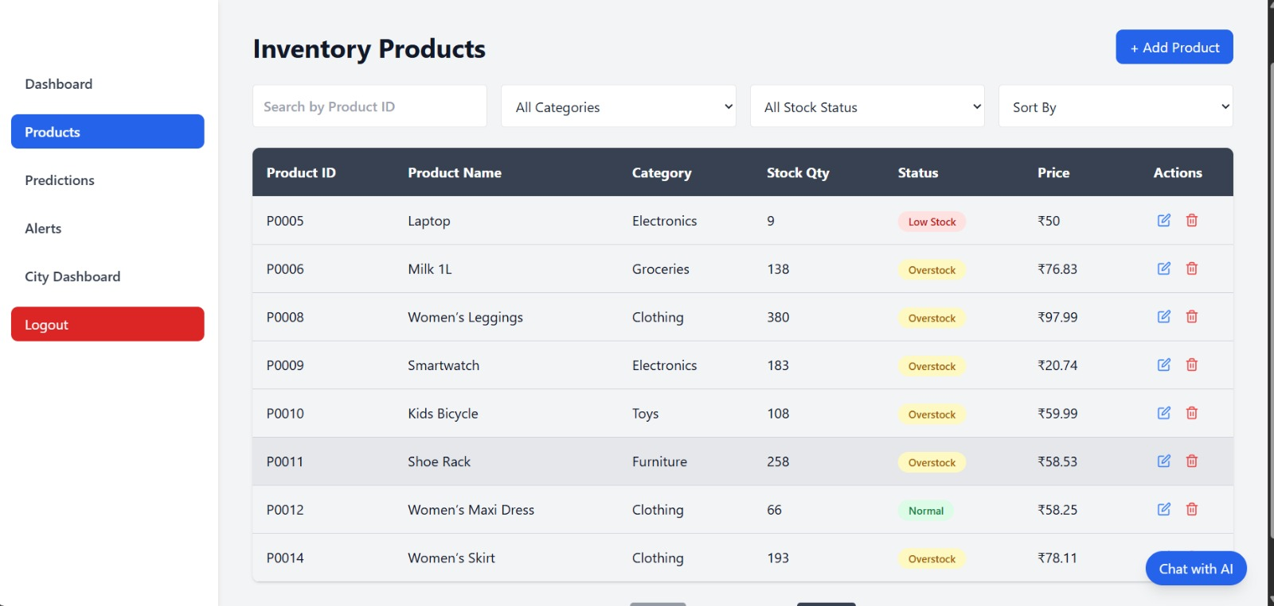

This is the Predictions page we can predict the next 7days sales based on previous sales data
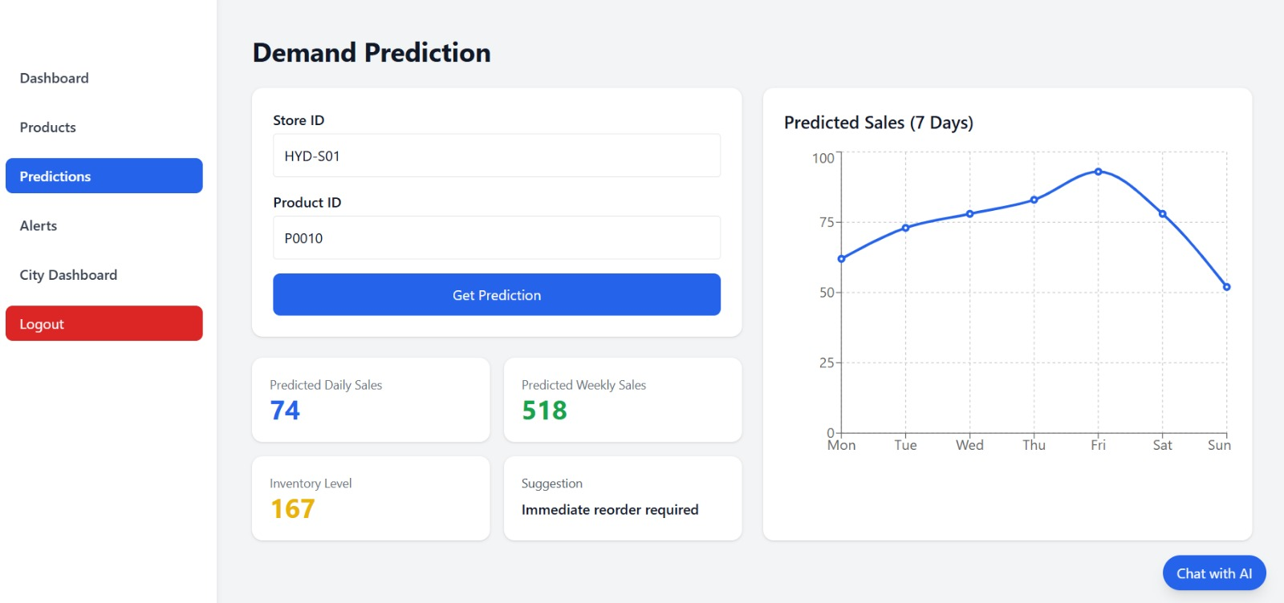

This is the Alerts page we can see the product is overstock or understock we represent with specific colour over here

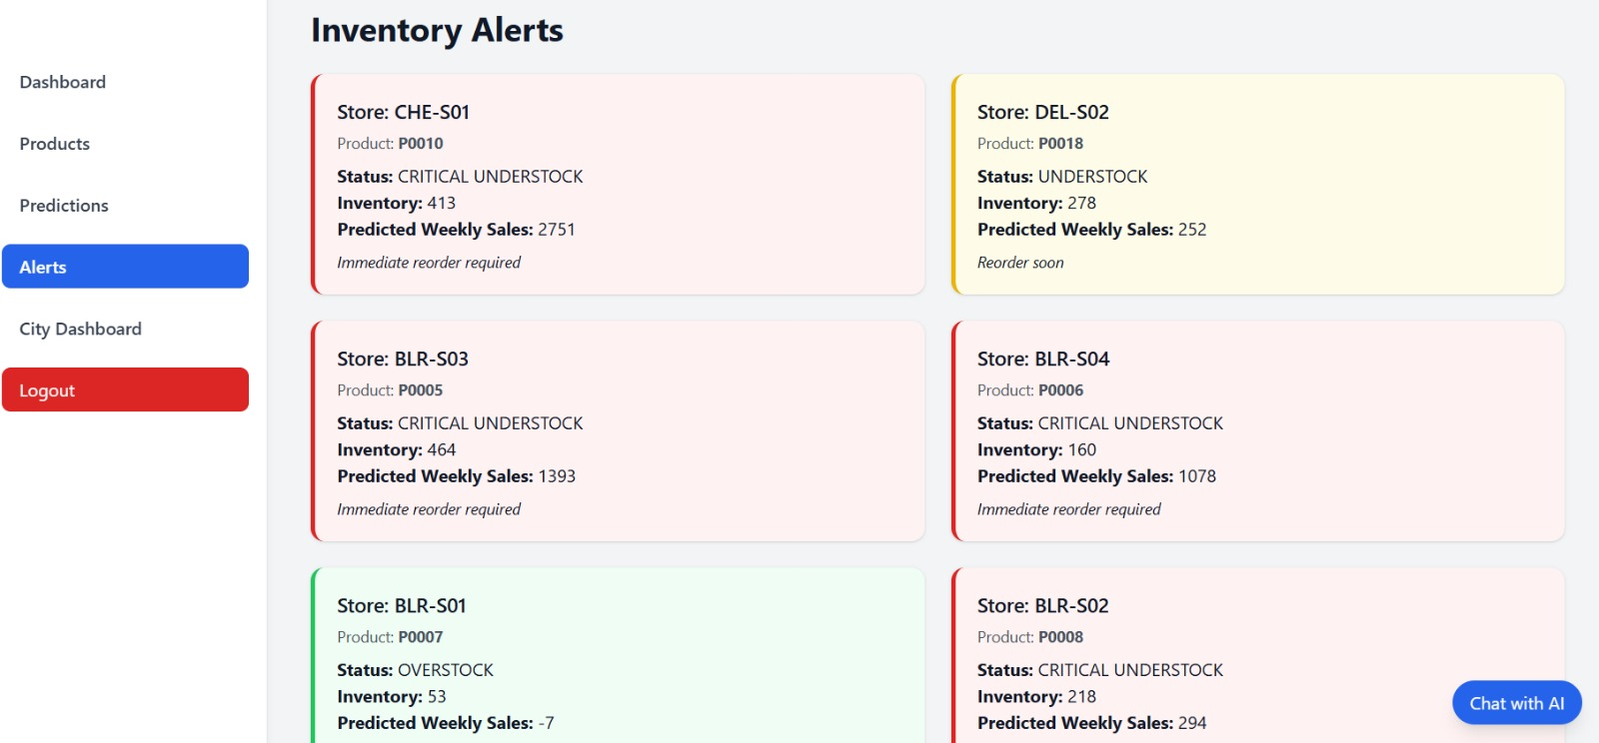

This is the ity Dahboard page here we can see the city level store and we can select the store and see the sales .
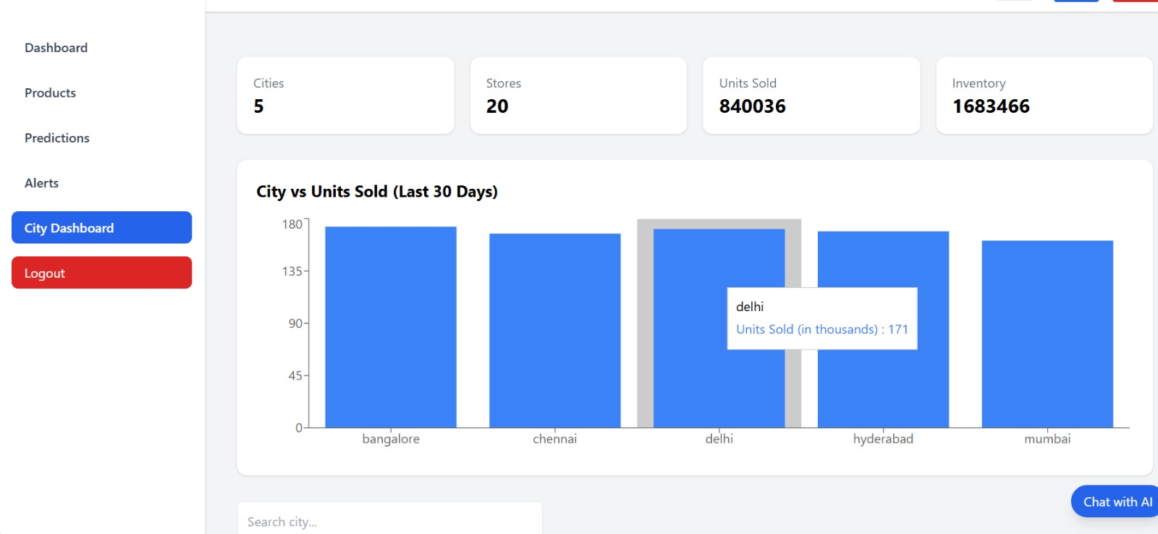

Here,we can see the city store and each city have some stores and sold and Inventory and Bar graph in this page

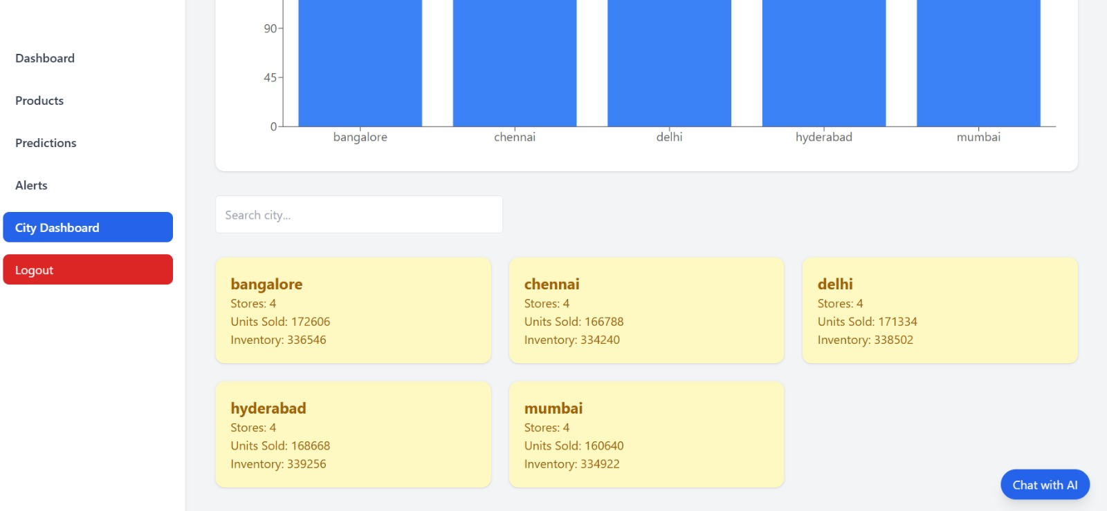

This is the button we can Logout from this web
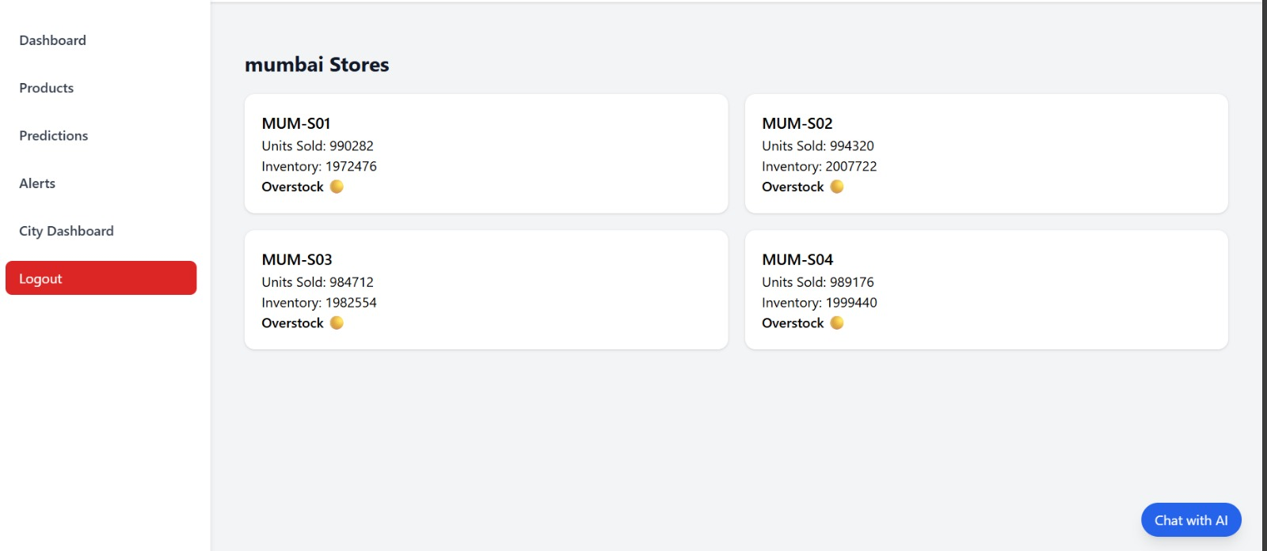
- Challenges Faced

During development of the SmartStock system, several technical and operational challenges were encountered:

- Data Preprocessing Accuracy
Different sales datasets contained missing values, inconsistent formats, and irregular timestamps, requiring extensive cleaning, normalization, and feature engineering to ensure reliable forecasting.
- Forecasting Model Limitations
Initial ARIMA and Prophet models struggled with seasonality and promotional spikes, requiring multiple refinements and the integration of LSTM for improved accuracy.
- Database Schema Complexity
Designing normalized tables for products, transactions, suppliers, and forecasts while ensuring relational integrity posed challenges, especially when integrating multi-store data.
- Backend Integration Issues
Connecting FastAPI services with the database and ML models required careful dependency management and debugging of API endpoints to ensure smooth data flow.
- Frontend Responsiveness and Visualization
Dynamic dashboards with charts and alerts sometimes misaligned across devices, requiring CSS restructuring and testing for adaptability across screen sizes.
- Performance Constraints
Handling large datasets and running ML models in real-time slowed processing, necessitating optimization strategies, caching, and query tuning.
- Troubleshooting Library Conflicts
Version mismatches in libraries (numpy, pandas, scikit-learn, TensorFlow) caused compatibility issues that required environment recreation and dependency isolation.
- User Interaction Enhancements
Integrating dark/light mode toggle and chatbot support introduced challenges in state persistence, theme retention, and UI integration without disrupting backend logic.
- Testing & Validation Challenges
Collecting diverse retail datasets and validating forecast accuracy across product categories was time-consuming, especially when demand patterns varied significantly.
ross formats and domains.

Despite these challenges, iterative debugging, testing, and UI refinement allowed the system to achieve stable performance, accurate forecasting, and an improved user experience.

Learnings & Skills Acquired

The development of the SmartStock Inventory Optimization system resulted in significant technical, analytical, and professional learning outcomes

Practical Understanding of Demand Forecasting
- Gained hands-on experience in preprocessing retail data, applying ARIMA/Prophet/LSTM models, and interpreting forecast outputs.
AI-Driven Inventory Systems
- Understood how machine learning can support real-world automation such as stock replenishment and supplier management.
Backend Development & Workflow Integration
- Learned to design FastAPI-based backend logic for handling data ingestion, request routing, and integration with ML models and databases.
Database Design & Management
- Enhanced skills in designing normalized schemas, managing SQL queries, and ensuring relational integrity for inventory systems.
UI/UX Development & Dashboards
- Strengthened expertise in React and Tailwind CSS for building responsive dashboards, theme toggling, and analytics visualization.
Debugging & Dependency Management
- Encountered and solved version conflicts, library errors, and environment configuration challenges—boosting troubleshooting skills.
System Testing & Iterative Improvement
- Practiced evaluating forecast accuracy using sample datasets, identifying mismatch patterns, and fine-tuning algorithms.
Technical Communication & Documentation
- Improved ability to document system architecture, track progress, and deliver structured presentations.
Overall, the project strengthened both AI-technical competencies and full-stack engineering mindset, enhancing capability to build scalable, user-centric solutions.

Testimonials from team

Team Member 1:
“This project deepened my understanding of demand forecasting models and exposed me to practical ML workflows for analyzing retail data.”

Team Member 2:

“I gained hands-on exposure to building dashboards, integrating APIs, and designing responsive layouts that strengthened my applied engineering skills.”

Team Member 3:
“SmartStock improved my ability to design normalized schemas, manage SQL queries, and collaborate effectively with backend and ML components.”

Team Member 4:
“The project allowed me to develop stronger analytical thinking through full-stack integration, data preprocessing, and visualization techniques, boosting my confidence in solving real-world inventory challenges.”

- Conclusion

The SmartStock Inventory Optimization system successfully demonstrates how AI, databases, and full-stack development can transform retail inventory management. The system efficiently analyzes sales data, forecasts demand, computes optimal reorder points, and provides actionable recommendations — delivering value to both store managers and customers.
Throughout development, the team strengthened its expertise in end-to-end pipeline design, from database schema creation and backend API development to ML forecasting and frontend visualization. The project validated that intelligent inventory tools can significantly reduce manual workload, improve decision accuracy, and enhance customer satisfaction.
Overall, SmartStock stands as a practical, scalable, and industry-aligned solution with potential for further enhancement, such as chatbot assistance, dark-light UI mode switching, and richer supplier analytics — showcasing the team’s innovation mindset and future readiness.

- Acknowledgements

We express our sincere gratitude to Infosys Springboard for providing us with an excellent learning environment, industry-level curriculum support, and access to resources that helped shape this project effectively.
We extend heartfelt thanks to Ms.Shakthi Gopalakrishnan , our mentor, for her continuous guidance, constructive feedback, and encouragement throughout the development lifecycle. Her insights played a pivotal role in refining our approach, validating our methods, and enhancing our learning experience.
We also appreciate the support from our faculty members, peers, and family for their motivation, collaboration, and valuable suggestions, which helped us stay committed and deliver the SmartStock project successfull

