**TEAM ID:** PNT2022TMID50813

**Project Link:** <http://ibmsmart.pythonanywhere.com/home>

# INTRODUCTION

* 1. **Project Overview**

Students are often worried about their chances of admission to University. The aim of this project is to help students in shortlisting universities with their proﬁles. The predicted output gives them a fair idea about their admission chances in a particular university. This analysis should also help students who are currently preparing or will be preparing to get a better idea .

# Purpose

A persons education plays a vital role in their life. While planning for education students often have several questions regarding the courses, universities, job opportunities, expenses involved, etc. Securing admission in their dream university is one of their main concerns. It is seen that often students prefer to pursue their education from universities which have global recognition.

# Literature survey

when it comes to international students the ﬁrst choice of the majority of them is the United States of America. With the majority of worlds highly reputed universities, wide range of courses offered in every sector, highly accredited education system and teaching, scholarships provided to students, best job market and many more advantages make it the dream destination for the international 1 students. According to research, there are above 8 Million international students studying in more than 1700 public and 2500 private universities and colleges across the USA. (MasterPortal (2017)) .

# Existing problem

Universities take into consideration different factors like score on aptitude based examination like the General Record Examination (GRE), command over the English language is judged based on their score in English competency test like Test Of English as a Foreign Language (TOEFL) OR International English Language Testing System (IELTS), their work experience in same or other ﬁelds, the quality of the Letters Of Recommendation (LOR) and the Statement Of Purpose documents provided by the student etc. Based on the overall proﬁle of the student decision is taken by the universities admission team to admit or reject a particular candidate.

# References

1. Geiser, Saul, and with Roger Studley. "UC and the SAT: Predictive validity and differential impact of the SAT I and SAT II at the University of California." Educational Assessment 8.1 (2002): 1-26.
2. Rothstein, Jesse M. "College performance predictions and the SAT." Journal of Econometrics

121.1-2 (2004): 297-317.

1. Leonard, David K., and Jiming Jiang. "Gender bias and the college predictions of the SATs: A cry of despair." Research in Higher education 40.4 (1999): 375-407.

# Problem Statement Deﬁnition

Build an application that predicts the university admission chances of a student powered by machine learning models. Train the model and host it on IBM cloud. The majority of international students studying in the USA are from India and China. In the past decade, India has seen a huge increase in the number of students opting to pursue their education from foreign universities in countries like The USA, Ireland, Australia, Germany, etc. Although there are signiﬁcant universities and colleges in India, students are ﬁnding it diﬃcult to get admission in the highly ranked colleges and also getting a job is a challenge as the ratio of number students to the number work opportunities available is quite high. India is one of the leading counties in the number of software engineers produced each year; it becomes tough for the students to ﬁnd jobs in elite companies due to high competition. This motivates a good number of students to pursue post-graduation in their ﬁeld. It is seen that the number of students pursuing Masters in Computer Science ﬁeld from universities in the USA is quite high; the focus of this research will be on these students .

# IDEATION & PROPOSED SOLUTION

The project aims to develop an application that uses artiﬁcial intelligence with the help of chat bot to customize products for the customers which enhances the fame of ecommerce store and reduce the time which customers spends on choosing products. The application also uses IBM cloud storage for storing objects.

An application that predicts the university admission chances of a student powered by machine learning models. Solution architecture is a complex process – with many sub-processes – that bridges the gap between business problems and technology solutions. The primary objective of this research is to develop a system to solve the problems the international students are facing while applying for universities in the USA.

# Empathy Map Canvas

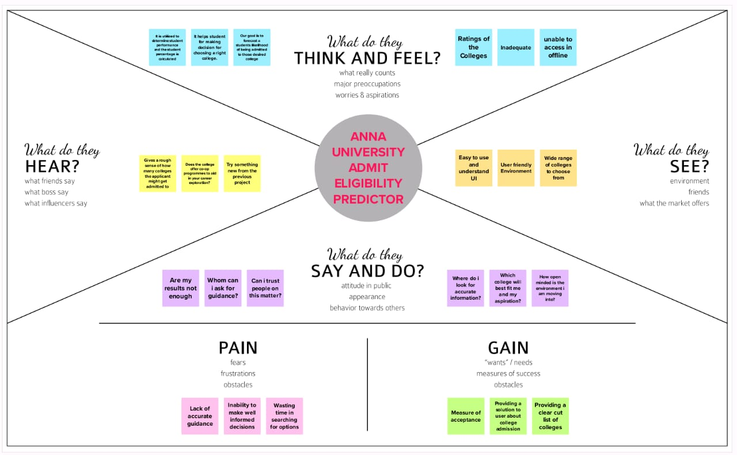

* 1. 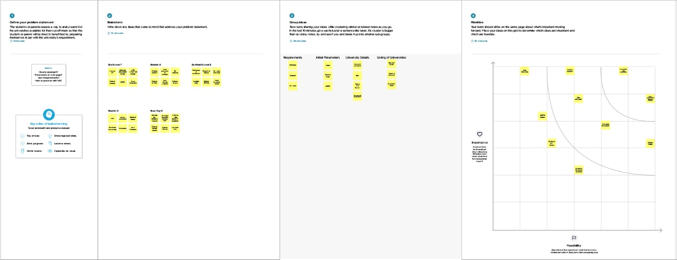**Ideation & Brainstorming**

This task of shortlisting the universities where the student has high chances of admission is diﬃcult for mainly for the international students, so they end up with applying to many universities in hopes of getting admission in few of them thus investing an extra amount of money in the applications. There are several portals and websites which provide information and help to students in shortlisting the universities, but they are not reliable. Most of the students dont take the risk of evaluating the colleges by themselves, and they seek the help of the education consultancy ﬁrms to do it for them. Again for this students have to pay a huge amount of fee to the education consultant.

# Proposed Solution

# WhatsApp Image 2022-11-19 at 11.14.39 PM.jpeg

Finally, K Nearest Neighbours and Decision Tree algorithms were used as they were found to be the best ﬁt for the system developed. Also, we will be creating a simple user interface which will help the users to input the data related to student proﬁle and get the predicted result for the application based on the proﬁle as output. This research will thus eventually help students saving the extra amount of time and money they have to spend at the education consultancy ﬁrms. And also it will help them to limit their number of application to a small number by proving them the suggestion of the universities where they have the best chance of securing admission thus saving more money on the application fees.

# Problem Solution ﬁt

# WhatsApp Image 2022-11-19 at 11.15.55 PM.jpegWhatsApp Image 2022-11-19 at 11.15.56 PM.jpeg

We will be developing a University Admit Eligibility Predictor system which will help the students to predict the chances of their application being selected for a particular university for which they wish to apply based on their proﬁle. Also, the system will provide a recommendation of universities to the student to which the student has a high possibility of getting admission.

Multiple machine learning classiﬁcation algorithms were evaluated to develop the system.

# REQUIREMENT ANALYSISWhatsApp Image 2022-11-19 at 11.18.51 PM.jpegWhatsApp Image 2022-11-19 at 11.18.52 PM.jpeg

Requirements analysis, also called requirements engineering, is the process of determining user expectations for a new or modiﬁed product. These features, called requirements, must be quantiﬁable, relevant and detailed. In software engineering, such requirements are often called functional speciﬁcations. Requirements analysis is critical to the success or failure of a systems or software project. The requirements should be documented, actionable, measurable, testable, traceable, related to identiﬁed business needs or opportunities, and deﬁned to a level of detail suﬃcient for system design.

# Functional requirement

* prediction
* input form
* percentage of chance

# Non-Functional requirements

* Speed
* Security
* Portability
* Compatibility
* Capacity
* Reliability
* Environment
* Localization

# PROJECT DESIGN

* 1. **Data Flow Diagrams**

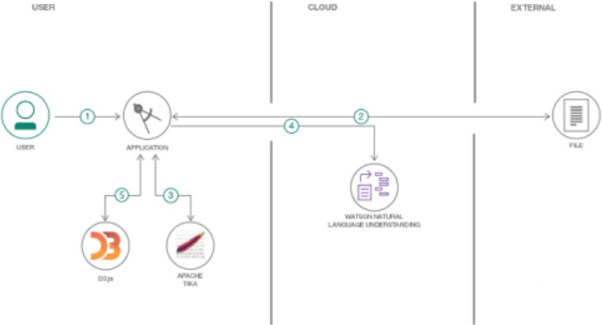

# Solution & Technical Architecture

Solution architecture is a complex process – with many sub-processes – that bridges the gap between business problems and technology solutions. Its goals are to:

* Find the best tech solution to solve existing business problems.
* Describe the structure, characteristics, behavior, and other aspects of the software to project stakeholders.
* 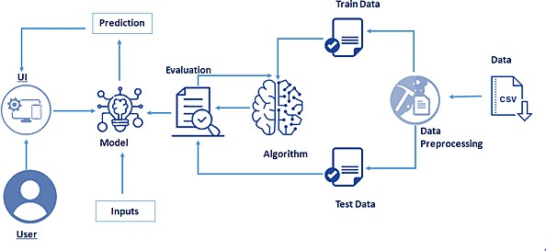Deﬁne features, development phases, and solution requirements. Provide speciﬁcations according to which the solution is deﬁned, managed, and delivered.

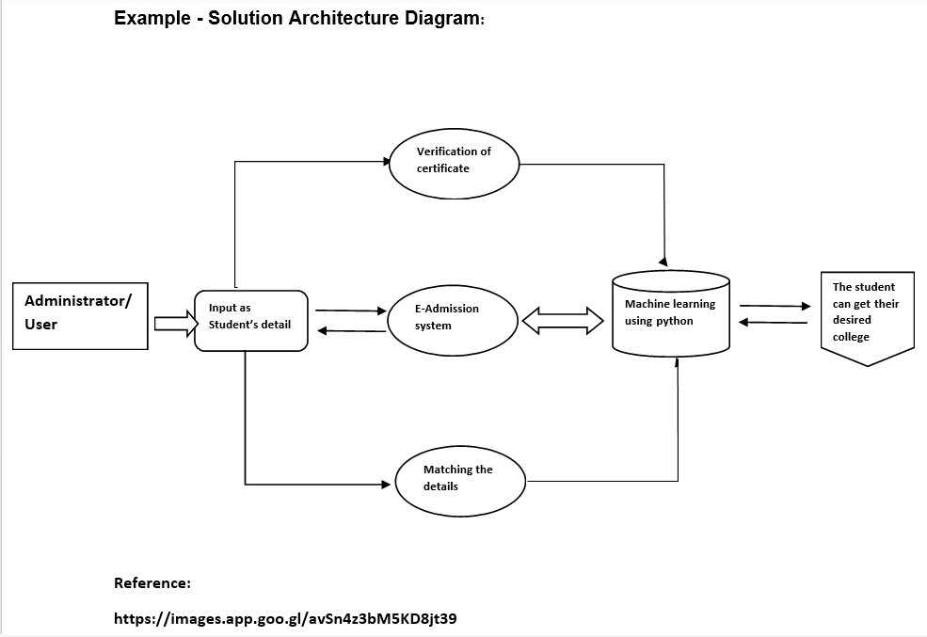

# User Stories

A user story is an informal, natural language description of features of a software system. They are written from the perspective of an end user or user of a system, and may be recorded on index cards, Post-it notes, or digitally in project management software.[1] Depending on the project, user stories may be written by different stakeholders like client, user, manager, or development team.

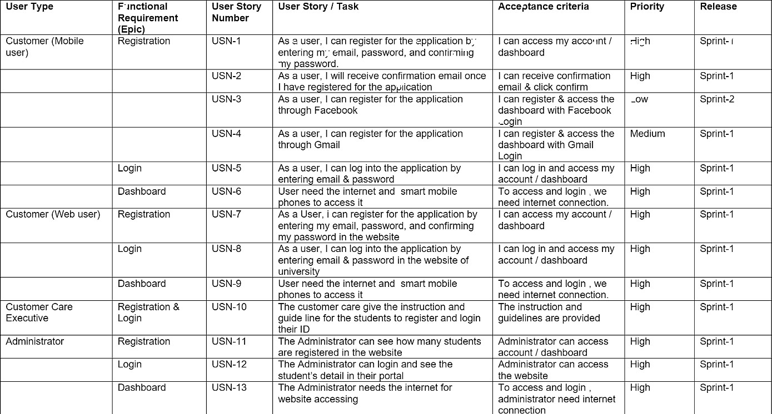

# PROJECT PLANNING & SCHEDULING

* 1. **Sprint Planning & Estimation**

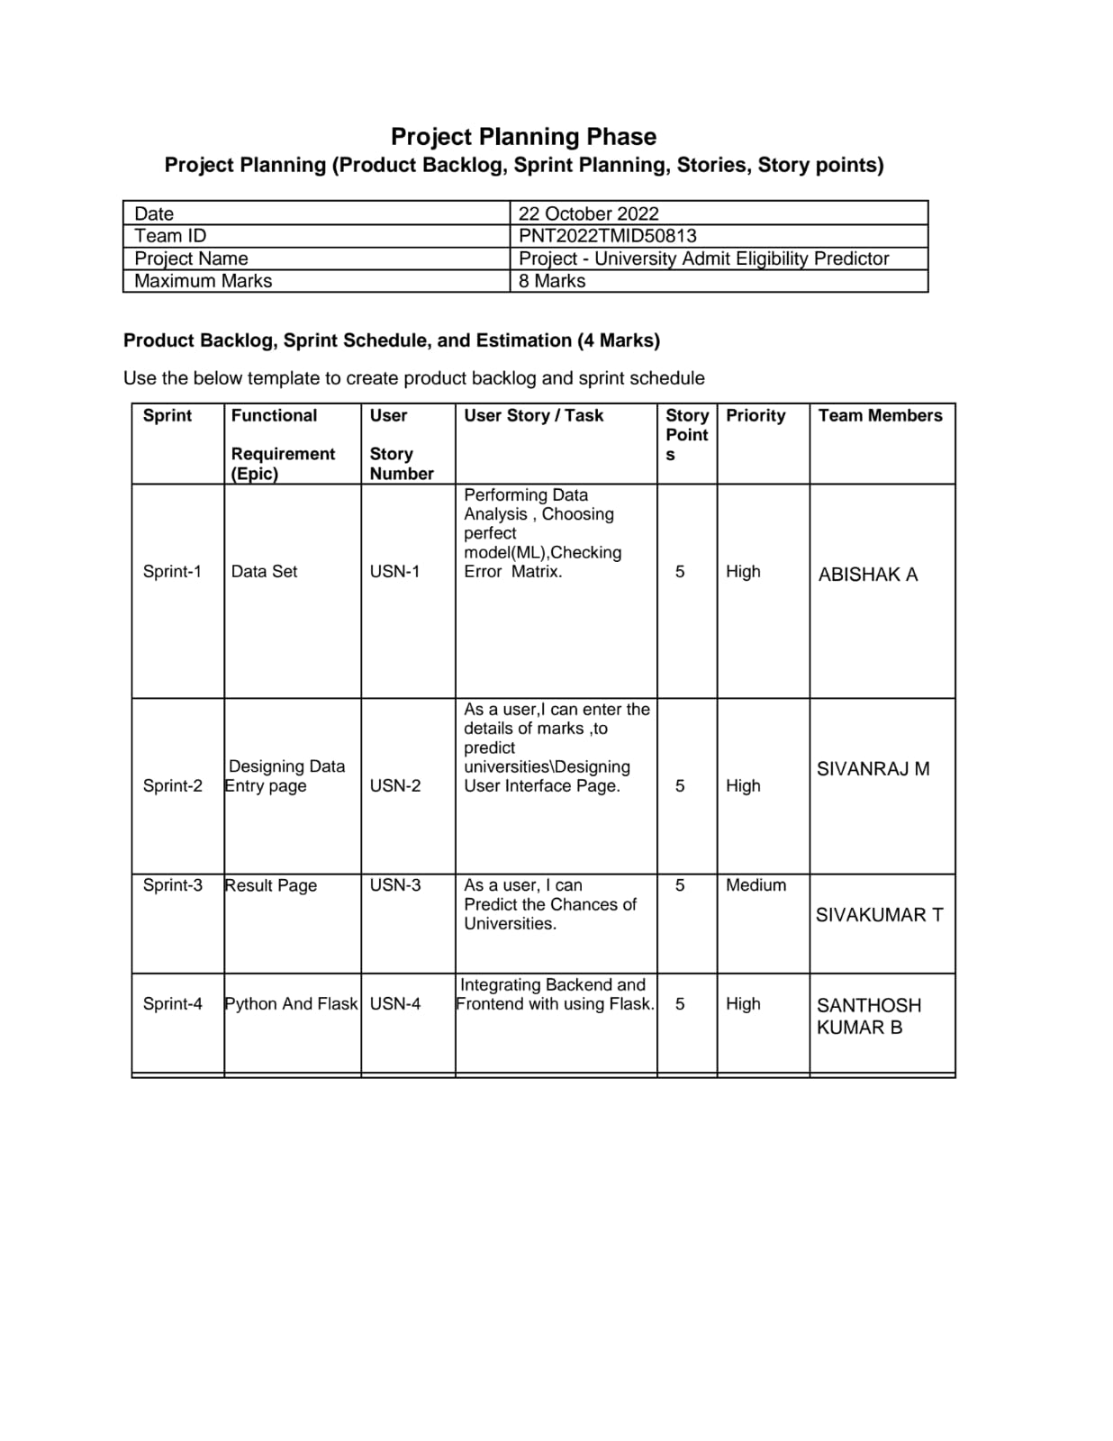

# Sprint Delivery Schedule

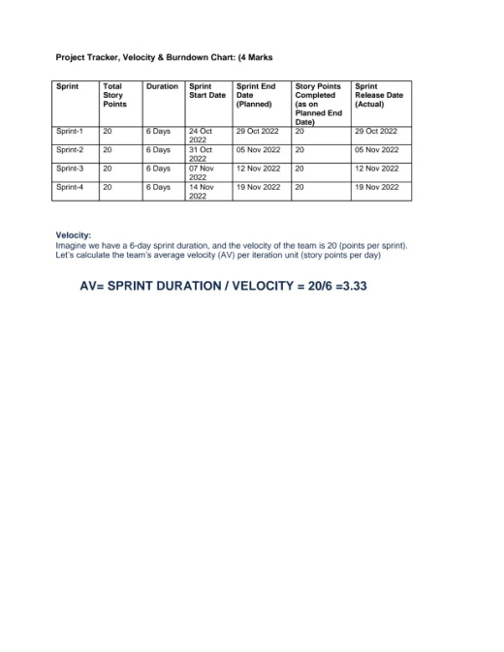

* 1. 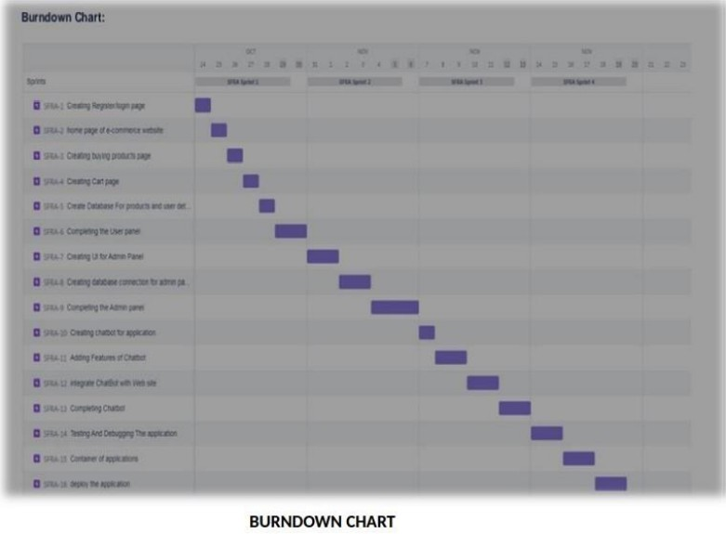**Reports from JIRA**

# CODING & SOLUTIONING

* 1. **Feature 1 - FLASK APP**

The following is the ﬂask app code and working

1

2

3

4

5

6

7

8

9

10

11

12

13

from flask import Flask, render_template, redirect, url_for, request

import requests

app = Flask( name )

@app.route("/", methods = ['POST', 'GET']) def index():

if request.method == 'POST': arr = []

for i in request.form: val = request.form[i]

if val == '':

* + 1. return redirect(url_for("demo2"))
    2. arr.append(float(val)) 16

1. # deepcode ignore HardcodedNonCryptoSecret: <please specify a reason of ignoring this>
2. API_KEY = "wf8mge_OQdwVO8ao2kmWCtfxOfLWl8442SH44V85v2Ls"
3. token_response = requests.post('https://iam.cloud.ibm.com/identity/token', data={
4. "apikey": API_KEY,
5. "grant_type": 'urn:ibm:params:oauth:grant- type:apikey'

22 })

1. mltoken = token_response.json()["access_token"]
2. header = {'Content-Type': 'application/json', 'Authorization': 'Bearer ' + mltoken}
3. payload_scoring = {
4. "input_data": [{"fields":[ 'GRE Score',
5. 'TOEFL Score',
6. 'University Rating',
7. 'SOP',
8. 'LOR ',
9. 'CGPA',
10. 'Research'],
11. "values": [arr]

34 }]

35 }

36

1. response_scoring = requests.post(
2. 'https://us- south.ml.cloud.ibm.com/ml/v4/deployments/8308fd4c-24a5-46ab-96fa- 263657ae4ad0/predictions?version=2022-10-18',
3. json=payload_scoring,
4. headers=header
5. ).json() 42

43 result = response_scoring['predictions'][0]['values'] 44

45 if result[0][0] > 0.5:

46 return redirect(url_for('chance', percent=result[0][0]*100))

1. else:
2. return redirect(url_for('no_chance', percent=result[0][0]*100))
3. else:
4. return redirect(url_for("demo2")) 51
5. @app.route("/home")
6. def demo2():
7. return render_template("demo2.html") 55
8. @app.route("/chance/<percent>")
9. def chance(percent):
10. return render_template("chance.html", content=[percent]) 59
11. @app.route("/nochance/<percent>")
12. def no_chance(percent):
13. return render_template("noChance.html", content=[percent]) 63
14. @app.route('/<path:path>')
15. def catch_all():
16. return redirect(url_for("demo2")) 67
17. if name == " main ":
18. app.run()

# Feature 2 - UI

The following is the UI code for the application.

1. html code
2. {% extends 'index.html' %}
3. {% block body %}
4. <div class="p-4">
5. <div class="row mb-3">
6. <div class="col-4">
7. <h2 class="text-responsive-h">
8. Enter your details and get probability of your admission

9 </h2>

1. <p class="text-responsive">
2. Students are often worried about their

chances of admission to University. The aim of this project is to help students in shortlisting universities with their profiles.

The predicted output gives them a fair idea about their admission chances in a particular university. This analysis should also help students who are currently preparing or will be preparing to get a better idea.

12 </p>

1. <div class="d-flex justify-content-right">
2. <img src="../static/img/animated-teach.gif" border="0" alt="..." />
3. </div>
4. </div>
5. <div class="col-8">
6. <div class="card p-2 ms-2 my-2">
7. <div class="card-body">
8. <h5 class="card-title pb-4">
9. Enter the details

22 </h5>

1. <form action="/" method="post" id="theForm">
2. <div class="row mb-3">
3. <label for="gre" class="col-lg-2 col-form-label">GRE Score:</label>
4. <div class="col-lg-10">
5. <input type="number"

class="form-control" id="gre" name="gre" min="250" max="340" placeholder="250 to 340" required>

1. </div>
2. </div>
3. <div class="row mb-3">
4. <label for="tofel" class="col-lg-

2 col-form-label">TOFEL Score:</label>

1. <div class="col-lg-10">
2. <input type="number"

class="form-control" id="tofel" name="tofel" min="50" max="120" placeholder="50 to 120" required>

1. </div>
2. </div>
3. <div class="row mb-3">
4. <label for="university_rating"

class="col-lg-2 col-form-label">University Rating:</label>

1. <div class="col-lg-10">
2. <input type="number"

class="form-control" id="university_rating" step="0.01" name="university_rating" min="1" max="5" placeholder="1 to 5" required>

1. </div>
2. </div>
3. <div class="row mb-3">
4. <label for="sop" class="col-lg-2 col-form-label">SOP:</label>
5. <div class="col-lg-10">
6. <input type="number"

class="form-control" id="sop" name="sop" step="0.01" min="1" max="5" placeholder="1 to 5" required>

1. </div>
2. </div>
3. <div class="row mb-3">
4. <label for="lor" class="col-lg-2 col-form-label">LOR:</label>
5. <div class="col-lg-10">
6. <input type="number"

class="form-control" id="lor" name="lor" step="0.01" min="1" max="5" placeholder="1 to 5" required>

1. </div>
2. </div>
3. <div class="row mb-3">
4. <label for="cgpa" class="col-lg-2 col-form-label">CGPA:</label>
5. <div class="col-lg-10">
6. <input type="number"

class="form-control" id="cgpa" name="cgpa" step="0.01" min="5" max="10" placeholder="5 to 10" required>

1. </div>
2. </div>
3. <fieldset class="row mb-3">
4. <legend class="col-form-label

col-sm-2 pt-0">Research:</legend>

1. <div class="col-sm-10">
2. <div class="form-check">
3. <input class="form-check-

input" type="radio" name="yes_no_radio" id="gridRadios1" value="1">

1. <label class="form-check-

label" for="yes_no_radio">

1. Yes
2. </label>
3. </div>
4. <div class="form-check">
5. <input class="form-check-

input" type="radio" name="yes_no_radio" id="gridRadios2" value="0" checked>

1. <label class="form-check-

label" for="yes_no_radio">

1. No
2. </label>
3. </div>
4. </div>
5. </fieldset>
6. <div class="row lg-3">
7. <div class="col-lg-2 mb-2 me-3">
8. <button type="submit"

class="btn btn-primary" id="button">Predict</button>

1. </div>
2. <div class="col-lg-2"

id="spinner">

1. <div class="spinner-border

text-primary m-1" role="status">

1. <span class="visually-

hidden">Loading...</span>

1. </div>
2. <div class="spinner-grow

text-primary m-1" role="status">

1. <span class="visually-

hidden">Loading...</span>

1. </div>
2. </div>
3. </form>
4. </div>
5. </div>
6. </div>

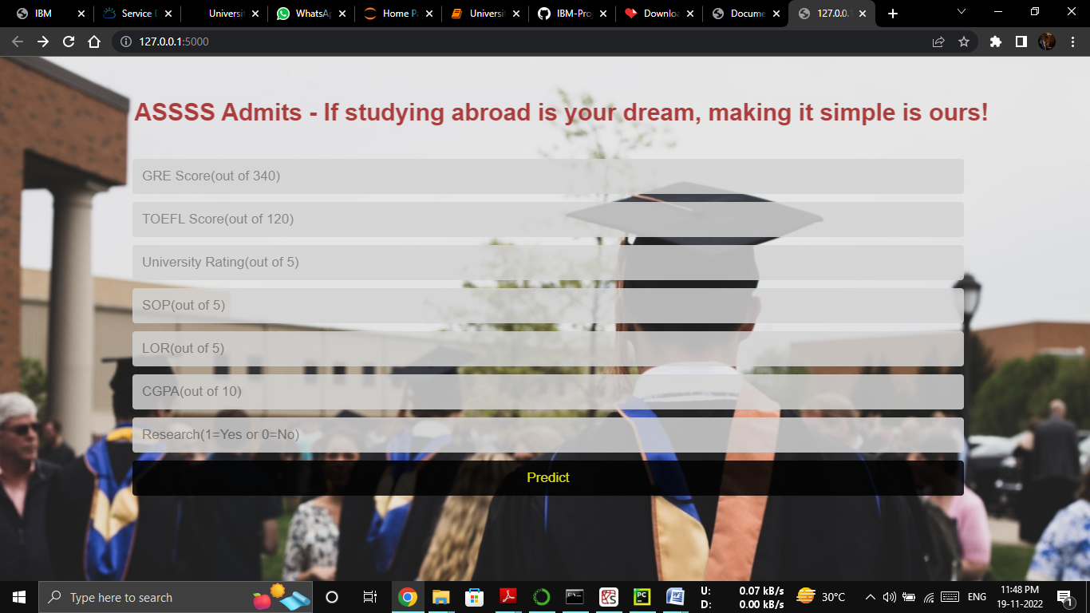

# TESTING

* 1. **Test Cases**

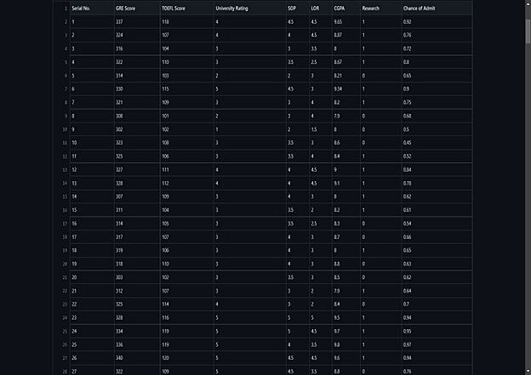

# User Acceptance Testing

User Acceptance Testing (UAT) is a type of testing performed by the end user or the client to verify/accept the software system before moving the software application to the production environment. UAT is done in the ﬁnal phase of testing after functional, integration and system testing is done. The User Acceptance of this product is not surveyed enough to give a solid conclusion. The theretical and hypothetical acceptance is calculated to be high enough to conclude that this product is usable and valuable.

# RESULTS

* 1. **Performance Metrics**

The Performance is the Accuracy of the model trained. The training accuracy of the model is 92%.

The testing accuracy of the model is 89%.

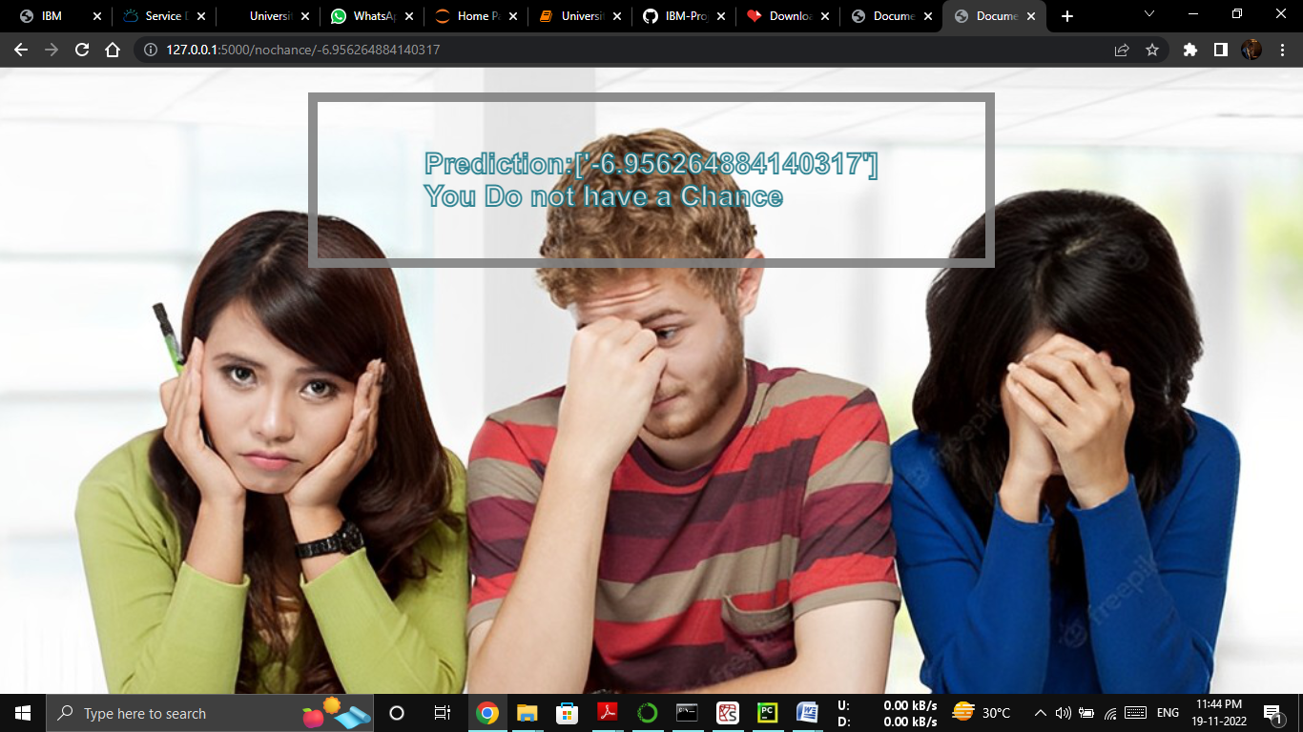

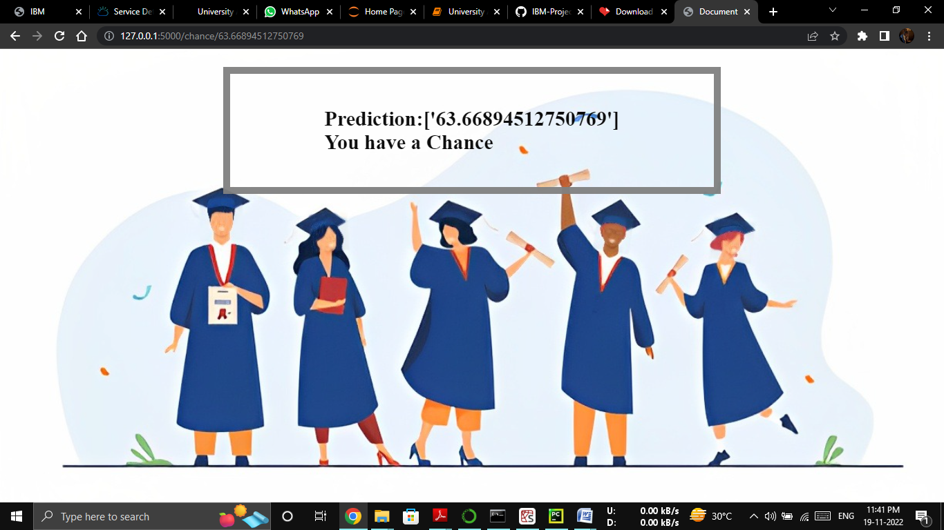

# ADVANTAGES & DISADVANTAGES

* **ADVANTAGE**

1. Know the percentage 2.Lower investigation 3.Provide Relevant Material

1. Reduce time consumption
2. Good user experience

# DISADVANTAGE

1.Signiﬁciant investments required 2.Inable to capture changes 3.Privacy concerns

# CONCLUSION

We have successfully developed an application using python ﬂask, HTML, CSS. By using the application we can predict weather we can get adimition in the desired University or not.

# FUTURE SCOPE

In fut re we would like to enhance the existing model in such a way that consumer feels the same way when purchasing in store using Virtual reality and other upcoming technologies.Reaserch to improve the accuracy of the system is under progress.

1. APPENDIX Source Code GitHub & Project Demo Link

**Project Link:** <http://ibmsmart.pythonanywhere.com/home>

**github:** <https://github.com/IBM-EPBL/IBM-Project-15550-1659600285>

# Demo : https://github.com/IBM-EPBL/IBM-Project-15550-1659600285/blob/main/Final%20Deliverables/Demo.mp4?raw=true