Lovely professional university

ARTIFICIAL INTELLIGENCE - INT404

REPORT

PROJECT : SMART PARKING SYSTEM



SUBMITTED TO -POOJA RANA

SUBMITTED BY -

CH S SIVA VARMA -11803635 -22

GEETHIKA NAIDU-11806783-24

HARSHA GUPTHA -11801554-23

ABSTRACT:

The aim of this project is to automate the car and the car parking as well. It discusses a project which presents a smart model of an automated car parking system that can regulate and manage the number of cars that can be parked in a given space at any given time based on the availability of parking spot. Automated parking is a method of parking and exiting cars using sensing devices. The entering to or leaving from the parking lot is commanded by an Android based application. We have studied some of the existing systems and it shows that most of the existing systems aren't completely automated and require a certain level of human interference or interaction in or with the system. The difference between our system and the other existing systems is that we aim to make our system as less human dependent as possible by automating the cars as well as the entire parking lot, on the other hand most existing systems require human personnel (or the car owner) to park the car themselves.

INTRODUCTION:

A car parking system is a mechanical device that multiplies parking capacity inside a parking lot. Parking systems are generally powered by electric motors or hydraulic pumps that move vehicles into a storage position. Car parking systems may be traditional or automated.

In a nutshell, Smart Parking is a parking solution that can include in-ground Smart Parking sensors, cameras or counting sensors. These devices are usually embedded into parking spots or positioned next to them to detect whether parking bays are free or occupied.

Smart Parking uses sensing devices such as cameras, vehicle counting equipment, sensors installed in pavements, etc. to determine occupancy of the parking lot. ... Internet of Things wireless sensors detect the vacant parking spaces and transmit the data to help the drivers get an idea about the vacant spaces for parking.

Smart Parking are not known to issue many court claims to enforce private parking tickets. Since tickets are based on contract law the only way they can force motorists to pay is by taking them to the county court. ... More information on legal enforcement of parking tickets can be found here.

PROPOSED METHODOLOGY:

It is often difficult to find the space to park their respective vehicle in crowded areas. This proposed Smart parking system consists of the onsite deployed Internet of Things (IoT) module which delivers real-time

output and monitors the flow of the parking of vehicles in and out of that particular parking lot. The methodology provides the optimal solution for the parking space. Using this method one can get to know the space for parking the vehicle.

RESULT AND DISCUSSIONS:

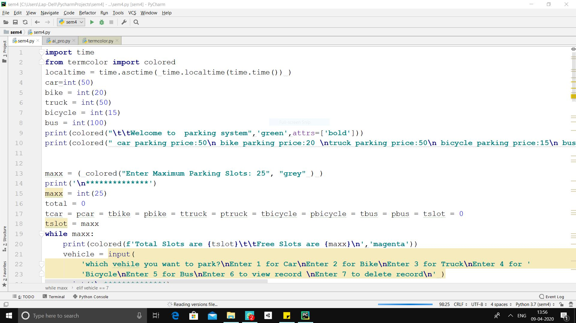

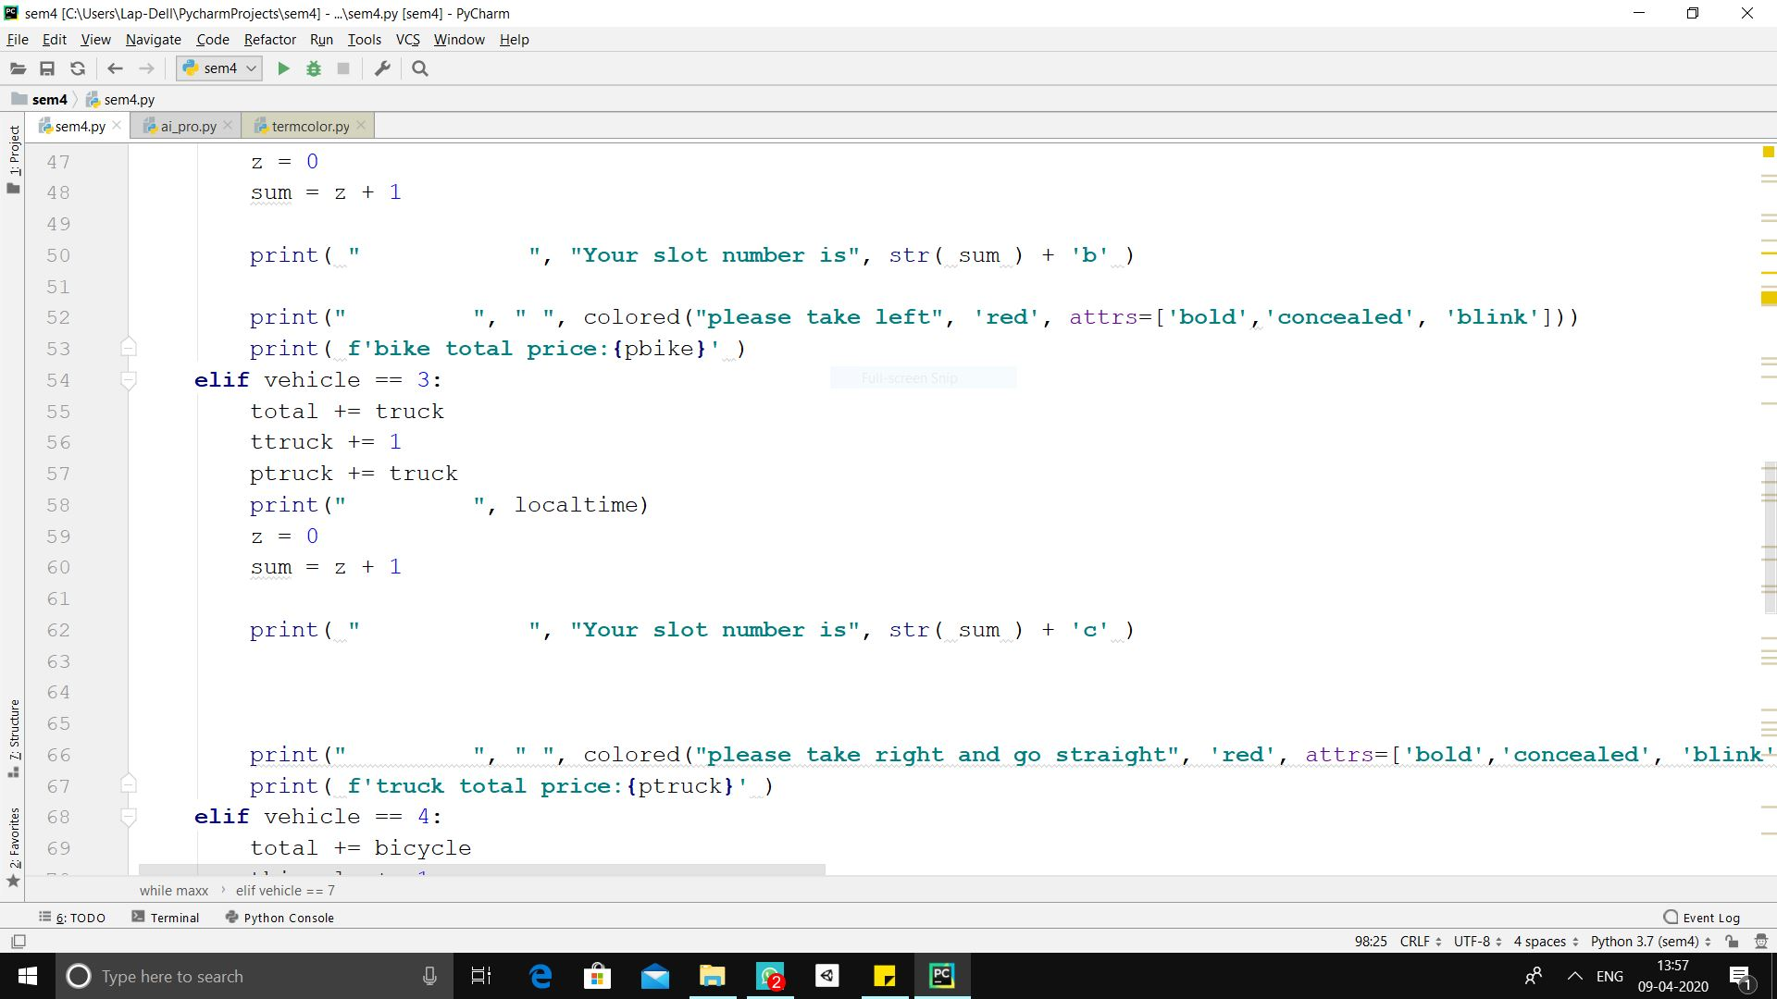



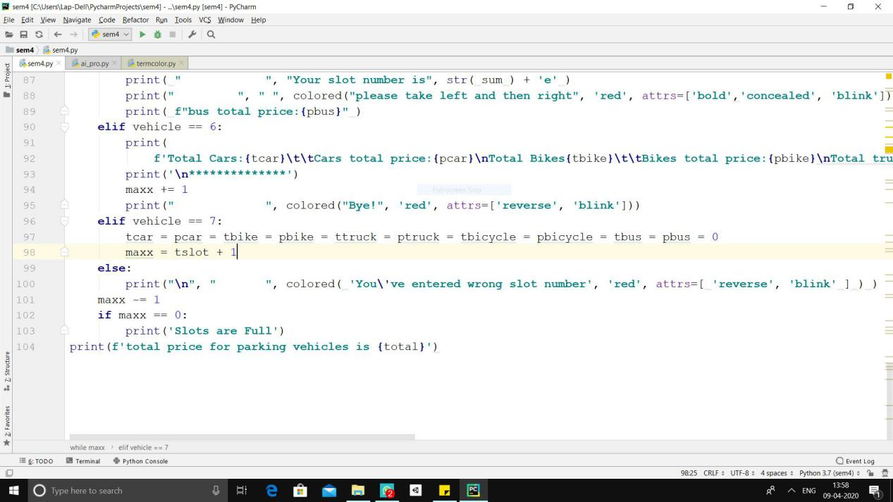

RESULT

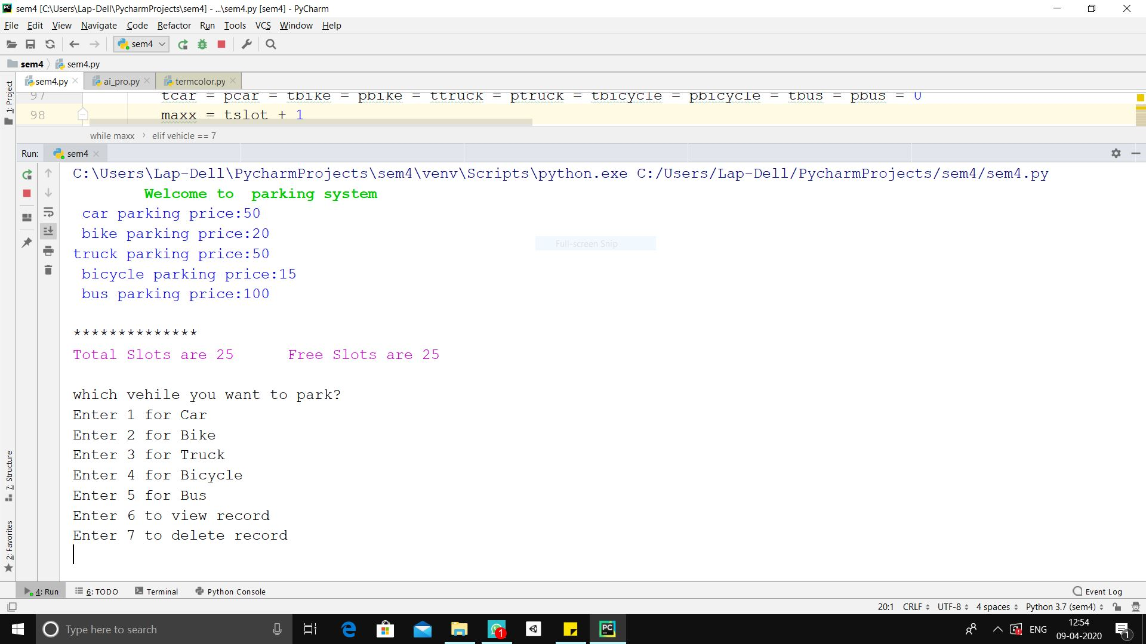

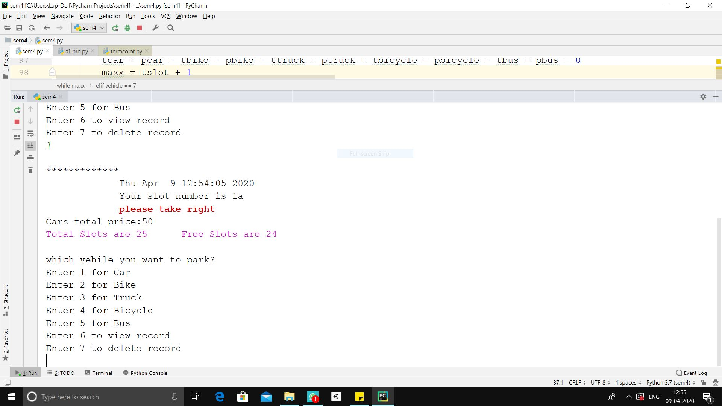

CONCLUSION:

The **system** benefits of **smart parking** go well beyond avoiding the needless circling of city blocks. It also enables cities to develop fully integrated multimodal **intelligent** transportation **systems** that don't rely on cars in the first place.