16: Creating and Testing a Clone of a VM Using VMware Workstation
1. Aim
To create a clone of an existing Virtual Machine (VM) using VMware Workstation and test it by loading the cloned VM.
2. Procedure
- Open VMware Workstation on the host computer.
- Select the Virtual Machine that needs to be cloned.
- Shut down the Virtual Machine.
- Click on VM → Manage → Clone.
- Select the cloning method (Full Clone or Linked Clone).
- Choose the current state or an existing snapshot as the cloning source.
- Enter the name and storage location for the cloned VM.
- Click Finish to create the clone.
- Open the cloned Virtual Machine in VMware Workstation.
- Click Power On to start the cloned VM.
- Verify that the cloned VM works independently of the original VM.
IMPLEMENTATION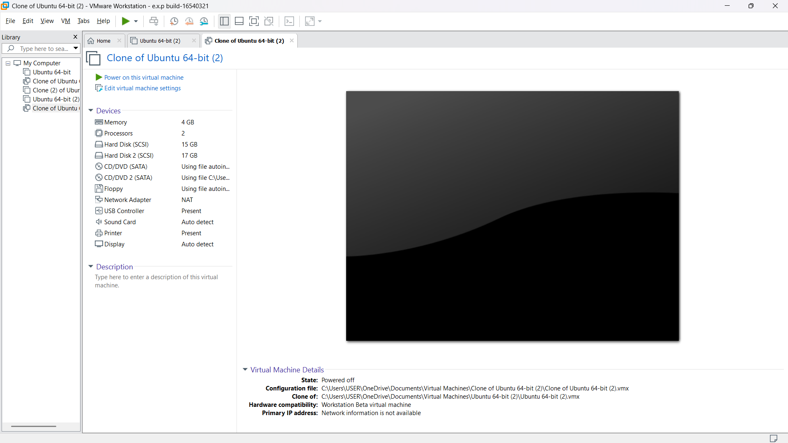

3. Result
Thus, a clone of the Virtual Machine was successfully created using VMware Workstation and tested by loading and running the cloned VM.

