CO3 ASSESSMENT TOOL 1- EXPERIMENTS

- Design and simulate a system that performs register transfer operations along with basic arithmetic and logic operations such as addition, subtraction, AND, and OR. Use multiple registers to demonstrate how data is transferred between them during execution, and analyze the sequence of operations and the role of the ALU in processing data.

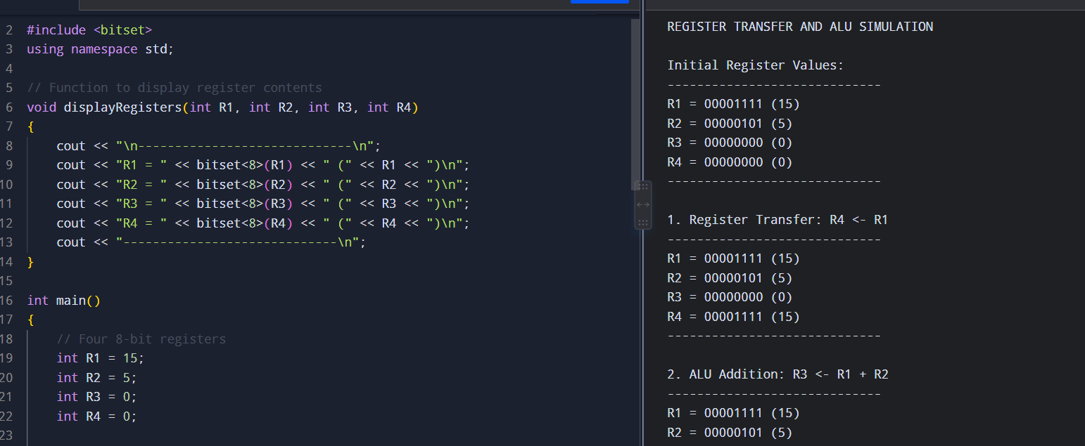

- Create a model of a computer system using single-bus and multi-bus organization, and perform data transfer operations between registers, memory, and I/O. Compare the time taken and efficiency of both approaches, and analyze how multiple bus structures improve parallel data transfer and reduce bottlenecks.
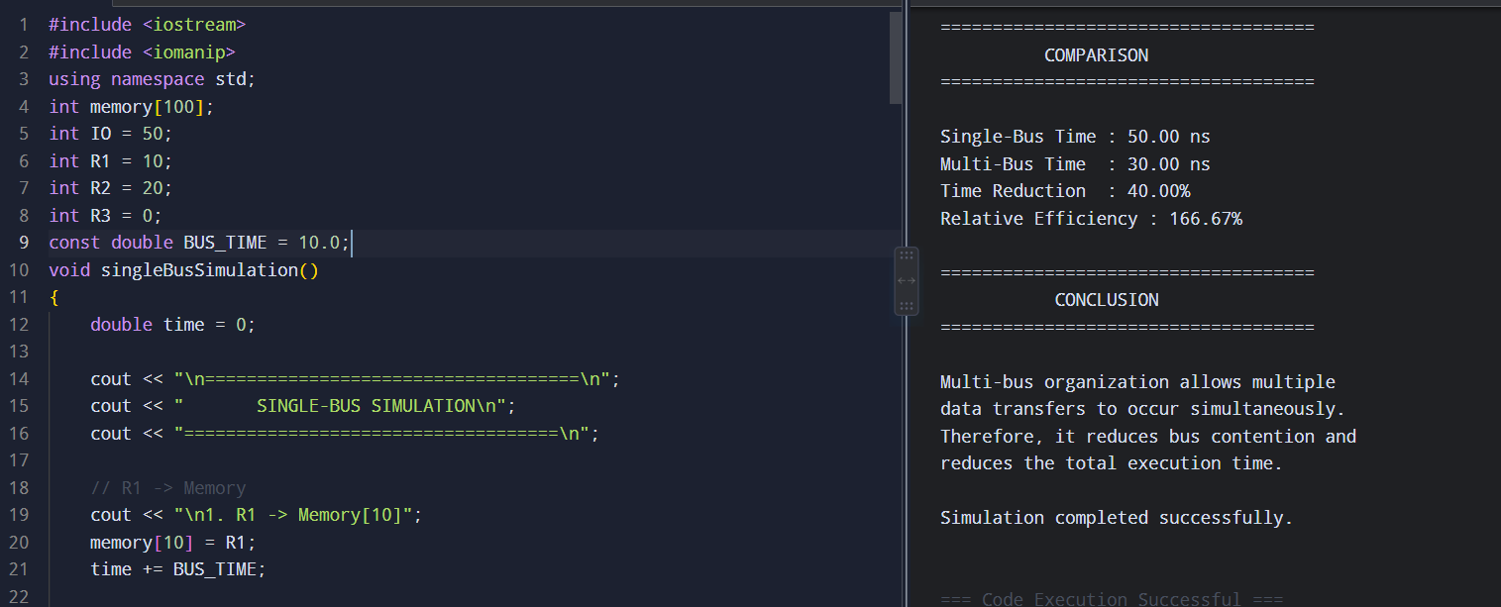

- Simulate a 5-stage instruction pipeline (Fetch, Decode, Execute, Memory, Write-back) and execute a set of instructions. Measure the performance in terms of speedup and throughput, and compare it with a non-pipelined system to evaluate the effectiveness of pipelining.
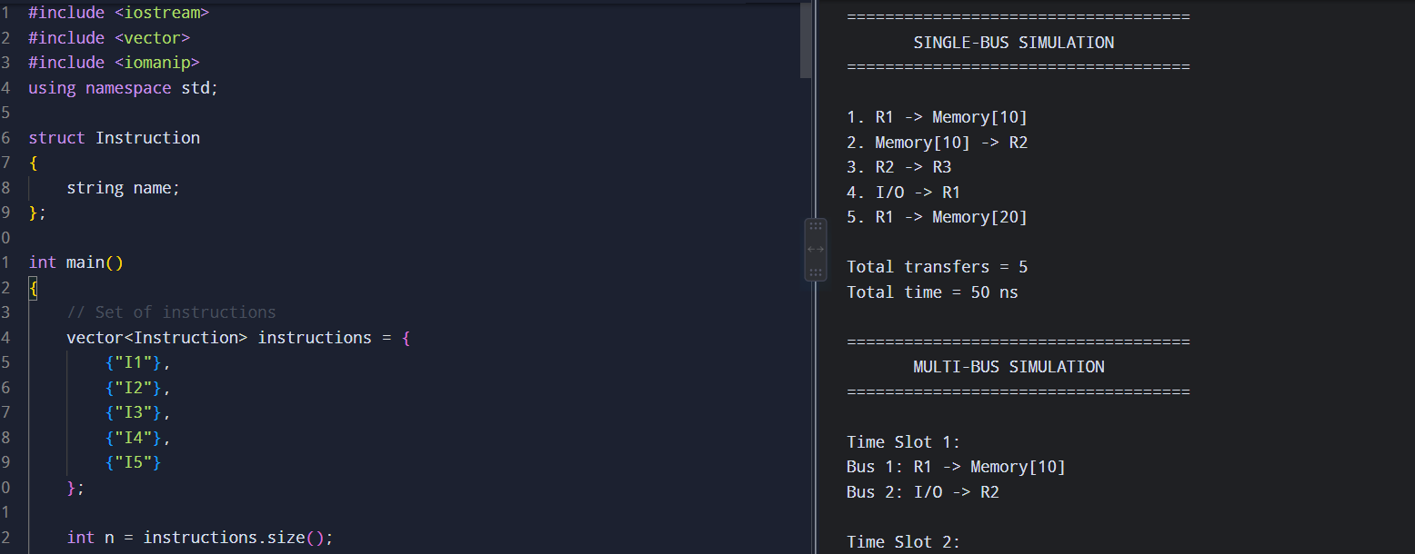
- Develop a pipeline execution scenario where data hazards, control hazards, and structural hazards occur. Observe their impact on instruction execution, and implement techniques such as stalling, data forwarding, and branch prediction to resolve these hazards and improve performance.
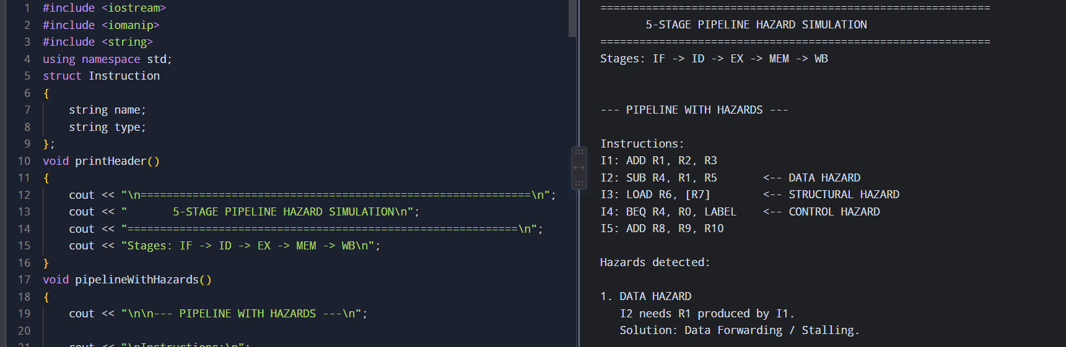
- Analyze a processor supporting superscalar execution, including out-of-order and speculative execution, and extend the study to include hyper-threading and simultaneous multithreading (SMT). Evaluate how multiple instructions are executed in parallel and compare the performance improvements in terms of instruction throughput and resource utilization.
