**Swiggy Funnel Analysis**

**Introduction**

Swiggy is one of the largest food e-commerce platforms in the country, with over 1 million users transacting daily. This report analyses Swiggy's performance in 2019 using data from three sheets:

* **Session Details:** Includes the number of sessions for orders, payments, carts, menus, and listings.
* **Channel-wise Traffic:** Dissects listing session traffic according to its origin.
* **Supporting Data:** Provides supplementary information like discounts, out-of-stock items, and delivery fees.

**Insights**

1. **Order Highs and Lows:**

* [Tuesday,7/23/2019]: Orders increased by 135% from last week's order which was -63%.

The reasons for the increase are higher average discounts, which are 19% higher than last week's 17%, lower average delivery chargesand also average cost of two purchases is less compared to last week.

* [Tuesday,1/29/2019]: Orders decreased by -72% from last week's orders which were 85%.

The reason for the decrease in orders is that the number of restaurants has significantly decreased from the previous week. Near 108238 restaurants are reduced. There is the dip. The average delivery charge and discount are also lower compared to last week.

1. **Traffic Fluctuations:**

* Traffic increased by 119% on [Thursday,6/27/2019] due to a significant increase in the traffic in social media platforms and other platforms when compared to last week when the percentage was -53%.
* Traffic decreased by -53% on [Thursday,6/20/2019] due to a significant decrease in the traffic in social media platforms and other platforms when compared to last week when the percentage was -3%. The dip in traffic on social media was half when compared with each other.

1. **Overall Conversion Change:**

* Overall conversion has increased significantly by 128% on [Tuesday,6/23/2019] when compared to last week which was -59%. The reason can be due to traffic increased through channels and where the delivery and discount is decreased.
* Overall conversion has decreased significantly by -59% on [Tuesday,6/16/2019] when compared to last week which was -1%. The reason can be due to traffic decreased through channels and where the delivery and discount is decreased.

**4. Conversion Metrics:**

* **L2M (Menu/Listing):**

Significant improvement on [Tuesday,2/5/2019] can be due to enhanced menu designs and easy navigation.

* **M2C (Cart/Menu):**

Drop on [Sunday,11/17/2019], likely due to unclear menu information and can be due to out-of-stock items on this particular date there is an increase.

* **C2P (Cart/Payment):**

Drop on [Saturday,3/2/2019], can be likely due to high delivery charges.

* **P2O (Payment/Orders):**

Drop on [Tuesday,3/19/2019] caused by payment gateway issues and not enough payment options

**Recommendations**

1. **Order Drop:**

* Increase discounts on low-performing days.
* Improve stock availability to minimize order cancellations.
* Offer rewards for referrals to attract new users.
* Run time-sensitive promotions

1. **Traffic Issues:**

* Invest in marketing campaigns during low-traffic periods.
* Optimize traffic sources with declining performance.
* Invest in underperforming traffic sources (e.g., social media, search engine ads).
* Use push notifications and email campaigns to re-engage users.

1. **Conversion Issues:**

* Redesign menu layouts to boost engagement.
* Streamline payment gateways to reduce failures.
* Offer one-click checkout options
* Add multiple payment methods (e.g., UPI, wallets, cash on delivery)

**Charts**

Daily Orders Trends

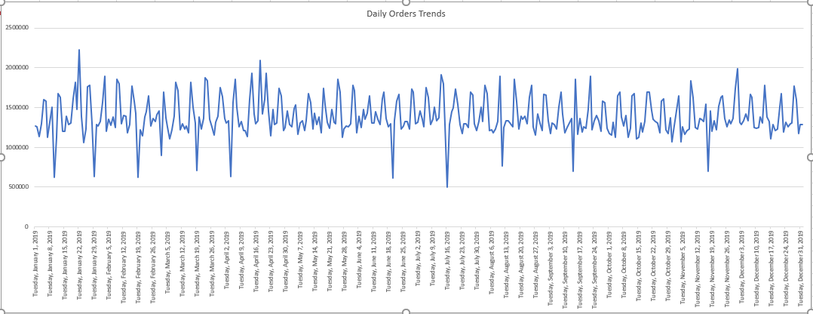

* The lowest Daily Orders Trends can be seen on [Tuesday,7/16/2019]. This is due to the Orders on this date being the lowest when compared with other dates.
* The Highest Daily Traffic Trends can be seen on [Tuesday,1/22/2019]. This is due to the traffic on this date being the Highest when compared with other dates.

Daily Traffic Trends

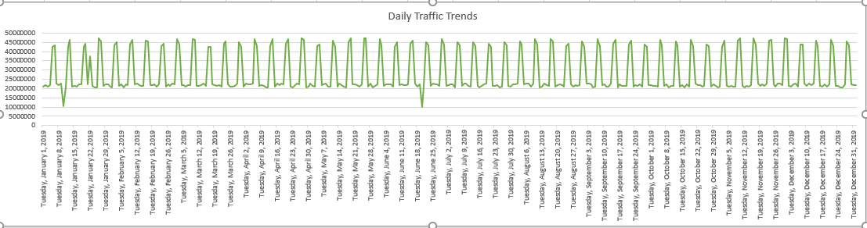

* The lowest Daily Traffic Trends can be seen on [Thursday,6/20/2019]. This is due to the traffic on this date being the lowest when compared with other dates.

Daily Conversion Trends

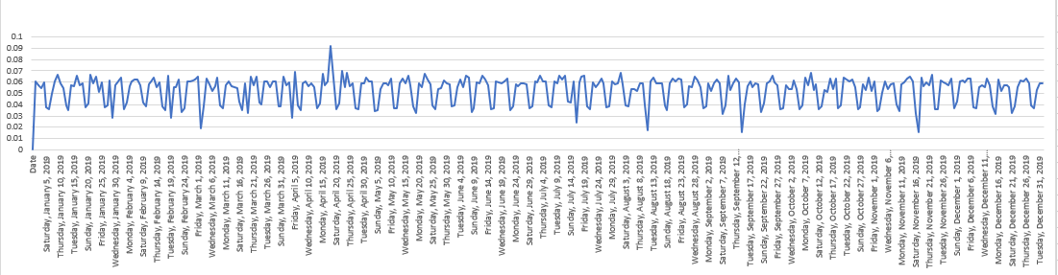

* The highest Conversion percentage in the chart is on the date [Thursday,4/18/2019]. This increase is because of the sudden increase in the average discount which was 29%.

Conversion Metrics

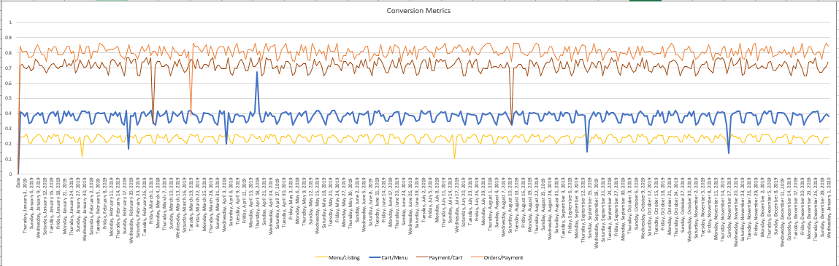

* Most of the dip in the line chart can be seen at the weekends.
* L2M is the lowest percentage of conversion in L2M on [Tuesday,7/16/2019] because the average price of two items is at the highest when compared to the other dates in L2M. This can be the reason for the dip.
* M2C has the highest percentage of conversion in M2C on [Thursday,4/18/2019]. This increase is because of the sudden increase in the average discount which was 29%.
* C2P has the lowest percentage of conversion in C2P on [Saturday,3/2/2019]. This dip in percentage is due to high average delivery charges.
* P2O has the lowest percentage of conversion in P2O on [Tuesday,3/19/2019]. This dip is due to the low success rate of payment which is 65% and this is the lowest when compared to other dates in P2O