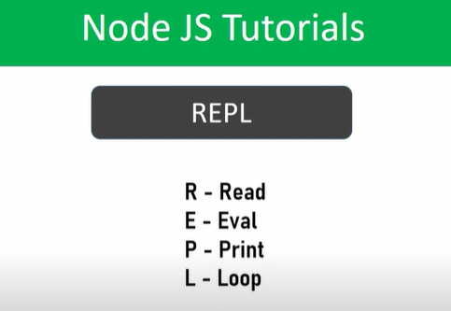

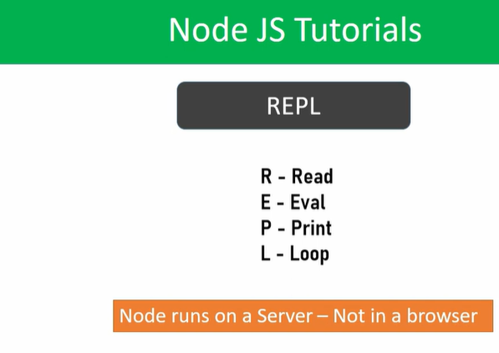

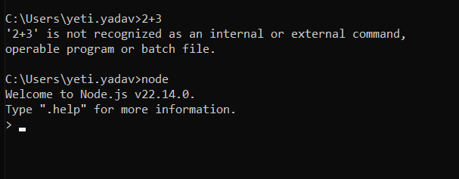

//These is called ‘repl’, here we can write our logics and code

//These REPL will open , when we type ‘node’ in cmd prompt

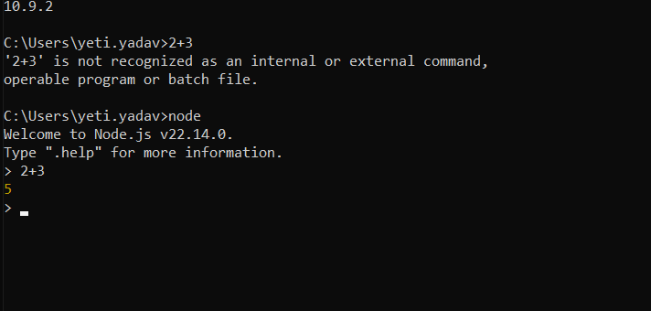

//In these we can write logics, and also javascript code

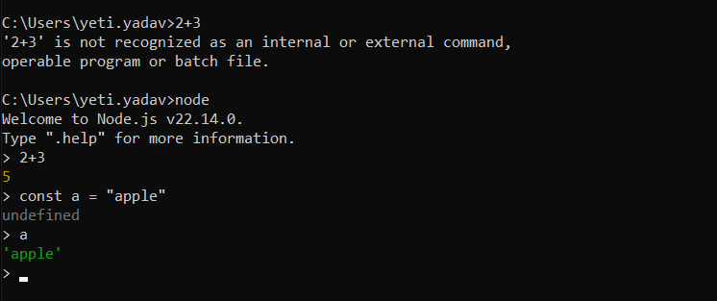

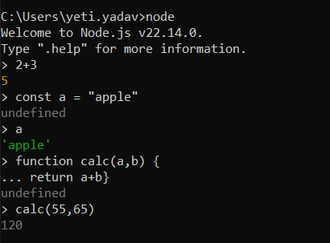

//By using these REPL , we can write our javascript code instantly.

//REPL is also , usefult to test the javascript code instantly

//when ever ,we close the terminal which has the REPL , and the code in the repl will not save and erased completely.

//In next class,we will see, by using the cli, we will implement the code which we run in node or node REPL