CLI

//Command Line Interface

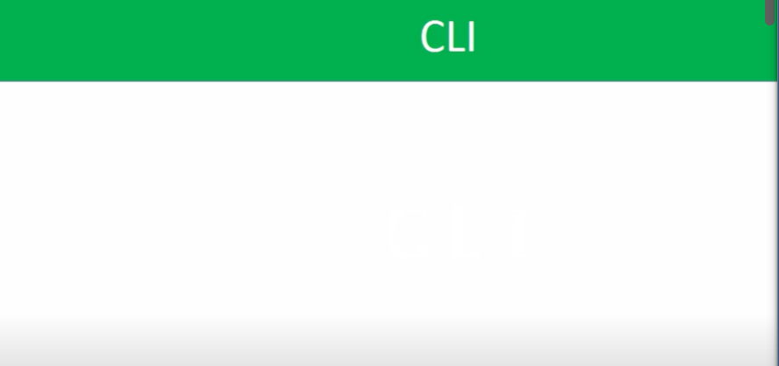

//We will see the output of the code in CLI which we run in node /node REPL

Node/Node REPL codes or logics are runs on a server – not in a browser

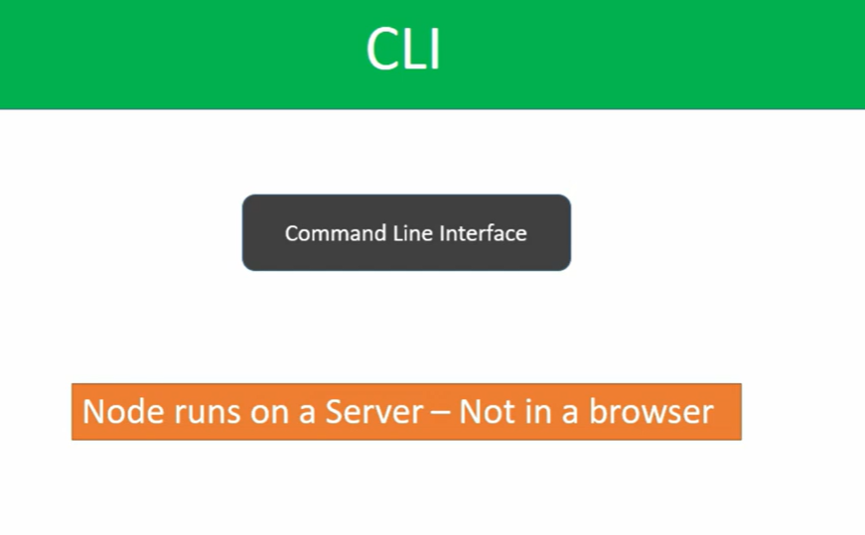

//To see the output of code, which we written on node, we have to use CLI

//In before, in REPL , we write the code and close the terminal, then the code in REPL ,will be erased

//But ,if we create the file by using cli, in that file, if we write the node code.Then even after we close the terminal, our code will not erased it will saved in the file , in which we write it.

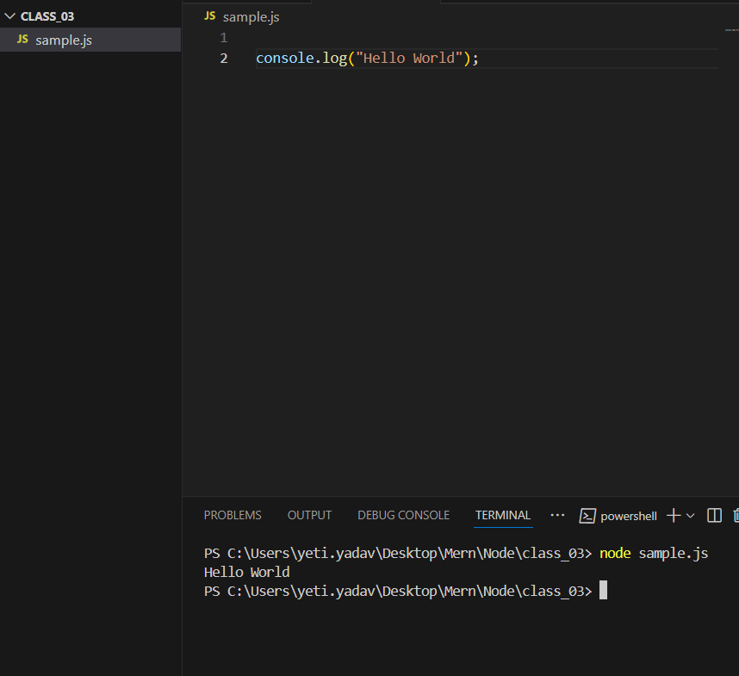

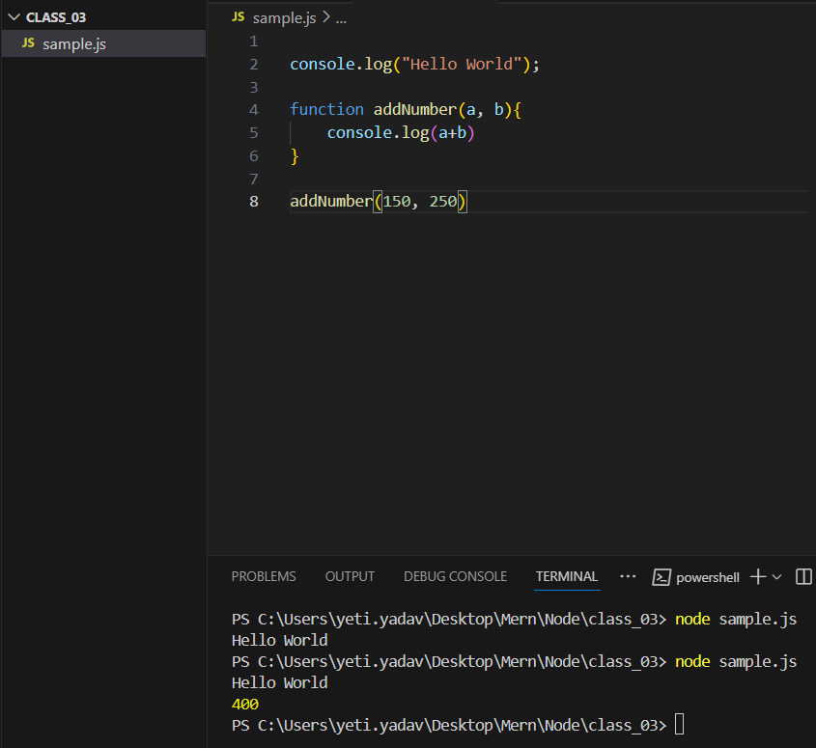

//Even, if we close, the terminal, then our code will not effect, because, we write our code in a file class_03.

//So, in these way ,we can see the output of code in node, in cli, by creating a file, in that writing the code of Node, which will not effect, even when we close the terminal