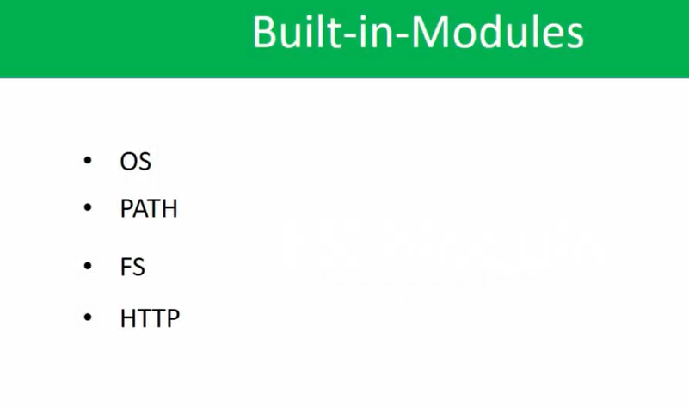

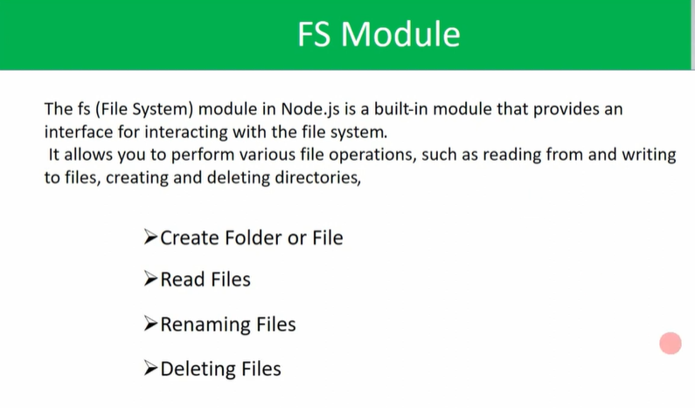

FS – File System

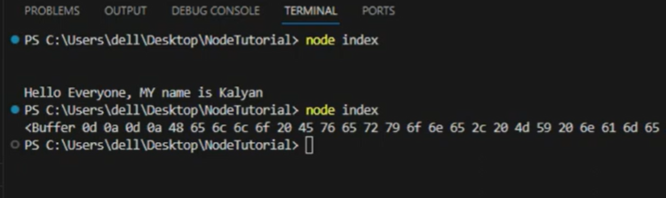

//if we didn’t use the ‘utf8’ encoder in our fs.readFile(), then our output will be displayed like these, to convertthe output into stringify, then we have to use ‘utf-8’.