//HTTP Module

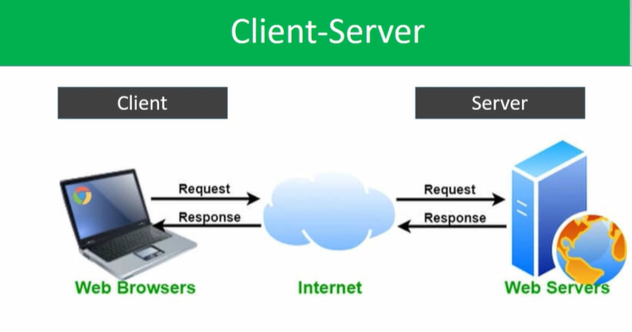

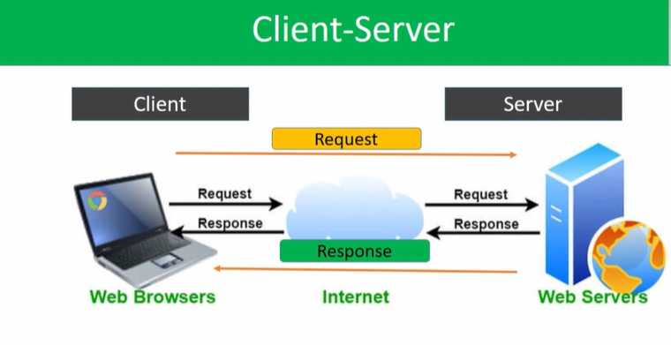

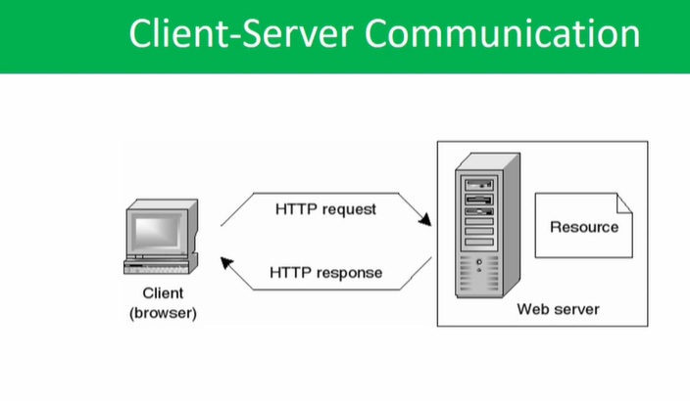

//Purpose – whatever the request from client to server, to ensure server should understand the request was handled by http.

Whatever the response from server to client , to ensure client should understand the response was handled by http

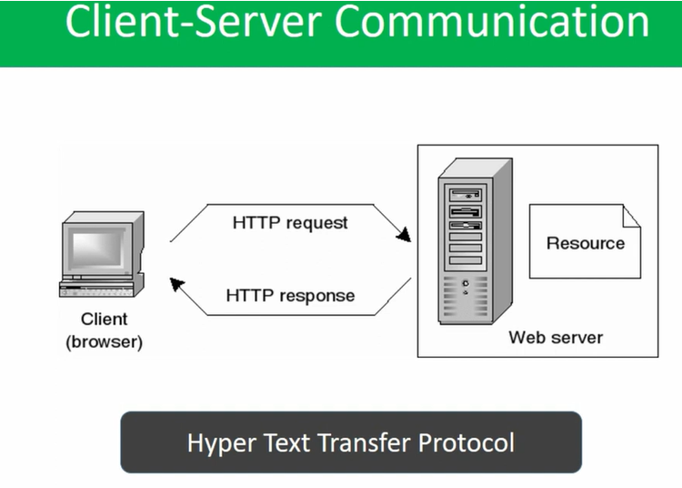

//Lets implement these practically

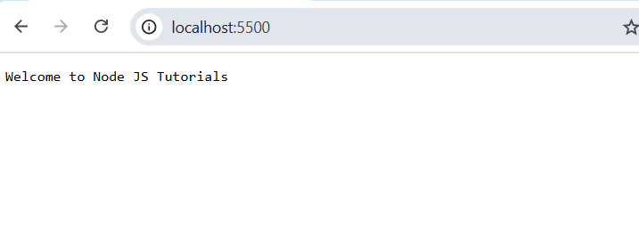

//Browser is client, from browser, we have sent the request by server port number 5500, in return the server returns the response based on the client request