//Local Module

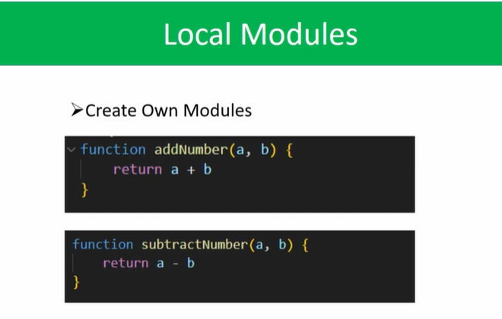

// we can create a piece of codes , we use that codes anywhere in our code file, similar to functions.