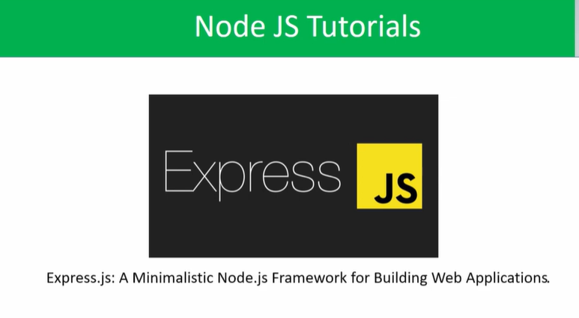

//By using these Express js framework, we can implement the Node.js features efficiently

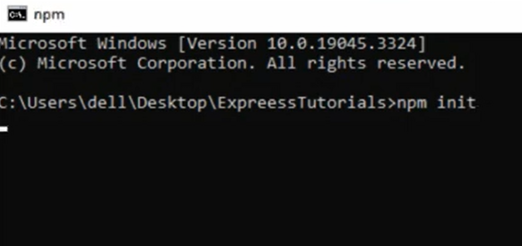

//These command setups the node environment in Express Tutorials folder

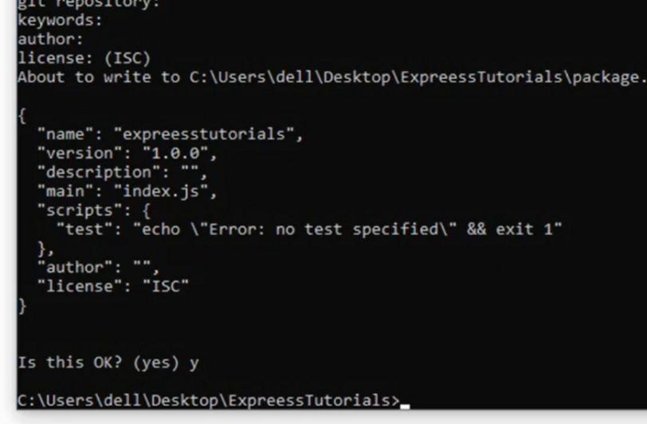

//after all these package.json will be created in our folder

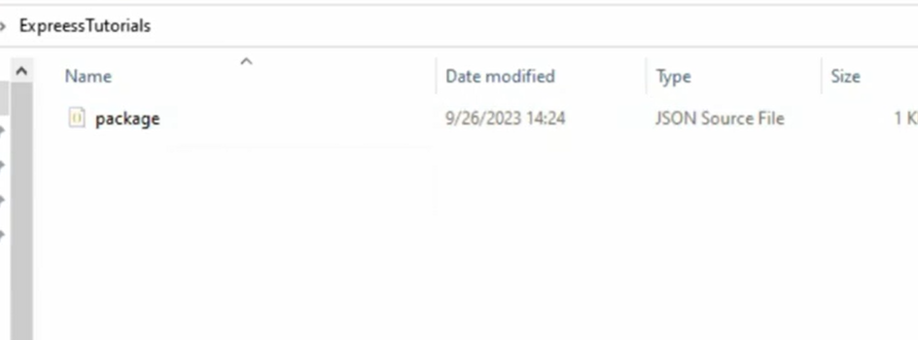

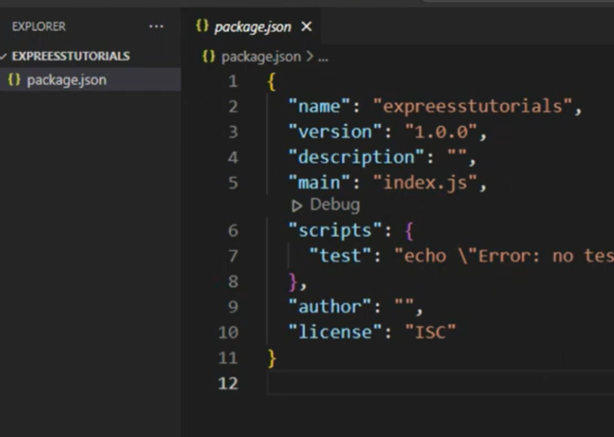

//In package.json has our file info

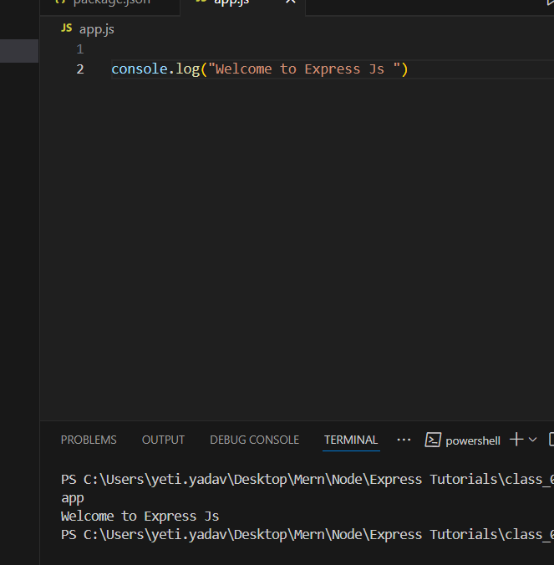

//In node.js, whenever we have done the changes in our code to see that changes in terminal output, we have to run our file ‘node file_name’

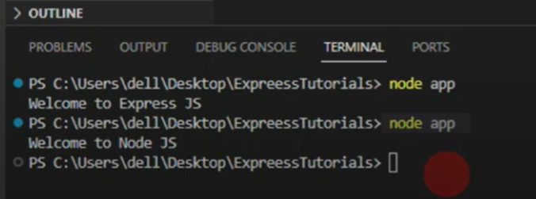

//We have a package ‘nodemon’ , whenever we have done the changes, and save the file, then that changes will automatically render on terminal output.

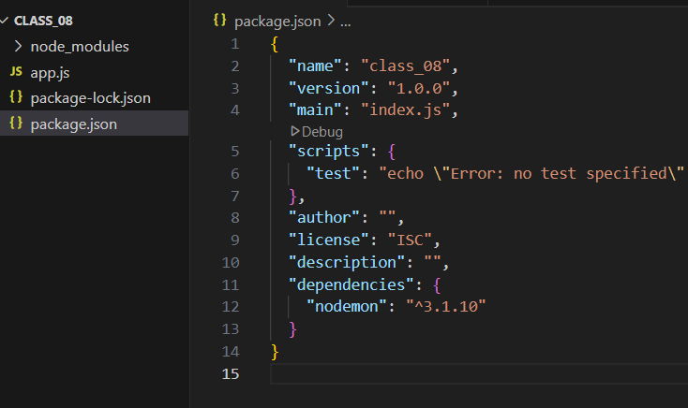

//To run these nodemon in our project, we have a simple process i.e by using ‘start’ attribute in ‘scripts’

