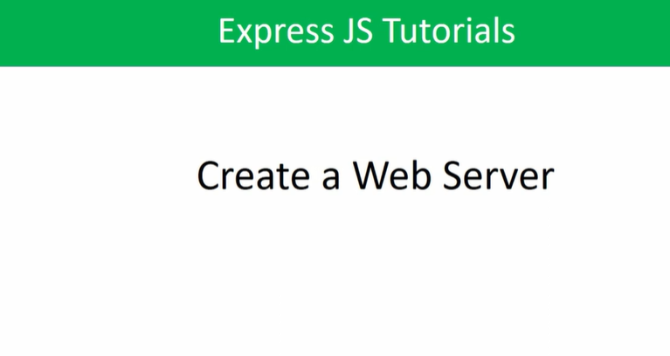

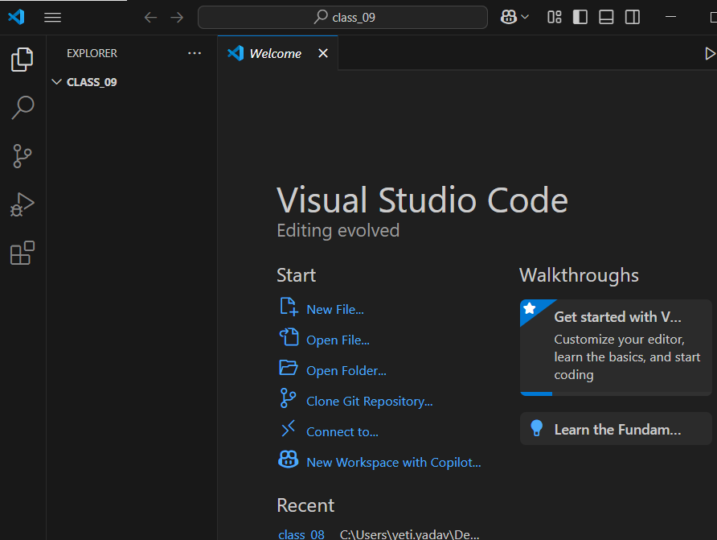

//firstfall, we have to initialize a node in our project by using ‘npm init’

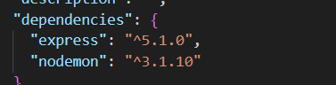

//Here we have installed two dependencies in our project’

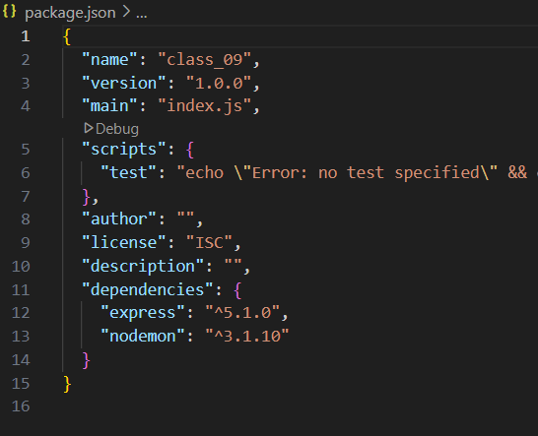

//to start our application, i.e enables to application run automatically whenever we performs save on file, by using ‘start’ attribute {“start”: “nodemon entry_point_of_our_application” }

