//Middlewares

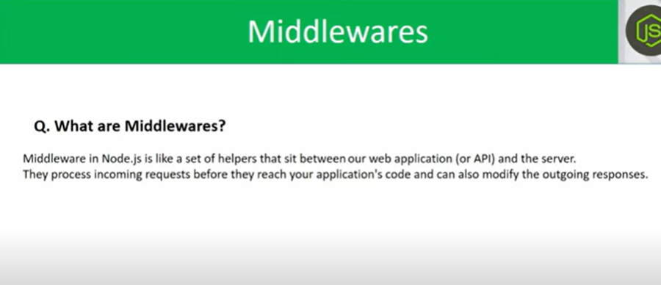

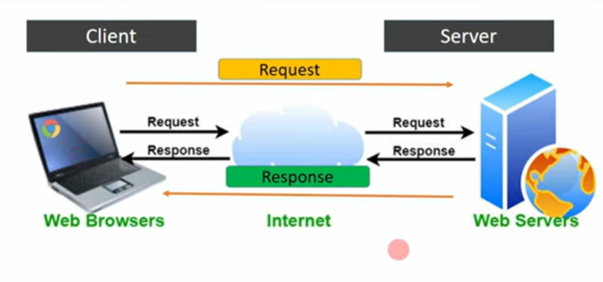

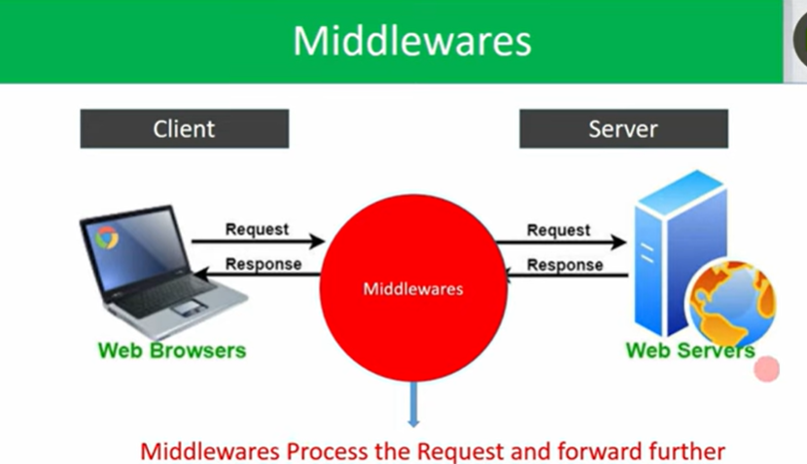

//To implement the MiddleWares we need the ‘Routes’

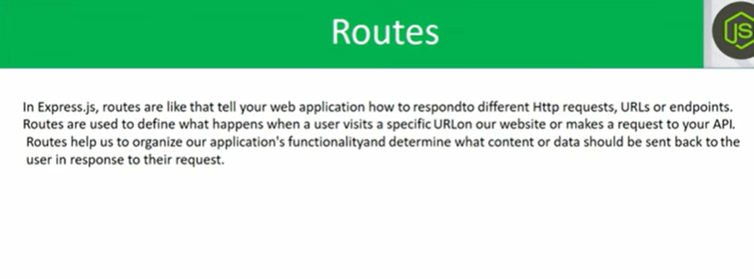

//These routes are used to decide which response we have to sent based on which request.



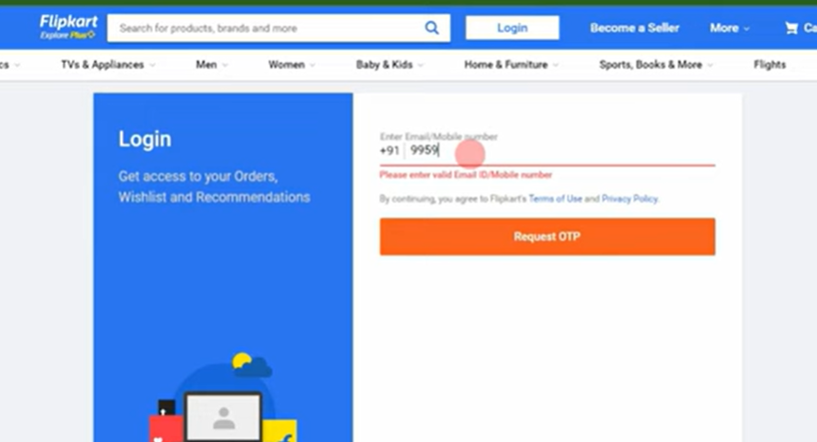

//developer developed a middleware that in between client & server, i.e whenever user enetered 10 digits number then only, it middleware evaluates, and sends the reuest to server.

//if middleware criteria is not matched in client request’s like entering 4 digits instead of 10 digits and sending the request, then, middleware evaluates and sends a response i.e ‘invalid credentials’ instead of sending the request to server.

//Middleware checks our requests criteria, if request matched our criteria, then only Middleware forwards clients request to server.

//Lets implement the routes and middlewares practically

//npm init – to setup node in our project (provides node modules, package,json)

//node i express nodemon – installs express, nodemon in our project

//Lets register the middlewares, and implement the middlewares in between client and server

//Middleware is a function (app.use()) //app the variable which we assigned the imported express framework

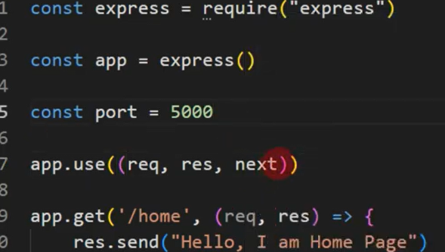

//Middleware function syntax

//app.use( ( req, res, next) => {

If(10 < 20){

next() //if the condition is true then next() function will be called

}

}

//whenever the next() function will be called then remaining code will be executed with out disturbance.

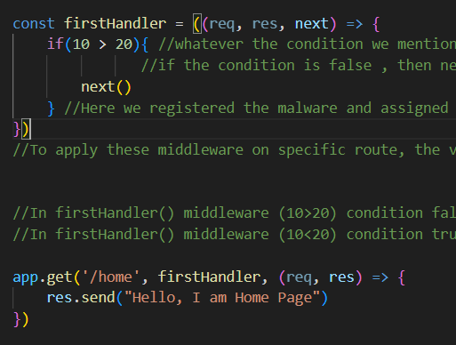

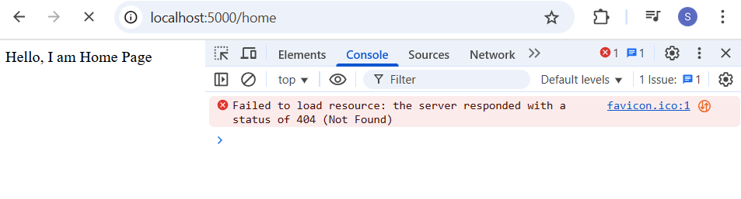

//In next class, we can see how we can create the apis by using these routes, and also we can see by using methods how we can create the apis.