//Connect MongoDB with Node/ExpressJS

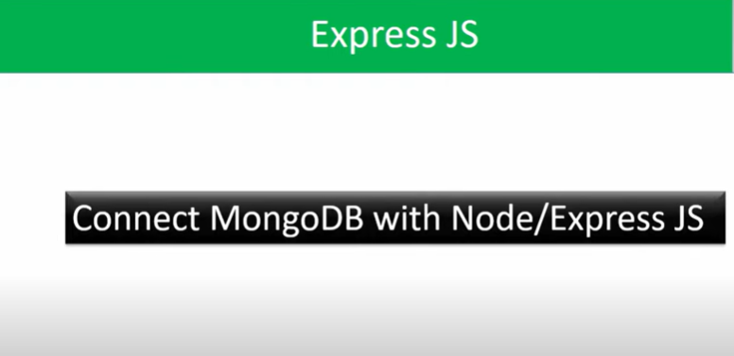

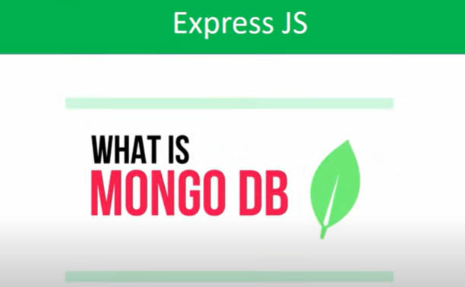

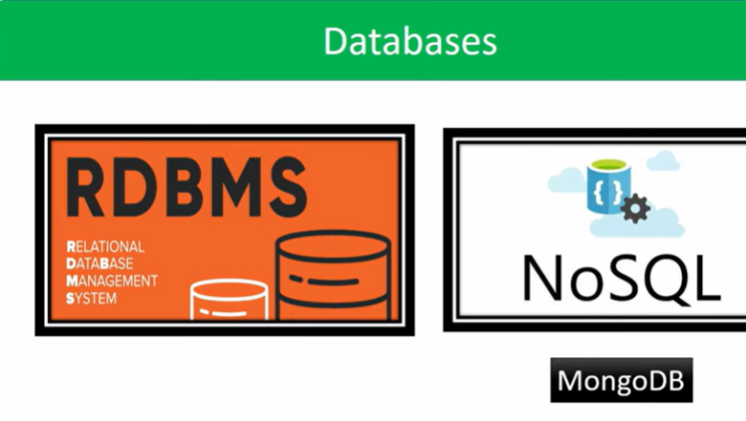

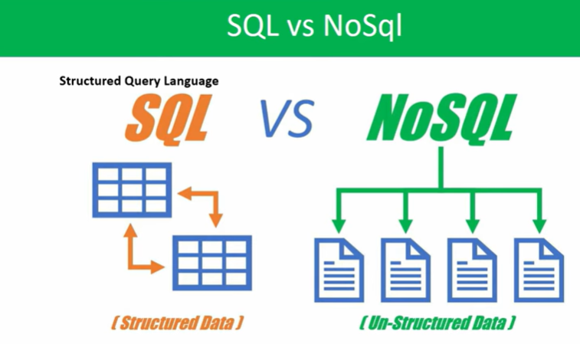

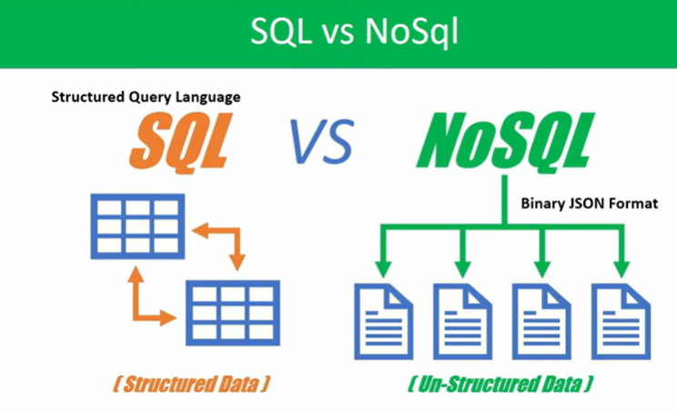

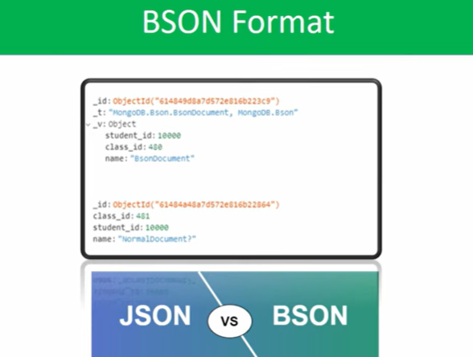

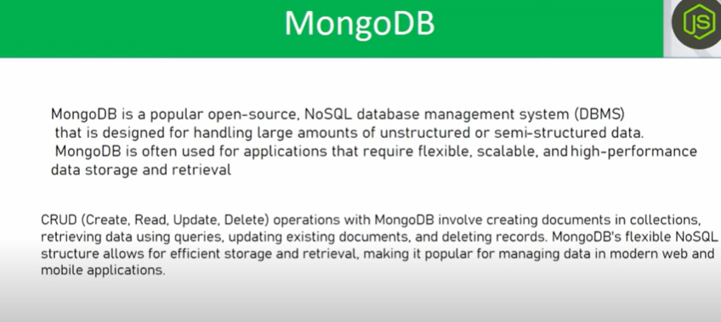

//Two ways to connect with MongoDB

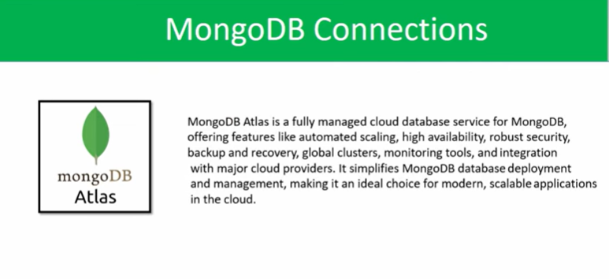

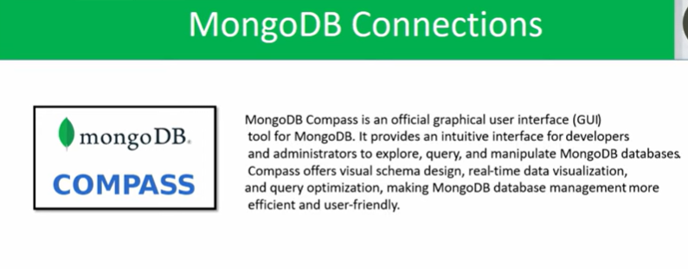

//Here, we are using MongoDB Atlas to connect with Mongo DB

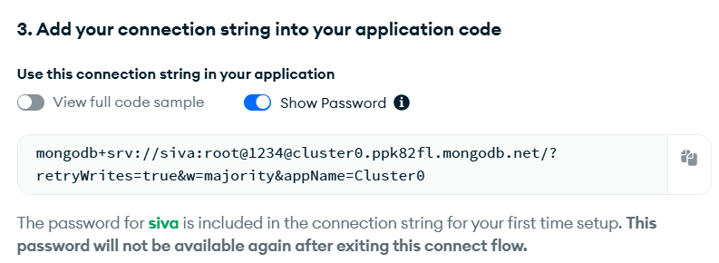

//Using these url, we can establish the connection between mongodb and node/express

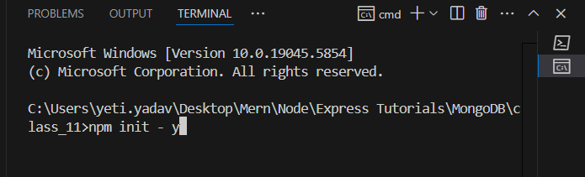

//To setup the node in project by using the command ‘npm init –y’



//To install express nodemon in our project

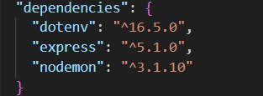

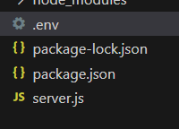

//The sensitive information can be stored in .env file

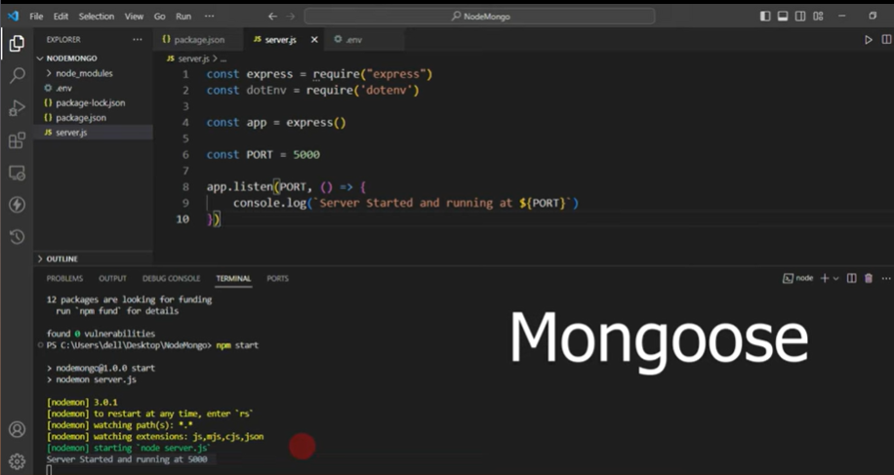

//By using Mongoose Library , we can make connection to MongoDB, and perform the crud operations on it.In next classes we can use mongoose library

//But now we can implement manually, installing the MongoDB in our project and perform the crud operations.

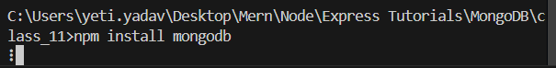

//After mongodb installing in our project, we have to require or import the mongodb in our project, for that by using MongoClient class we will require/import the installed mongodb in our project.

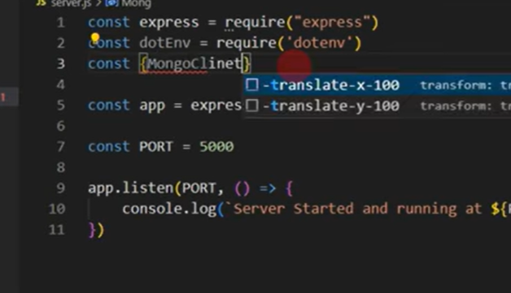

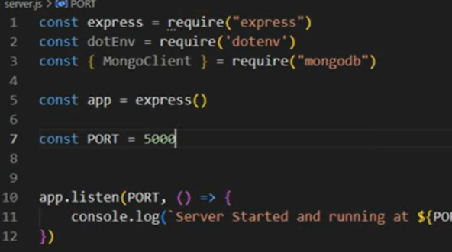

//Whatever the .env file we created , which has the MongoDB project url, which is used to connet the node/express with mongodb

//To import that env into our server.js, we use ‘process.env’

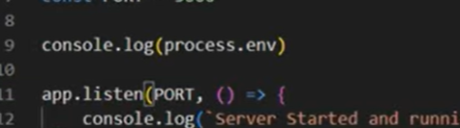

//By these process.env , global object, the features , variables in our files/folder we can access.

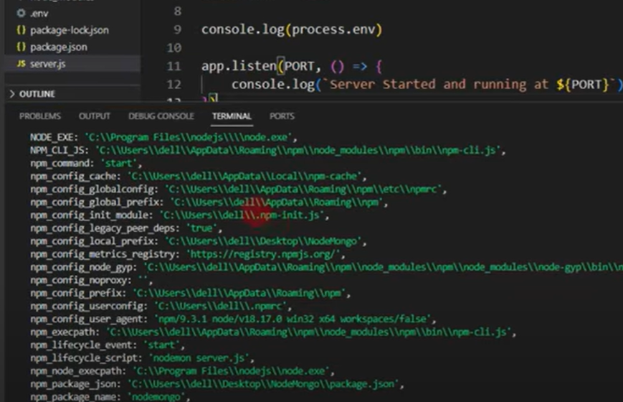

//Here we can see the all features in our application, By using process.env we are able to access the any feature in our application

