//Restful Crud API

//To verify the get() method we can proceed with browser

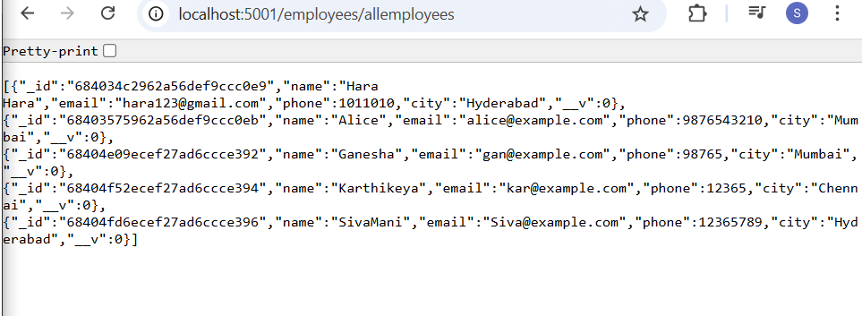

//MongoDB will creates a unique id, for each record, if we didn’t specify the id, while post operation

