//JWT Tokens

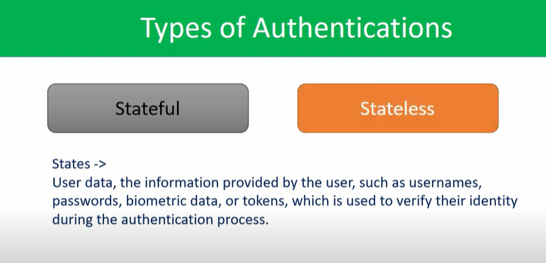

1.Project setup

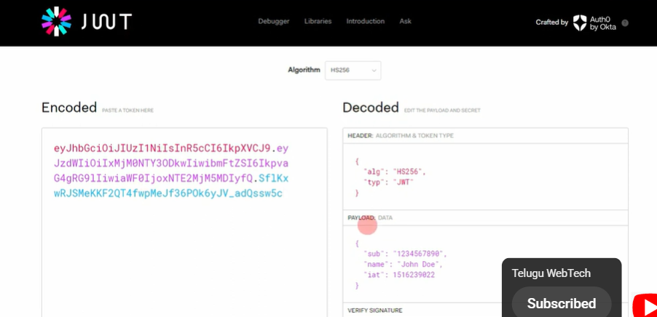

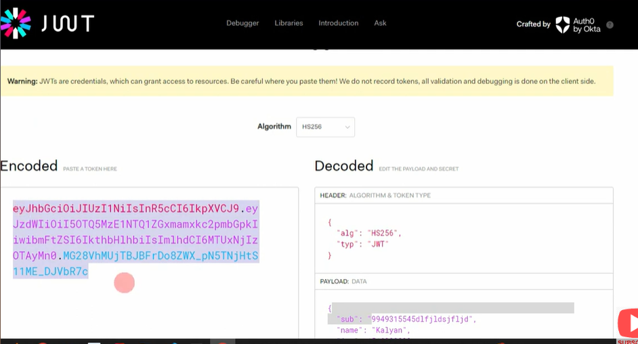

//Whatever the value under the encoded tab, it is called JWT token, which is prepared based on the data in payload, and applying the algorithm on it.

2.create api

3.api testing

//whatever the api we created test that api, by using postman

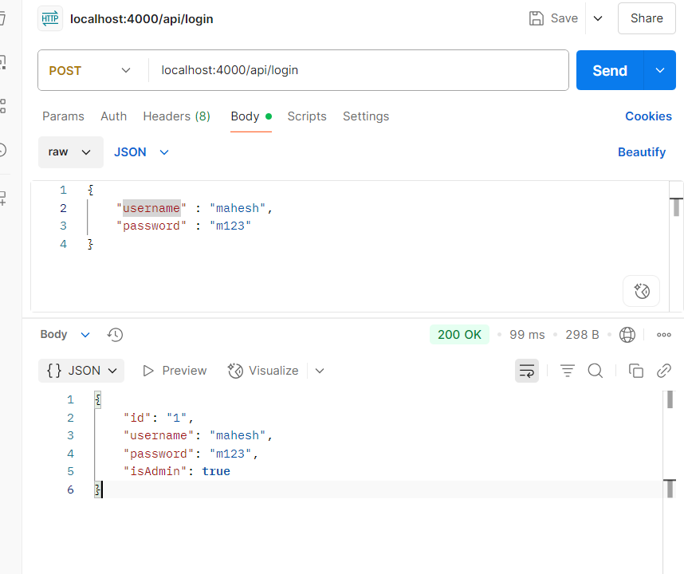

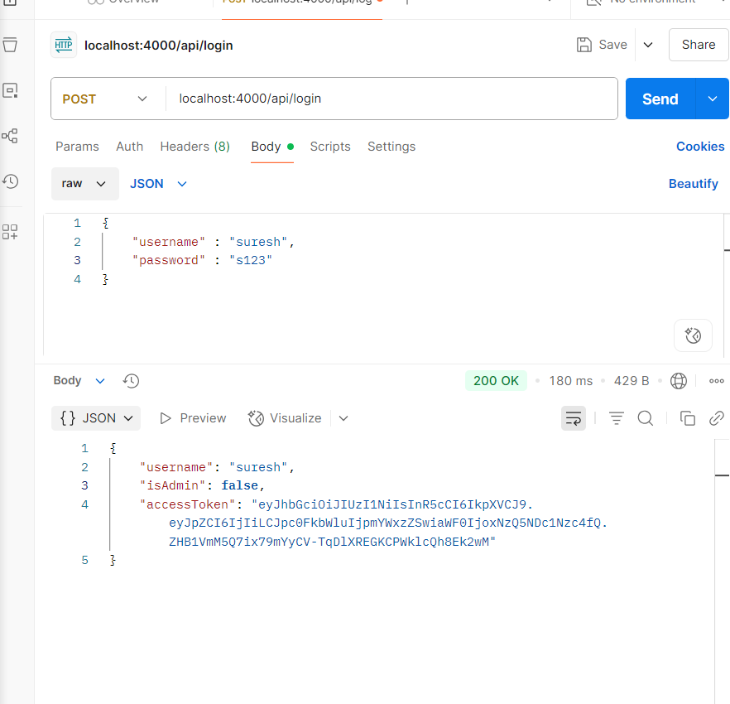

//Access token generated in JWT implementation, by using jwt.sign( credentials in object format, secretKey)

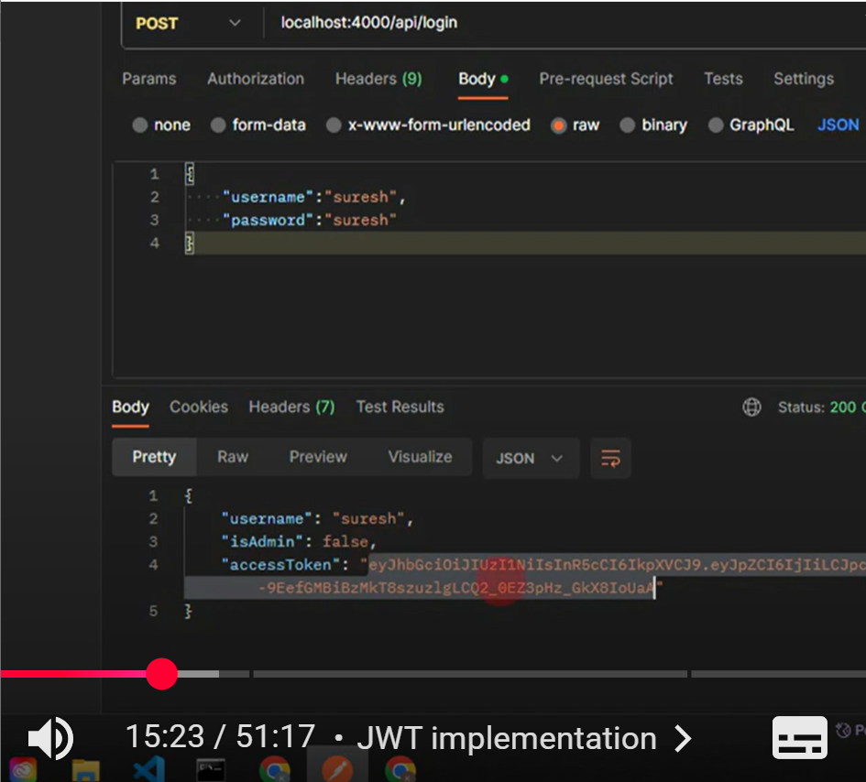

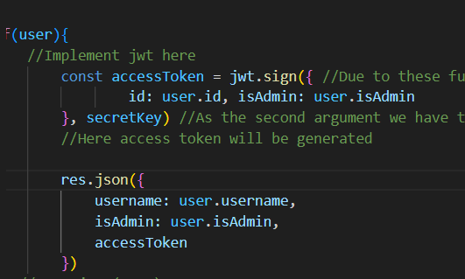

//On these user.id, user.isAdmin values we applied the algorithm and generated the jwt.

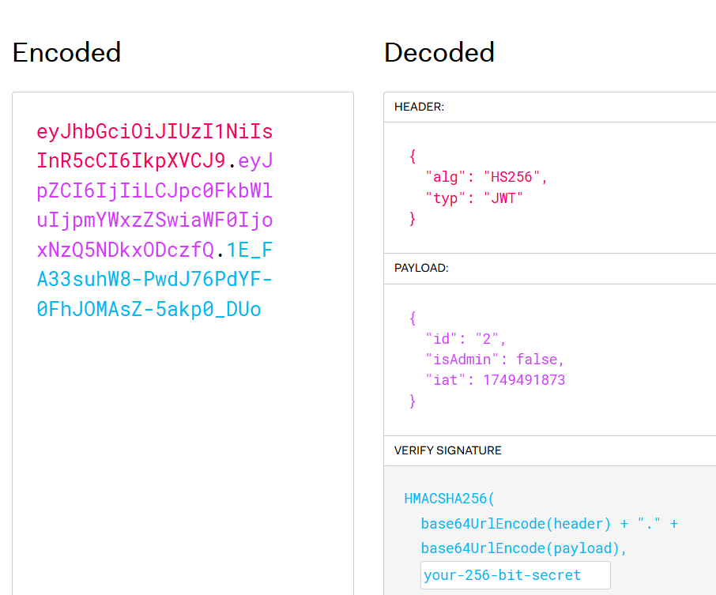

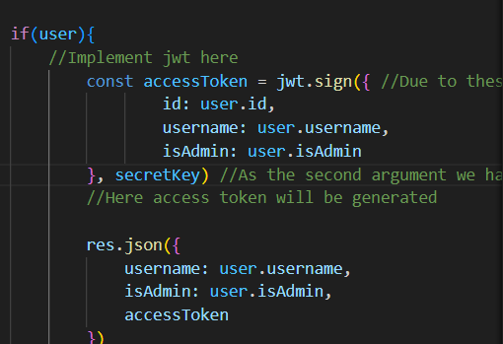

//Here we applied the algorithm on id,username,isAdmin and generated the jwt

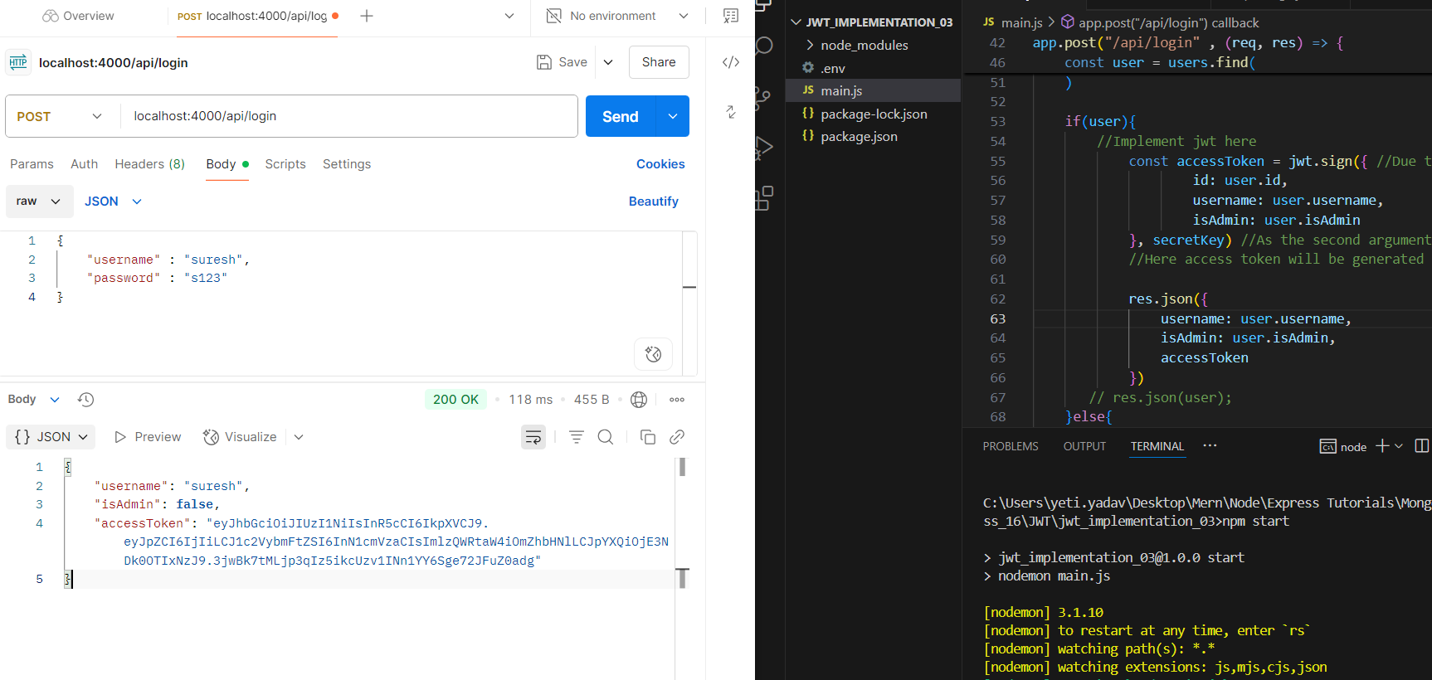

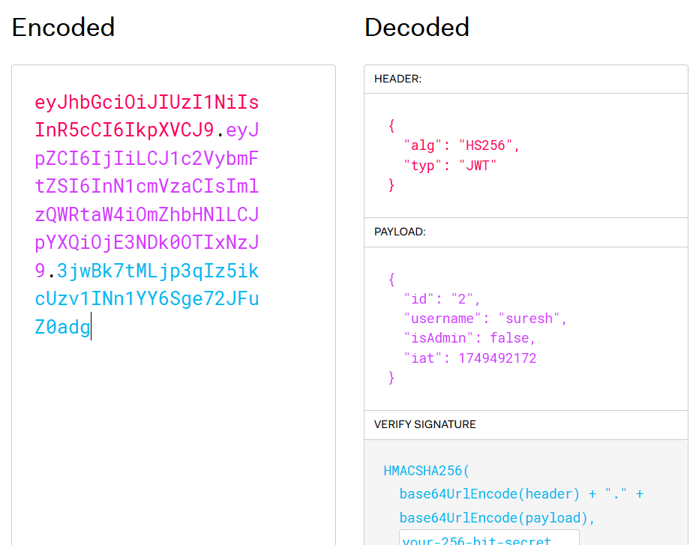

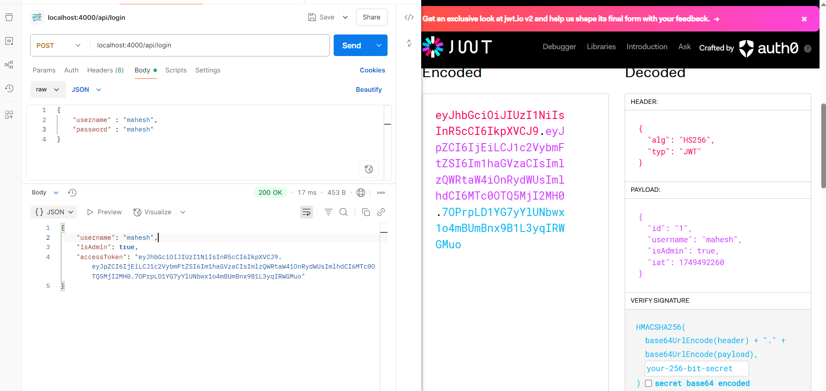

//Upto know we are succefully login, and generated the access tokens for the user login, on particular user info (id, username,isAdmin)

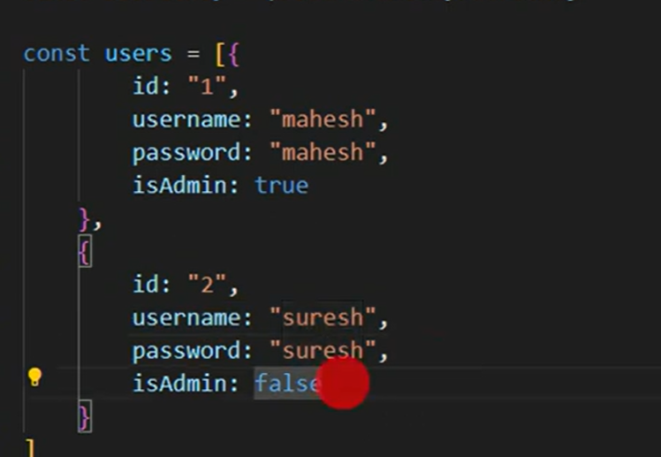

//Mahesh is Admin, he can delete any users, but suresh is not admin , he can’t delete other users, suresh can only delete his account only

5.Dynamic Tokens

//We can achieve these by creating a routing for delete action, inside that function which performs delete, andby using the jwt token how we can perform the operations

//Lets create a delete routing

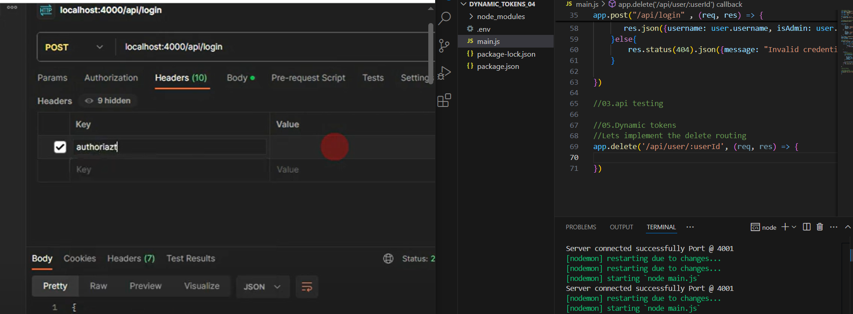

//Based on the headers, we will perform the authentication of a user here.

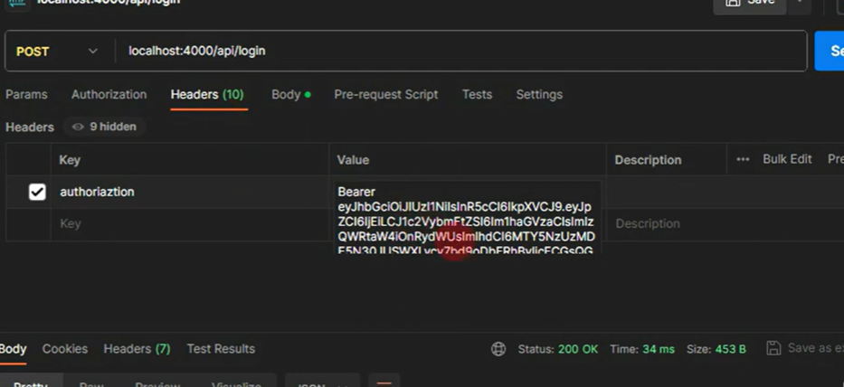

//Based on the token provided here, from postman we can identify the user.

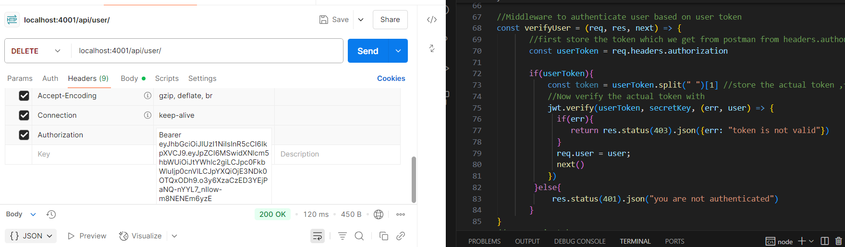

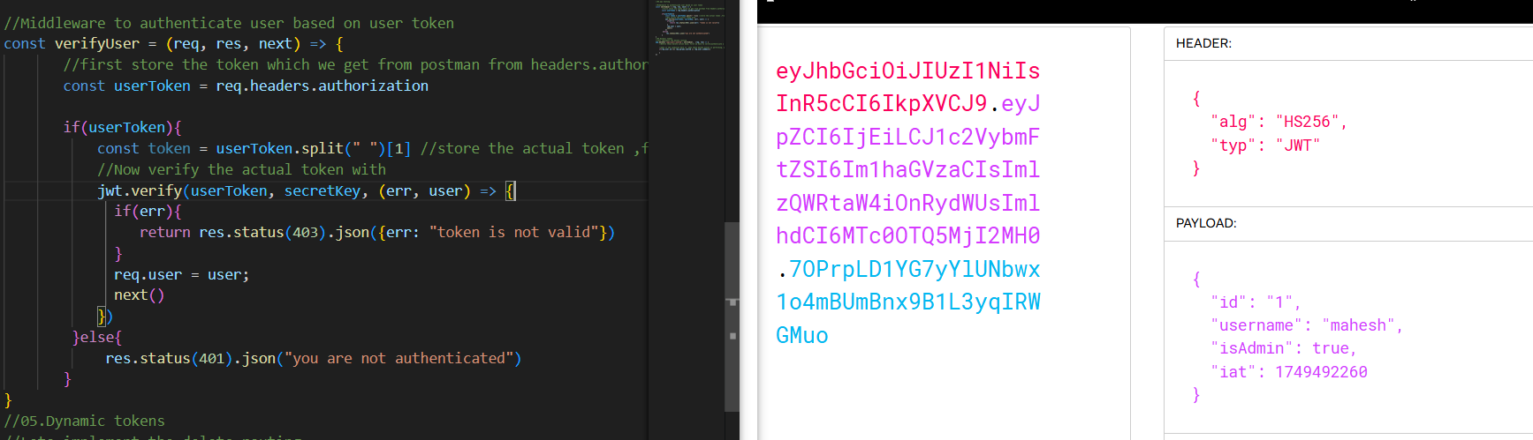

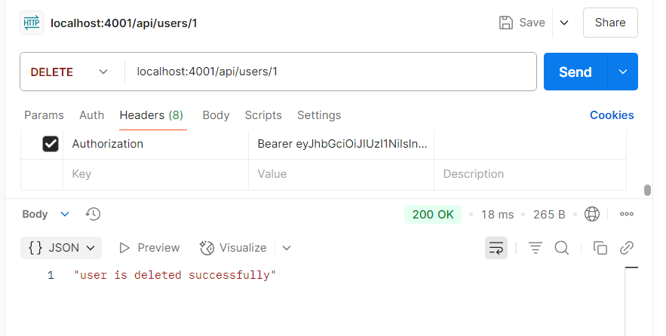

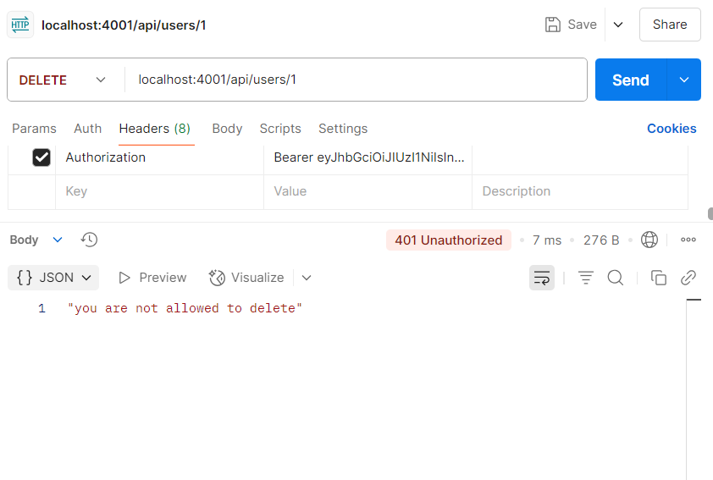

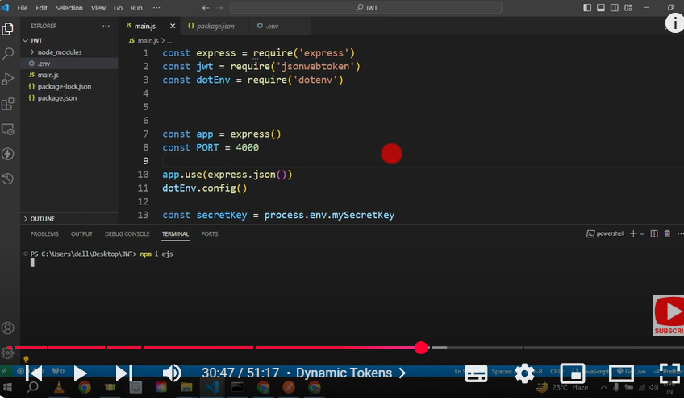

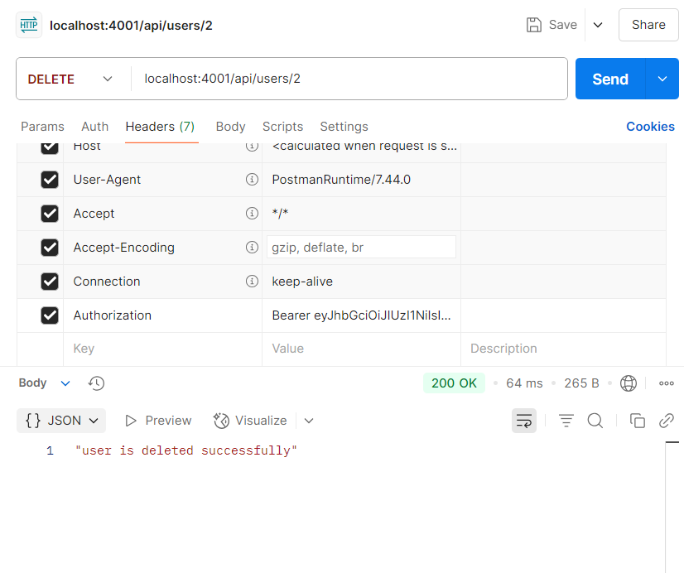

6.Authentication

